■CUSHION

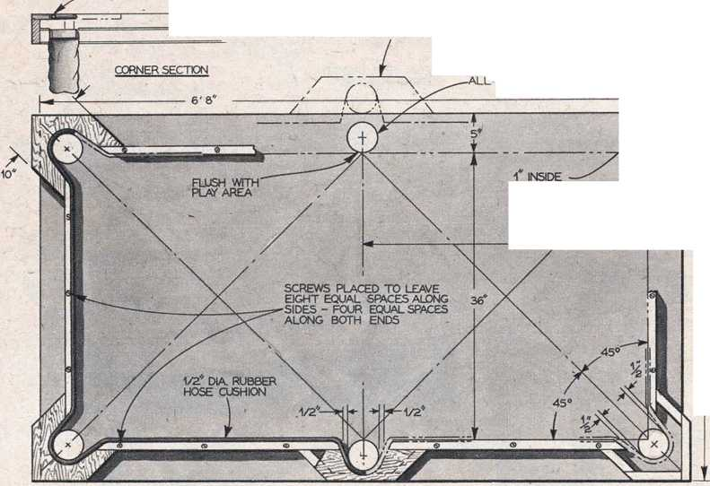

HOLES 3 3/4

HOLES PLACED OUTSIDE 'TABLE' AREA REQUIRES BUILT OUT BACKINGS

3'W"

PLAY AREA 36ff

manufactured for other purposes, for this billiard table is accurate and true to the most intricate requirements of cloth, cush­ions and structural rigidity demanded by expert players. >

A full-sized slate-bedded regulation bil­liard table requires a playing room at least 14xl9-ft. For home billiards, the first requirement is b table size that will fit into a small room and still allow ample cue space around the table. A second require­ment is the elimination of weight. A flush door is the answer to both.

Flush doors can be obtained from most lumber yards or millwork suppliers and in the larger cities are sometimes offered at a far lower price than a sheet of %-in. second grade plywood. Flat, true, rigid, light in weight and dimensionally stable, such a door will provide the perfect bed for your pocket billiards table.

Now for the construction details. The sketches show the layout of pockets and angles of approaches to the pockets, as well as the proper relationship between bed, rails, cushions and balls. Study the sketches and photos thoroughly before attempting to star,t construction.

If pocket positions are to lie outside the limits of the flush door, a smaller sized door can be used and' there is no need to cut into its surface in order to place the pockets, but this method will require careful and

accurate attachment of a considerable number of pieces to the edges of the door. However, this method is also shown in the plan view drawing in case you want to tackle it.

If pocket positions are to fall within the surface area of the door, its size must be chosen large enough so that the holes you cut for the pockets will leave about an inch of material at the door edge. Flush doors have solid wood only at their edges and if its continuity is broken, the rigidity and strength of the door is destroyed. Pocket holes can be safely cut, however, without loss of strength provided that the full hole lies inside the surface area of the door.

In cutting the pocket holes, the usual hole-cutting tools and devices are not satis­factory for there is nothing solid between the door faces—once the faces are pierced —for the center pin of the bit to bite into. Best method is to lay out the pocket hole circumference with a compass and then drill a series of small-diameter holes along the circumference completely through the thickness of the door. Thread the blade of a scroll or coping saw through one of these holes and carefully saw from hole to hole until the piece drops out. Rasp and sand the edges, being careful not to sliver the ve­neers of the thin plywood, until the pocket hole is true and smooth.

At this stage of [Continued on page 138]

100

Mechanix Illustrated