**Основные использованные команды и их вывод**:

alexandrganitev@Alexandrs-MBP minikube-hw % **minikube start --nodes 3 -p minikube-hw**

😄 [minikube-hw] minikube v1.30.1 on Darwin 13.3.1

✨ Using the docker driver based on existing profile

👍 Starting control plane node minikube-hw in cluster minikube-hw

🚜 Pulling base image ...

🔄 Restarting existing docker container for "minikube-hw" ...

🐳 Preparing Kubernetes v1.26.3 on Docker 23.0.2 ...

🔗 Configuring CNI (Container Networking Interface) ...

🔎 Verifying Kubernetes components...

▪ Using image docker.io/kubernetesui/dashboard:v2.7.0

▪ Using image docker.io/kubernetesui/metrics-scraper:v1.0.8

💡 Some dashboard features require the metrics-server addon. To enable all features please run:

minikube -p minikube-hw addons enable metrics-server

🌟 Enabled addons: dashboard

❗ The cluster minikube-hw already exists which means the --nodes parameter will be ignored. Use "minikube node add" to add nodes to an existing cluster.

👍 Starting worker node minikube-hw-m02 in cluster minikube-hw

🚜 Pulling base image ...

🔄 Restarting existing docker container for "minikube-hw-m02" ...

🌐 Found network options:

▪ NO_PROXY=192.168.49.2

🐳 Preparing Kubernetes v1.26.3 on Docker 23.0.2 ...

▪ env NO_PROXY=192.168.49.2

🔎 Verifying Kubernetes components...

👍 Starting worker node minikube-hw-m03 in cluster minikube-hw

🚜 Pulling base image ...

🔄 Restarting existing docker container for "minikube-hw-m03" ...

🌐 Found network options:

▪ NO_PROXY=192.168.49.2,192.168.49.3

🐳 Preparing Kubernetes v1.26.3 on Docker 23.0.2 ...

▪ env NO_PROXY=192.168.49.2

▪ env NO_PROXY=192.168.49.2,192.168.49.3

🔎 Verifying Kubernetes components...

🏄 Done! kubectl is now configured to use "minikube-hw" cluster and "default" namespace by default

alexandrganitev@Alexandrs-MBP minikube-hw % minikube -p minikube-hw addons enable metrics-server

💡 metrics-server is an addon maintained by Kubernetes. For any concerns contact minikube on GitHub.

You can view the list of minikube maintainers at: https://github.com/kubernetes/minikube/blob/master/OWNERS

▪ Using image registry.k8s.io/metrics-server/metrics-server:v0.6.3

🌟 The 'metrics-server' addon is enabled

alexandrganitev@Alexandrs-MBP minikube-hw % minikube dashboard --profile=minikube-hw

🔌 Enabling dashboard ...

▪ Using image docker.io/kubernetesui/dashboard:v2.7.0

▪ Using image docker.io/kubernetesui/metrics-scraper:v1.0.8

💡 Some dashboard features require the metrics-server addon. To enable all features please run:

minikube -p minikube-hw addons enable metrics-server

🤔 Verifying dashboard health ...

🚀 Launching proxy ...

🤔 Verifying proxy health ...

^C

alexandrganitev@Alexandrs-MBP minikube-hw % **minikube -p minikube-hw addons enable metrics-server**

💡 metrics-server is an addon maintained by Kubernetes. For any concerns contact minikube on GitHub.

You can view the list of minikube maintainers at: https://github.com/kubernetes/minikube/blob/master/OWNERS

▪ Using image registry.k8s.io/metrics-server/metrics-server:v0.6.3

🌟 The 'metrics-server' addon is enabled

alexandrganitev@Alexandrs-MBP minikube-hw % **kubectl get nodes**

NAME STATUS ROLES AGE VERSION

minikube-hw Ready control-plane 2d v1.26.3

minikube-hw-m02 Ready <none> 7m31s v1.26.3

minikube-hw-m03 Ready <none> 7m20s v1.26.3

alexandrganitev@Alexandrs-MBP minikube-hw % **kubectl get svc**

NAME TYPE CLUSTER-IP EXTERNAL-IP PORT(S) AGE

kubernetes ClusterIP 10.96.0.1 <none> 443/TCP 2d

mysql-service ClusterIP 10.97.203.5 <none> 3306/TCP 47h

webapp-service NodePort 10.101.13.216 <none> 80:30100/TCP 47h

alexandrganitev@Alexandrs-MBP minikube-hw % **kubectl cluster-info**

Kubernetes control plane is running at https://127.0.0.1:50841

CoreDNS is running at https://127.0.0.1:50841/api/v1/namespaces/kube-system/services/kube-dns:dns/proxy

To further debug and diagnose cluster problems, use 'kubectl cluster-info dump'.

alexandrganitev@Alexandrs-MBP minikube-hw % **kubectl get pods**

NAME READY STATUS RESTARTS AGE

mysql-deployment-8d85bf6-4wkh7 1/1 Running 1 (10m ago) 24h

webapp-deployment-575c58b769-sjnnc 0/1 ContainerCreating 0 24h

alexandrganitev@Alexandrs-MBP ~ % **kubectl get pods**

NAME READY STATUS RESTARTS AGE

mysql-deployment-8d85bf6-4wkh7 1/1 Running 4 (84m ago) 37h

webapp-deployment-575c58b769-sjnnc 1/1 Running 5 (84m ago) 37h

alexandrganitev@Alexandrs-MBP minikube-hw % **minikube dashboard --profile=minikube-hw**

🤔 Verifying dashboard health ...

🚀 Launching proxy ...

🤔 Verifying proxy health ...

^C

alexandrganitev@Alexandrs-MBP minikube-hw % **kubectl apply -f mysql-config.yaml**

configmap/mysql-config unchanged

alexandrganitev@Alexandrs-MBP minikube-hw % **kubectl apply -f mysql-secret.yaml**

secret/mysql-secret unchanged

alexandrganitev@Alexandrs-MBP minikube-hw % **kubectl apply -f mysql-deployment.yaml**

deployment.apps/mysql-deployment unchanged

service/mysql-service unchanged

alexandrganitev@Alexandrs-MBP minikube-hw % **kubectl apply -f webapp-deployment.yaml**

deployment.apps/webapp-deployment unchanged

service/webapp-service unchanged

alexandrganitev@Alexandrs-MBP ~ % **kubectl get nodes**

NAME STATUS ROLES AGE VERSION

minikube-hw Ready control-plane 2d11h v1.26.3

minikube-hw-m02 Ready <none> 74s v1.26.3

minikube-hw-m03 Ready <none> 63s v1.26.3

alexandrganitev@Alexandrs-MBP ~ % **kubectl get svc**

NAME TYPE CLUSTER-IP EXTERNAL-IP PORT(S) AGE

kubernetes ClusterIP 10.96.0.1 <none> 443/TCP 2d11h

mysql-service ClusterIP 10.97.203.5 <none> 3306/TCP 2d11h

webapp-service NodePort 10.101.13.216 <none> 80:30100/TCP 2d11h

alexandrganitev@Alexandrs-MBP ~ % **kubectl get pods**

NAME READY STATUS RESTARTS AGE

mysql-deployment-8d85bf6-4wkh7 1/1 Running 4 (11m ago) 36h

webapp-deployment-575c58b769-sjnnc 1/1 Running 5 (11m ago) 36h

Вывод команды **kubectl get all -o wide**:

alexandrganitev@Alexandrs-MBP ~ % **kubectl get all -o wide**

NAME READY STATUS RESTARTS AGE IP NODE NOMINATED NODE READINESS GATES

pod/mysql-deployment-8d85bf6-4wkh7 1/1 Running 4 (42m ago) 36h 10.244.0.3 minikube-hw <none> <none>

pod/webapp-deployment-575c58b769-sjnnc 1/1 Running 5 (42m ago) 36h 10.244.0.6 minikube-hw <none> <none>

NAME TYPE CLUSTER-IP EXTERNAL-IP PORT(S) AGE SELECTOR

service/kubernetes ClusterIP 10.96.0.1 <none> 443/TCP 2d12h <none>

service/mysql-service ClusterIP 10.97.203.5 <none> 3306/TCP 2d11h app=mysql

service/webapp-service NodePort 10.101.13.216 <none> 80:30100/TCP 2d11h app=webapp

NAME READY UP-TO-DATE AVAILABLE AGE CONTAINERS IMAGES SELECTOR

deployment.apps/mysql-deployment 1/1 1 1 2d11h minikube-hw-mysql-1 alexandrganitev/23mifiibag:minikube-hw-mysql app=mysql

deployment.apps/webapp-deployment 1/1 1 1 2d11h minikube-hw-php-apache-1 alexandrganitev/23mifiibag:minikube-hw-php-apache app=webapp

NAME DESIRED CURRENT READY AGE CONTAINERS IMAGES SELECTOR

replicaset.apps/mysql-deployment-8d85bf6 1 1 1 2d11h minikube-hw-mysql-1 alexandrganitev/23mifiibag:minikube-hw-mysql app=mysql,pod-template-hash=8d85bf6

replicaset.apps/webapp-deployment-575c58b769 1 1 1 2d11h minikube-hw-php-apache-1 alexandrganitev/23mifiibag:minikube-hw-php-apache app=webapp,pod-template-hash=575c58b769

replicaset.apps/webapp-deployment-7f9cd746d9 0 0 0 2d11h webapp nanajanashia/k8s-demo-app:v1.0 app=webapp,pod-template-hash=7f9cd746d9

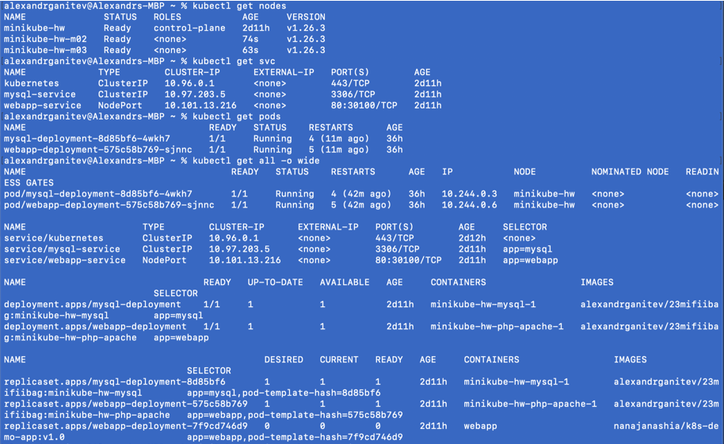

Работающий Dashboard:

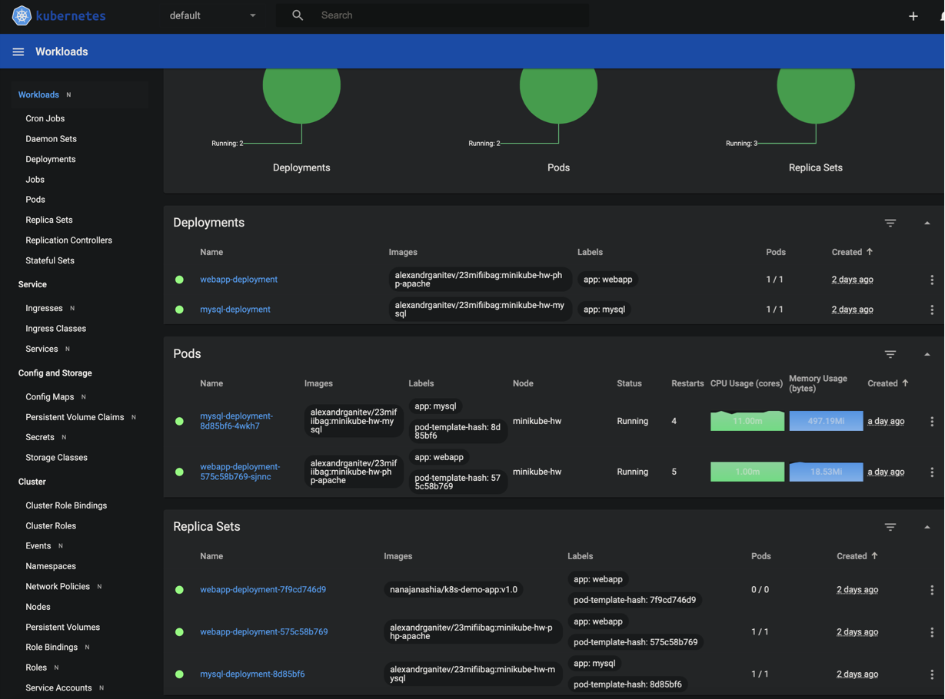

Работающая программа, вывод набора инструментов из Mysql базы данных на Apache вебсайт посредством php:

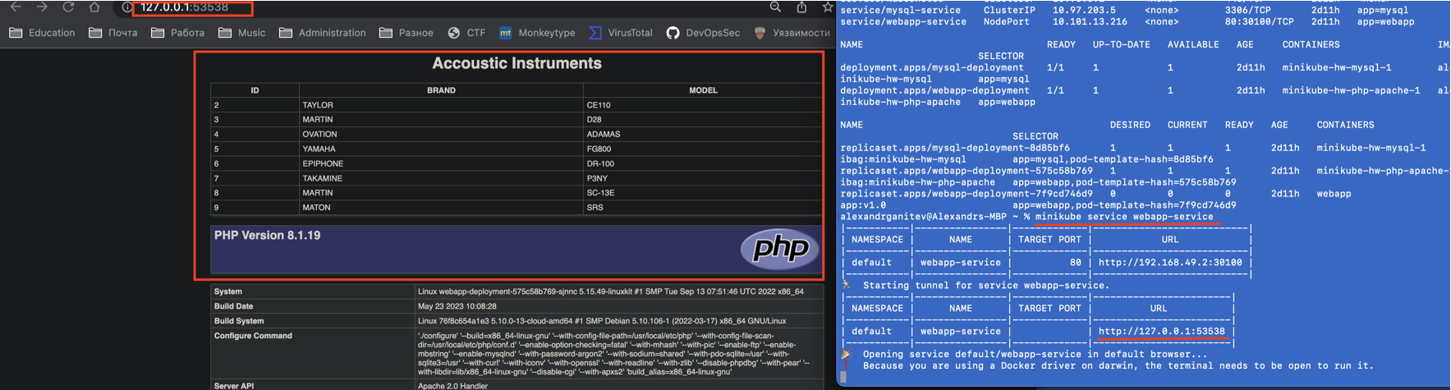

Заметка к проверяющему.

Я так и не смог разобраться, за недостатком времени, как настроить StatefulSet, чтобы сохранить состояние и данные моих подов, а также не смог выяснить, как мне передавать пароль для доспупа в базу данных посредством переменных окружения. Мне нужен пример использования данных технологий или гораздо больше времени для исследования. Учитывая тот факт, что я основательно завяз в выполнении данной работы и в практически отсутствующей помощи от менторов (благодарность Константину за первый ответ), я принял решение сдать работу как есть, и идти дальше.