Testing

test1.csv contains entries made my brother under no instruction by me. I allowed him to try whatever he wanted and experience message boxes. All fields contain information I would consider valid. This is my actual results.

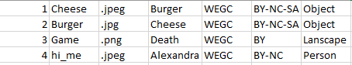

|  |  |
| --- | --- |
| Image ID | Image ID must be an integer and must be a least one character. It cannot be an identical value to one previously entered. |
| File Name | Can only contain lower-case and upper-case letters, numbers, and underscores. Must contain at least one character and cannot be a match to a previously entered file name. |
| File extension | Drop down menu, no validation requires, except for insuring there is a selected option. |
| Image Name | Validation it must contain at least one character. |
| Owner | Defaults to WEGC. Validation it must contain at least one character. |
| License | Drop down menu, no validation requires, except for insuring there is a selected option. |
| Photo Category | Drop down menu, no validation requires, except for insuring there is a selected option. |

image_meta.csv contains entries that I created. Seen here in excel format. I tried to break the program and couldn’t. Here are the results. As you can see all entries meet the criteria set above for each variable.

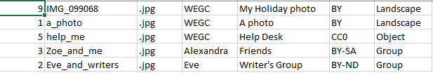

# Test cases

|  |  |
| --- | --- |
|  | Illegal/Invalid This will not be accepted as:  File name contains something other than lower or upper case characters, numbers or underscores.  Image ID is not an integer and therefore will not be accepted.  Licence does not contain any value and therefore will not be accepted. |
|  | Boundary – Image ID Image ID allows all numbers whole numbers between 1 and 250.  The first and secondary entries will not be accepted and will display an error message. The third entry passes the conditions.  The entries 249 and 250 will be accepted (passes conditions). The entry 251 will not be accepted and will display an error message. |
|  | Boundary – File Name File Name has a character limit between 1 and 250. These characters can allow be ‘a-z’,’ A-Z’, ‘0-9’, and ‘_’.  The first entry contains 249 h’s and will be allowed.  The second entry contains 250 h’s and will be allowed.  The third entry contains 251 h’s. It will not be accepted and will display an error message. |
|  | Expected This is acceptable and will be accepted and appended to list.  Unless file name is a duplicate value. The user will be asked to enter a value again.  OR  Unless image ID is a duplicate value.  The user will be asked to enter a value again. |

|  |  |
| --- | --- |
|  | When ‘write to csv’ button is pressed before information has been validated. |
|  | When all information is correct and ‘submit’ has been pressed. |
|  | When ‘write to csv’ button is pressed and information has been validated. |
|  | When image ID exceeds 250. |
|  | When file name exceeds 250 characters. |