MERIDIAN TECHNOLOGIES
Investor Day Positioning Memo | March 11, 2026
Catherine Park, President & CEO | CONFIDENTIAL — Pre-release draft

Executive Summary
Meridian will declare itself the enterprise-governed agentic work platform — the company that combines the Helio agent framework with the deepest enterprise governance stack in the category. Project management is our wedge and our proven foundation; agents running on trusted, auditable, regulation-ready infrastructure are our three-year strategy. We are not building AI features on top of a PM tool. We are building the platform on which regulated enterprises can run agents safely — and no competitor owns that position today.

Our Position (One Sentence for the Market)
"Meridian is the agentic work platform that regulated enterprises trust — built on the governance infrastructure that banks, pharma, and federal agencies already rely on, and powered by the Helio agent framework."

Why This Position — Three Reasons
- 1. The white space is ours. The competitive white space is here. Asana and Monday are agentic but have no governance. Smartsheet has governance but explicitly rejects agentic. Atlassian is agentic + governance but only for software/IT teams. No one owns 'agentic + regulated-industry governance.' We do, today.
- 2. Our customers are already asking for it. 18 of 22 enterprise advisory board sessions in the last 90 days asked for agent auditability, role-based permissions, model selection, and data residency. These customers are not asking for better PM features. They are asking for a governed agent platform. We should name what we already are.
- 3. We have the assets to execute it. We have $506M liquidity, $55M AI R&D budgeted, and the Helio team — 28 engineers from leading AI labs with a working agent framework. Option A (PM-with-AI) would likely cost us the Helio team at their 2026 compensation cliff. Option B keeps them and uses their full capacity.

Competitive Landscape
The 2×2 below maps all four direct competitors on two dimensions: how agentic their public positioning is (X-axis) and how premium their AI pricing model is (Y-axis). The upper-right quadrant — agentic positioning with premium/consumption pricing — is the target zone. Only Atlassian and Meridian are positioned there; Atlassian's footprint is in software/IT, not regulated general enterprise.
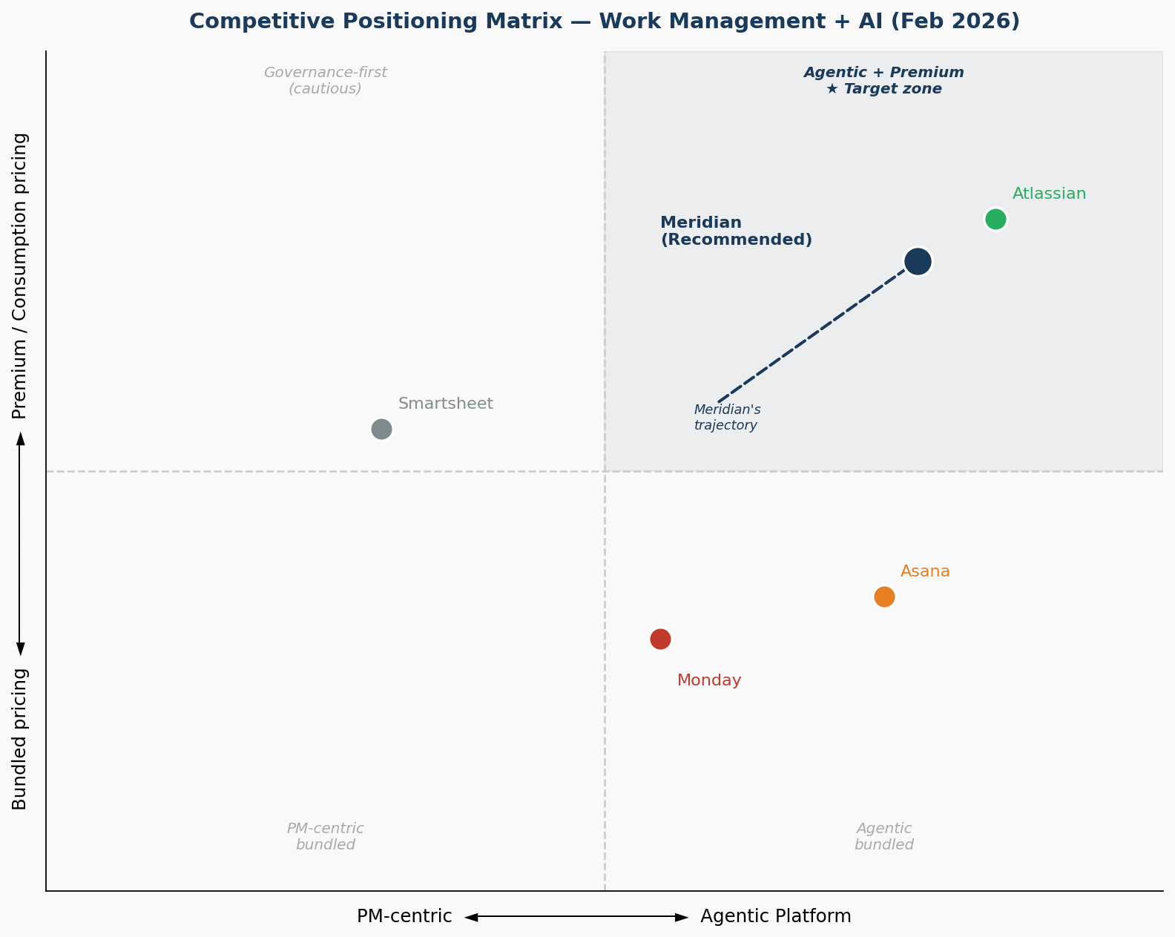
Figure 1 — Competitive positioning matrix. Meridian's recommended trajectory shown by dashed arrow.

Competitor AI Positioning — Summary Table
Company | AI Positioning | Pricing | Flagship Announcement | vs. Meridian
Asana | Work mgmt + AI built in; 'agent OS' language | Bundled Advanced+ | AI Studio + Smart Workflows bundled, Nov 2025 | Agentic, no governance moat
Monday.com | Work OS 'supercharged with AI'; breadth play | Bundled Pro+ | monday AI Agents GA, Jan 2026 | Price aggressor, no regulated-industry depth
Smartsheet | Enterprise trust + AI; avoids 'agentic' | AI bundled + Compliance Pack add-on | AI Compliance Pack, Dec 2025 | Closest to Option A; decelerating growth
Atlassian | Agentic enterprise platform; Rovo Studio | Per-seat + consumption | Rovo Studio GA, Jan 2026 | Closest peer to Option B; software/IT focus only
Meridian  (target) | Enterprise-governed agentic work platform | Per-seat + consumption H2 2026 | Copilot GA + Helio integration; governance suite Q1 2026 | Owns regulated-industry agentic governance

Three Biggest Risks
- Risk 1 — Atlassian out-executes us in our own white space. Atlassian has more R&D, bigger install base, and 6–12 months head start in agentic. If they invest in regulated-industry certifications (FedRAMP High, GxP), our moat narrows. Mitigation: accelerate GxP in 2026, add a second regulated vertical (federal or insurance).
- Risk 2 — Consumption pricing ramps slowly in regulated enterprise. Enterprise consumption pricing ramps slower than projected. Regulated-industry procurement cycles are 9–14 months. If per-consumption revenue is not measurable by Q4 2026, we will face a credibility gap with investors. Mitigation: announce pricing model at Investor Day with specific 2026 milestones we are willing to be held to.
- Risk 3 — We concede mid-market while agentic ramp takes hold. PM motion softens while agentic ramps. Mid-market NRR is already at 102%. If Copilot bundling for mid-market is not decided by Q2, renewals will continue to erode. Mitigation: separate the pricing decision for enterprise (hold at $40/seat) vs. mid-market (consider bundled or heavily discounted).

Three Commitments to Investors
- 1. AI adoption is measurable and we will be held to it. Copilot attach rate on enterprise renewals stays above 40% through 2026. We will report this metric publicly starting Q1 2026.
- 2. Consumption pricing is not a roadmap item — it is a 2026 commitment. Consumption pricing goes live in H2 2026. We will share the pricing architecture at Investor Day and report consumption ARR as a separate line starting Q3 2026.
- 3. We expand the regulated-industry footprint — not just deepen it. GxP certification ships in Q4 2026. One additional regulated vertical (federal or insurance) enters the pipeline by Q2 2026. We are not a two-vertical company.

CONFIDENTIAL — For Internal Use and Board Review Only | Meridian Technologies, Inc. | NASDAQ: MRDN

