MERIDIAN TECHNOLOGIES
Annual Board Strategic Review | CEO Opening Remarks
Catherine Park, President & CEO | May 2026 | 5 minutes

Our enterprise franchise is the strongest it has ever been — and 2026 is the year we decide whether AI makes us a platform or leaves us a feature.

The Picture in One Chart
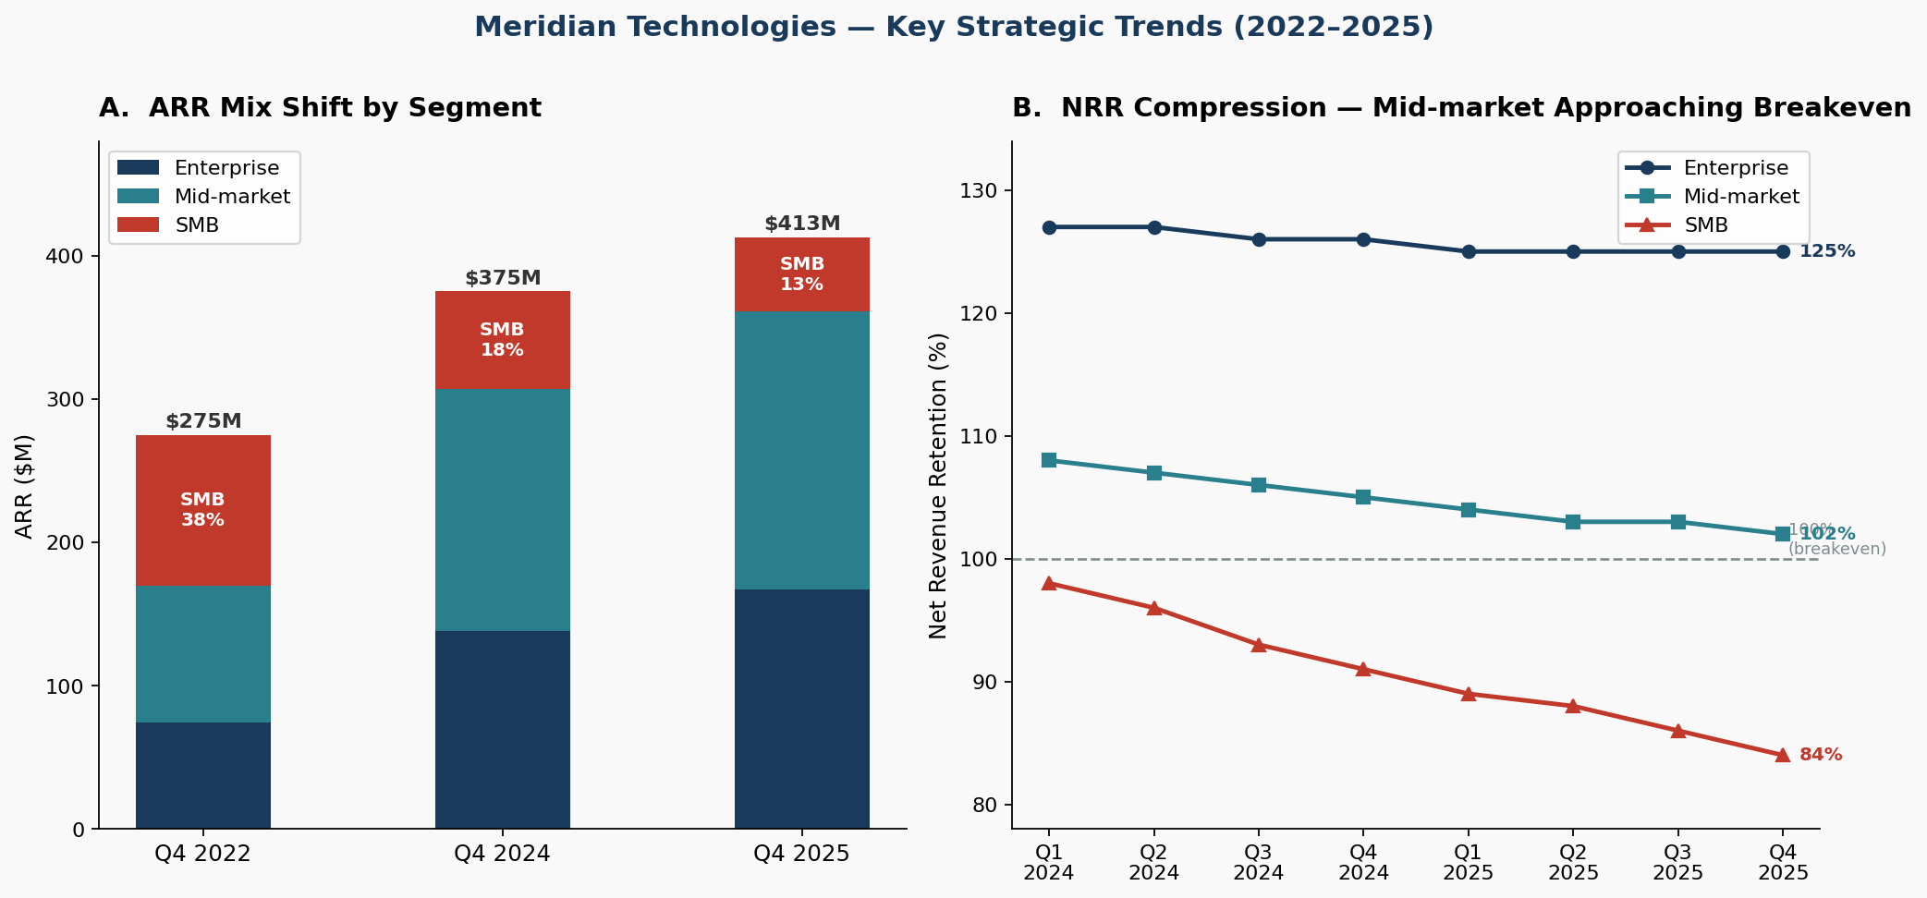
Left: ARR by segment — Enterprise doubled, SMB collapsed 50%. Right: NRR compression — Mid-market trending toward breakeven.

Issue 1 — AI Competitive Gap: We Are Behind and Time Is Not Neutral
This is the most urgent issue. We shipped Copilot GA in September 2025 — roughly 18 months after Asana, which bundled AI into its standard tier in October. Today we have 710 paying Copilot seats and $3.5M in AI ARR. That is a beginning, not a moat.
- Evidence: 710 Copilot paying seats at Q4 2025 vs. zero twelve months prior — real traction, but $3.5M ARR on a $413M base.
- Evidence: Magic number declined from 1.20 (Q1 2024) to 0.92 (Q4 2025) as R&D rose to 25.4% of revenue — we are spending more to grow less.
- Evidence: ClearAI Work raised $120M at $1B+ valuation. Atlassian announced agentic Jira. Asana full agent suite shipped November 2025.
- Risk: Engineering net hiring is ~25 heads/year at 15% attrition — the 2026 plan requires 80. Helio retention cliff hits in 2026.

Issue 2 — Mid-Market NRR at 102%: One Bad Year From a Net ARR Drain
Mid-market is 47% of our ARR and growing at 6%. NRR has compressed from 115% in 2022 to 102% today. If it crosses 100%, our largest segment becomes a headwind, not a tailwind — and enterprise cannot grow fast enough to compensate.
- Evidence: NRR: 115% (2022) → 108% (Q1 2024) → 102% (Q4 2025). GRR has declined from 89% to 86% — customers are leaving, not just expanding less.
- Evidence: Mid-market renewals now routinely demand a price hold, expanded seats at flat price, or Copilot bundled at no cost (Q3 2025 earnings call).
- Evidence: Resource management module — the #1 mid-market customer ask — deferred twice; now targeting Q2 2026.

Issue 3 — We Need a 3-Year Plan: The Board Authorized One for Q1 2026
The board authorized a successor strategic plan in Q1 2026. The March 11 Investor Day will be the public version. Today I am asking the board to approve the internal version that drives our R&D, M&A, and capital allocation decisions this year.
- Context: The 2023–2026 plan explicitly noted it was 'no longer the right plan for 2025' and authorized the new CEO to write a successor (Strategic Plan document).
- Stakes: The central strategic question — agentic work platform vs. PM tool with AI features — changes R&D priorities, sales motion, pricing model, and positioning (Q4 2025 earnings call).
- Dependency: Two additional AI-native acquisition targets in early diligence. Capital allocation in 2026 requires a resolved strategic direction.
- Internal risk: 31% of engineers cite 'roadmap thrash' in the 2025 employee survey. The organization will not execute a plan it doesn't believe is durable.

MY ONE ASK OF THE BOARD TODAY
Approve the 3-year strategic direction — specifically, the decision to position Meridian as an agentic work platform for regulated enterprises — so that every R&D, M&A, and go-to-market decision in 2026 flows from a single, board-sanctioned answer to the question: what is Meridian?
Supporting detail on the 3-year financial model, AI roadmap, and M&A pipeline follows in the board package. I will spend the balance of today's session on Q&A and the strategic direction decision.

CONFIDENTIAL — For Board Use Only | Meridian Technologies, Inc. | NASDAQ: MRDN

