Documentation

1. ***Introduction:***

**Project Title:** Early Discovery of Anxiety/Depression in Teenagers Using Digital Tools

**Objective:**

Anxiety/Depression for teenagers - To enhance mental health support for teenagers by developing digital tools that can proactively identify signs of anxiety and depression. These tools aim to engage with adolescents in their digital environments—whether through chatbots, social media, video games, or other innovative platforms—to provide early intervention and emotional support.

**Main idea:**

The Early Discovery of Anxiety/Depression in Teenagers solution leverages digital platforms to identify and monitor mental health challenges among adolescents. The system combines multiple approaches, including AI-powered chatbots capable of conversational analysis, sentiment evaluation through social media interactions, and mental health assessments embedded in video game experiences. By engaging teenagers where they spend most of their time—whether online or gaming—the system aims to provide real-time insights and early warnings of anxiety or depression. This integrated solution offers a holistic approach, blending digital engagement with predictive analytics and personalized intervention strategies.

**Motivation:**

Teen anxiety and depression are pressing issues, often going unnoticed due to social stigma, lack of awareness, or teens' reluctance to seek help. Traditional detection methods are limited in reach and timing, missing critical opportunities for early intervention. By embedding intelligent algorithms in digital spaces where teens naturally engage—like social media, chat apps, and video games—we can monitor signs of mental distress in real time.

AI-powered tools, especially those using natural language processing and machine learning, can analyse behavioural patterns, detect early signs of anxiety or depression, and respond immediately, offering instant, personalized support. These algorithms not only provide proactive intervention but also reduce barriers to help-seeking by creating a safe, accessible way for teens to explore mental health support in familiar digital environments. This intelligent approach can help prevent more serious issues, offering timely and compassionate care to teens who need it most.

1. ***The scientific problem addressed***
2. ***Existing problem-solving methods (related work)***
3. First approach
4. **Anxiety Data:**

We used a data set of 500 rows (small data)

* **Hyperparameters:** ID, Text, Target
* **Target:** normal(246), anxiety(254)
* **Models:** Support Vector Classification(Support Vector Machine) with encoding Word2Vec
* **Results:**
* accuracy: 0.64
* precision average: 0.6481481481481481
* precision for Anxiety Class: 0.6481481481481481
* precision for Normal Class: 0.6304347826086957
* recall: 0.6730769230769231
* confusion matrix:

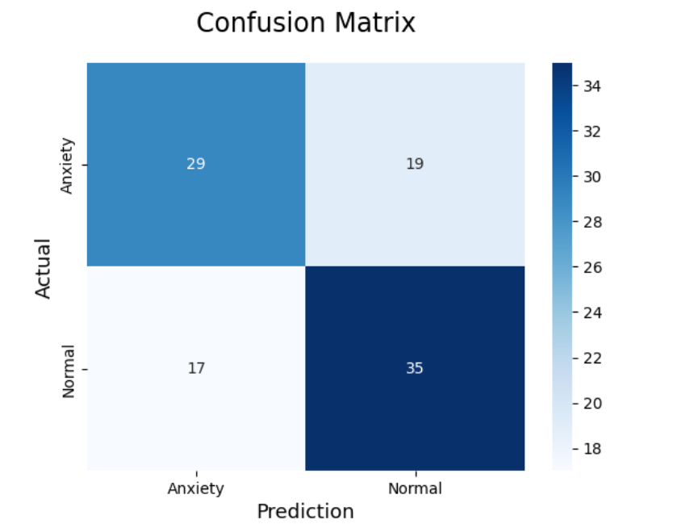

1. **Depression Data:**

We used a data set of 500 rows (small data)

* **Hyperparameters:** ID, Text, Target
* **Target:** normal(249), anxiety(251)
* **Models:** Support Vector Classification(Support Vector Machine) with encoding Word2Vec
* **Results:**
* accuracy: 0.62
* precision average: 0.6181818181818182
* precision for Depression Class: 0.6181818181818182
* precision for Normal Class: 0.6222222222222222
* recall: 0.6666666666666666
* confusion matrix:

