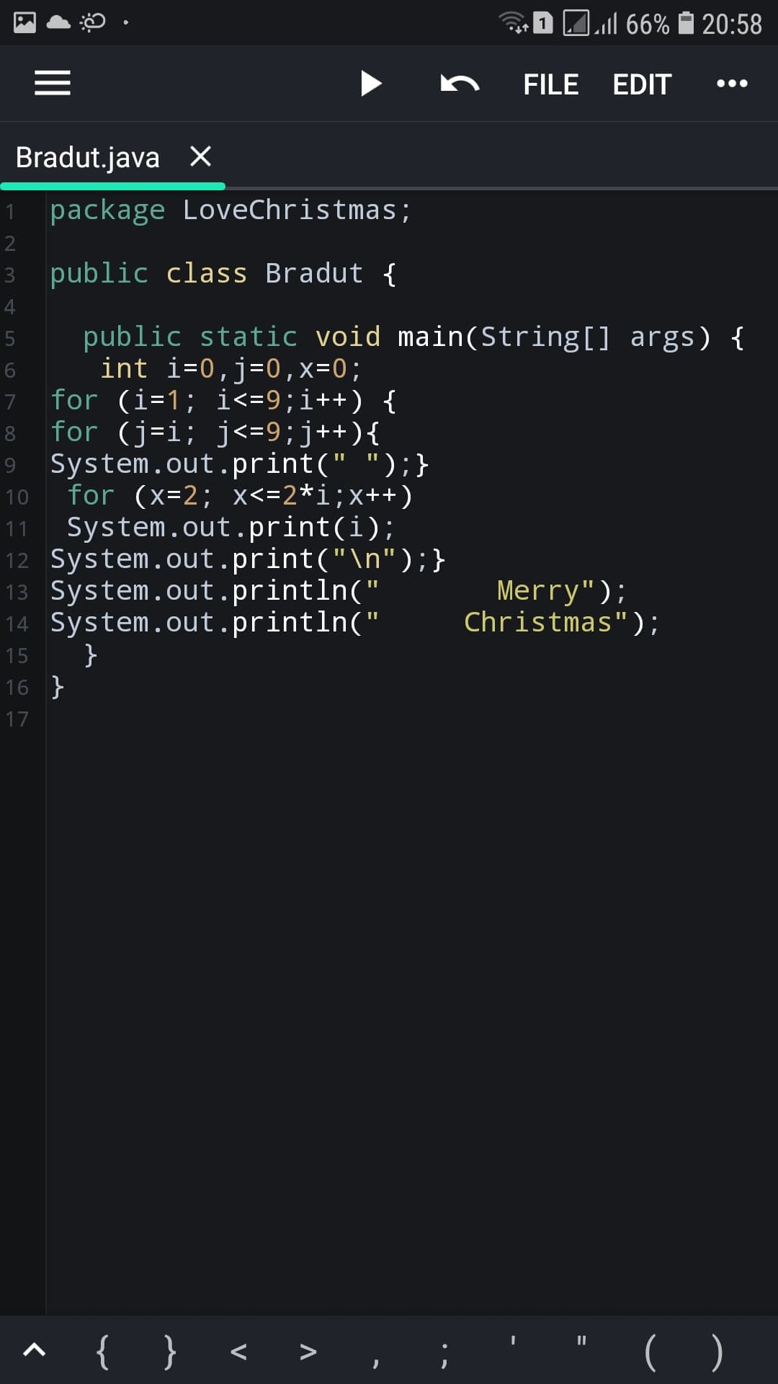

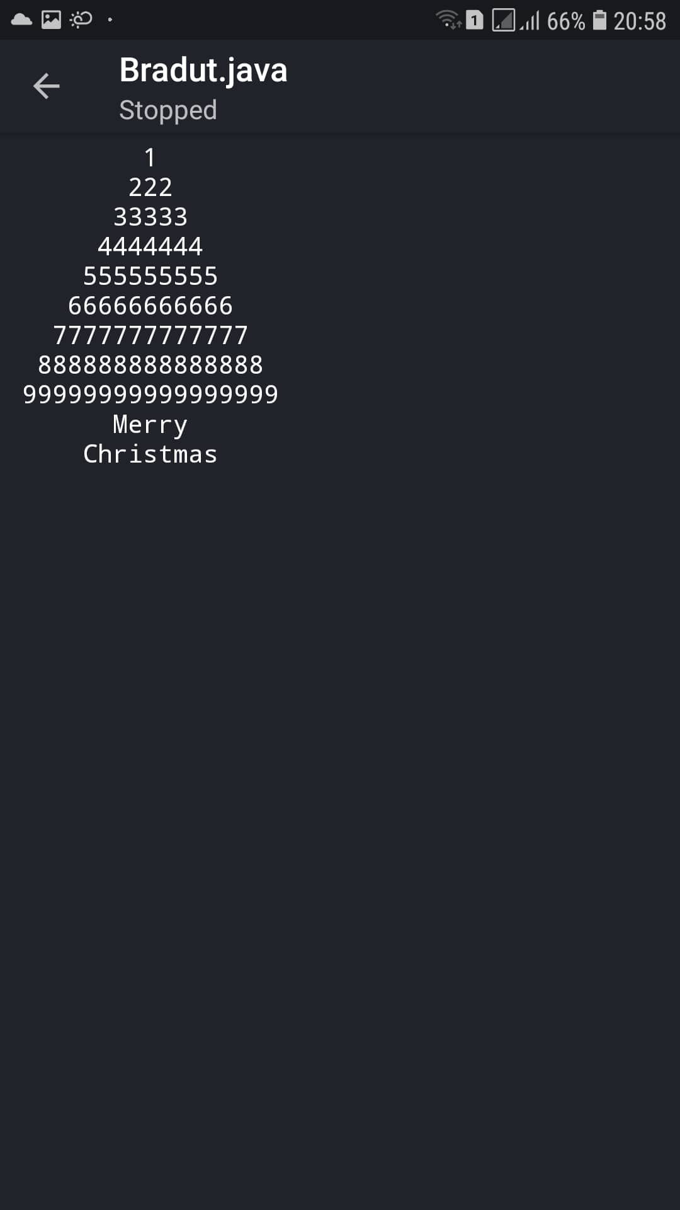

package LoveChristmas;

public lass Bradut{

public static void main(String[] args){

int i=0, j=0,x=0;

for (i=1; i<=9;i++){

for(j=i;j<=9;j++){

System.out.print(‘’ ‘’);{

for (x=2; x<=2\*i;x++)

System.out.print(i);

System.out.print(“\n”);}

System.out.println(“ Merry”);

System.out.println(“ Christmas”);

}

}