Distribution of rockfish species along environmental gradients in Gulf of Alaska bottom trawl surveys

Contributed by Alexandra Dowlin 1 and Ned Laman1  
1 Resource Assessment and Conservation Engineering Division, Groundfish Assessment Program, Alaska Fisheries Science Center, National Marine Fisheries Service, NOAA, Seattle, WA

Contact: [Alexandra.Dowlin@noaa.gov](mailto:Alexandra.Dowlin@noaa.gov)  
Last updated: October 5, 2023

**Description of index**: In a previous analysis of rockfish from 14 bottom trawl surveys in the Gulf of Alaska and Aleutian Islands (Rooper 2008), five species assemblages were defined based on similarities in their distributions along geographical position, depth, and temperature gradients. The 180 m and 275 m depth contours were major divisions between rockfish assemblages inhabiting the shelf, shelf break, and lower continental slope. Another noticeable division was between species centered in southeastern Alaska and those found in the northern Gulf of Alaska and Aleutian Islands.

In this time-series, the mean-weighted distributions of six rockfish species (four *Sebastes spp.*, rougheye-blackspotted rockfish complex, and *Sebastolobus alascanus*) along the three environmental gradients (position, depth and temperature) were calculated for the Gulf of Alaska and Aleutian Islands. A weighted mean value for each environmental variable was computed for each survey as:

$$Mean=\frac{∑\left(f_{i}x_{i}\right)}{∑\left(f_{i}\right)},$$

where $f_{i}$ is the CPUE of each rockfish species group in tow $i$ and $x_{i}$ is the value of the environmental variable at tow $i$. The weighted standard error (*SE*) was then computed as:

$$SE=\frac{\sqrt{\frac{\left(∑\left(f_{i}x_{i}^{2}\right)\right)-\left(\left(∑\left(f_{i}\right)\right)*mean^{2}\right)}{(∑\left(f_{i}\right)-1}}}{\sqrt{n}},$$

where $n$ is the number of tows with positive catches. Details of the calculations and analyses can be found in Rooper (2008). These indices can be used to monitor the distributions of major components of the rockfish fisheries along these environmental gradients to detect changes or trends in rockfish distribution. Changes in geographic position are referenced to Hinchinbrook Island in the Gulf of Alaska.

In 2001, budgetary limitations precluded the survey from sampling the Yakutat to Southeast Alaska INPFC districts and so this year is excluded from the position data time series (Raring et al. 2011).

**Status and trends**: There are two statistically significant depth-related trends observed in the Gulf of Alaska time series through 2023: the depth distribution of northern rockfish and shortspine thornyhead have become shallower over time (Figure 1). The mean-weighted depth distribution of most species examined appears to be trending shallower, though the depth distribution of dusky rockfish has gotten slightly deeper in the last few surveys. There are no significant rockfish distribution trends with temperature, although it could be expected that, with most rockfishes examined here shifting to shallower depths, warmer temperature might become more common at the depth of collection. There is a very interesting shift in the distribution of adult Pacific ocean perch along the geographical position gradient. In 2013, the highest mean-weighted position occurred for this species around 270 km west of Hinchinbrook Island, Alaska. Over the last 10 years, the mean-weighted position has shifted approximately 500 km southeastward. The distribution of adult Pacific ocean perch was found approximately 220 km southeastward of Hinchinbrook Island in 2023. There were no other significant trends in distance from Hinchinbrook Island or in mean-weighted temperate distributions for any of the rockfishes, all of which were found within about a 1°C temperature envelope.

**Factors causing observed trends**: In the Gulf of Alaska, the overall stability of the distributions indicates that each species occupies a fairly consistent geographical and depth distribution. This stability is seen in the flat line time series of distribution across areas and depths despite the variability in temperature over the last few years. As temperatures rise and fall around the mean, the depth distribution does not change, indicating that most rockfishes are not changing their habitat or distribution to maintain a constant temperature. The slight decrease in depth overtime for most rockfishes and the southeastward shift of adult Pacific ocean perch could be explained by the changing abundance of these species. Estimated Pacific ocean perch abundance has increased by approximately 500,000 MT since 2013 which may help to explain their southeastward shift.

**Implications**: The trends in the mean-weighted distributions of rockfishes should continue to be monitored, with special attention to potential causes of the shift in depth to shallower waters, especially as they relate to changing temperatures. In 2019, five of the six rockfish species were found at the highest mean-weighted temperature in the time series with the exception of adult rougheye-blackspotted rockfish complex. The slight decrease in depth over time for most rockfishes and the southeastward shift of adult Pacific ocean perch warrant further investigation to determine if these trends will continue.

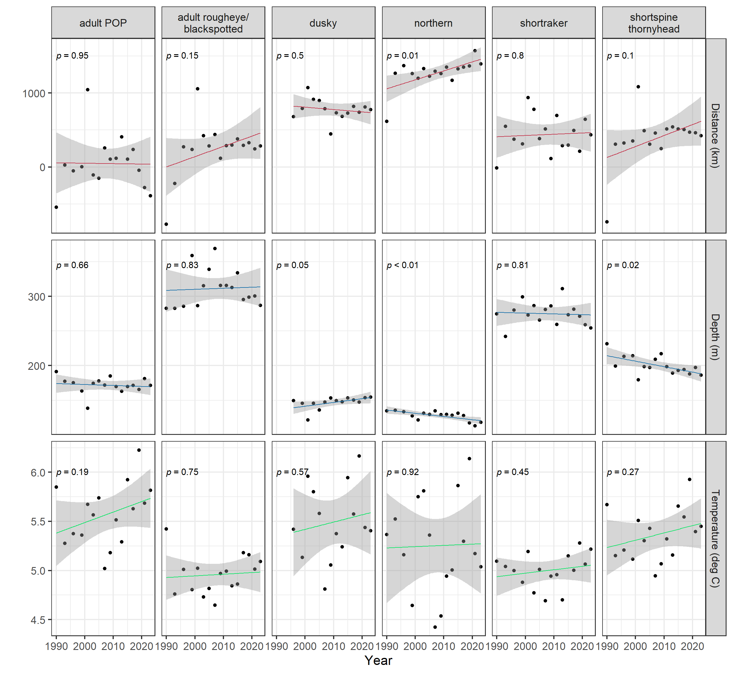

Figure 1. Plots of mean weighted (by catch per unit effort) distributions of six rockfish species-groups along three environmental gradients in the Gulf of Alaska. Mean weighted distributions of rockfish species-groups are shown for A) position, B) depth, and C) temperature. Position is the distance from Hinchinbrook Island, Alaska, with positive values west of this central point in the trawl surveys and negative values is southeastward. P-values are located on each plot. P-values close to zero are defined as statistically significant.

Raring, N. W., P. G. von Szalay, F. R. Shaw, M. E. Wilkins, and M. H. Martin. 2011. “Data Report: 2001 Gulf of Alaska Bottom Trawl Survey.” {NOAA} {Technical} {Memorandum} {NMFS} {AFSC} NMFS-AFSC-225.

Rooper, C. N. 2008. “An Ecological Analysis of Rockfish (Sebastes Spp.) Assemblages in the North Pacific Ocean Along Broad-Scale Environmental Gradients.” *Fishery Bulletin* 106: 1–11.