**Year 2 – semester A – Object Oriented Course – Report EX0**

**Names**: Alex Fishman & Alona Kondratenko

At this time we improved the last work in several cases:

* For writing KML file, **we used A library** named "org.jsefa" that we found on the internet (this library included in src folder on Github).

We chose that library because of several things:

* + Its free to use
  + Its creates the exact file that we need
  + We can view the source files
  + It makes it easier to debug
* Into the writing of the KML file we added a **time stamp** that allows as to use the time bar on google earth and select part/s of data that we want to watch.
* **J-Unit-Tests** was created.
* Also we got to do a code review for 2 other works (but notice that we didn't get a code review about ours work).

Only got one from Sefi (the teacher assistant) – his review was:

* To add J-docs – done!
* To deal with the many comparators that we had and unite them to one 'mother-class' – done!
* Change the name of the function "writeCSV" to "readCSV" – done!

**Examples of the usage of this program:**

Union CSV file:

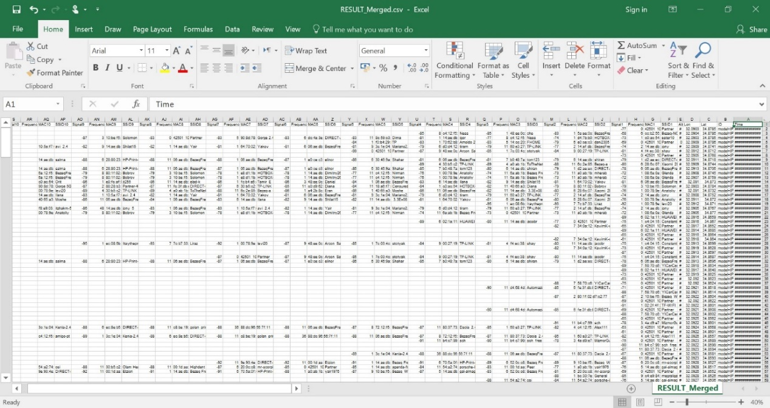

Filtered CSV file:

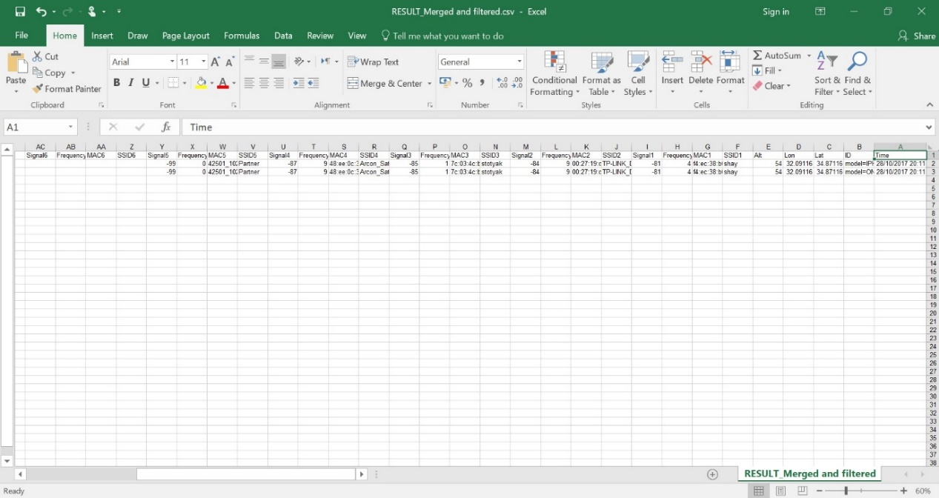

KML format file:

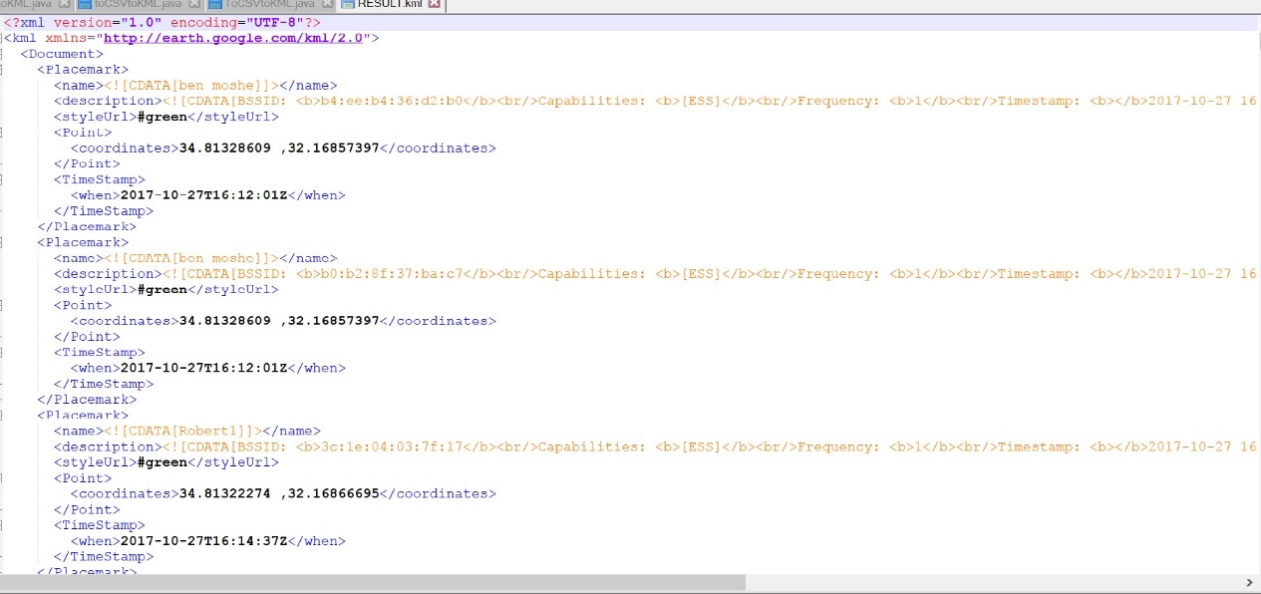

Opening the files on google earth:

Filtered file:

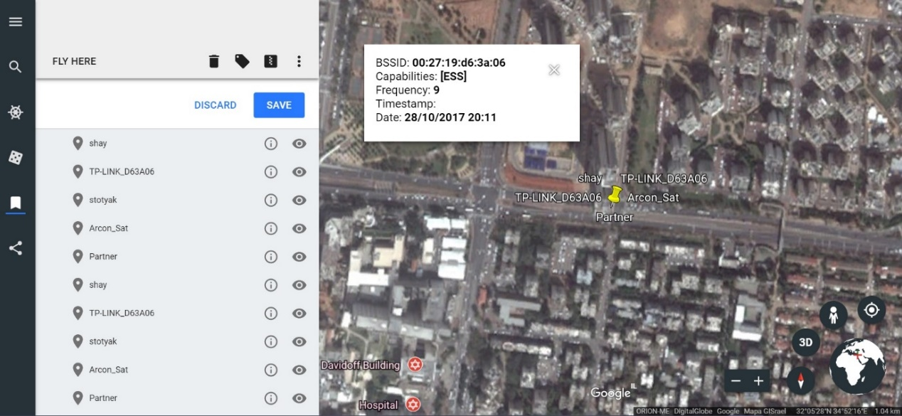

Unfiltered file:

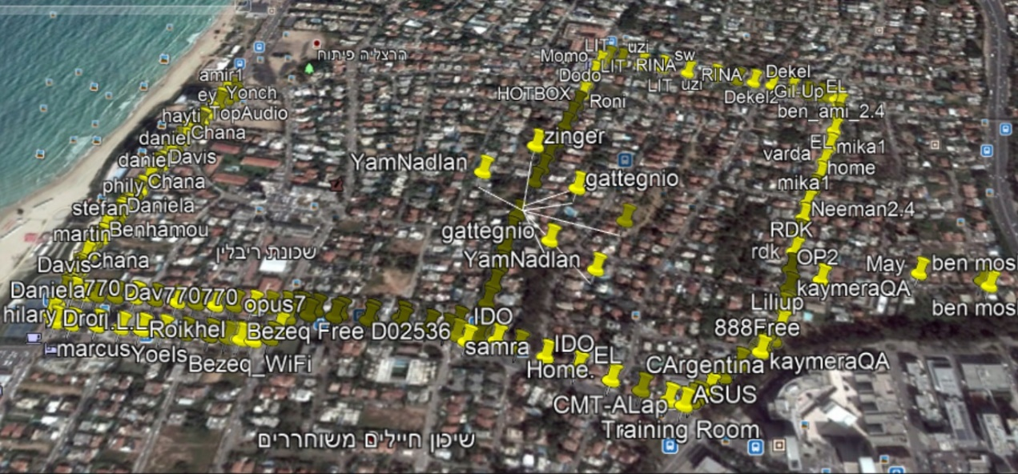

Time Stamp:

