**Year 2 – semester A – Object Oriented Course – Report EX2**

**Names**: Alex Fishman & Alona Kondratenko

At this time we improved the last work in several cases:

By adding 2 algorithms to our work, we now can deal differently with data that we make from csv-wiggle files.

1. Algorithm_1 – calculate close coordinate of a chosen MAC address.
2. Algorithm_2 – calculate self-coordinate by the surrounding MACs and signals.

**Examples of testing the program:**

Algo_1 is running on the big merged data file (that we created in ex0) and make a list of all MACs and their Full_Coordination data (by using the exel algo instruction that was given to us), that is the result:

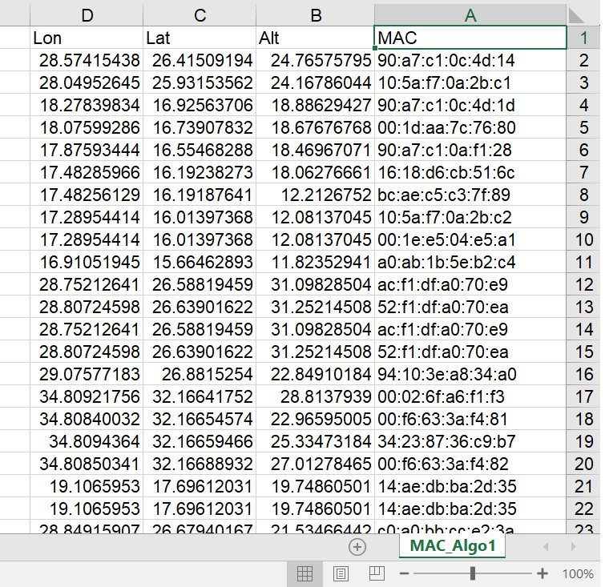

Algo_2 gets a file that the coordinates on him is missing, then it also running on the big merged data file (that we created in ex0) and makes new file that contains all the missing data after the algorithm calculations (by using the exel algo instruction that was given to us), that is the the file before the algo run:

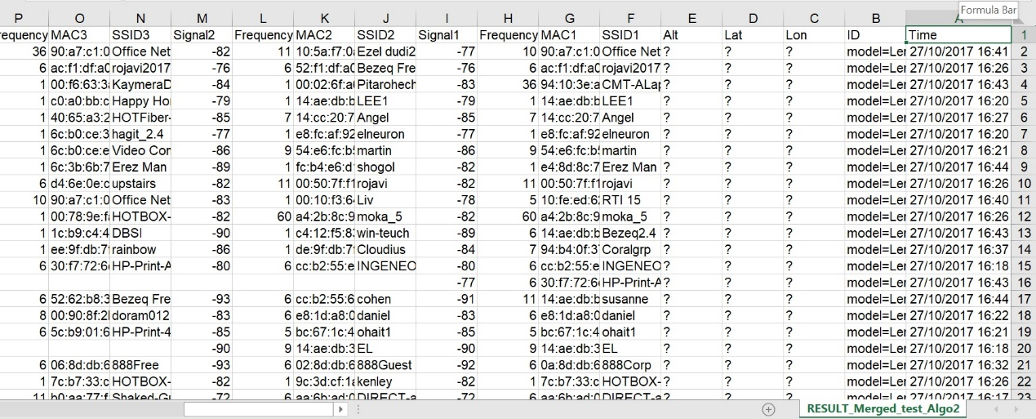

And this is after:

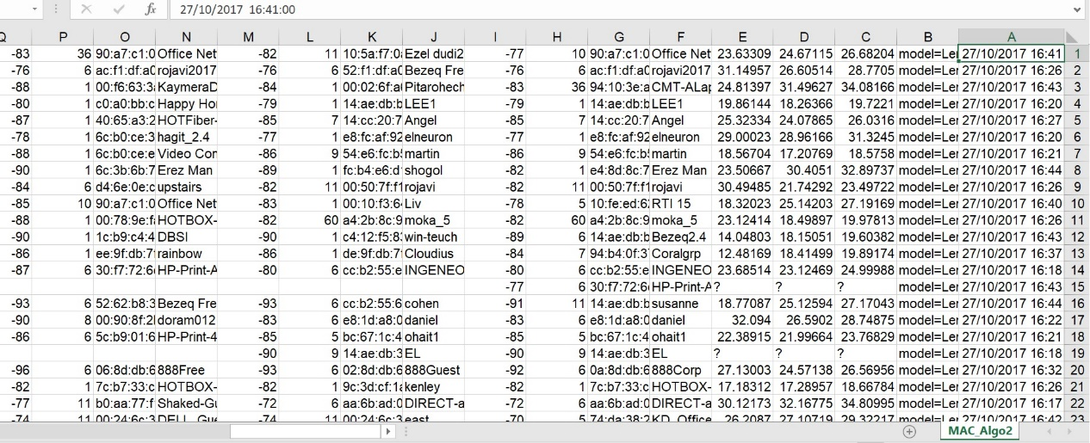

You can see that most of the coordinates that was missing, got full.

At ex2 we worked on our data.