DIVVY BIKE-SHARE
Data Engineering Pipeline
Apache Airflow • Python • Parquet • DuckDB • dbt • Docker
End-to-end batch pipeline with incremental loading,
SCD Type 2 station history and analytical marts
Project Report
Ghiba Alexandra

1. Project Overview and Objectives
This project implements an end-to-end batch data pipeline for historical Divvy bike-share trips. The objective is to demonstrate a reproducible data engineering workflow from monthly ingestion to analytical outputs, while addressing a non-trivial modeling problem: station identifiers and station attributes can change over time.

Objectives
- Ingest monthly Divvy ZIP/CSV data through an Airflow-orchestrated workflow.
- Convert raw files to Parquet and partition them by processing year and month.
- Use DuckDB as a lightweight analytical warehouse and dbt for transformations and testing.
- Maintain historical station identity using a Slowly Changing Dimension Type 2 (SCD2).
- Build an incremental trip fact table keyed by ride_id with time-aware station foreign keys.
- Produce business-facing marts for weekday station imbalance, monthly rider usage and station identity changes.
- Make failures visible through Airflow logs and dbt tests while keeping reruns idempotent.

Technology Stack
Layer | Technology | Role
Orchestration | Apache Airflow | Monthly workflow, dependencies, retries and logs
Ingestion | Python | Download, extract and convert Divvy data
Raw storage | Parquet | Columnar files partitioned by year/month
Warehouse | DuckDB | Local analytical database
Transformation | dbt | Staging, intermediate, dimensions, facts and marts
History | dbt Snapshot | SCD Type 2 station versions
Infrastructure | Docker | Reproducible Airflow environment

Pipeline at a Glance
Divvy ZIP/CSV → Airflow → Python → Parquet → DuckDB → dbt → SCD2 → Fact/Dimension → Marts → Tests

2. Dataset and Subset Selection
The source is historical Divvy bike-share trip data. Each ride includes a ride identifier, bike type, start and end timestamps, station identifiers and names, station coordinates, and rider classification (member or casual). The implemented project subset covers January through March 2024.
Month | Raw trips
January 2024 | 144,873
February 2024 | 223,164
March 2024 | 301,687
Total | 669,724

Why this subset?
Three consecutive months provide enough history to demonstrate incremental processing and station changes while keeping the project small enough to run locally and to debug repeatedly. Consecutive chronological processing is particularly important because the SCD2 station model represents changes through time.

Raw Storage Design
The ingestion script converts the monthly source data to Parquet. Parquet is a columnar format suited to analytical workloads: it preserves types, compresses efficiently and allows query engines to read only required columns. Hive-style partitions make the processing month explicit.
raw/
└── year=2024/
├── month=01/divvy_trips_202401.parquet
├── month=02/divvy_trips_202402.parquet
└── month=03/divvy_trips_202403.parquet

Observed Row Reconciliation
The three raw monthly partitions contain 669,724 rides. After duration validation and analytical filtering, fct_trips contains 669,493 rows. The fact table also contains 669,493 distinct ride_id values, demonstrating that no duplicate ride keys were introduced.

3. Architecture and Airflow Orchestration
Airflow is the orchestration layer for the monthly pipeline. The DAG is parameterized by year and month and executes seven sequential stages. Each stage has a clear responsibility, making failures easy to locate and allowing ingestion, modeling and validation to be observed independently.
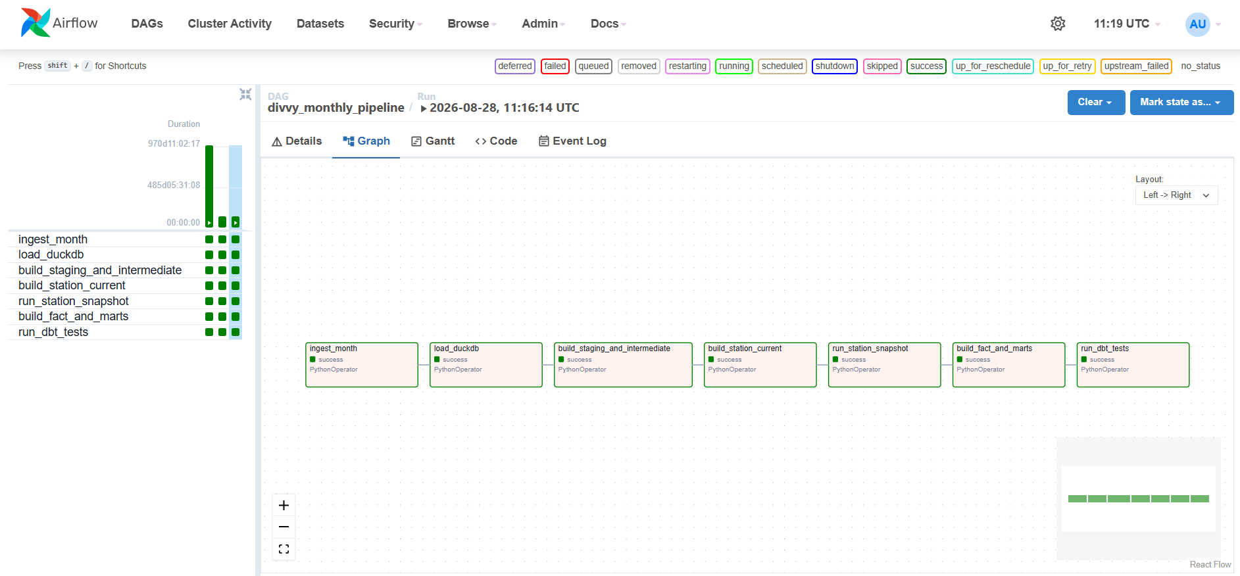
Figure 1. Airflow Graph view showing the seven successful pipeline tasks.

DAG Stages
Stage | Purpose
ingest_month | Download the requested month and write partitioned Parquet
load_duckdb | Expose all available Parquet partitions in DuckDB
build_staging_and_intermediate | Standardize and enrich trip/station data
build_station_current | Prepare the station state for the processing month
run_station_snapshot | Capture SCD2 changes
build_fact_and_marts | Build the incremental fact and analytical outputs
run_dbt_tests | Fail on critical validation problems
The DAG uses retries and meaningful task logs. max_active_runs=1 prevents two monthly executions from modifying station history at the same time. The current design expects SCD2 months to be processed chronologically.

4. Data Modeling and SCD Type 2
Station identity is the main modeling challenge. A station_id can be observed with different names or coordinates across months. Using only the latest station record would incorrectly assign historical trips to the current identity.

Model Layers
- stg_trips: casts and standardizes raw trip fields and partition metadata.
- int_trips_enriched: derives trip duration and flags invalid duration observations.
- int_station_observations: creates one station state per station_id and source month.
- int_station_current: isolates the station state for the month currently being processed.
- stations_snapshot: dbt snapshot tracking changes to station_name, latitude and longitude.
- dim_stations: exposes business-valid station versions with valid_from and valid_to.
- fct_trips: one row per valid ride with start and end station-version foreign keys.

Temporal Station Attribution
The fact table does not join a trip to the latest station record. The start station is resolved using started_at and the end station using ended_at. Each timestamp must fall within the validity interval of the matching station version.
started_at ∈ [station.valid_from, station.valid_to) → start_station_version_key
ended_at ∈ [station.valid_from, station.valid_to) → end_station_version_key
This design preserves historical correctness even when the same station_id later changes name, moves or appears to be re-issued.

Incremental and Idempotent Fact Loading
fct_trips is incremental and keyed by ride_id. After January and February were loaded, rerunning an already processed month did not increase the row count. Adding March increased the fact table to 669,493 rows while keeping the distinct ride_id count equal to the total row count. Relationship validation reported zero missing start and end station-version keys for resolved station relationships.

5. dbt Lineage and Data Quality
dbt separates transformation logic into staging, intermediate, snapshot, dimension/fact and mart layers. The lineage graph makes dependencies visible from the raw source through the final analytical outputs.
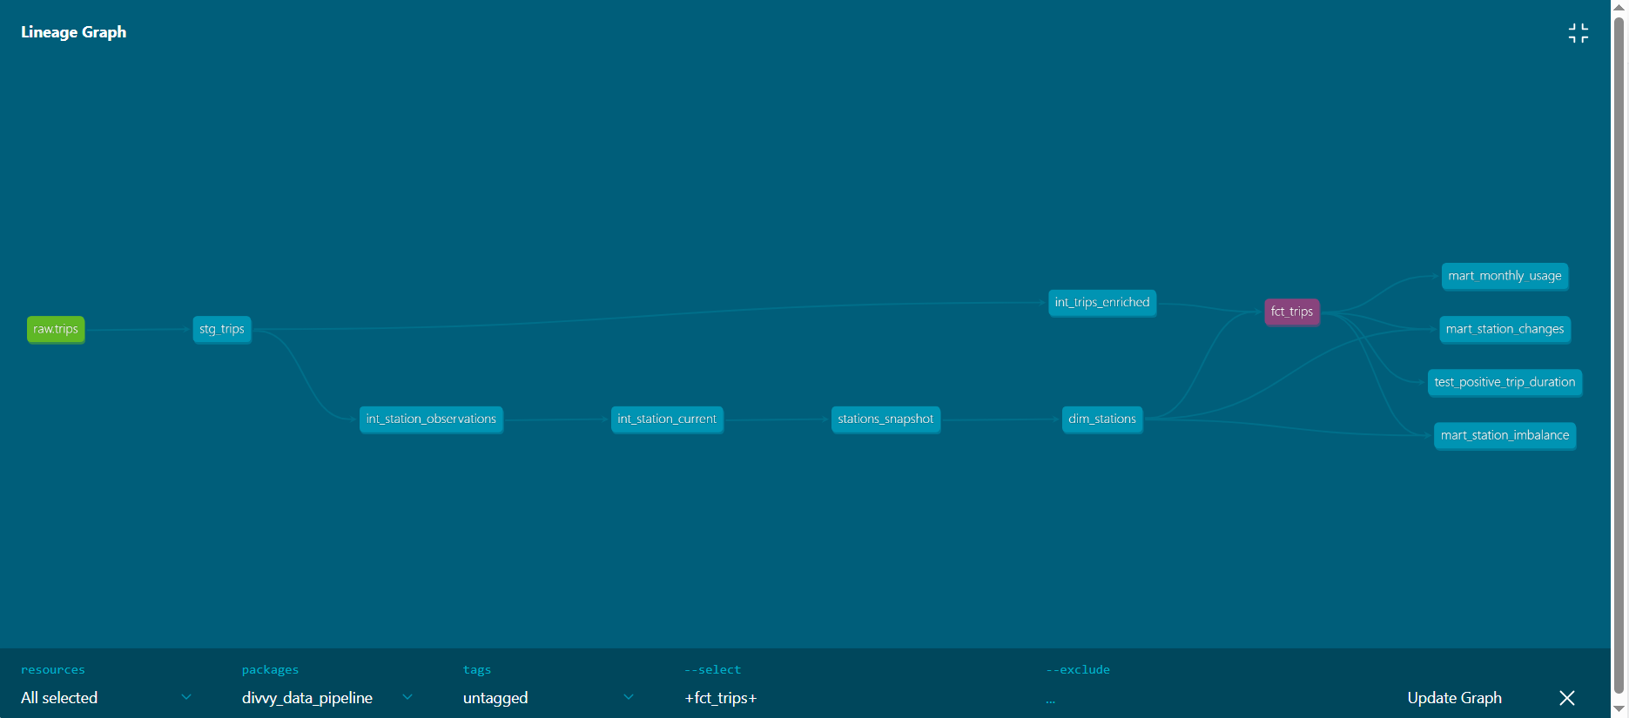
Figure 2. dbt lineage from raw trips to station history, fct_trips and analytical marts.

Automated Tests
The final dbt test suite completed with 12 passes, 1 warning and 0 errors. Critical tests cover ride-key uniqueness and nullability, accepted rider/bike values, station-version uniqueness, fact-to-dimension relationships and positive trip duration.
Result | Count | Interpretation
PASS | 12 | Critical integrity and quality checks succeeded
WARN | 1 | Missing start_station_id values retained as a visible source-quality issue
ERROR | 0 | No critical test failures
TOTAL | 13 | Complete final test suite
The warning contains 86,838 staged rows with a missing start_station_id. This test is intentionally configured with warning severity because the missing identifiers originate in the source data and should remain visible without failing the entire pipeline.

6. Analytical Deliverables and Findings

6.1 Average Weekday Station Imbalance
mart_station_imbalance measures average weekday departures versus arrivals by station and rider type. A weekday date spine includes zero-activity weekdays, avoiding an upward bias that would occur if only active days were averaged.
Station | Rider | Avg departures | Avg arrivals | Net
Streeter Dr & Grand Ave | Casual | 44.29 | 49.19 | -4.90
Streeter Dr & Grand Ave | Member | 18.24 | 13.71 | +4.52
Aberdeen St & Jackson Blvd | Member | 28.57 | 24.48 | +4.10
Ellis Ave & 60th St | Casual | 13.10 | 9.10 | +4.00
The same station can show opposite directional patterns by rider type. Streeter Dr & Grand Ave receives more casual arrivals than departures, while member trips show the reverse pattern.

6.2 Monthly Usage
Month | Rider | Trips | Avg min | Share
Jan 2024 | Casual | 24,446 | 21.32 | 16.89%
Jan 2024 | Member | 120,330 | 13.80 | 83.11%
Feb 2024 | Casual | 47,157 | 25.19 | 21.13%
Feb 2024 | Member | 175,979 | 12.92 | 78.87%
Mar 2024 | Casual | 82,500 | 24.97 | 27.36%
Mar 2024 | Member | 219,081 | 11.97 | 72.64%
Trip volume rises from January to March. Casual rider share increases from 16.9% to 27.4%, and casual riders consistently have longer average trip durations than members.

6.3 Station Identity Changes
mart_station_changes compares consecutive station versions and flags renames, relocations and potential re-issued IDs. A re-issued-ID candidate is treated as a heuristic: the station name changes and the observed location moves by at least 1 km.
ID | Previous identity | Current identity | Movement
517 | Public Rack - Pulaski Rd & Armitage Ave | Clark St & Jarvis Ave | ~11.8 km
579 | Phillips Ave & 79th St | Public Rack - Oketo Ave & Belmont Ave | ~29.1 km
572 | Public Rack - Hiawatha Park | State St & 76th St | ~26.7 km
For station_id 517, the previous and current versions contain 58 and 77 start trips respectively. A naive ID-only aggregation would merge these populations even though the observed station identity moved approximately 11.8 km. SCD2 keeps the historical identities separate.

7. Challenges, How to Run and Conclusion

Implementation Challenges
- Station coordinate jitter created multiple versions; a 100 m threshold is used in the analytical change mart to highlight meaningful relocation.
- Large name and coordinate changes required careful wording: potential re-issued IDs are reported as candidates rather than asserted as facts.
- SCD2 state is order-sensitive, so months must be processed chronologically; max_active_runs=1 prevents concurrent history updates.
- A first weekday-imbalance implementation averaged only active days; it was improved with a weekday date spine so zero-activity days are included.
- Pipeline success was not accepted on task status alone: total rows, distinct ride IDs and temporal foreign keys were reconciled.

How to Run
docker compose up -d
Open Airflow:
http://localhost:8080
Trigger:
divvy_monthly_pipeline
Provide:
year = 2024
month = 1, then 2, then 3
Run the dbt test suite manually when required:
docker exec -it divvy_airflow dbt test --project-dir /opt/airflow/dbt_project --profiles-dir /opt/airflow --vars "{processing_year: 2024, processing_month: 3}"
Generate and serve dbt documentation:
docker exec -it divvy_airflow dbt docs generate --project-dir /opt/airflow/dbt_project --profiles-dir /opt/airflow --vars "{processing_year: 2024, processing_month: 3}"
docker exec -it divvy_airflow dbt docs serve --project-dir /opt/airflow/dbt_project --profiles-dir /opt/airflow --vars "{processing_year: 2024, processing_month: 3}" --host 0.0.0.0 --port 8081

Conclusion
The project demonstrates a complete local data engineering workflow: parameterized ingestion, partitioned Parquet storage, analytical processing in DuckDB, dbt transformation and testing, Airflow orchestration, incremental loading and SCD Type 2 history. The most important modeling outcome is correct time-bound station attribution: historical rides remain connected to the station identity that was valid when the ride occurred. The final pipeline processes 669,724 raw trips into 669,493 unique analytical fact rows and completes all critical dbt tests without errors.

