**Unit 5. Speaking about yourself.**

**Revise pronouns.**

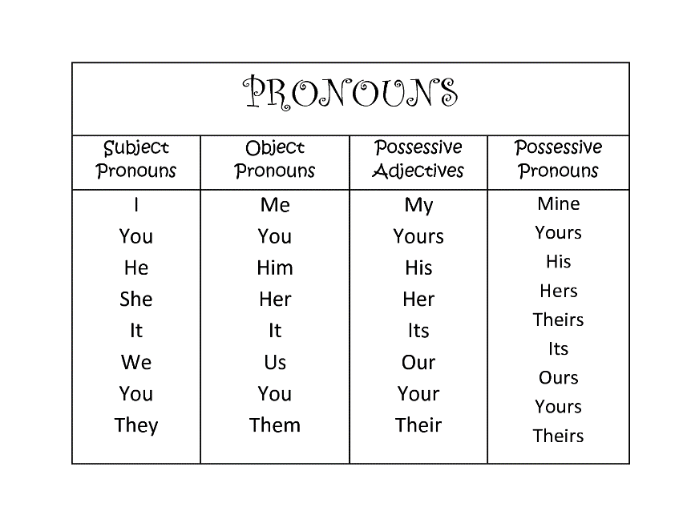

**Read and translate the text:**

So, let me introduce myself. My name is Pavel, my surname is Demidoff. I’m 19 years old man. As you might have already understood, I’m a student.

I have been studying at Saint-Petersburg State Medical University named after I.Pavlov since 2013, and I’m going to be a highly qualified specialist in surgery as my dad. I’m absolutely sure, that when I complete my degree, I might get the opportunity to start a stable and fantastic career in the main hospital of our city.

I grew up in a happy family. I had an elder brother and two little sisters and this brightened my childhood, as we were always together. When I was younger I played the piano and my parents wanted me to become a great pianist. It was too hard to disappoint them when I decided to be a doctor, to heal people and to take care about them.

As for my interests, I devote much time to coin collecting and writing my own medical researches. Moreover, some years ago I started to write a fantasy novel in George Martin’s style. I suppose that when I finish it, the novel becomes a bestseller of a year. I also like computer games and good rock music.

I’m very sociable, that’s why I have a lot of friends and a lovely girlfriend. It would be a mistake to say that I’m the life and the sole of the party, but my friends try to stay in touch with me anytime and share their secrets with me. I highly appreciate this and always give feedback.

Итак, позвольте представиться. Меня зовут Павел, моя фамилия Демидов. Мне 19 лет. Как вы уже, наверно, поняли, я студент.

Я обучаюсь в Санкт-Петербургском государственном медицинском университете имени И.Павлова с 2013 года и собираюсь стать высококвалифицированным специалистом в области хирургии, как мой папа. Я абсолютно уверен, что когда я получу диплом, у меня может появиться возможность начать стабильную и фантастическую карьеру в главной больнице нашего города.

Я вырос в счастливой семье. У меня был старший брат и две младшие сестры, и это скрасило мое детство, так как мы всегда были вместе. Когда я был моложе, я играл на пианино, и мои родители хотели, чтобы я стал великим пианистом. Было слишком тяжело разочаровывать их, когда я решил стать врачом, исцелять людей и заботиться о них.

Что касается моих интересов, то я посвящаю много времени коллекционированию монет и написанию собственных медицинских исследований. Более того, несколько лет назад я начал писать фантастический роман в стиле Джорджа Мартина. Я полагаю, что когда я закончу его, роман станет бестселлером года. Мне также нравятся компьютерные игры и хорошая рок-музыка.

Я очень общительный, поэтому у меня много друзей и замечательная девушка. Было бы ошибкой сказать, что я – душа компании, но мои друзья стараются оставаться на связи со мной в любое время и делиться со мной своими секретами. Я высоко ценю это и всегда даю обратную связь.

**Study the vocabulary:**

|  |  |
| --- | --- |
| Graduate student  Intramural graduate student  Extramural graduate student  Surgery  Complete one’s degree  To disappoint  To devote to  To stay in touch with  Appreciate | Студент-магистрант  Студент очной магистратуры  Студент заочной магистратуры  Хирургия  Получить степень  Разочаровывать  Посвящать  Поддерживать связь с  Ценить |

**Answer the questions:**

1. Where does Pavel study?
2. How long has he been studying at the university?
3. What degree does Pavel want to complete?
4. What does he say about himself?
5. What are his hobbies and interests?

**Translate the text into Russian:**

I am a graduate student in Physics department. I received my bachelor's degree at Fudan University and joined Shen group in 2015. I'm working with graduate students and postdocs from Prof. Nick Melosh's group and Prof. Steve Chu's group on the diamondoid project. I have been synthesizing diamondoid-seeded high-purity nanodiamond and doping it with different defect centers by using PECVD system. In the near future, I am excited to explore the novel physical and biological application of this material, including quantum information processing, diamond-based superconductor and bio-imaging.

Я аспирант физического факультета. Я получил степень бакалавра в университете Фудань и присоединился к “Шен групп” в 2015 году. Я работаю с аспирантами и молодыми учеными из группы профессора Ника Мелоша и группы профессора Стива Чу по алмазоидному проекту. Я синтезировал высокочистый наноалмаз с алмазоидным покрытием и легировал его различными дефектными центрами с помощью системы PECVD. В ближайшем будущем я с нетерпением жду возможности изучить новое физическое и биологическое применение этого материала, включая квантовую обработку информации, сверхпроводник на основе алмаза и биовизуализацию.

**Speak about yourself using the template:**

Let me introduce myself. My full name is Ilya Kulikow. I’ve been studying English for seventeen years already. I am a graduate student at Historical Faculty of Bryansk State University named after academician I.G. Petrovsky. I’m studying to complete master degree in History. As for my master thesis, I’m working on “The plague in Russia in the 14th-16th centuries”. I think my education will help me win the position of a qualified specialist in future. As for my interests, I devote much time to bodybuilding.

**Unit 3. My University**

**Degrees of Comparison of Adjectives**

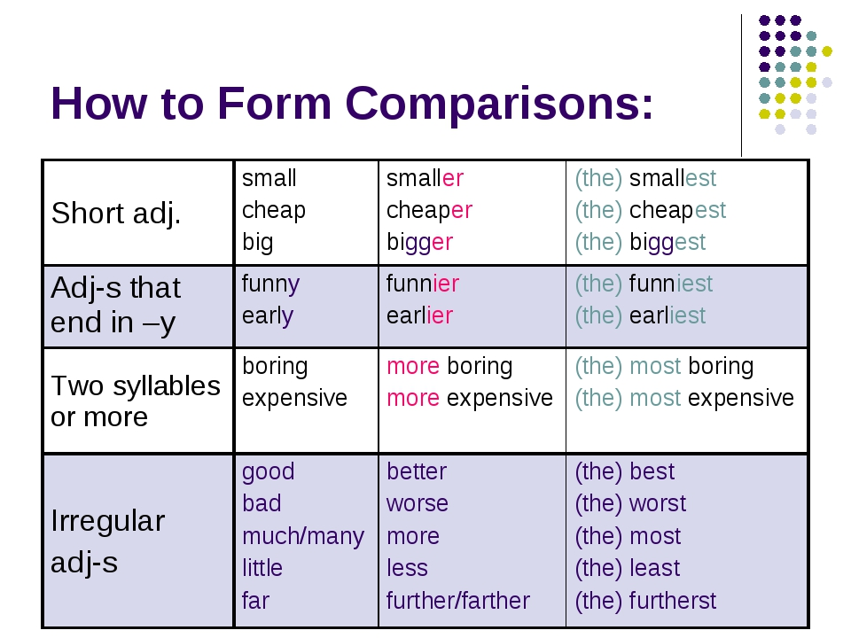

**Translate into Russian:**

*Good, better, best. Never let it rest. 'Til your good is better and your better is best. St. Jerome*

*Time is what we want most, but what we use worst. William Penn*

*The best and most beautiful things in the world cannot be seen or even touched - they must be felt with the heart. Helen Keller*

*My best friend is the one who brings out the best in me. Henry Ford*

*Life would be infinitely happier if we could only be born at the age of eighty and gradually approach eighteen. Mark Twain*

*There are worse crimes than burning books. One of them is not reading them. Ray Bradbury*

*Education is the most powerful weapon which you can use to change the world. Nelson Mandela*

**Conjugate the adjectives:**

Hot, long, short, clever, silly, great, red, black, white, thin, thick, fat, nice, warm, cold, merry, small, tall, high, weak, strong, heavy, light, green, dry, clean, dirty, wide, deep, brave.

**Read and translate:**

**My University**

I am a student of the Bauman Moscow State Technical University. This university is one of the oldest universities of Russia. It was founded in 1830 by Emperor Nicholas I as the industrial school. Russia's developing industry needed skilled labour in many trades. So, the aim of the new school was to train qualified artisans with a solid theoretical background to improve and spread skills in various trades all over Russia. Such famous Russian scientists as Zhukovsky, Tchaplygin, Vavilov were among the founders of the School. Nowadays this university is one of the most prestigious educational institutions of our country.

My university is one of the biggest universities of Russia. It consists of 8 scientific and educational divisions. Every division includes faculties and research institutes. BMSTU has 19 departments providing full-time education. University provides postgraduate and doctorate programs and has two affiliated secondary schools. More than 19,000 students study in BMSTU, and specialties cover all range of modern machine and instrument building. More than 320 doctors of science (Russian degree higher than PhD) and 2000 candidates of science (similar to PhD) teach and do research in BMSTU. Main parts of the University are eight scientific and educational divisions. Each of them consists of scientific and educational branch. Several branch departments also exist, they deal with particular fields of industry. They are based on big factories and organizations, situated in Moscow, Moscow suburbs (Reutov, Krasnogorsk and Korolev) and in Kaluga. BMSTU has unique experience of teaching hearing-impaired students since 1934. Bauman University annually grants 800 to 3,000 students free room and board in one of 13 university residences.

Vocational training is also carried on large factories located in Moscow and Moscow suburbs. This is due to the close collaboration of the Bauman University with industrial companies of our country.

I study at the faculty of engineering technology. It is one of the University’s oldest faculties. The faculty prepares specialists in the field of engineering technology. The level of education in the Bauman University meets high requirements of Russian employers.

The University takes an active part in student exchange programs. It also takes part in various research activities, scientific studies and international conferences.

**Vocabulary**

|  |  |
| --- | --- |
| Artisans  Division  research institutes  departments  full-time education  hearing-impaired students  university residences  Vocational training | **Ремесленники**  **подразделение, институт**  **НИИ**  **кафедры**  **очное обучение**  **слабослышащие студенты**  **университетские общежития**  **профессиональная подготовка** |

**Translate the text into English in writing**

ФГБОУ ВО "Брянский государственный университет имени академика И.Г. Петровского" - самый крупный вуз региона, в котором обучается более 7 тысяч студентов. Историческим предшественником БГУ является Новозыбковский государственный педагогический институт, основанный в 1930 году. В его состав входили 3 отделения по подготовке учителей словесности, математики, биологии и химии. В 1976 году Новозыбковский государственный педагогический институт был переведен в г. Брянск и переименован в Брянский государственный педагогический институт, которому в августе того же года было присвоено имя академика И.Г.Петровского (постановление Совета Министров РСФСР от 18 августа 1976 года № 460). В 1995 году Брянский государственный педагогический институт имени академика И.Г.Петровского становится педагогическим университетом, а в 2001 году получает статус классического университета (приказ Министерства образования Российской Федерации № 2292 от 6 июня 2001 года). Вуз известен своими образовательными, научными, историко-культурными традициями. Вехи новейшей истории БГУ убедительно свидетельствуют о его динамичном развитии, упрочении позиций классического университетского образования. В его структуре 5 институтов: естественно-научный, педагогики и психологии, филологии, истории и международных отношений, экономики и права, научно-исследовательский институт фундаментальных и прикладных исследований, 11 факультетов, 40 кафедр и филиал в г. Новозыбкове Брянской области. 2006 году Брянский государственный университет вошел в ассоциацию классических университетов России, возглавляемую Московским государственным университетом имени М.В.Ломоносова. В числе почетных докторов и профессоров университета - ректор МГУ В.А.Садовничий, поэт Е.А.Евтушенко. В 2015 году университет отметил 85-летие со дня основания.

Bryansk State University named after Academician I.G. Petrovsky is the largest university in the region, with more than 7 thousand students studying there. The historical predecessor of BSU is the Novozybkovsky State Pedagogical Institute, founded in 1930. It consisted of 3 departments for the training of teachers of literature, mathematics, biology and chemistry. In 1976, the Novozybkovsky State Pedagogical Institute was transferred to Bryansk and renamed the Bryansk State Pedagogical Institute, which in August of the same year was named after Academician I.G.Petrovsky (resolution of the Council of Ministers of the RSFSR of August 18, 1976 No. 460). In 1995, the Bryansk State Pedagogical Institute named after Academician I.G.Petrovsky became a pedagogical university, and in 2001 it received the status of a classical university (Order of the Ministry of Education of the Russian Federation No. 2292 of June 6, 2001). The university is known for its educational, scientific, historical and cultural traditions. The milestones of the recent history of BSU convincingly testify to its dynamic development, strengthening the positions of classical university education. There are 5 institutes in its structure: natural science, pedagogy and psychology, philology, history and international relations, economics and law, Research Institute of Fundamental and Applied Research, 11 faculties, 40 departments and a branch in Novozybkov, Bryansk region. In 2006, Bryansk State University joined the Association of Classical Universities of Russia, headed by Lomonosov Moscow State University. Among the honorary doctors and professors of the university are the Rector of Moscow State University V.A.Sadovnichy, poet E.A.Yevtushenko. In 2015, the university celebrated its 85th anniversary.

**Use the information from the text above to speak about your faculty and university.**