# StudyHub

-application for learning a foreign language-

## Actor - Aim

| Actor | Aim |
| --- | --- |
| Admin | -Adding texts for users |
| User | -Editing personal dictionary   1. Deleting words from the personal dictionary 2. Adding new words to the personal dictionary 3. Adding images for words to the personal dictionary   -Reading texts   1. Asking for a translation   -Complete tasks:   1. flash-cards; 2. inserting new words into sentences; 3. asking for a hint or translation; |
| System | -Adding context for words  -Analyzing results of users  -Generating tasks for users |
| Timer | -Sending a reminder on a regular basis |

## Use Case Diagram

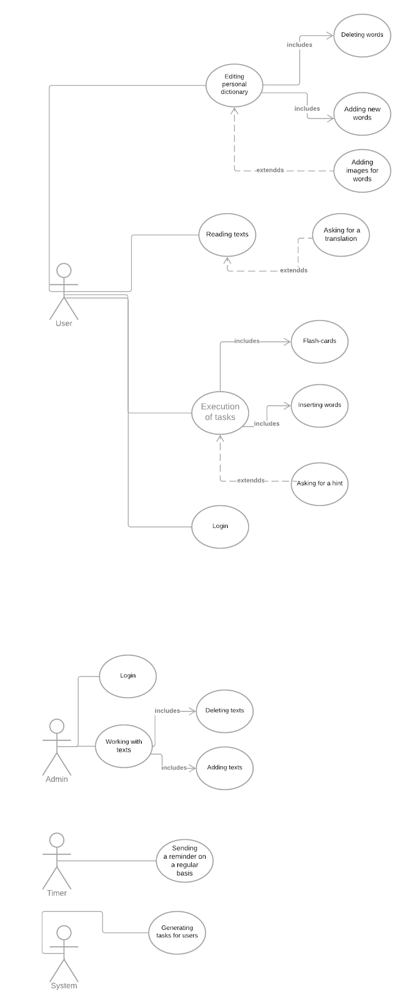



## Dictionary of the subject area

| Term | Definition |
| --- | --- |
| User | A person who learns language and wants to use an application for educational purposes |
| Flash-card | An interactive card which contains a word on one side and its definition or synonyms on the other. User can rotate card and note if the answer was correct |
| Task | A flash-card, task which demands inserting new words into sentences |
| Text | Text is a group of sentences that are interconnected by the meaning stored in the database |
| Admin | A person who can add texts to the system |
| Dictionary | List of words with meaning and translation stored in the database |
| Personal dictionary | A set of words which the user wants to learn stored in the database. A user has an opportunity to edit it. |
| Hint | Meaning of the word in a foreign language |
| Context | The sentence in which the word was used in the text |
| Regular basis | Fixed time period by a user |
| Translation | This is the reproduction of a text by means of another language |
| Analyzing results | Counting how many scores the user gained |
| System | An application that generates and analyzes tasks |
| Timer | An app that sends reminders to your email |
| Database | An organized structure designed to store, modify, and process interrelated information |
| Text level | Beginner : А1  Pre-Intermediate: A2  Intermediate: В1  Upper-Intermediate: B2  Advanced : C1  Mastery : C2 |

## 

## Business rules

| Id | Rule | Changeabillity | Source |
| --- | --- | --- | --- |
| RULE_1 | The text name is a must be entered field  The text name must contain at least 3 characters | Low | Data template policy |
| RULE_2 | The text level is a must -have to choose | Low | Data template policy |
| RULE_3 | The text is a must be entered field  The text must contain at least 50 characters | Low | Data template policy |
| RULE_4 | The system does not consider the character " " | Low | Data template policy |
| RULE_5 | Password contains 6 characters | Low | Data template policy |
| RULE_6 | Password contains at least 1:  lower case  upper case  0-9  ~!@#$%^&*_ | Low | Data template policy |
| RULE_7 | Entered e-mail-ending exists | Low | Data template policy |
| RULE_8 | Email contains at least 5 characters without a domain name  the gmail.com domain is used exclusively | Low | Data template policy |

## Description of precedents

### Adding texts

**Aim**: Give students the opportunity to read texts

**Prerequisite**: The system is running, the administrator is authorized in the system and admin is on the page for editing texts

**Typical scenario**:

| **Actors’ actions** | **System’s response** |
| --- | --- |
| Admin initiates a process of assigning a text to a student | The system provides admin  a window with the possibility of choosing a text name, text, its level and button for nonconfirms/confirms |
| The administrator enters the name of the text, its level and the text in the corresponding fields | The system checks whether all fields are entered,  if RULE_1 is not fulfilled then T1,  if RULE_2 is not fulfilled then T2,  if RULE_3 is not fulfilled then T3,  where T1,T2,T3 - alternative scenarios |
| The administrator confirms the addition of the text | The system adds the text to the database. |
| The administrator does not confirm the addition of the text | The system does not add the text to the database. |

**Posthumous**:The text has been added to the database

### Deleting texts

Aim: Be able to delete unnecessary texts

**Prerequisite**: The sys tem is running, the administrator is authorized in the system and admin is on the page for editing texts

**Typical scenario**:

| **Actors’ actions** | **System’s response** |
| --- | --- |
| Admin initiates a process of deleting a text | The system provides admin  a window with list with text name |
| The administrator chooses the text | The system displays a window with the text, its level and name and the possibility to delete the text |
| The administrator confirms the deleting of the text | The system deletes the text |
| The administrator does not confirm the deleting of the text | The system does not deletes the text |

**Posthumous**:The selected text has been removed from the database

### Reading texts by users

**Aim**: to give an opportunity for users to read texts and learn by it

**Prerequisite**: The system is running, the user is authorized in the system and user is on the page for list texts

**Typical scenario**:

| **Actors’ actions** | **System’s response** |
| --- | --- |
| User chooses a text from a list | Opens a page with a text for reading |
| User clicks on a word | Shows the translation of the word in a given context (provides a user with a small window containing translation) |
| User selects word and clicks on the button “ask for a hint” | Shows the meaning of the word in a given context |
| User clicks on the button "return to the list of texts" | Returns the user to the reading page |

**Posthumous: Unknown words have been added to the database, the system returned the user to the list texts page**

### Execution of tasks by users

**Aim**:to improve current language level, to check the progress and to train on a regular basis

**Prerequisite**:a user had read a text before trying to complete a task, the system is running, the user is authorized in the system and user is on the page for completing tasks

**Typical scenario**:

| **Actors’ actions** | **System’s response** |
| --- | --- |
| User initiates the process of the execution of tasks | Generates and shows list oftasks for completing if there are some words in the dictionary, IF User wants to do some tasks without having a word in the personal dictionary, alternative scenario E1. |
| A user chooses a task (flash-cards / inserting new words into sentences) | Opens a chosen task for completion. |
| User clicks on a button “ask for a hint” | Shows the meaning of the word which must be inserted. IF User asks for a hint of a word which is not in a main common dictionary, alternative scenario D2. |
| User inserts a word or a phrase into a sentence (enters the text in a gap) | The inserted word remains visible. After the user completes the whole task system checks the answers and calculates the results and shows them to the user. |
| User competes flash-cards( answers to him/ herself on a task, rotates card, checks the answer, rotates card,clicks on the right button) | System calculates the quantity of correct answers. |
| User confirms the completing of a task | Calculates the results and shows them to the user.Returns user to a page with tasks |

**Posthumous: The system returned the user to the tasks page, the results of completed tasks were saved**

### Setting of a timer

**Aim:**to allow user to choose a suitable period of time

**Prerequisite:**The system is running, the user is authorized in the system, user is on a page for setting a timer

**Typical scenario:**

| User sets the period of time for a regular reminder | Sets a timer |
| --- | --- |

**Posthumous: Reminder time has been set**

### Working with a dictionary

**Aim**: to allow user to make a personal dictionary more comfortable

**Prerequisite**:The system is running, the user is authorized in the system and user is on the page for completing tasks, user is on the page for work with a personal dictionary

**Typical scenario**:

| User initiates the process of editing the personal dictionary(presses the button) | Opens a dictionary in editing mode. IF Adds the existing word to a dictionary with the same context, alternative scenario D1. |
| --- | --- |
| User initiates the process of adding an image to a personal dictionary(presses the button) | Searches in the Internet for an appropriate picture and adds it to the word in a dictionary |
| User initiates the process of adding a word to the personal dictionary | Inserts a chosen word to the personal dictionary |
| User initiates the process of deleting a word from the personal dictionary | Deletes a chosen word from the personal dictionary |
| User confirms changes | Saves changes and throws user to a page where he can choose whether to going on editing, going to the start page or browsing the personal dictionary |
| User initiates a process of browsing a personal dictionary(presses the button) | The dictionary displays the word, translation, and image if available.IF User browses personal dictionary without having a word in it, alternative scenario D3. |

**Posthumous: a system saved all the editions and corrections**

### Login

**Aim**: To enter a personal account

**Prerequisite**: user(admin) has opened login page

**Typical scenario**:

| User/admin enters and confirms personal data | IF RULE_5, RULE_6,RULE_7, allows user/admin to enter a system, ELSE L1 |
| --- | --- |
|

**Posthumous: a user/an admin is redirected to the setting/editing page**

### Alternative scenarios

| № | Actors’ actions | System’s response |
| --- | --- | --- |
| **T1** | Admin omitted name of the text or name contains less than 3 characters | The system displays a message under the field for entering the name of the text "Missing name" |
| **T2** | The admin did not select a text level from the proposed one | The system displays a message under the text level list "Text level not selected" |
| **T3** | Admin entered less than 50 characters in the text input field | IThe system displays a message under the field for entering the text "Not enough characters. More than 50 are expected" |
| **D1** | Adds the existing word to a dictionary with the same context | Sends a reminder that there is already a word with this context in the dictionary and asks whether a user wants to change it |
| **D2** | User asks for a translation of a word which is not in a main common dictionary | Informs a user that this word is not in a system |
| **D3** | User browses a personal dictionary having no words in it | Informs the user that he has no words in a personal dictionary |
| **E1** | User wants to do a task without having a word in the personal dictionary | Gives a message with an offer to read some texts in order to add new words to the personal dictionary |
| **L1** | User/admin enters inappropriate data that break rules | Informs about the mistake and offers an opportunity to login one more time |

D-for problems with dictionary; T-for cases with text; L-for login cases