QuickVolunteer
Appendix C | Testing Evidence, Sprints 1 to 3 and release audit
CPU4106-20C Group Project · Team QuickVolunteer · 9 October to 2 November 2026
This appendix brings together the tests we ran in each sprint, what we found, and what we changed as a result. Each sprint ended with a test that fed the next Sprint Planning: the prototype review shaped the scope, the database tests shaped the design, and the website tests shaped the final release.
How we tested. We tested in two ways, following the Week 4 session on verification and validation. Verification checked that we built the product correctly: database design tests, automated API tests, browser and layout checks and, after Sprint 3, standards validators. Validation checked that we built the right product: prototype and live-site testing with users. Every delivered user story is linked to its tests in Appendix B (Table B10).
Sprint | What we tested | Who tested | Main result | What we changed
1 · 9-15 Oct | Clickable Figma prototype | Khadija, Gioacchino (team); Sohel, Chaymaa (external) | 8 findings: login, scope, contrast, member summary, document alignment, spacing, name fields, required data | One shared login; organisations and donations removed; contrast improved; member summary (US-22); first and last name; required fields set to NOT NULL
2 · 16-22 Oct | Database design (MySQL) and website review | Team | 11 design tests: 6 passed, 5 problems found; website review: 5 issues | Accounts active at sign-up; admins can hide reviews; each report names one target; deadline required; password rule aligned; admin, location and dashboard changes planned for Sprint 3
3 · 23-29 Oct | Website: API, browser, layout, live site | Team; live site: Khadija, Gioacchino (team), Sohel, Chaymaa (external) | 104 automated API tests, 39 browser checks, 27 test cases, 23 pages at 10 sizes: all passed | Clearer task status; Verified badge in the member summary; report link on the task page
After Sprint 3 · 30 Oct-2 Nov | Standards and accessibility audit of the live site | Khadija | Lighthouse 100 for accessibility (2 pages); WAVE 0 errors (4 pages); HTML and CSS validators 0 errors | Small alerts recorded for fixing (Section 4)
1. Sprint 1: Prototype review
What: walkthrough of the clickable Figma prototype at the Sprint 1 Review. Testers: Khadija and Gioacchino (team), Sohel and Chaymaa (external).
Review finding | Team decision | Improvement made
The account entry needed to support people who may both offer and request help. | Use one shared login for both user journeys. | We brought the entry point together around one login, supporting the volunteer and help-seeker journeys.
Organisations and donations were broader than the agreed micro-volunteering scope. | Remove organisations and donations from the first version. | We simplified the prototype to focus on individuals and short volunteering tasks.
Some screen elements had insufficient contrast and were harder to distinguish. | Improve contrast to make the interface easier to read. | We adjusted the contrast of the relevant text and interface elements. This is a design improvement, not a formal accessibility conformance result.
Help seekers wanted to know who is coming before they accept a volunteer. | Show a short summary of each volunteer before choosing. | We added a member summary to the backlog (US-22): first name, area, Verified badge and completed tasks, shown with each offer. It was built in Sprint 3.
The database, the prototype and the personas did not match, because they had been designed separately. | Define the data fields together and add an administrator persona. | We aligned all documents with the new decisions and added Daniel, the administrator persona.
The prototype had a lot of empty vertical space. | Make the layout more compact. | Spacing was reduced, so users scroll less.
Registration asked for one full name field. | Separate the first name and the last name. | The database stores first_name and last_name separately, and the sign-up form matches.
The normalised database had no NOT NULL constraint on some important data. | Review which data is compulsory. | Compulsory fields were set to NOT NULL, and the website forms were aligned with them.
Login: before and after
Before: login with Individual / Organisation  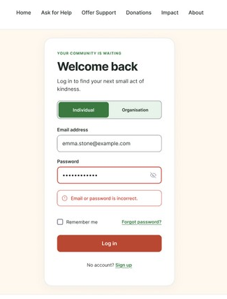 | After: one shared login  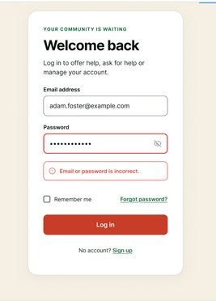
Figure C1. The first login asked users to choose Individual or Organisation; the revised login is one entry point for everyone.

Outcome
The revised prototype has a clearer entry point and a narrower, more coherent scope, and the contrast changes improve readability. These decisions became the Sprint 2 backlog: one shared account (US-01), individuals only, organisations and donations moved to Later (US-30, US-33), and a member summary so help seekers can see who is coming (US-22).
2. Sprint 2: Database tests and website review
What: design tests on the MySQL schema, run before building features on it, and a review of the website on 17 and 18 October.
Check | What we found
11 design tests | 6 passed: 15 and 60 minute tasks worked; 14 and 61 were blocked. Duplicate applications and invalid task owners were blocked.
Design problems | An in-person task could have no location; a report could name no target, or two; a task could finish before both people confirmed; an approved check could have no review date. The team also decided that ID verification should be optional.
38 website tests | In the repository but not run at this point: a separate MySQL test database had to be set up first. They cover sign-up, access, applications, tasks and CSRF. They were run in Sprint 3 (Section 3.3).
Admin pages | The administrator could offer help and ask for help like a member, the admin pages were not consistent, and the dashboard had no filters. Fixed in Sprint 3: own admin menu, view-only member forms, and members search, sort and filters (US-28).
Location | The website used a neighbourhood list. Changed in Sprint 3 to a postcode with the area name worked out automatically, and a map (S3-17).
Password rule | The website asked for at least 8 characters, while the back end required 12. Both now require at least 12 characters.
Required data | A task could be saved without a deadline. The Complete by date is now required in the database (deadline_at NOT NULL) and in the API.
Dashboard | Members who choose skills at onboarding should see tasks that match them. Built in Sprint 3: tasks that match the member's skills come first (US-13).
Changes recorded in Excel and the ERD
- Accounts are active as soon as someone signs up. Identity checks were planned for later; optional ID verification was then added in Sprint 3 (US-11).
- Admins can hide reviews. The design saves the review status, admin, date and optional reason.
- Each report must name one user or one task. The target record is protected from deletion.
These changes were then added to MySQL and Flask, and the final ERD and normalisation workbook include them.
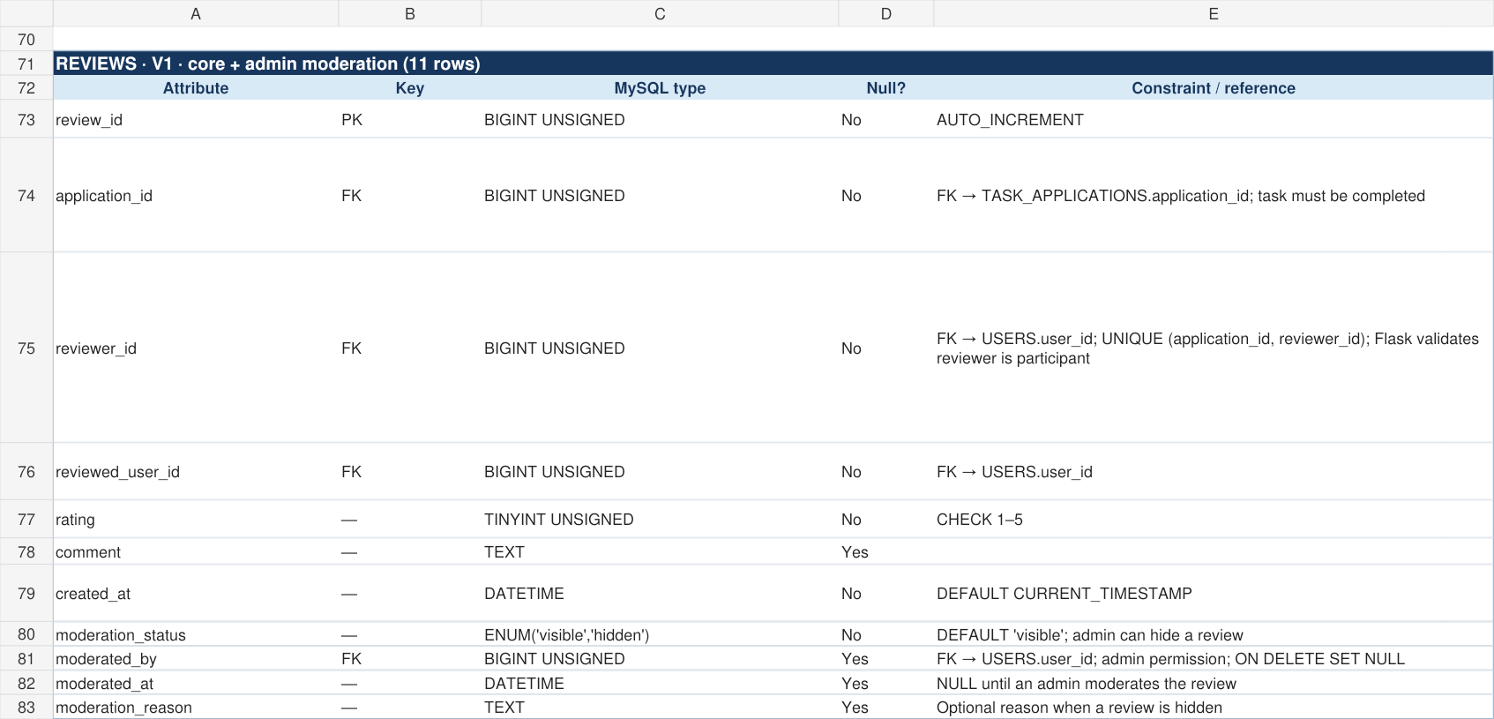
Figure C2. Excel excerpt: review moderation fields added to REVIEWS.
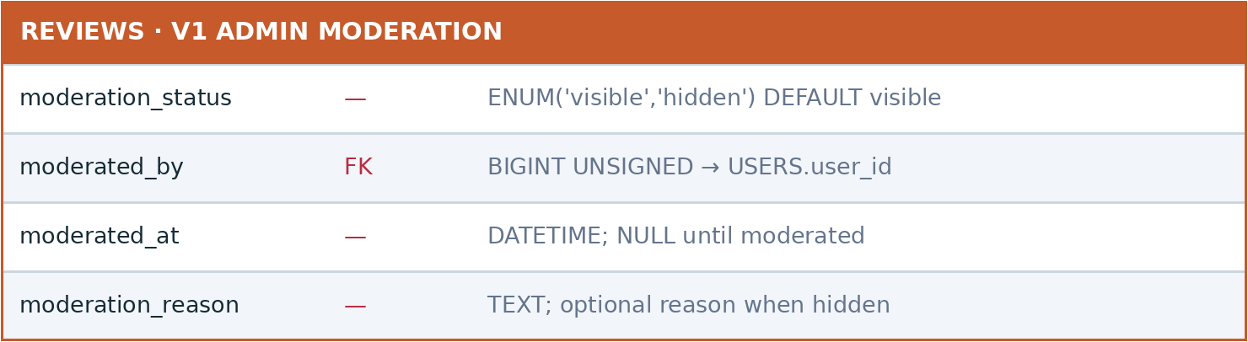
Figure C3. ERD excerpt: fields used when an admin hides a review.
3. Sprint 3: Website testing
What: the website as a whole, on the live site (Flask API on Render, MySQL on Aiven) and on the same code run locally, for all four roles: visitor, help seeker, volunteer and administrator.
3.1 Test approach and results
Test set | Tool | Run | Result
API tests, 5 modules | Python unittest, Flask test client, separate test database | 104 tests (320 runs in the log) | All passed, 0 failed
Browser journey checks | Playwright with Chromium | 39 | 39 passed
Functional test cases (T01-T27) | Browser, real API and database | 27 | 27 passed
Layout check | Playwright: 23 pages at 10 sizes, 320 to 1920 px, logged out and in | 23 pages | No overflow or overlap
Feature checks | Playwright scripts, phone and desktop | 7 scripts | All passed
Live-site testing | Khadija, Gioacchino (team); Sohel, Chaymaa (external), on the live site | 4 users | 3 changes made (3.2)
Standards and accessibility audit | Lighthouse, WAVE, Nu HTML Checker, W3C CSS Validator | 8 page checks | 0 errors; small alerts (Section 4)
3.2 Live-site testing: three changes
The same four testers, Khadija and Gioacchino (team) and Sohel and Chaymaa (external), tested the live site. The findings come from the User Testing sheet of the Scrum tracker; each led to a change, shown below as it is in the final website.
ID | Finding | Change made | Figure
UT-05 | 3/4 testers were unsure whether "filled" meant that a task was finished | Task status now reads "Volunteer accepted" or "Accepted · [name]" instead of "filled" (US-08, US-09) | C4, C5
UT-06 | 2/4 testers wanted to see the volunteer’s verification status before applying | Verified badge shown in the member summary (US-22) | C6
UT-07 | 2/4 testers had difficulty finding how to report a concern | "Report a concern about this task" link with a flag icon on the task page (US-12) | C6, C7
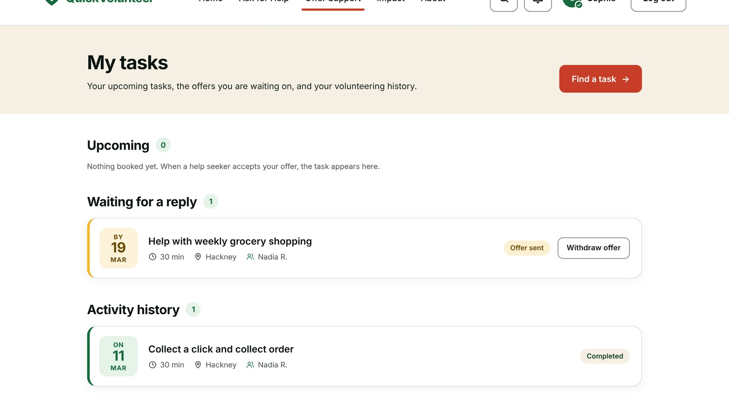
Figure C4. Change 1: status labels on My tasks (volunteer Sophie): Offer sent and Completed.
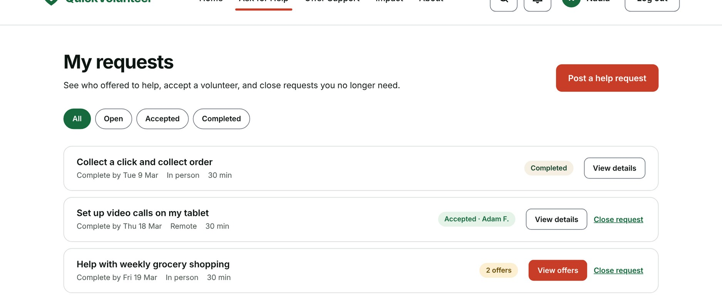
Figure C5. Change 1: status labels on My requests (help seeker Nadia): Completed, Accepted · Adam F., 2 offers.
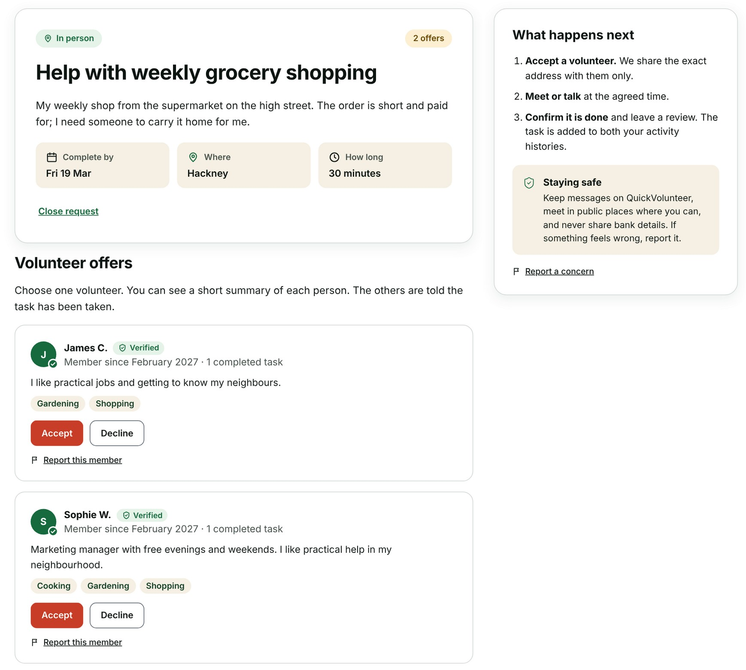
Figure C6. Change 2: each offer shows a short member summary with the Verified badge. Change 3: Report this member and Report a concern.
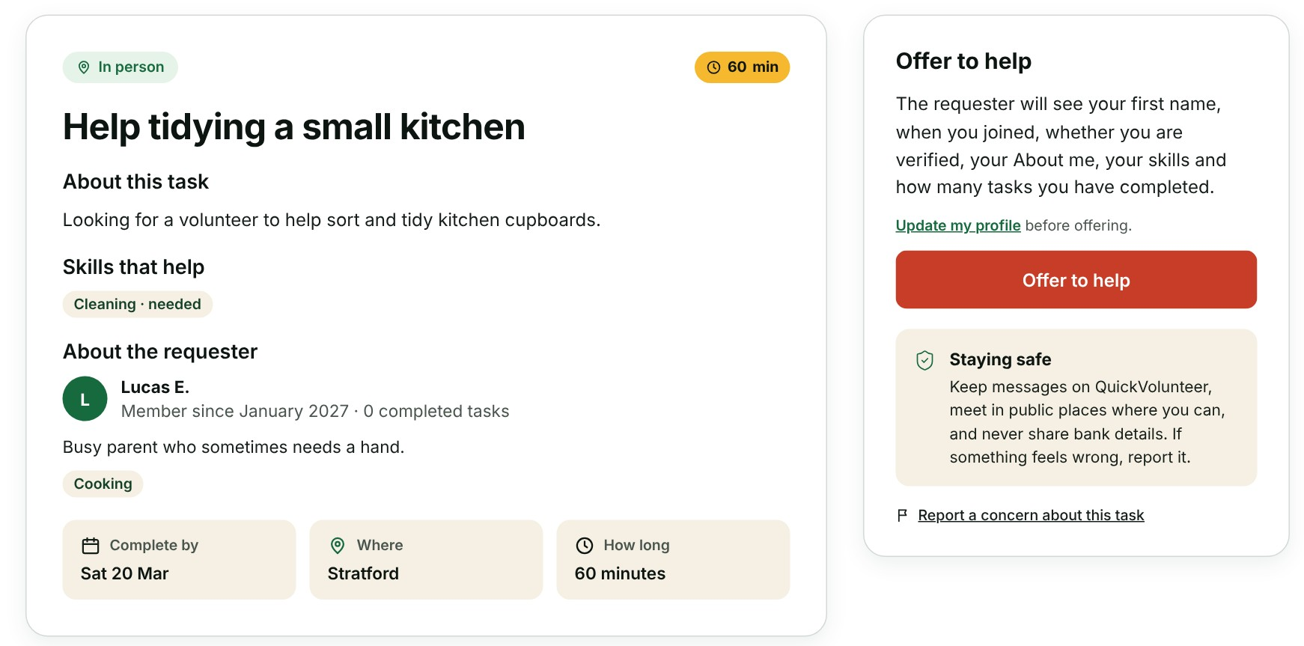
Figure C7. Change 3: the task page has a Report a concern about this task link.
3.3 Automated tests
The API tests run against a separate test database (quickvolunteer_test_db), so demo data is never touched. The final run was on 27 October 2026: 320 runs in 98.5 seconds, all OK. The full output is saved in the repository as evidence/unittest_run_27Oct2026.log.
Test module | Unique tests | What it covers
test_backend.py | 72 | Sign up, login, roles, tasks, offers, completion, cancelling, reports, reviews, ID verification, skills and CSRF
test_sprint3.py | 20 | Sprint 3 features: notifications, withdrawing offers, profile edits, member summary, skills, reports, ID documents, admin tools
test_messaging.py | 5 | Private conversation API after a volunteer is accepted
test_notifications.py | 5 | Members see only their own notifications; accept and decline notices
test_audit.py | 2 | Audit log entries when an offer is accepted or declined
Total | 104 | All passed, 0 failed
Why the log shows 320. Three modules (test_audit, test_messaging and test_notifications) import the core test class from test_backend.py to reuse its set-up, so unittest runs those 72 tests four times: 104 + 3 × 72 = 320 runs. They are 104 unique tests, and every run passes.
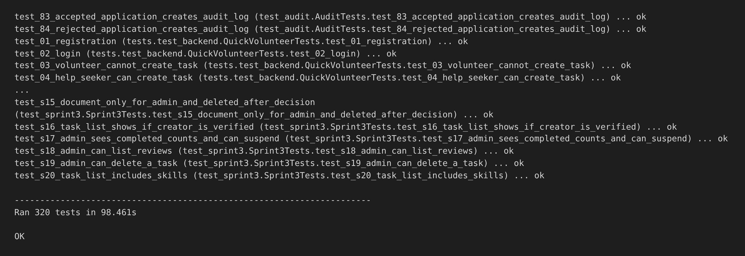
Figure C8. Excerpt from the test log of 27 October 2026: Ran 320 tests, OK (104 unique tests; see above).

3.4 Functional test cases
Each case was run in the browser against the real API and database.
ID | Role | Test | Expected result | Result
T01 | Visitor | Open Offer Support | Open tasks load from MySQL, no sample data mixed in | Pass
T02 | Visitor | Location pin, Edit, enter E8 1AB and Apply | In person tasks within 3 miles, nearest first; the pin opens a map with the circle and task dots | Pass
T03 | Visitor | Pick a suggested area, or use Locate me | Only in person tasks in that area, or near the nearest postcode | Pass
T04 | Visitor | Filter by type of help, duration and Only verified members | List updates, count matches, Clear filters resets | Pass
T05 | Visitor | Use Accessibility tools: bigger text, colour themes, read aloud | Page changes at once and the choice is remembered | Pass
T06 | Member | Sign up | Goes to set up: postcode with map, role, skills | Pass
T07 | Member | Finish set up without a skill | Blocked with a clear message | Pass
T08 | Member | Leave set up unfinished, log in again | Bell shows Finish setting up your profile | Pass
T09 | Member | Edit My profile and save | Saved; admins get a profile change to check | Pass
T10 | Member | Upload an ID document | Status shows pending; admin can open it | Pass
T11 | Help seeker | Post an in person request | Saved with Complete by date and area name | Pass
T12 | Help seeker | Receive an offer | Notification; volunteer’s summary shown before accepting | Pass
T13 | Help seeker | Accept an offer | Volunteer notified, task moves to Upcoming | Pass
T14 | Volunteer | Dashboard and Offer Support | Tasks matching skills come first, distances shown | Pass
T15 | Volunteer | Offer to help | Offer sent, requester’s summary shown, no message box | Pass
T16 | Volunteer | Withdraw an offer | Offer disappears, request opens again, requester notified | Pass
T17 | Both | Complete a task and leave reviews | Task completed for both, review on the profile | Pass
T18 | Member | Report a concern, "something else", with no contact | Report saved; admin sees it without the reporter’s email | Pass
T19 | Admin | Log in | Goes to the admin dashboard with the admin menu | Pass
T20 | Admin | Approve an ID document | Member verified, document deleted (404 afterwards) | Pass
T21 | Admin | Members: search, sort and filter | Rows match the filters; message when none match | Pass
T22 | Admin | Suspend a member | Member cannot log in until reactivated | Pass
T23 | Admin | Hide a review | Review no longer shown on the profile | Pass
T24 | Admin | Delete a request | Request removed for everyone; requester and volunteers notified | Pass
T25 | Admin | Open Ask for Help, Contact and Report | Forms visible, button reads View only and cannot send | Pass
T26 | Admin | Open My profile | Name and email only, Administrator badge | Pass
T27 | Security | A member calls an admin route | Refused with 403 | Pass
T28 | Security | Request a back-end file (/backend/app.py), also with a path trick (/js/../../backend/app.py) | Refused with 404; only website files are served | Pass
T29 | Security | Log out, then call /api/me | 401: the session has ended | Pass
3.5 Accessibility, responsive design and admin access
We checked every page for one main heading, a skip link and labelled form fields. The mobile menu, the notifications panel and the accessibility panel open with the keyboard and close with Escape. Pages still fit the screen with bigger text, which led to a header fix. The area name and radius are also shown as text on the pin button, so the map is never the only way to find them.
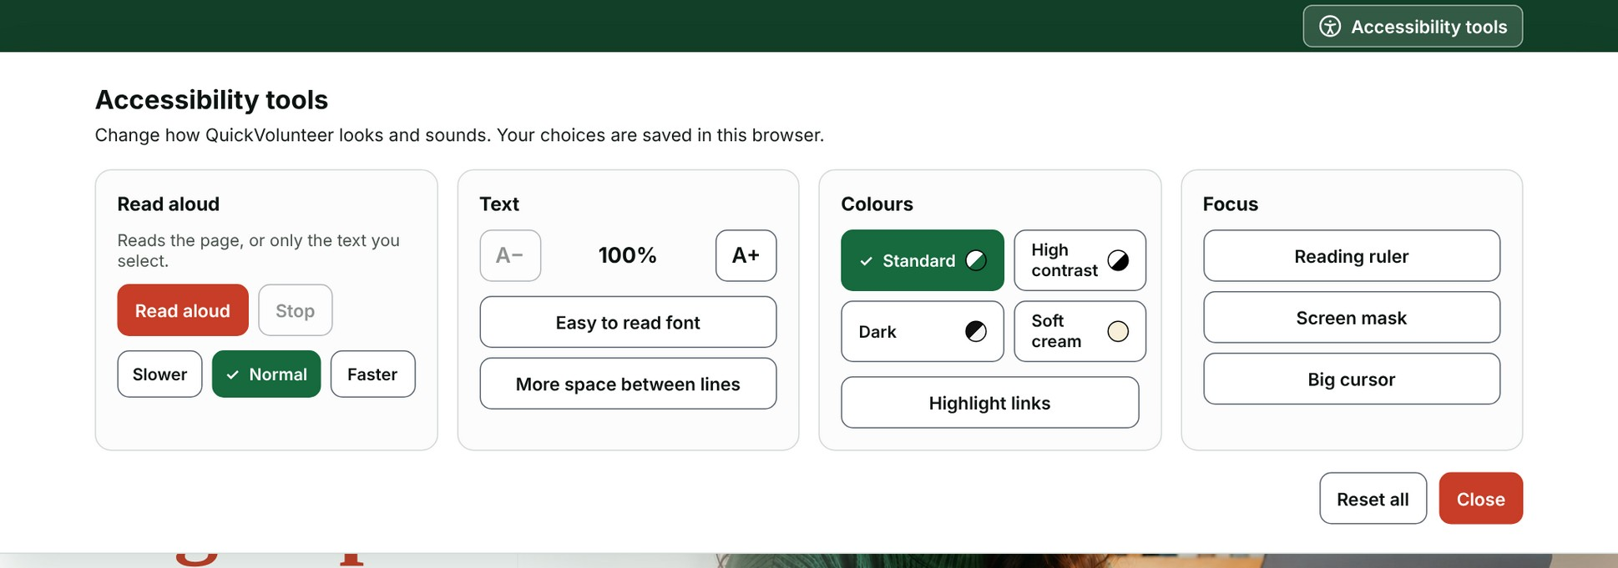
Figure C9. Accessibility tools (US-19), on every page: read aloud, text size, easy to read font, line spacing, colour themes, highlighted links, reading ruler, screen mask and big cursor.
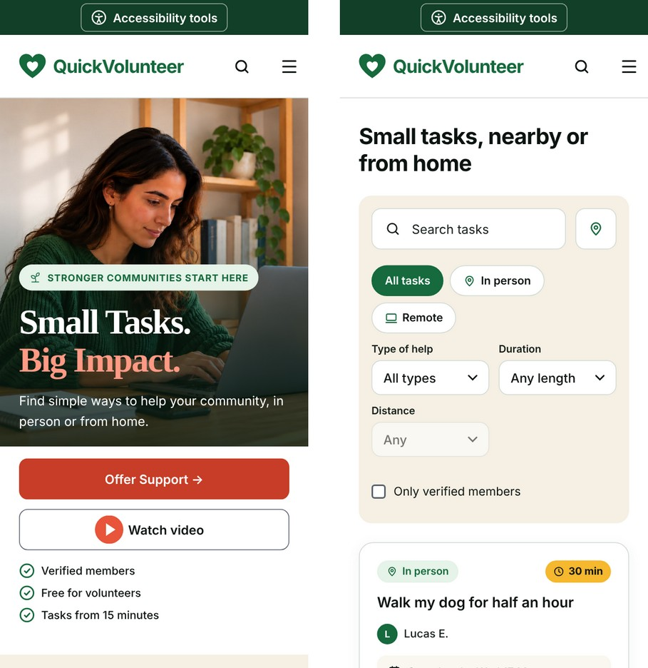
Figure C10. Responsive design: Home and Offer Support on a 390 px phone screen. Every page was checked at 10 sizes from 320 to 1920 px.
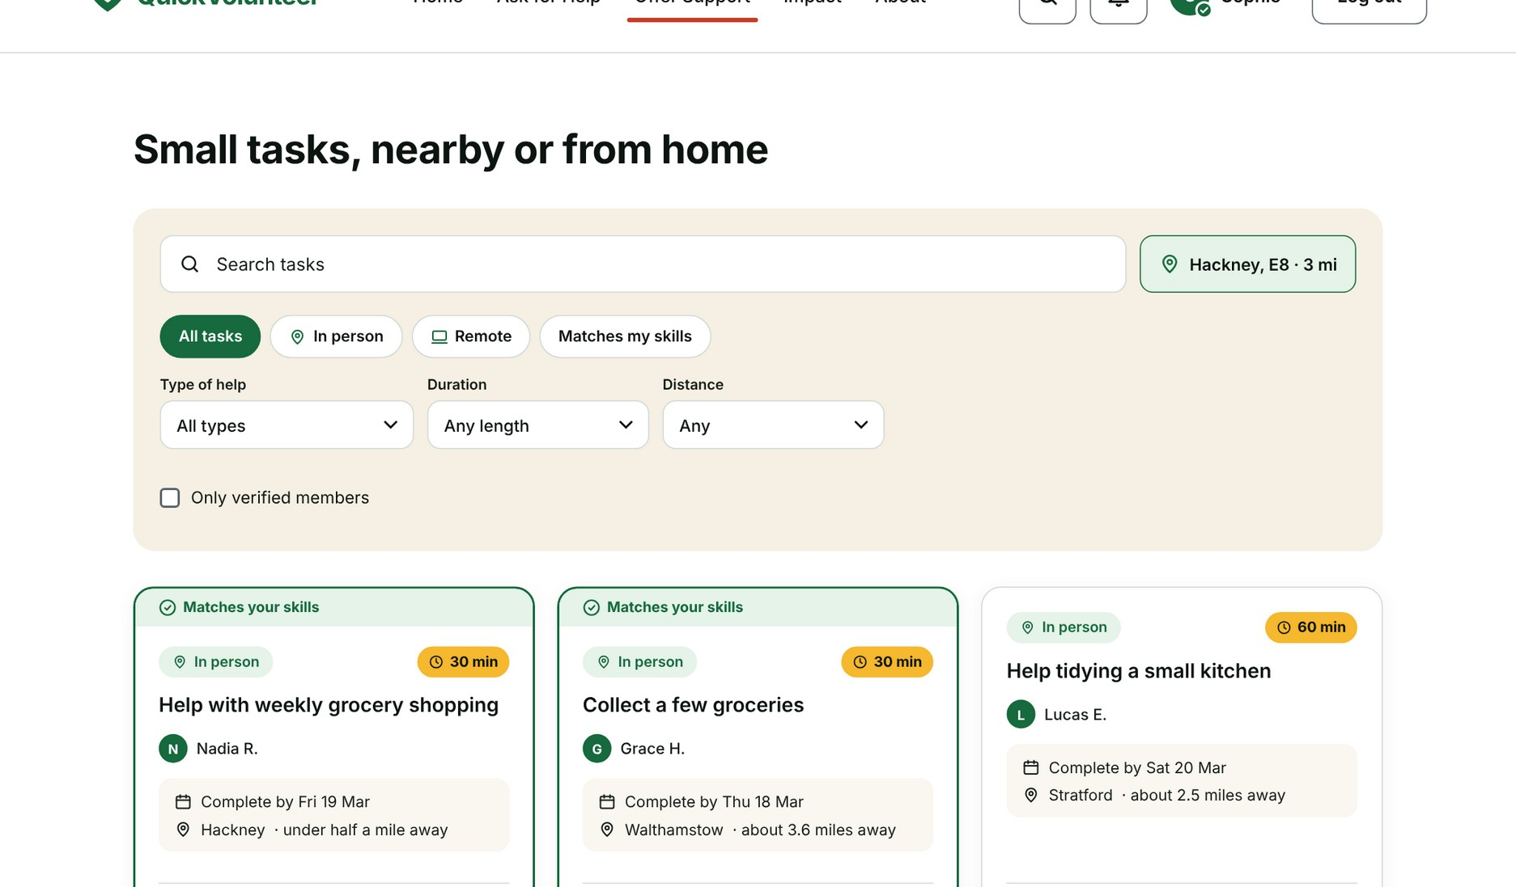
Figure C11. Offer Support for a logged-in volunteer: location set by postcode area (Hackney, E8, 3 mi), tasks matching the volunteer’s skills first, distances shown.
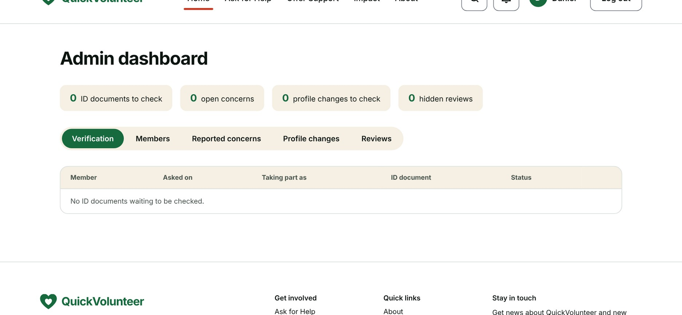
Figure C12. Admin access (US-28): own menu and dashboard with Verification, Members, Reported concerns, Profile changes and Reviews.
3.6 Defects and known limitations
20 defects were found during Sprint 3 testing; all were fixed and retested. Most recent first:
Area | Defect | Fix
Speed | Pages slow: Offer Support made 15 API calls and the dashboard 17, each opening a new database connection | Connections reused from a pool, skills sent with the task list, calls in parallel: 5 and 8 calls
Admin | Members table on tablets and phones lost its labels and spread "0 helping · 1 asking" across the card | Labels added to rows loaded from the API; count kept together
Impact | Coming soon icons in two different colours; the Mobile app icon was a phone handset | One green outline style; new calendar, building and smartphone icons
About, Impact | Call to action headings split over two lines on phones | Heading sized to the screen so it fits on one line
Profile | "No reviews yet" shown twice | Duplicate line removed
Admin | Admin tabs cut off on phones ("Verificatio") | Tabs wrap onto two lines on small screens
Admin | Admin saw "Finish setting up your profile" | Notice never shown to administrators
Admin | Admin had the member menu and a member profile with skills and area | Own admin menu and a name and email profile
Admin | Task page told admins "set up for asking for help only" | Admin panel with Delete this request
Post a request | Complete by date defaulted to the real date, before the 2027 demo data | Starts one week after 15 March 2027; earliest 15 March 2027
Website text | Developer-style hints ("Never shown…", "The latest date…") on forms | Removed; only real rules kept, such as minimum length
Find a task | Search needed a neighbourhood list | Location pin with postcode or area, distances and a map
Header | Menu overlapped the account buttons from 961 to 1279 px, and with bigger text | Menu button header at those widths
Accessibility | Accessibility bar covered the mobile menu | Menu placed above the bar
Map | Circle failed to draw ("layerPointToLatLng") | Map centred before the circle is added
Post a request | Area name not refilled when the postcode changed | Area worked out again from each new postcode
Live site | Sample tasks flashed before real ones loaded | Page hidden until live data is ready
My tasks | Sample tasks shown to members who are not volunteers | Sections cleared when the API refuses
Deployment | Database port blocked on the university network | Render creates the tables on first start
Demo data | Dates in the past made demo tasks look expired | All demo dates set as if today were 15 March 2027
Known limitations (they do not stop the demo):
- Free hosting: the Render server sleeps after about 15 minutes, so the first visit can take up to a minute.
- ID documents uploaded on the free Render plan are lost when the server restarts, so administrators must check them soon after they arrive. Aiven may also pause an unused free database.
- No emails are sent yet: notifications appear in the site only.
- The password reset page does not send a link yet.
- Private messaging is built and tested in the API (test_messaging) but is not yet shown on the website.
- Distances are worked out from the centre of each postcode district, so they are approximate.
- Automated browser tests ran in Chromium only; Safari and Firefox still need a test.
- The audit tools flagged small alerts (redundant links, one suspicious link text, an unnecessary list role). They do not stop the demo and are listed for fixing (Section 4).
4. After Sprint 3: standards and accessibility audit
What: from 30 October to 2 November 2026, Khadija checked the live site against external standards (WCAG 2.2) with four tools. Passing our own tests does not prove that the site meets web standards, so this audit added an independent check. All tools were run on the deployed site.
Tool | Pages checked | Result | Alerts
Lighthouse | Home, Find a task | Accessibility 100 on both; performance 99 and 94; best practices 96; SEO 91 and 100 | None for accessibility
WAVE (WebAIM) | Home, Log in, Find a task, Impact | 0 errors, 0 contrast errors, AIM score 10/10 on all four pages | Redundant links (two per page); one suspicious link text on Find a task
Nu HTML Checker (W3C) | Home | No errors | One warning: unnecessary role on a list
W3C CSS Validator | Home | No errors | None
Table C1. Results of the standards and accessibility audit.
Next step: remove the redundant links, rename the suspicious link and delete the unnecessary list role, then run WAVE and the HTML checker again.
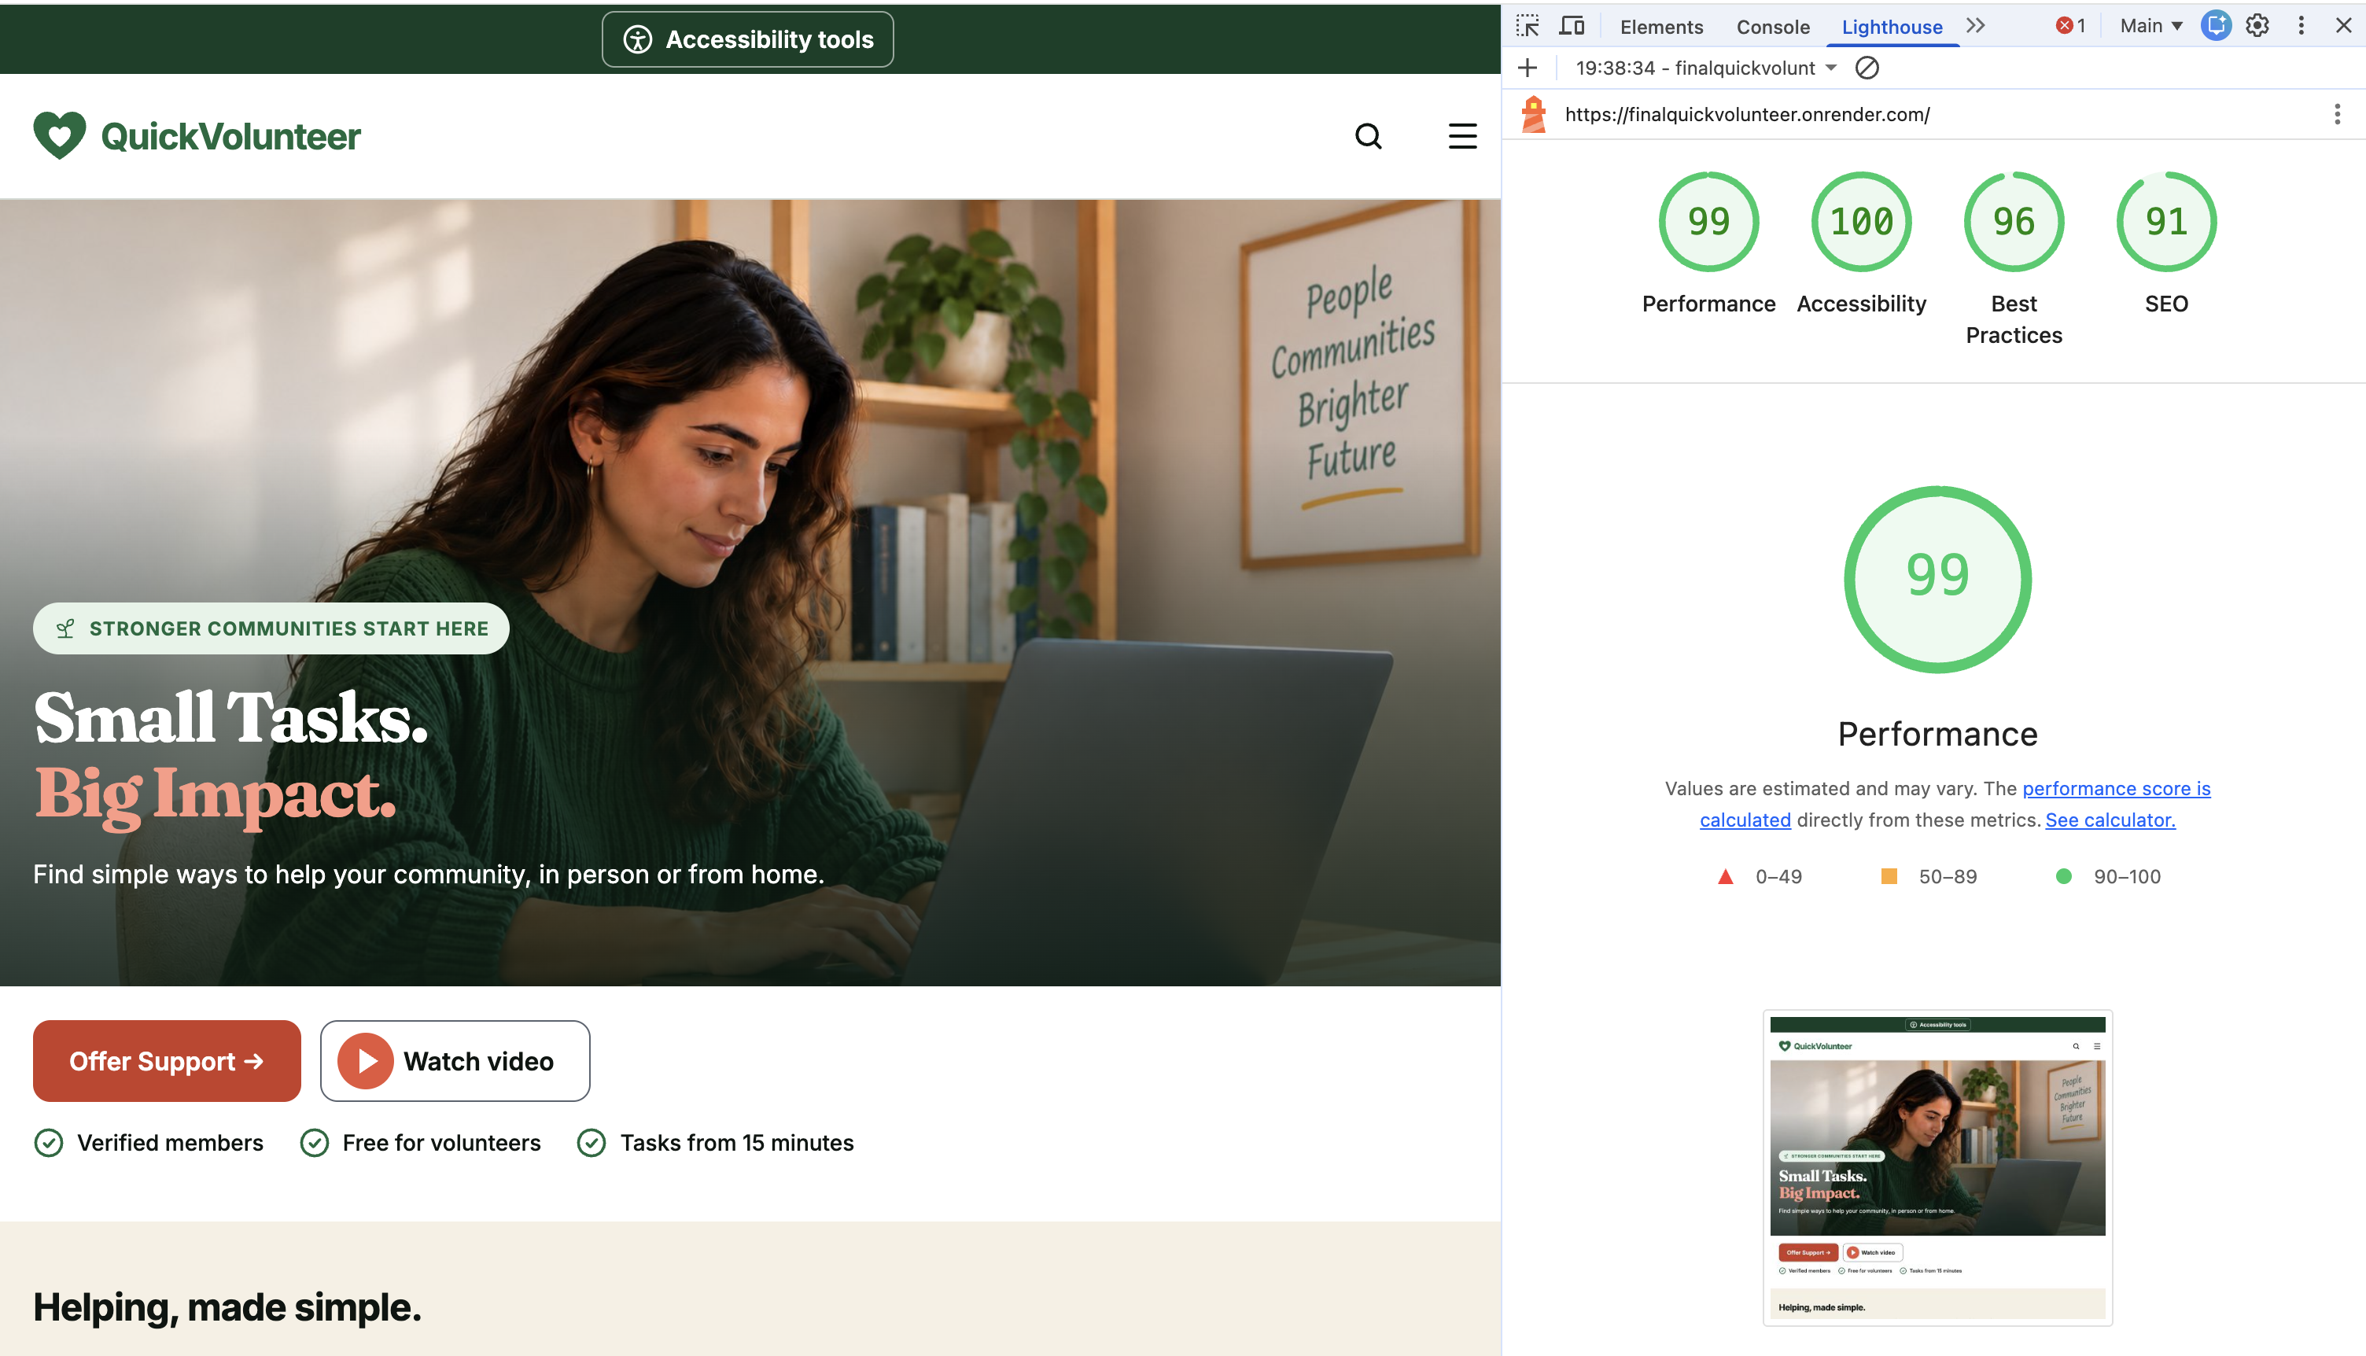
Figure C13. Lighthouse report for the Home page: 99 performance, 100 accessibility, 96 best practices, 91 SEO.
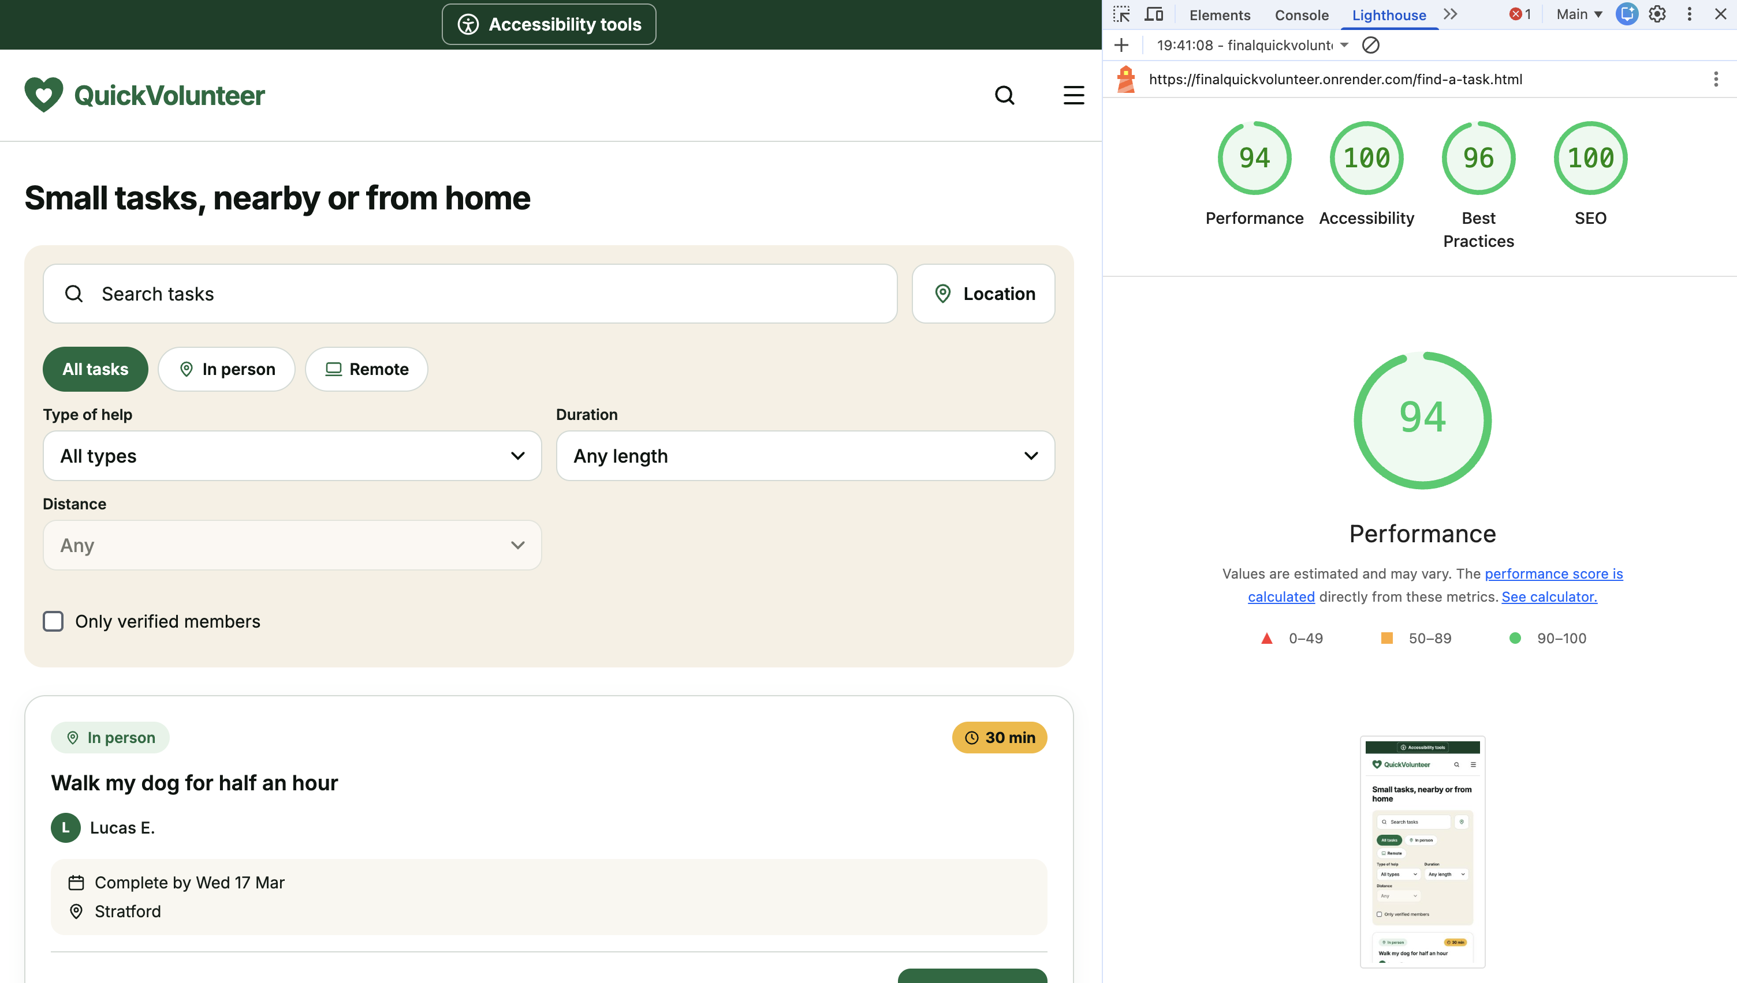
Figure C14. Lighthouse report for the Find a task page: 94 performance, 100 accessibility, 96 best practices, 100 SEO.
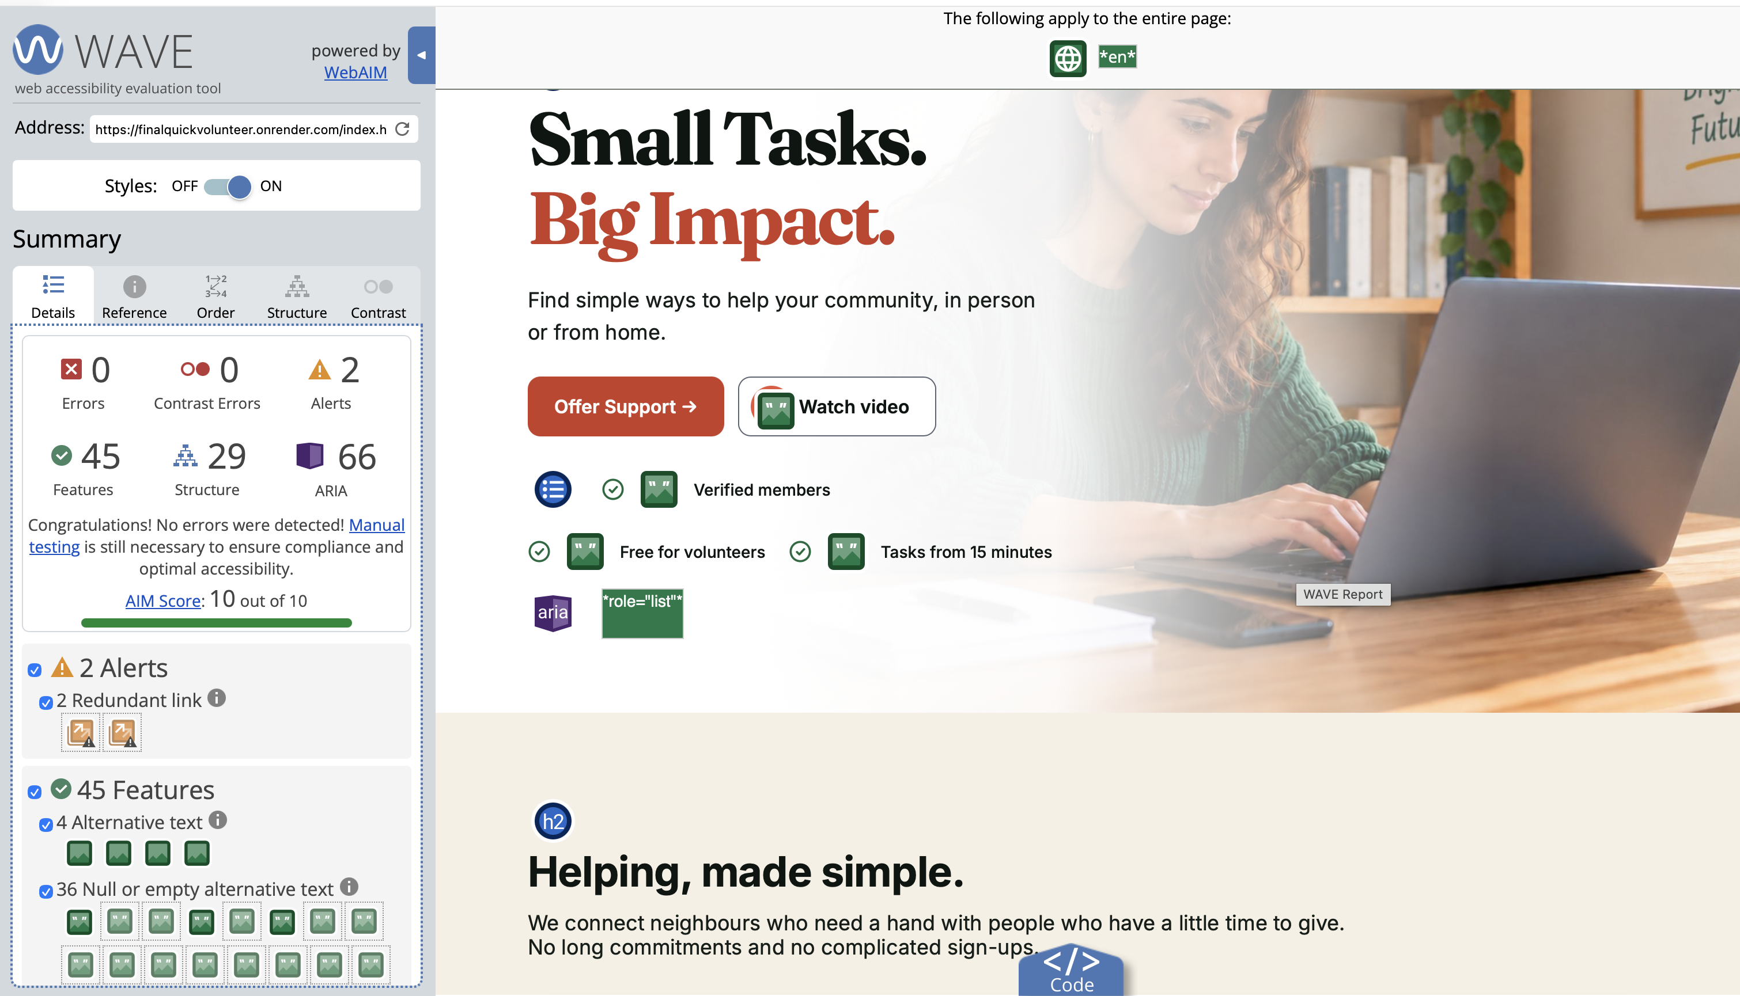
Figure C15. WAVE check of the Home page: 0 errors, 0 contrast errors, AIM score 10/10.
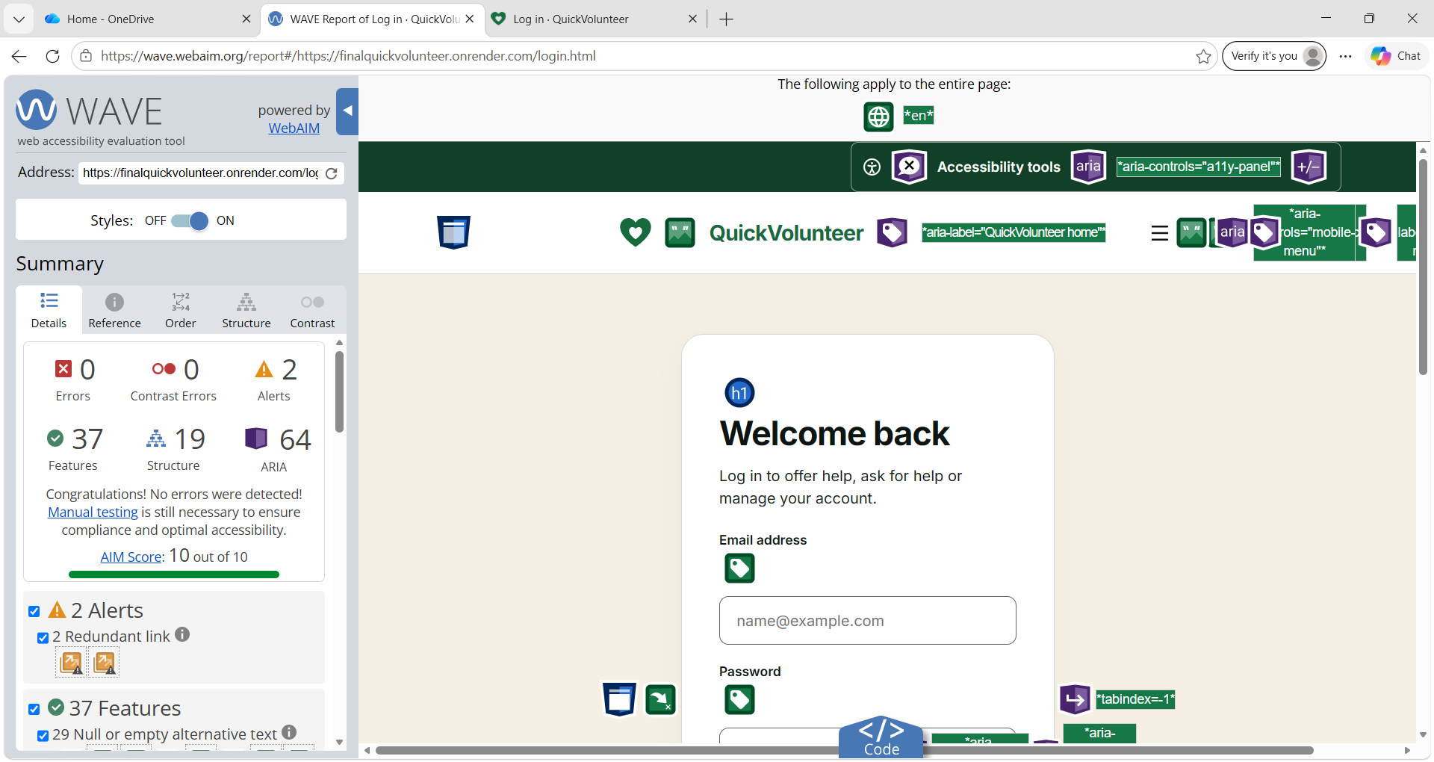
Figure C16. WAVE check of the Log in page: 0 errors, 0 contrast errors, AIM score 10/10; two redundant link alerts.
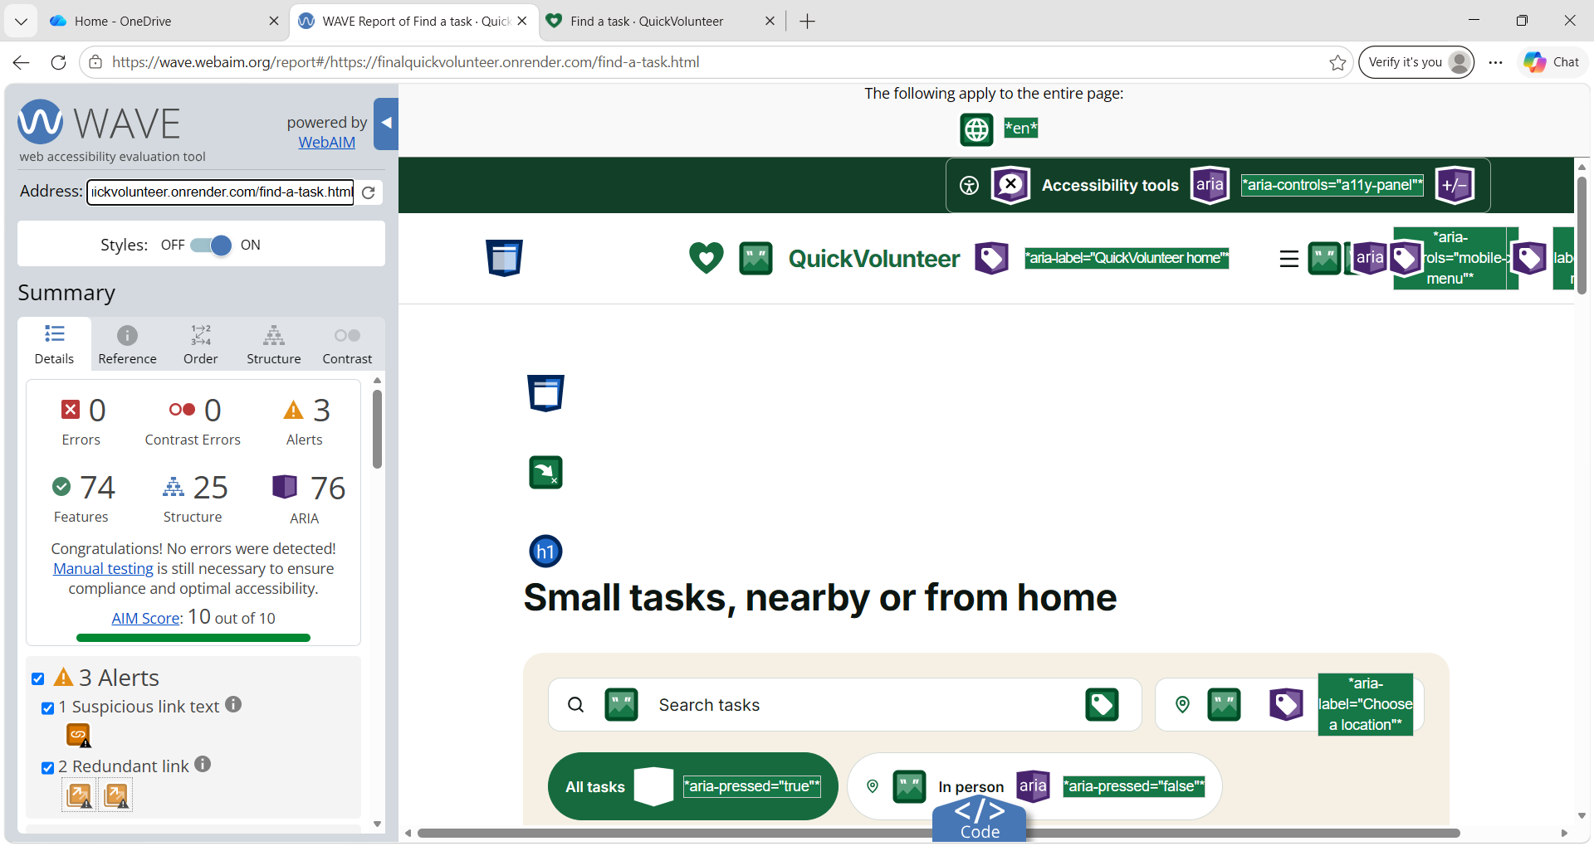
Figure C17. WAVE check of the Find a task page: 0 errors, 0 contrast errors, AIM score 10/10; one suspicious link text and two redundant link alerts.
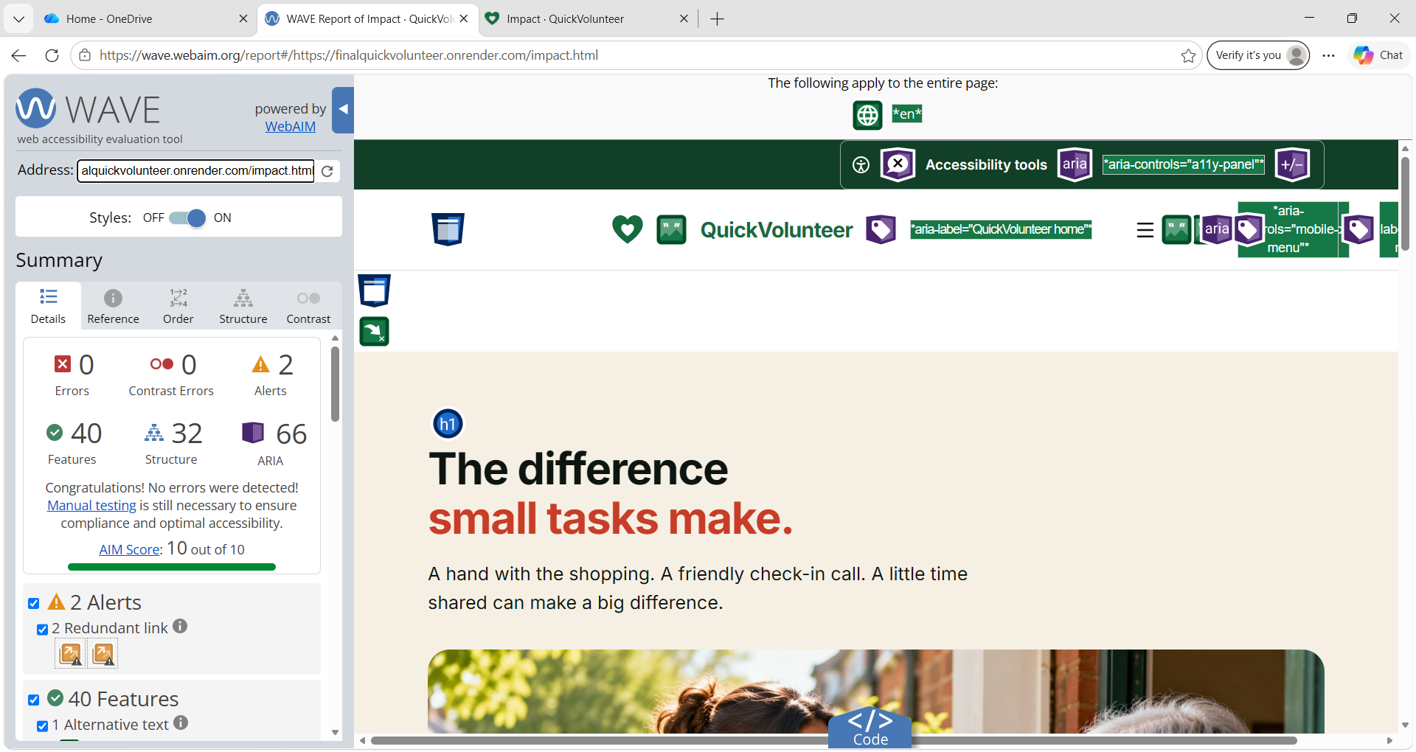
Figure C18. WAVE check of the Impact page: 0 errors, 0 contrast errors, AIM score 10/10; two redundant link alerts.
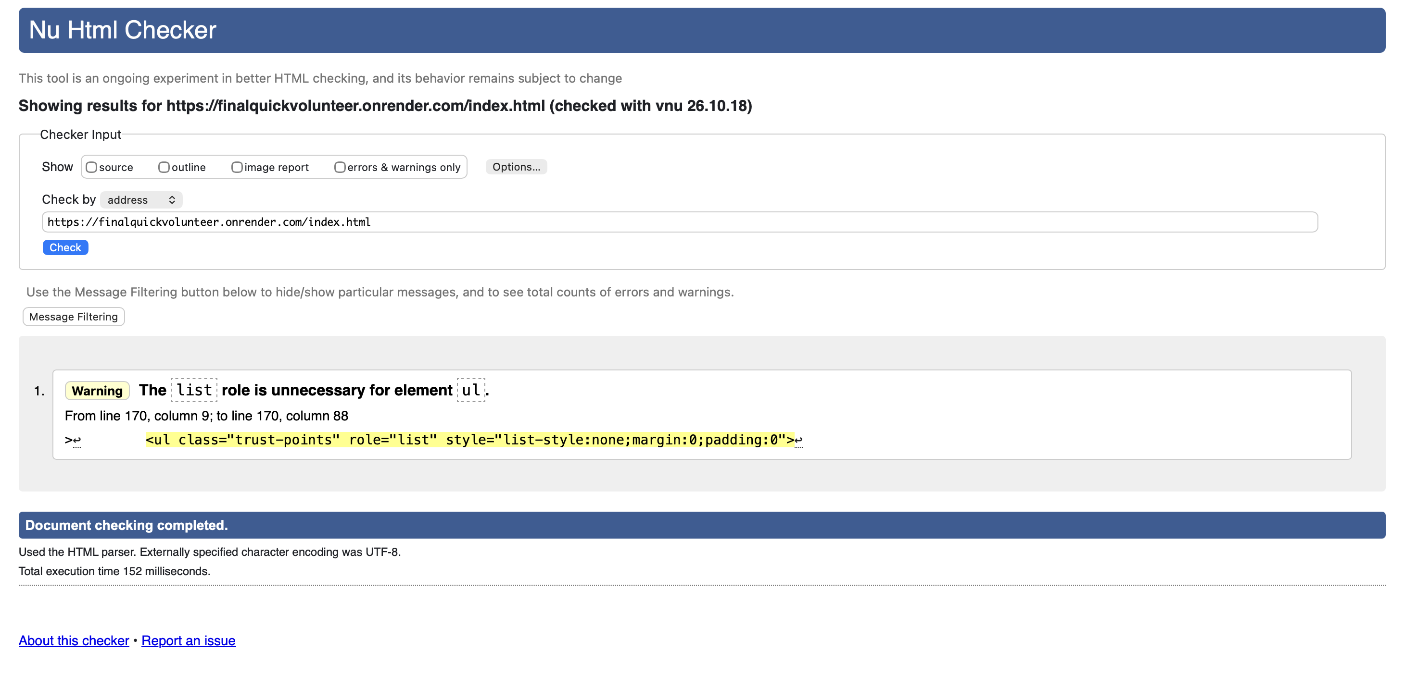
Figure C19. Nu HTML Checker on the Home page: no errors and one warning about an unnecessary list role.
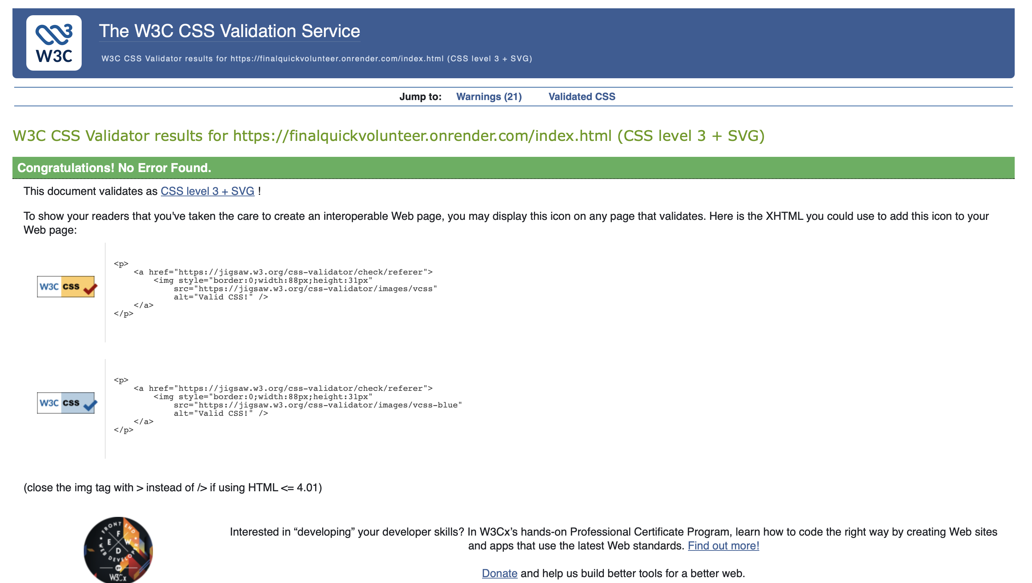
Figure C20. W3C CSS Validator on the Home page: no errors found.
5. Future improvements
How to read this table: each improvement below comes from evidence in this appendix or in the risk register (Appendix B, Table B7). Priority shows what we would do first in the next sprint; Backlog links each improvement to its Product Backlog story; US-11 is delivered and would be improved, the others are kept as Won't (this time).
Limitation or problem found | Evidence | Proposed improvement | Priority | Backlog
The free server sleeps after about 15 minutes, so the first visit can take up to a minute | R-07; Section 3.6 | Paid or always-on hosting | High | -
ID documents are lost when the free server restarts | R-08; Section 3.6 | Private cloud storage, with each document deleted automatically after the admin decision | High | US-11
No emails are sent, and the password reset page does not send a link | Section 3.6 | Emails for notifications and password reset | High | US-23
No safe way to share an address or phone number after an offer is accepted | R-11 | Private messages page (the API is already built and tested) and a choice of extra details to share | High | US-18, US-27
Shopping costs conflict with the "never exchange money" rule | R-12 | An expenses rule with receipts, agreed with both members | Medium | -
Home visits happen without a DBS check | R-13 | Administrators record DBS checks for volunteers who visit homes | Medium | US-17
Automated browser tests ran in Chromium only | Section 3.6 | Test the main journeys in Safari and Firefox | Medium | -
Distances are approximate, from the centre of each postcode district | Section 3.6 | Work out distances in the database (for example with PostGIS) | Low | -
The audit tools flagged small alerts | Section 4 | Remove the redundant links, rename the suspicious link, delete the list role, then run the checks again | Low | -
Table C2. Future improvements linked to the limitations and problems found in testing.
Other features already planned in the Product Backlog, and shown on the website's Impact page as Coming soon, are not caused by a problem: organisations and associations (US-30), group volunteering (US-31), community events (US-32), donations (US-33), a mobile app using the same Flask API (US-34) and a change of language (US-20).
Screenshots in Sections 3.2 and 3.5 were taken on 28 October 2026 from the final code with the demo data (demo dates set as if today were 15 March 2027). Section 4 screenshots were taken on the live site between 30 October and 2 November 2026. Maps need an internet connection to postcodes.io and OpenStreetMap and are not shown in the Section 3 screenshots.

