Laboratory Assignment AND Assessment Requirements Specification

Version 1.0

15 March, 2019

Developed by:
Ovadiuc Vlad, Petrea Alexandra
935
Version History

Version | Description of Change | Author | Date
V01 | Initial version | Ovadiuc Vlad, Petrea Alexandra | 09.03.2020
V02 | Second version | Ovadiuc Vlad, Petrea Alexandra | 16.03.2020

Contents
Laboratory Assignment AND Assessment Requirements Specification 1
Version 1.0 1
15 March, 2019 1
1 Functional Requirements 3
2 Actors 3
3 Use cases – diagram 3
3.1 Use case number 1 (Description of the use case) 3
4 Analysis 3
4.1 Entities 3
4.2 Relations between entities 3
4.3 Attributes 3
4.4 System behavior 4
4.4.1 Use case 1-2-3 4
4.5 System events 4
5 Design 4

Analysis and design Document

Functional Requirements
List the functional requirements (FR) of the system.

Section/ Requirement ID | Requirement Definition
FR0.1 | Add a new student specifying the required data: id, name and group.
FR0.2 | Update the information about a student by specifying the id from the repository, the new name and the new group.
FR0.3 | Delete a student specified by id
FR0.4 | Display all the students
FR1 | Add a new theme by specifying the id, name, start week and end week
FR2 | Extend the deadline of a theme
FR3.0 | Notify the students when a new theme is added or the deadline was modified.
FR3.1 | Unsubscribe from this notification
FR4 | Add a grade for a student at a theme
FR5 | Add a grade for a student at a theme consist in specifying the number of the theme, delivery week, deadline and feedback
FR6 | Send an email for every student with the weekely feedback
FR7 | Delay is not take in consideration if a student has a motivation
FR10 | Filter entities based on criteria
FR11.0 | Raport: laboratory grade for each student
FR11.1 | Raport: the hardest theme( the average of the grades is the smallest one)
FR11.2 | Raport: students who can enter the exam( average grade is grater or equal to 4)
FR11.3 | Raport: students who delivered all the themes on time

Actors
This application has only one actor – the teacher – because is the only one who can use it.

Use cases – diagram

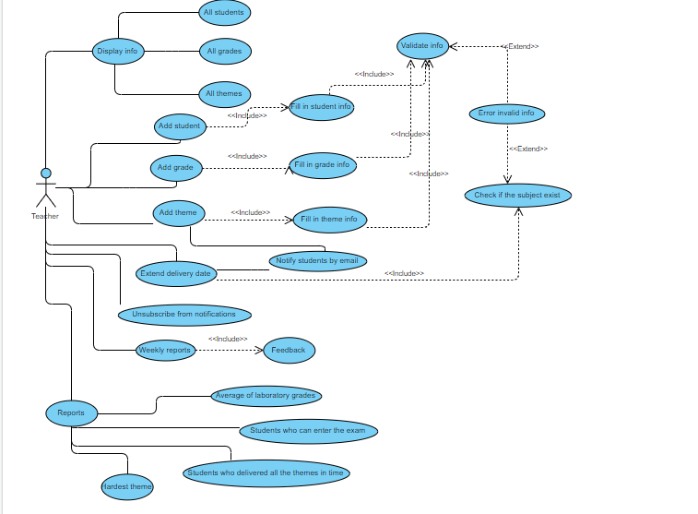

Use case number 1(Description of the use case)
Actors: Teacher
Description: Add a student
Precondition: valid information of the student(id, name, group)
Postcondition: the repository size increase with 1
Exceptions: when the fields aren’t filled

User action | System response
1Completes the necessary fields for adding | Check the integrity of the data
 | Add the student to repository
 | Display the corresponding message(success or failure)

Actors: Teacher
Description: Add a theme
Precondition: valid information of the theme(id, description, deadline, starline)
Postcondition: the repository size increase with 1
Exceptions: when the fields aren’t filled or the deadline is lower than starline ???

User action | System response
1Completes the necessary fields for adding | Check the integrity of the data
 | Add the theme to repository
 | Display the corresponding message(success or failure)

Actors: Teacher
Description: Add a grade for a student at a theme
Precondition: valid information of the grade (id_student, id_theme, grade, delivery week, deadline)
Postcondition: the repository size increase with 1
Exceptions: when the fields aren’t filled

User action | System response
1Completes the necessary fields for adding | Check the integrity of the data
 | Calculate the delay
 | Add the grade to repository
 | Display the corresponding message(success or failure)
Actors: Teacher
Description: Display all the students
Precondition: -
Postcondition: the list of students is displayed in console
Exceptions: -

User action | System response
1Enter the comand | Display the list of students or nothing if there are no students in repo
Actors: Teacher
Description: Display all the themes
Precondition: -
Postcondition: the list of themes is displayed in console
Exceptions: -

User action | System response
1Enter the comand | Display the list of themes or nothing if there are no students in repo

Actors: Teacher
Description: Display all the grades
Precondition: -
Postcondition: the list of grades is displayed in console
Exceptions: -

User action | System response
1Enter the comand | Display the list of grades or nothing if there are no students in repo

Actors: Teacher
Description: Update information for a student
Precondition: the student exist in the repo
Postcondition: the student with new information is saved in repo
Exceptions: when the fields aren’t filled

User action | System response
1Completes the necessary fields for updating | Check the integrity of the data
 | Update the information in repository
 | Display the corresponding message(success or failure)

Actors: Teacher
Description: Delete an existing theme
Precondition: the theme exist in repository
Postcondition: repository size decrease with 1
Exceptions: when the theme is not in repository

User action | System response
1Completes the necessary fields for deleting | Check the integrity of the data
 | Delete the theme from the repository
 | Display the corresponding message(success or failure)
Actors: Teacher
Description: Delete an existing student
Precondition: the student exist in repository
Postcondition: repository size decrease with 1
Exceptions: when the student is not in repository

User action | System response
1Completes the necessary fields for deleting | Check the integrity of the data
 | Delete the student from the repository
 | Display the corresponding message(success or failure)

Actors: Teacher
Description: Delay the deadline
Precondition: the theme exist in repository
Postcondition: theme has a new deadline
Exceptions: when the theme is not in repository

User action | System response
1Completes the necessary fields for delaying | Check the integrity of the data
 | Update the deadline for that theme
 | Display the corresponding message(success or failure)

Analysis

Entities
The entities are Student, Theme and Grade.

Relations between entities
A Student has only one Grade for a Theme.
A Grade has a Student and a Theme.

Attributes
Student:
- Id
- Name
- Group
Theme:
- Id
- Description
- Deadline
- Starline
Grade:
- IdStudent
- IdTheme
- Grade
- DeliveryWeek
- Feedback

System behavior

Use case 1-2-3
The system will probably act as a subsystem to a larger environment, in order to speed up a certain process in the company’s workflow.

System events

Design
  - Class diagram
    - Domain package 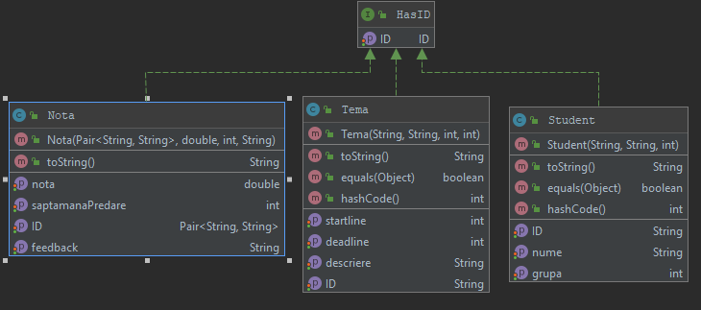
    - Repository package
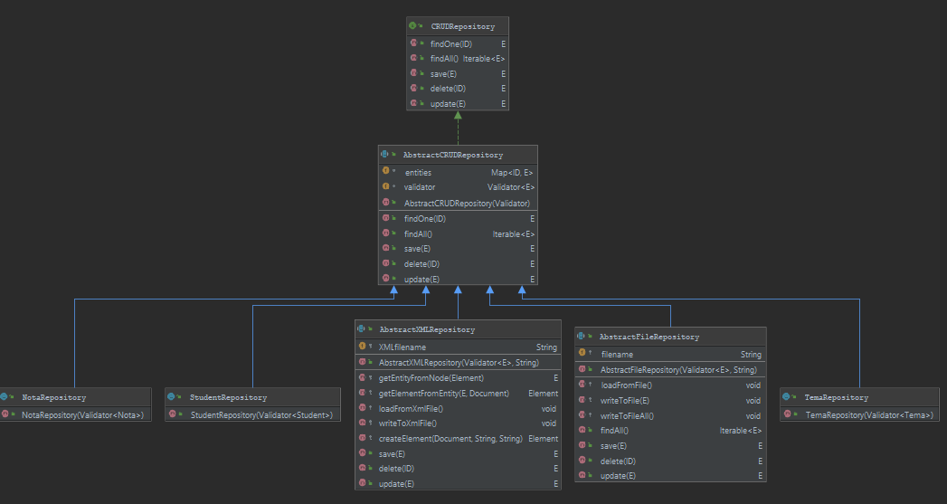
      - XML Repository
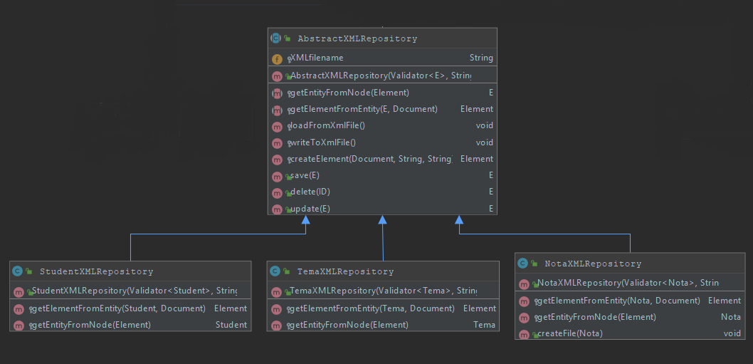
      - File Repository
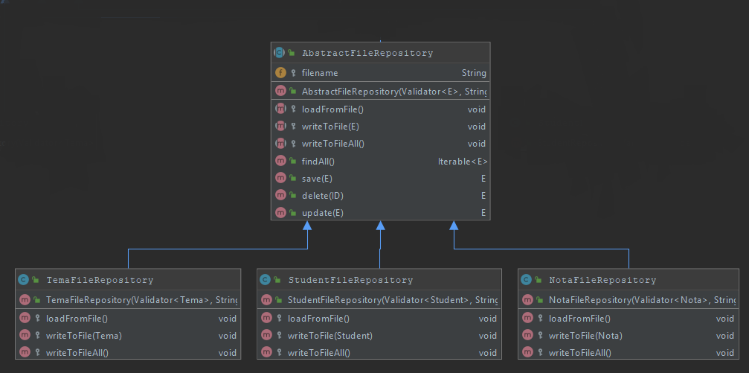
    - Service package
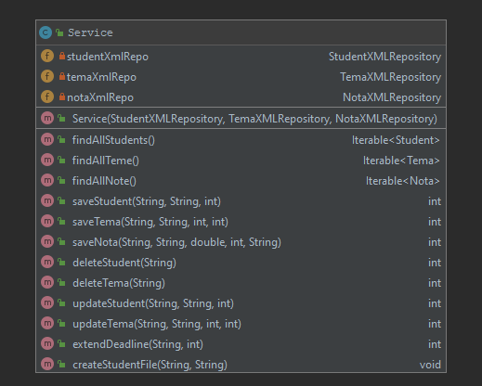
    - UI package
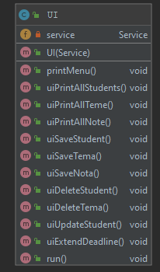
    - Validator package
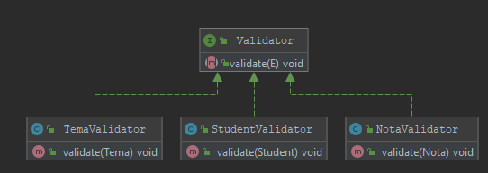

  - Sequence diagrams (for each use case)

  - GRASP

