Bookstore

Analysis and Design Document

Student:Alexandra Vereș

**Group:30234**

Revision History

|  |  |  |  |
| --- | --- | --- | --- |
| **Date** | **Version** | **Description** | **Author** |
| <dd/mmm/yy> | <x.x> | <details> | <name> |
|  |  |  |  |
|  |  |  |  |
|  |  |  |  |

Table of Contents

I. Project Specification 4

II. Elaboration – Iteration 1.1 4

1. Domain Model 4

2. Architectural Design 4

2.1 Conceptual Architecture 4

2.2 Package Design 4

2.3 Component and Deployment Diagrams 4

III. Elaboration – Iteration 1.2 4

1. Design Model 4

1.1 Dynamic Behavior 4

1.2 Class Design 4

2. Data Model 4

3. Unit Testing 4

IV. Elaboration – Iteration 2 4

1. Architectural Design Refinement 4

2. Design Model Refinement 4

V. Construction and Transition 5

1. System Testing 5

2. Future improvements 5

VI. Bibliography 5

# Project Specification

The bookstore application is meant to provide a digital representation and permanently store a bookstore’s information. The users of this application can be divided in two types:

* Employee
* Administrator

The employee can perform the following operations:

* Filter books by their properties
* Sell books

The administrator can perform the following operations:

* Create, update, delete, view employee information
* Create, update, delete, view book information

# Create a textual report on the books, which are out of stock

# Elaboration – Iteration 1.1

# Domain Model

*[Define the domain model and create the conceptual class diagrams]*

# Architectural Design

## Conceptual Architecture

## For this application the use of model-view-controller design pattern was encouraged.

## Package Design

*[Create a package diagram]*

## Component and Deployment Diagrams

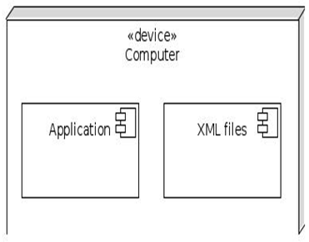

# Elaboration – Iteration 1.2

# Design Model

## Dynamic Behavior

*[Create the interaction diagrams (1 sequence, 1 communication diagrams) for 2 relevant scenarios]*

**UML Sequence Diagrams**

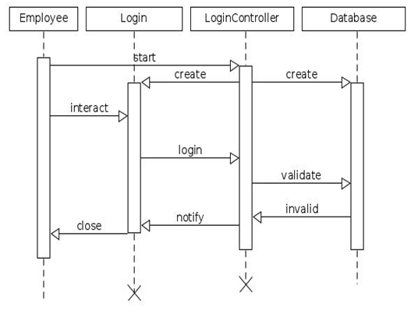

**Use-Case Model**

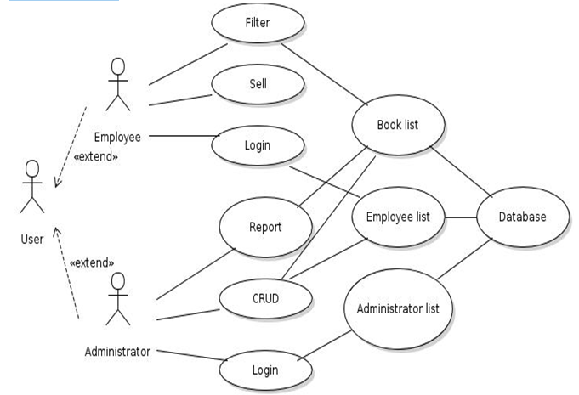

**Use case:** Create a new employee **Level:** user goal

**Main success scenario:** the user logs in, if it has an admin account, the list with all employees appearsafter changing the tab from books to employees. The admin can create a new employee by clicking on the create button and specifying the employee’s data in the dialog window.

**Possible failure scenario:** the user may have an employee account, therefore it cannot view and editother employee’s information.

**Possible failure scenario:** the user uses a wrong password to log in.

## Class Design

*[Create the UML class diagram; apply GoF patterns and motivate your choice]*

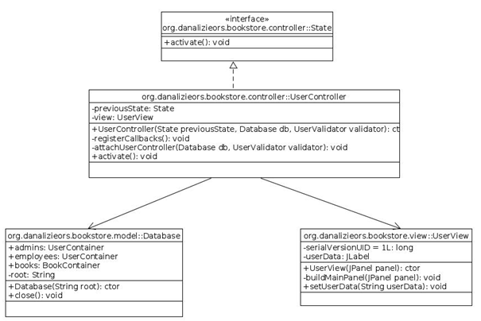

# Data Model

*[Create the data model for the system.]*

# Unit Testing

*[Present the used testing methods and the associated test case scenarios.]*

# Elaboration – Iteration 2

# Architectural Design Refinement

*[Refine the architectural design: conceptual architecture, package design (consider package design principles), component and deployment diagrams. Motivate the changes that have been made.]*

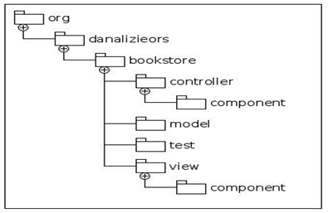

# Design Model Refinement

## *[Refine the UML class diagram by applying class design principles and GRASP; motivate your choices. Deliver the updated class diagrams.]*

# Construction and Transition

# System Testing

*[Describe how you applied integration testing and present the associated test case scenarios.]*

# Future improvements

*[Present future improvements for the system]*

# Bibliography