**Automated Customer Service Request Handling Automation**

Process Design Document (PDD)

|  |  |  |
| --- | --- | --- |
| Date issued: | Dd/MMM/yyyy |  |
| Replaces: | N/A - Initial Document |  |

Table of Contents

1. INTRODUCTION 3

1.1 Purpose 3

1.2 Objectives 3

1.3 Key Contacts 3

1.4 Revision History 4

1.5 Minimum Pre-Requisites for Automation 4

2. Process Overview – As Is & To Be 5

2.1 Process Overview 5

2.2 High Level – Automated Process Map 7

3. As Is Process Description 7

3.1 AS IS Process Map 7

3.1.1 High Level Process Map 7

4. To Be Requirements & Business Rules 8

4.1 Process Screenshots 13

5. To Be Process Description 18

5.1 Applications 19

5.2 Detailed TO BE Process Map 19

5.2.1 Validation Rules 19

5.3 Input Data Description 20

5.4 Parallel Initiatives 20

5.5 Out of Scope for RPA 20

5.6 Business Exceptions Handling 21

5.6.1 Known Business Exceptions 21

5.7 Systems Exception Handling 23

5.7.1 Known System Exceptions 23

5.7.2 Unknown System Exceptions 23

5.8 Reporting 24

6. Other 25

6.1 Referenced Documentation 25

# INTRODUCTION

## Purpose

The Process Definition Document outlines the business process chosen for automation. The document describes the sequence of steps performed as part of the business process, the conditions and rules of the process prior to automation (AS IS) as well as the new sequence of steps that the process will follow as a result of automating the process partially or entirely (TO BE).

**The PDD is a communication document between:**

* The RPA Business Analyst and the SME/Process Owner. The goal is to ensure that the RPA Business Analyst has the correct understanding of the process and has represented it accurately.
* The RPA Business Analyst and the Development team (represented by the Solution Architect and RPA Development Lead). The goal is to ensure that the process is documented appropriately and to a sufficient level of detail so that the Development team can then create the solution based on the PDD content

## Objectives

The business objectives and benefits expected by the Business Process Owner after automation of the selected business process are:

* Increase productivity among members of the client’s IT department via automation of user access request responses
* To reduce the risk of human error by minimizing manual email drafting
* Focus on value-added activities instead of manual email drafting

## Key Contacts

This document includes concise and complete requirements of the TO BE process and it is built based on the inputs provided by the process Subject Matter Expert (SME)/ Process Owner.

The Process Owner is expected to review this document and provide signoff for accuracy and completion of the AS IS and TO BE process steps, context, impacts and complete set of process exceptions.

|  |  |  |  |
| --- | --- | --- | --- |
| Role | Name | Contact Details | Notes |
| Process Owner |  |  |  |
| Process SME |  |  |  |
| ERPA Team | Daniel Bailey, Angela Chan, Kathy Ye, Bhargava Somarouthu  Matthew Tran | [daniel.bailey@hc-sc.gc.ca](mailto:daniel.bailey@hc-sc.gc.ca)  [kathy.ye@hc-sc.gc.ca](mailto:kathy.ye@hc-sc.gc.ca)  [angela.chan@hc-sc.gc.ca](mailto:angela.chan@hc-sc.gc.ca)  [bhargava.somarouthu@hc-sc.gc.ca](mailto:bhargava.somarouthu@hc-sc.gc.ca)  matthew.tran@hc-sc.gc.ca |  |
| ERPA Manager | Lorna Hart | lorna.hart@hc-sc.gc.ca |  |

## Revision History

|  |  |  |  |
| --- | --- | --- | --- |
| Date | Version | Created by / Role | Notes |
| 2024 Apr 15 | V1 | Alex J |  |

## Minimum Pre-Requisites for Automation

Development of Automation Solution will begin only after the following items are provided:

* Filled in Process Definition Document
* Test Data to support development
* User access and user accounts creations (licenses, permissions, restrictions to robot accounts)
* Credentials (user ID and password) required to logon to machines and applications

# Process Overview – As Is & To Be

This section contains an overview of the AS IS and TO BE processes.

## Process Overview

The information provided below is for the AS IS process unless otherwise indicated to be specifically for the automation / TO BE process.

|  |  |
| --- | --- |
| Item | Description/Answer |
| Process Name | **Business Process Name:** Customer Service Request Handler  **Automation Process Name:** Automated Customer Service Request Handler |
| Automation Area | NA – Sample Project |
| Short Description | **Purpose of the Process**: The client’s IT department periodically receives User Access Requests. The frequency of the requests varies during the fiscal year. The requests are received in a standardized format via xlsx email attachments. In the current process, a staff member needs to manually review the attachments, extract the transaction information, and finally draft appropriate emails for each transaction.  **Purpose of the Automation**: The automation aims to process the User Access Requests by determining the nature of the requests, if they conform to business standards (format, authorization, no duplicates, etc...), then produce email drafts based on the valid requests. The automation will also create a Transaction Log that can be easily perused. |
| Process Frequency | NA – Sample Project (During business days?) |
| Number of times the process is ran by selected frequency | This is an attended bot; users can run the bot as needed using UiPath Assistant  Note: Attended bots cannot be scheduled |
| Bot Process Scheduling  (PRD will contain the final schedule) | NA |
| Average Volume | NA – Sample Project |
| Percentage of business exceptions | NA – Sample Project |
| Average Handling Time | 5-10 minutes |
| Annual Average Total Time | NA – Sample Project |
| Peak Period | NA – Sample Project |
| Peak Volume Approximate Increase | NA – Sample Project |
| Number of persons performing the process | 1 dedicated resource |
| Expected Volume increase during next periods | NA – Sample Project |
| Input Data Description | AS IS and TO BE inputs are the same.   * User Access Requests with xlsx attachments |
| Output Data description | * User Access Request Email (if config setting is set to true) * Transaction Log (contains valid and invalid transactions) * Master Sheet (contains current active accounts and their information) |

## High Level – Automated Process Map

The information provided below is for the AS IS process unless otherwise indicated to be specifically for the automation / TO BE process.

# As Is Process Description

In this section the Business Analyst will document the AS IS process. This section will serve as the starting point for the automation effort.

## AS IS Process Map

## High Level Process Map

This section is useful for the Business Analyst in presentations and discussions with management to underline areas of weakness, inefficiency or to demonstrate which steps could be in scope for automation.

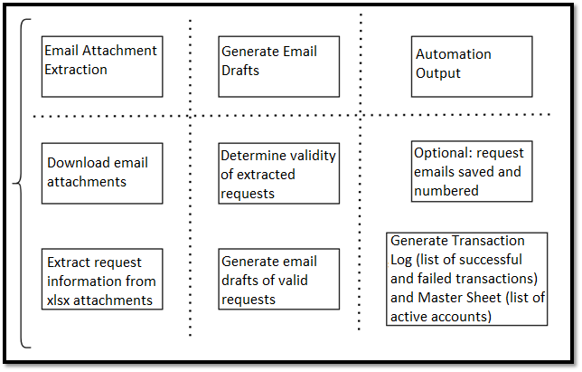

# To Be Requirements & Business Rules

This section captures the requirements and business rules of the TO BE process. The requirements can be a mix of user, system, and non-functional requirements. Any proposed improvements to the process should be captured as requirements here.

**Requirements:** Statements that tell you something the user or system will (or will not) do.

**Business rules:** Statements that tell you whether you may or may not do something or that give you the criteria and conditions for making a decision.

The requirements can be at a higher level but must cover breadth. Requirements will be mapped to business scenarios (features/functionality that will be tested) in the UAT Plan. See UAT Plan template for scenario examples.

Also use this section to capture the business rules as they come up when you are eliciting requirements. Business Rules for the most part will be embedded in the Detailed TO BE process map as decisions.

|  |  |  |
| --- | --- | --- |
| **Step** | **Action** | **Exceptions/Comments/References** |
| **1** | Kill Excel Processes |  |
| **2** | Determine if Folder Structure exists. Create if needed. | Ensure Data folder and its subfolders ProcessedEmails + Temporary exist  See **SCR01** |
| **3** | Determine if Config file exists.  Download if it does not and exit automation while prompting user to fill in Config file. | Throw Business Exception 01 on failure to download Config file and halt automation.  See **SCR02** |
| **4** | Determine if Transaction Log exists.  Download if it does not. | Throw Business Exception 02 on failure to download Transaction Log file and halt automation.  See **SCR03** |
| **5** | Determine if Master Sheet exists.  Download if it does not. | Throw Business Exception 10 on failure to download Master Sheet file and halt automation.  See **SCR04** |
| **6** | Initialize all settings by extracting information from the Config file and convert it into a Dictionary for use across the automation. | Key value pairs of String/Object |
| **7** | IF  RPA Challenge setting flag is set to true, Initialize Edge Browser. | See **SCR05** |
| **8** | Read all Emails from Inbox folder |  |
| **9** | IF  Download Email setting flag is set to true, download the email to ProcessedEmails folder | See **SCR07** & **SCR08** |
| **10** | IF  Email has ANY attachments, process them.  Move to **Step 11**  ELSE  Add failed Transaction record (Business Exception 03) to Active Transaction Data Table, and move Email to Config defined folder  Move to **Step 20** | Possibility of multiple attachments in an email. Look for attachment file name User Access Requests.  See **SCR09** & **SCR10** |
| **11** | Save Attachments from User Access Requests | Use Config File filter to determine if an email is a User Access Request  See **SCR06** |
| **12** | Generate Active Transaction Data Table | This Data Table will record all Transactions and their outcome in the currently being processed Email. |
| **13** | Iterate through each attachment  IF  Attachment is a xlsx file Try to read data from it.  On successful read move to **Step 14**. On failed read Add failed Transaction record (Business Exception 05) to Active Transaction Data Table.  ELSE if Attachment is not an xlsx file add failed Transaction record (Business Exception 06) to Active Transaction Data Table. |  |
| **14** | IF  Attachment data header format conforms to expected business norm. Move to **Step 15**  Else  Add failed Transaction record (Business Exception 05) to Active Transaction Data Table. | See **SCR11** |
| **15** | Iterate through each row of Transaction data.  IF  Transaction data Clearance is granted, is not required or is N/A move to **Step 16**  ELSE  Add failed Transaction record (Business Exception 07) to Active Transaction Data Table. | See **SCR12** |
| **16** | IF  Transaction data does no conflict with business rules add successful Transaction record to Active Transaction Data and modify Master Sheet to reflect modification done by Transaction.  ELSE  Add failed Transaction record to Active Transaction Data Table. | Master Sheet can be modified by adding Accounts, adding a record of the modification time, or deleting accounts.  See **SCR13**  Business Exception 11 if account already exists  Business Exception 12 if attempting to modify an account that does not exist  Business Exception 13 if failed to delete an account because it does not exist |
| **17** | Delete downloaded attachment the automation just processed from Temporary folder. |  |
| **18** | IF  RPA Challenge setting flag is set to true refresh browser, maximize it, and iterate through row of Active Transaction Data Table with Info Column set to Completed  FOR EACH VALID COLUMN  Enter all values into browser fields then click on the Submit Button  Minimize Browser  On repeated failure to enter values into browser terminate automation. | Sequence should accommodate browser crashing half way through field entries and attempt to restart while remembering how much information has been submitted.  Entry fields are: *Role in Company, Company Name, First Name, Last Name, Email, Address, Phone Number*  Note: RPAChallenge.com has moving entry fields for all information. Fuzzy Selector must be dynamic to account for it.  If browser fails to refresh Throw Business Exception 08.  On repeated failures to in this step Throw Business Exception 09  See **SCR05** & **SCR14** |
| **19** | Move Email from Inbox to Config defined processed Email folder | See **SCR10** |
| **20** | Iterate through each row of Active Transaction Data Table and append it to Transaction Log |  |
| **21** | Iterate through Inbox to see if new User Access Request was received during processing.  IF TRUE  Move to **Step 8** | Immediately loop and process Inbox again since new request(s) found. |
| **22** | Wait for new User Access Request to be received then kill Excel processes and move to **Step 8** |  |

4.1 Process Screenshots

SCR01 – Folder Structure

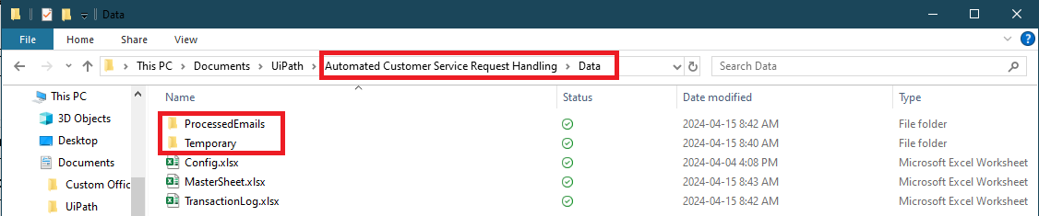

SCR02 – Config File Position

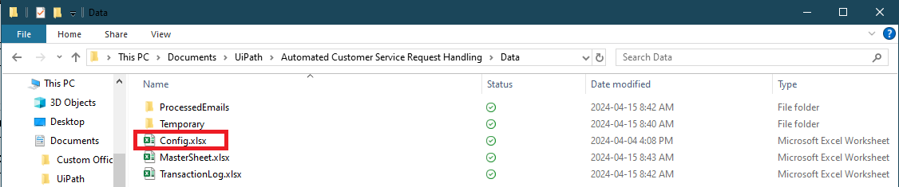

SCR03 – Transaction Log Position

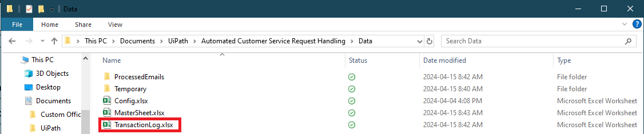

SCR04 – Master Sheet Position

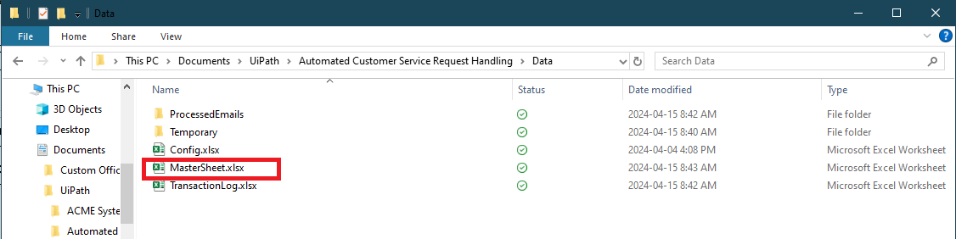

SCR05 – Config RPA Challenge Setting

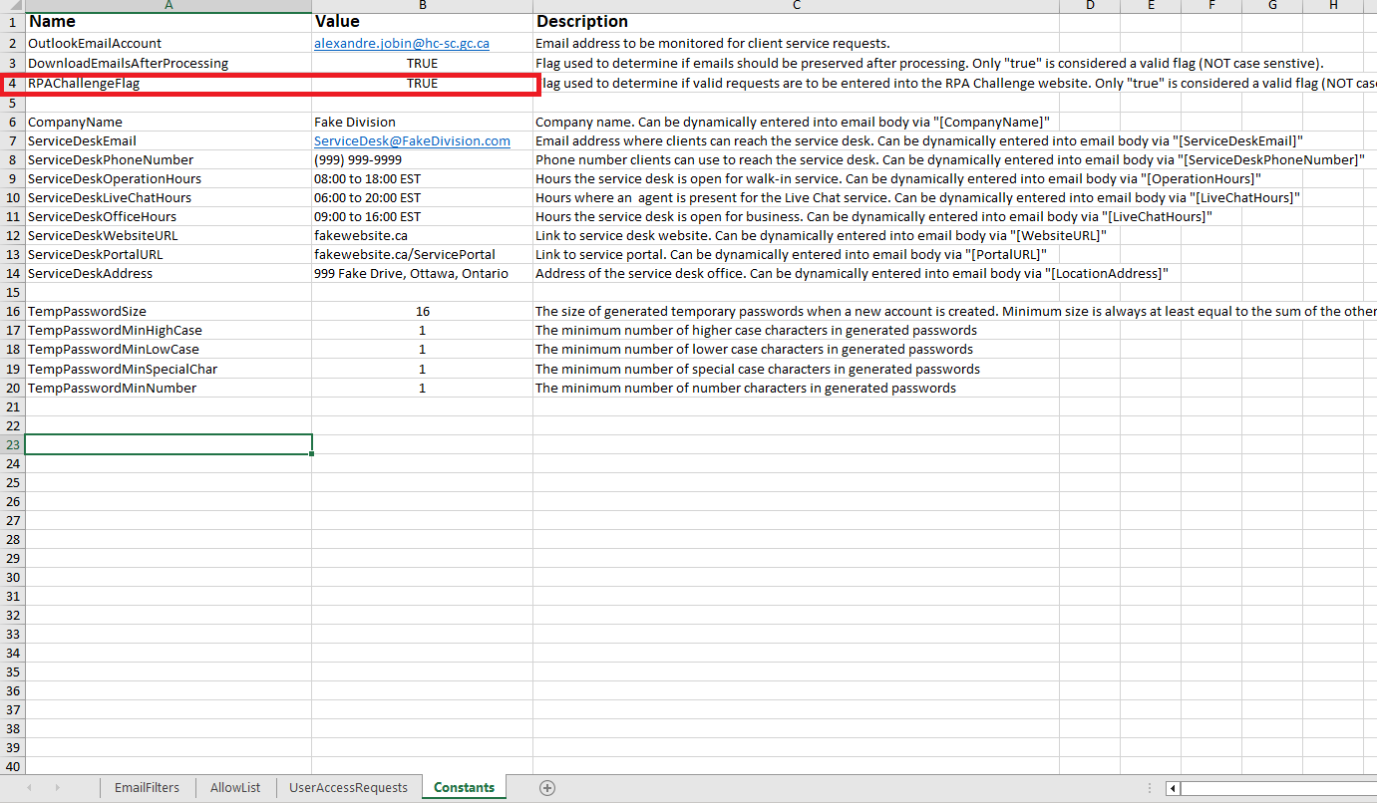

SCR06 – User Access Request Filter

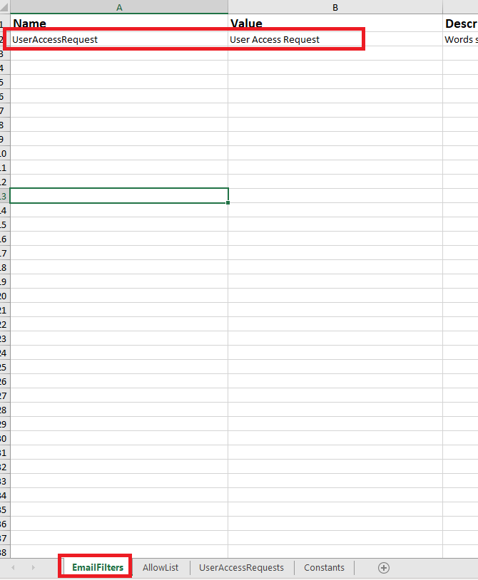

SCR07 – Download Emails Setting

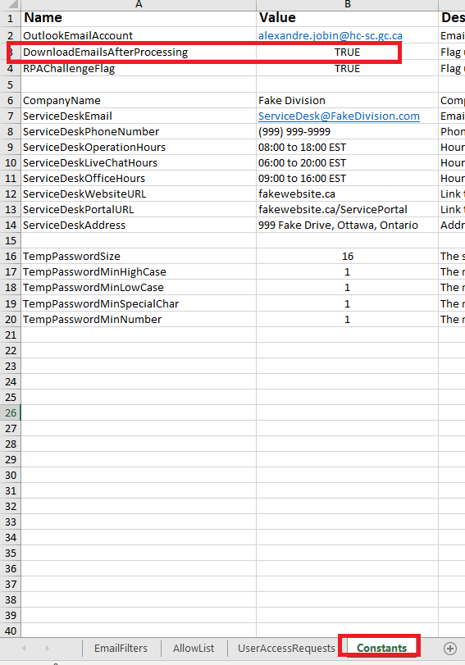

SCR08 – ProcessedEmails folder

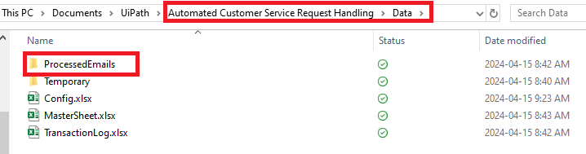

SCR09 – Email Attachment Name

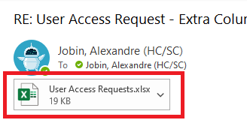

SCR10 – Config Defined Processed Emails Folder

SCR11 – Expected User Access Requests Format

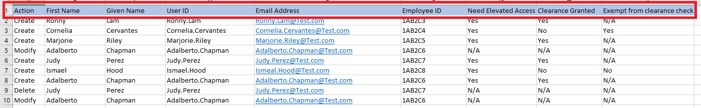

SCR12 – Clearance Status Columns from User Access Requests

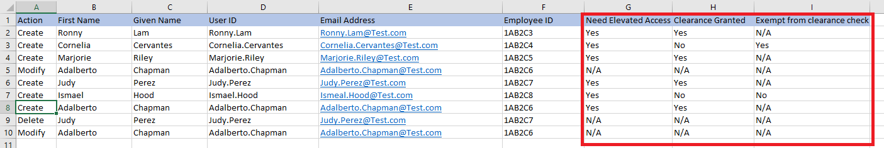

SCR13 – Master Sheet Account Details

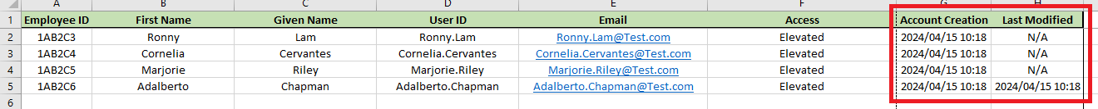

SCR14 – RPA Challenge Website (One possible configuration)

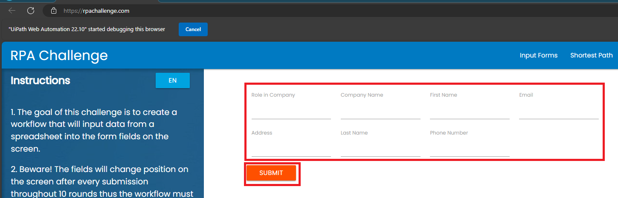

# To Be Process Description

This section outlines what the process will look like post-automation.

## Applications

|  |  |  |  |  |
| --- | --- | --- | --- | --- |
| Application Name | Short Description | Web-Based / Desktop | Usage (pertaining to this automation) | Comments |
| Outlook | Email platform | Desktop | RPA will save the Email object and attachments |  |
| Excel |  | Desktop | RPA will prepare Transaction Log of automation activity and keep a Master Sheet of Accounts |  |
| Edge |  |  |  |  |

## Detailed TO BE Process Map

A detailed process map specifying the automation steps and any hand-offs/manual processing will be outlined here.

*The process may be separated into sections/modules for better consumption and should be cross-checked with the Solution Architect and Developer. The type of robot (e.g., attended/unattended), where HITL is involved (Action Center/AARI), and when IDP is used (DU/IQ Bot) will also be indicated in the process map.*

*Process steps should be at click level. See Visio template. Screenshots are to be embedded in each step (zip the Visio, pdf version of the file, and screenshots for dev and clients). Add a screenshot(s) of the whole diagram in this section.*

## Validation Rules

This section describes the process at key-stroke level and is an essential part for the communication with the developers

*(Mandatory fields that need to be filled)*

|  |  |  |  |
| --- | --- | --- | --- |
| Field Name | Rule ID | Validations to be performed | Next Steps for Failed Validation |

## Input Data Description

The following table should contain details regarding the inputs that every step of the process takes.

|  |  |  |  |  |  |
| --- | --- | --- | --- | --- | --- |
| Step # | Input Name | Input Type | Location | Are inputs Natively Digital? | Are the Inputs Structured? |
|  | User Access Requests | Excel | Outlook Inbox | Yes | Yes |

* Native Digital: This is data that was originally created digitally e.g. excel, database or application reports etc. The non-native digital inputs are usually scanned images.

* Structured Data: has a predictable format and exists in fixed fields (e.g. an excel cell or a field in a form) and is easily detectable via search algorithms.

## Parallel Initiatives

The table below will capture any proposed Business, Process or Application changes that would impact the process at hand.

|  |  |  |  |
| --- | --- | --- | --- |
| Initiative Name | Impact on current Automation Request | Expected Completion Date | Contact Person |
| N/A | N/A | N/A | N/A |

## Out of Scope for RPA

The steps out of scope for RPA should be listed in the table below together with the reasoning. Actions out of scope (ie not Create, Modify, Delete)

|  |  |  |  |
| --- | --- | --- | --- |
| Activity/Step | Reason for out of scope | Impact on the TO BE | Possible measures to be taken into account for future automation |
| N/A | N/A | N/A | N/A |

## Business Exceptions Handling

Business exceptions (as compared to Application exceptions) prevent the automation from being able to complete the intended process goal. Regardless of how many times the bot is run, it will follow the same path and not be able to complete the process goal. This may be a result of certain data or conditions being incomplete, missing, or not meeting specific business rules.

**Known exceptions** = Previously encountered. A scenario is defined with clear actions and workarounds for each case.

Unknown exceptions are usually processed by the bot as if they were successful transactions but end in an incorrect outcome.

## Known Business Exceptions

Details regarding how the robot should handle the exceptions are specified below.

*\*Note: If Section 5.3.1 – Validation Rules is utilized, it will contain business exception handling pertaining to failed invoice validations.*

*Parameters, in the table below, are those data items needed for actioning the business exception.*

|  |  |  |  |  |
| --- | --- | --- | --- | --- |
| Exception Name | Step # | Parameters | Action to be taken by bot | Action to be taken manually (optional) |
| BE01: Failed to download Config file | 03 |  | Terminate automation | Review Orchestrator settings and Storage Bucket |
| BE02: Failed to download Transaction Log file | 04 |  | Terminate automation | Review Orchestrator settings and Storage Bucket |
| BE03: Email had no attachments | 10 | Email | Add Transaction record to log | Business to review User Access Request email in question |
| BE04: Email attachment extension was not a xlsx file | 13 | Excel | Add Transaction record to log | Business to review User Access Request email in question |
| BE05: xlsx file formatting does not match Transaction Log | 14 | Excel | Add Transaction record to log | Business to review User Access Request email in question |
| BE06: Failed to extract data from xlsx file | 14 | Excel | Add Transaction record to log | Business to review User Access Request email in question |
| BE07: Account creation request denied. User does not have clearance and is not exempt | 15 | Excel | Add Transaction record to log | Business to review User Access Request email in question |
| BE08: Browser failed to respond. | 18 | RPA Challenge Website | Terminate Automation | Determine if RPA Challenge website is active |
| BE09: Repeated failed attempts to input values into RPA Challenge website | 18 | RPA Challenge Website | Terminate Automation | Determine if RPA Challenge website is active |
| BE10: Failed to download Master Sheet | 5 |  | Terminate Automation | Review Orchestrator settings and Storage Bucket |
| BE11: Account already exists | 16 | Master Sheet | Add Transaction record to log | Business to review User Access Request email in question **and** Master Sheet |
| BE12: Modification failed. No account found | 16 | Master Sheet | Add Transaction record to log | Business to review User Access Request email in question **and** Master Sheet |
| BE13: Deletion failed. No account found | 16 | Master Sheet | Add Transaction record to log | Business to review User Access Request email in question **and** Master Sheet |

## Systems Exception Handling

A comprehensive list of all errors, warnings or notifications should be consolidated here together with the action to be taken for each by the Robot. There are 2 types of exceptions/errors:

**Known** = Previously encountered and action plan or workaround available for it (e.g., SAP unresponsive during peak times)

**Unknown** = these are exceptions and errors that cannot be anticipated but for which the robot needs to have a rule so that the RPA solution is sustainable.

## Known System Exceptions

Similar to business exceptions, the systems exceptions also prevent the automation from being able to complete the intended process goal however they are rooted in a technical issue. Unlike business exceptions, if the automation is re-run, it may successfully proceed. Application exceptions are commonly the result of an unresponsive application.

Details regarding how the robot should handle the exceptions are specified below and should be verified with the Development team.

*Specify below under ‘Action to be taken’ whether the automation should proceed with other steps, e.g., retrieve information from other applications; proceed with other transaction items if this makes sense to do, or stop entirely.*

|  |  |  |  |
| --- | --- | --- | --- |
| Exception Name | Step # | Parameters | Action to be taken by bot |

## Unknown System Exceptions

An umbrella rule that includes a notification needs to be designed for all other exceptions that could happen and cannot be anticipated.

Details regarding how the robot should handle the exceptions are specified below and should be verified with the Development team.

## Reporting

In this section all the reporting requirements of the business should be detailed so that when the RPA solution is moved to production the administrators can track the performance of the solution.

*Data points need to be specified in the table below, or in a report mockup.*

|  |  |  |  |  |
| --- | --- | --- | --- | --- |
| Report Type | Update frequency | Details | Data Points | Monitoring Tool to visualize the data |
| Transaction Log | Per User Access Request | Summary of all the transaction processed by the Bot | Number of emails transactions per email and their states | Excel |

# Other

## Referenced Documentation

|  |  |  |
| --- | --- | --- |
| Documentation Type | Description | Document Link |
| Process Design Document |  |  |
| Standard Operating Procedure |  |  |
| Work Instructions (Training doc/’how to guide’) |  |  |
| Input Files |  |  |
| Output Files |  |  |