RapiTest Workflow Editor – Overview and Quick Guide

This draft-like document was made to provide a sort of “quick guide” for the RapiTest Editor. While the editor was designed with the goal of being intuitive and easy to use, this will provide some help in getting started (as well as serving as an overview for those not using the application).

Note: It is possible some of the images used are slightly outdated, as some improvements were done after the first version of this document was made.

Accessing the app

As of writing this, the application is currently executing in a ISEL VM (I’m not sure if I should put the IP here, as this is public, if so I will update this in the future. For now please reach out.). It can of course also be executed locally.

The app will start on the home screen. From there please follow the below steps.

First steps

The first thing to do will be registering a new account, or login if you already have one.

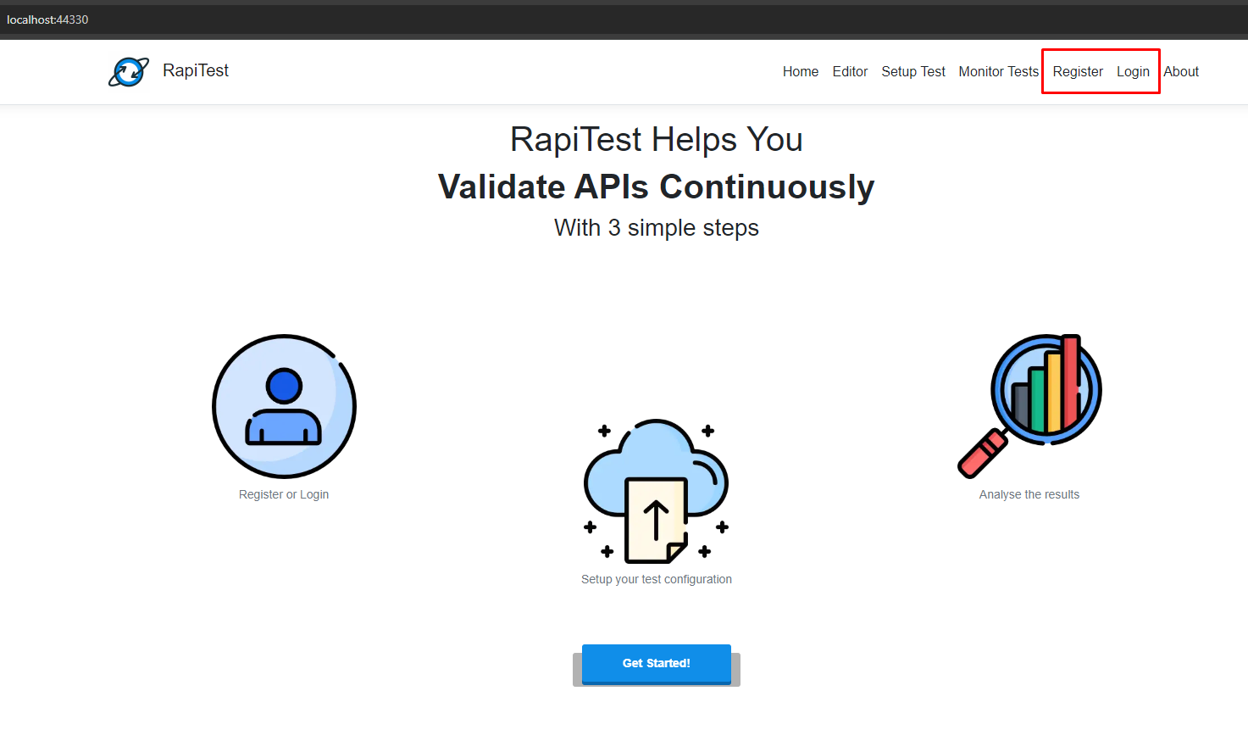
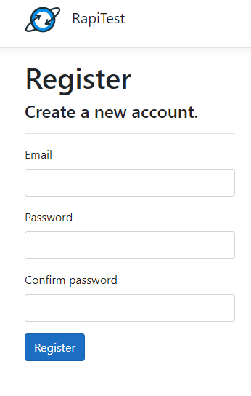
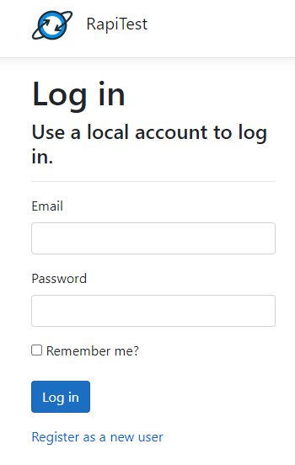

After register, the view will be similar to the below:

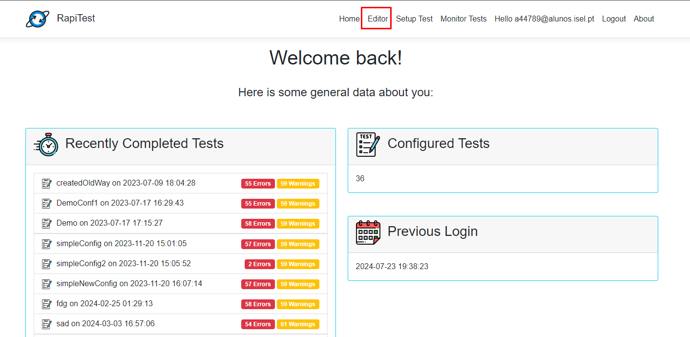

Clicking “Editor” in the navbar, the app will navigate to the Editor:

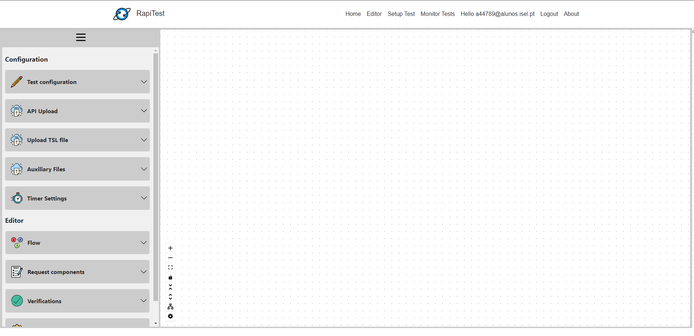

Building a simple workflow

In this section we will follow the steps to finalize a simple test configuration with 1 Workflow.

1 – Pick a name

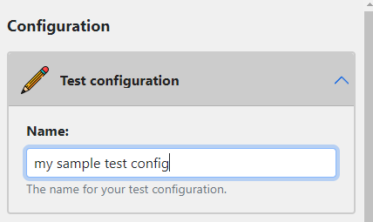

2 – Upload the API Specification

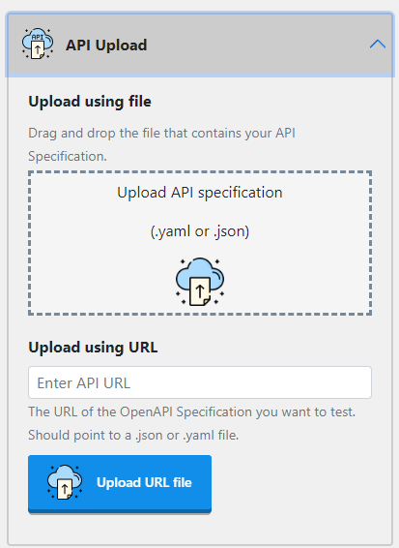

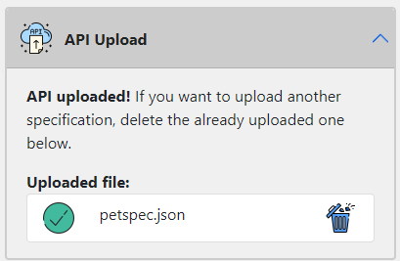

Note: If you are following this while testing in the application, check the section regarding helper files at the end of this document. You will find (in the repository) helper files including the specification for PetStore API. You can use that file in your tests.

3 – Insert the Nodes

Pressing in one of the Sidebar buttons will add the corresponding node to the editor, in a semi-random position. For this simple workflow, we will add 3 nodes:

- Workflow (Flow)
- Test (Flow)
- Status Code (Verifications)

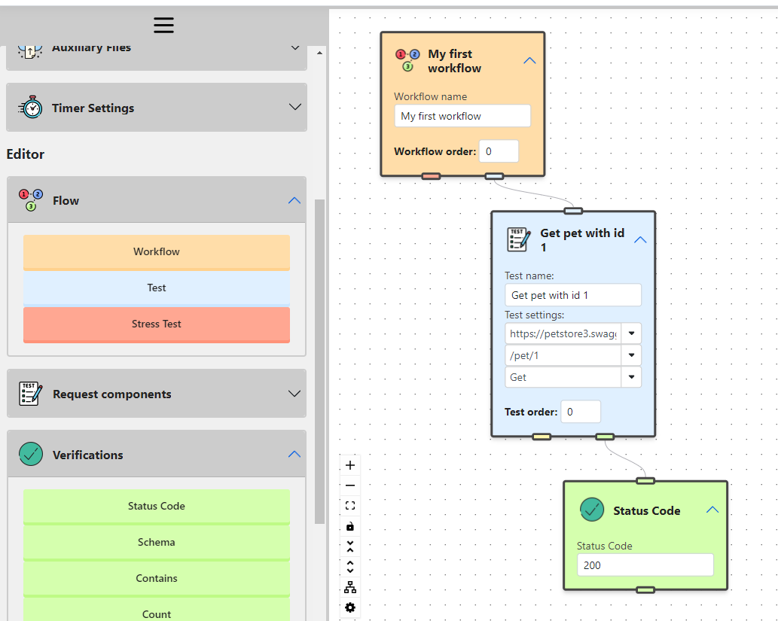

Connect and fill the information in the nodes according to the image above.
This simple Workflow is trying to fetch a Pet with the id of 1 from the PetStore API, and then performs a simple validation by checking if the Status Code of the response is 200.

4 – Finish setup
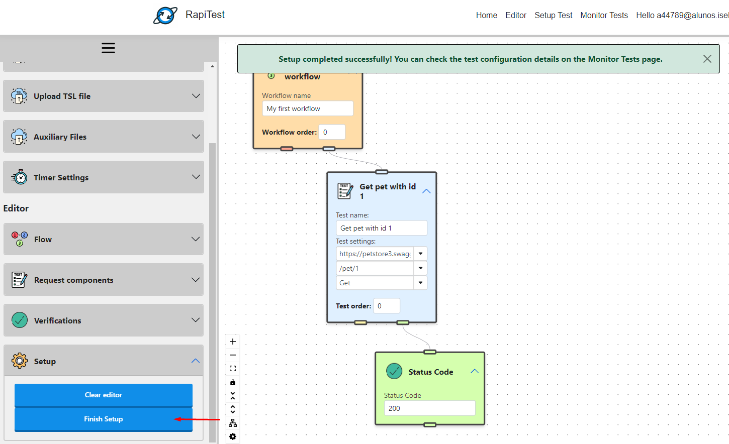

Just press the Finish Setup button. If all goes well, a popup indicating success will show. The TSL file will also be automatically downloaded.

5 – Check the result in the “Monitor tests” page

In the Monitor Tests page we can see and manage the created test configuration. Select the respective entry. To analyze the latest execution, click the “Analyze” button.

Note: Since PetStore is a public API, it’s possible that pet number 1 (which we try to fetch in our test) is not created (it could have been deleted by someone else). Therefore, it’s possible that the validation fails and the app indicates errors in the configuration.

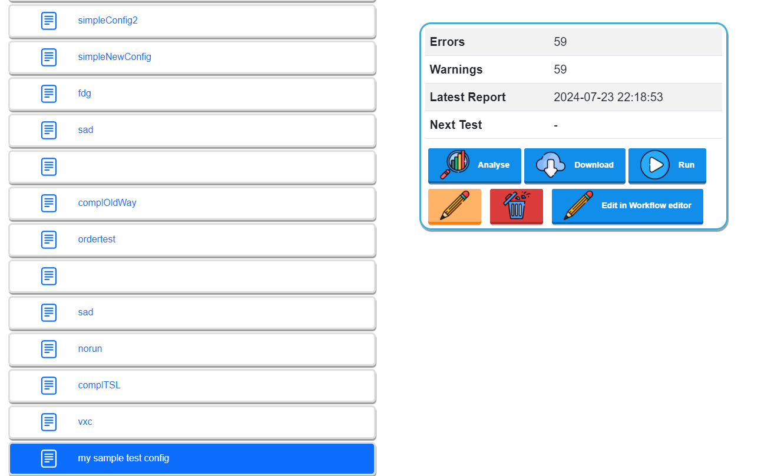

6 – That’s it!

Complete TSL

The other example in this Quick Guide is a “complete” test configuration, in the sense that it uses all the TSL capabilities. We will make use of a pre-made TSL file to populate the editor automatically.

1 – Go to (blank) Editor page again

2 – Choose a name and upload the specification as in the previous example

3 – Upload the TSL file

Nota: once again you can check the helper files section for a pre-made TSL file.

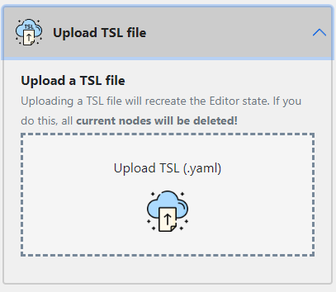

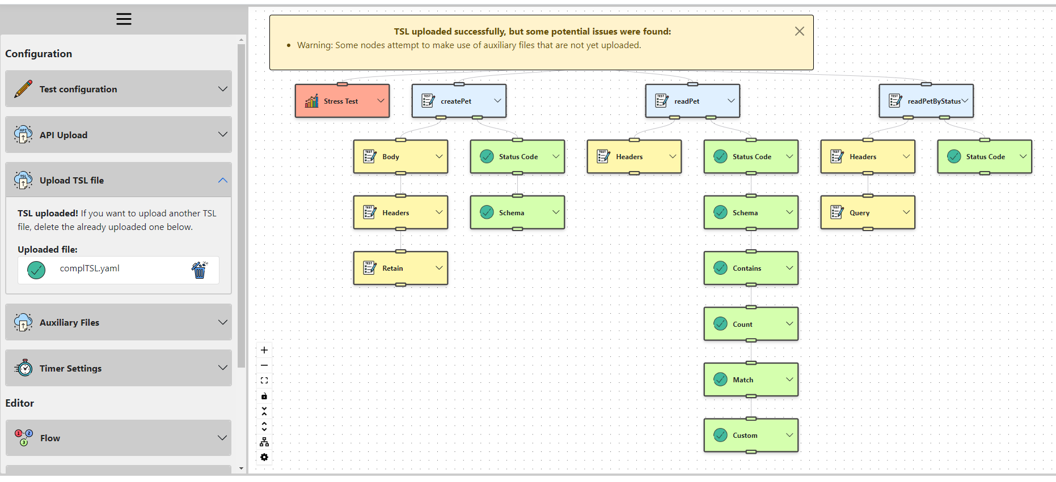

After the file is uploaded, the editor is automatically populated with the file’s contents, and the nodes are also immediately organized with the layout algorithm.

In this example we can see a popup warning – this is because the Editor detects that some nodes attempt to use auxiliary files that aren’t uploaded yet (for example, the “Custom” verification node tries to use a .dll file).

4 – Upload auxiliary files

Uma vez que o TSL que estamos a usar faz referência a ficheiros auxiliares (dicionário e .dll), temos de fazer o upload dos mesmos.

Since the TSL file we used references auxiliary files, we must upload them.

Note: once again, helper files are available in the repository.

After the upload is done, ensure the nodes are now using the files. For this example, in the “Custom” node, select the .dll you just uploaded.
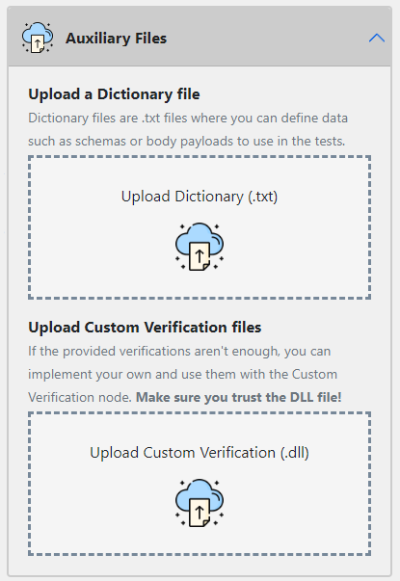
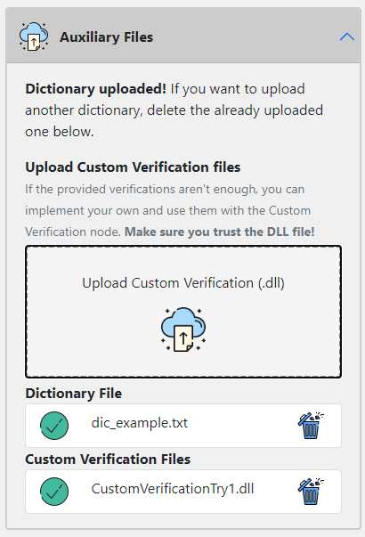

5 – Finish setup (as in the previous example)

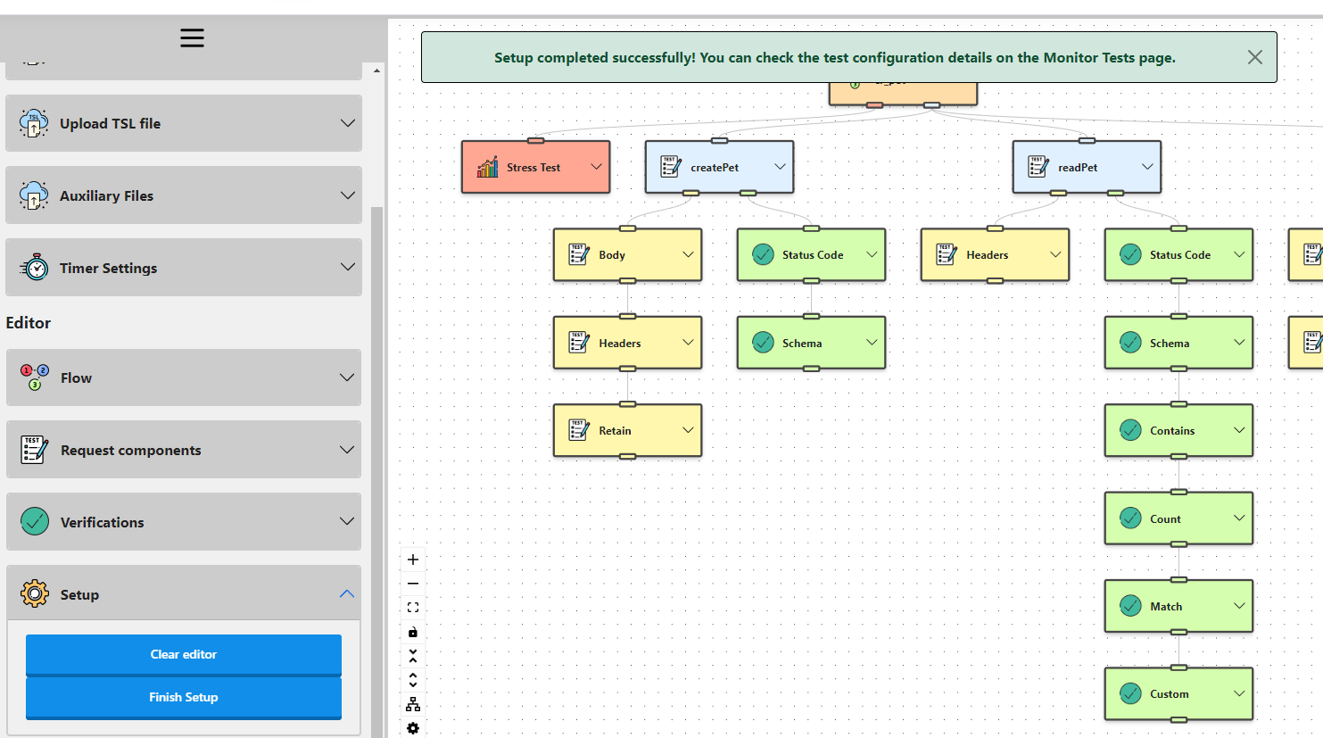

6 - That’s it!

Helper Files

During this document we make use of several files: API specification, TSL, .dll and dictionary files. For convenience, we provide examples of each of these files in the repository. They should be under the same folder as this document. Their names should be self-explanatory. We recommend that you use these files for your testing, if you wish to do so.

