**COMP417, Winter 2017**

**Quiz 1**

**First Name:**

**Last Name:**

**Student #:**

1. You are given the two following frames, C and D, both of which are static. Write down the 3x3 rotation matrix that transforms vectors from frame D to frame C:



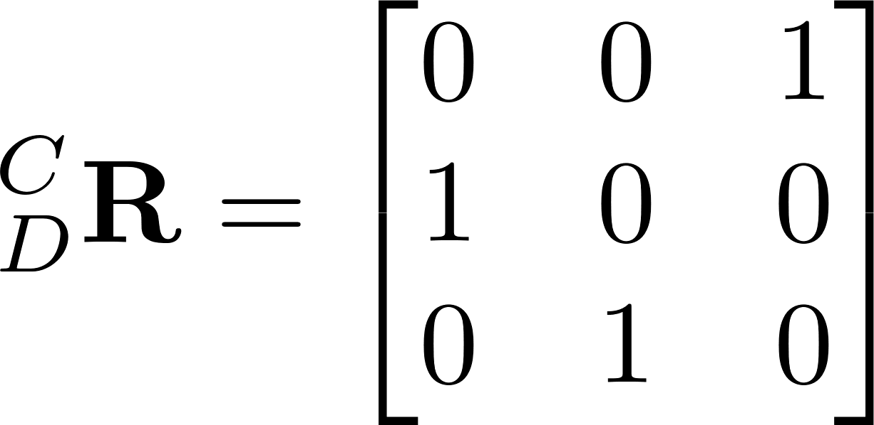

2) You have a vector expressed in the body frame, a rotation matrix , and the

origin of the body frame B with respect to the world frame W, expressed in world

coordinates. How can you express the vector in the world frame W?



3) You have a point expressed in the body frame, a rotation matrix , and the

origin of the body frame B with respect to the world frame W, expressed in world

coordinates. How can you express the point in the world frame W?



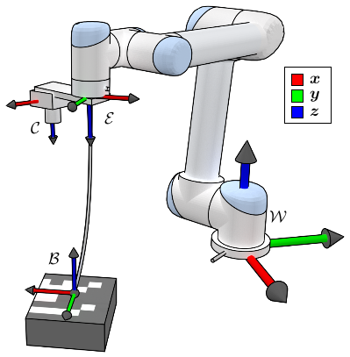

4) Suppose you are given the 4x4 homogeneous

transformation matrices , , .

Write the transformation from the box frame B to the world

frame W in terms of the above transformations.

5) You are trying to tune a PID controller. You observe that your robot exhibits significant oscillations around the desired target state/setpoint. Circle the most likely answer:

(a) The P gain is too high

(b) The P gain is too low

(c) The I gain is too high

(d) The I gain is too low

(e) The D gain is too high

(f) The D gain is too low

Either of these two answers was very likely.