**Quiz 4**

**COMP417, Winter 2017**

**First Name:**

**Last Name:**

**Student #:**

Q1. Which of the paths depicted in the figure below belong to the same homotopy class? Note that the three filled shapes are obstacles.

A

B

C

D

Paths B and C are in the same class.

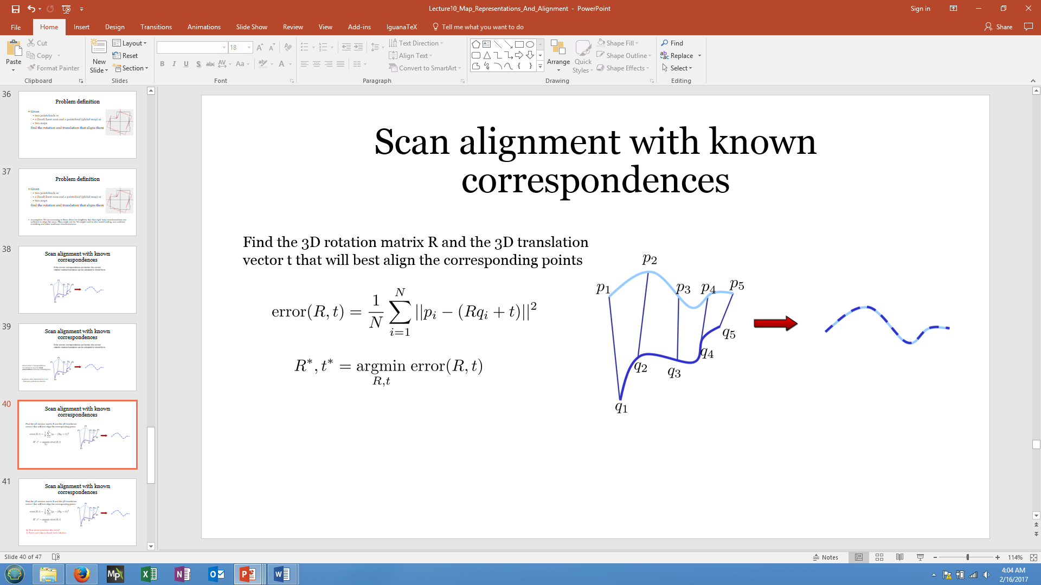Q2. Suppose you are given the following two scans that need to be aligned. Suppose, in addition, that the correspondences between the points in the scan have been given. Formulate an objective error function in terms of the relative rotation and translation between the two scans, such that after optimization the scans will be optimally aligned. Do not provide a solution to the optimization problem, just an objective function.

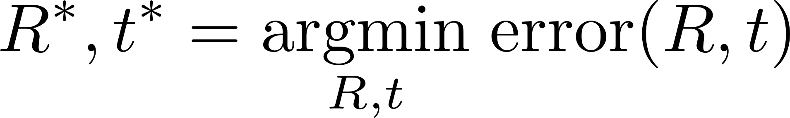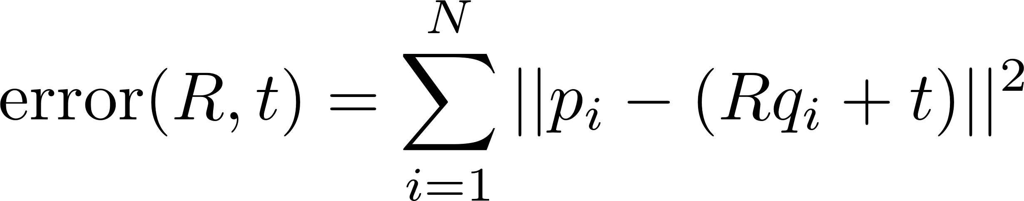

Q3. The Generalized Voronoi Graph can only be defined in 2D. True or False?

FALSE. The GVG edges defined by points that are equidistant to 2 objects, and GVG nodes are defined by points that are equidistant to at least 3 objects, in terms of shortest distance. Nothing in this construction is specific to 2D.

Q4. Prove Bayes’ conditional rule

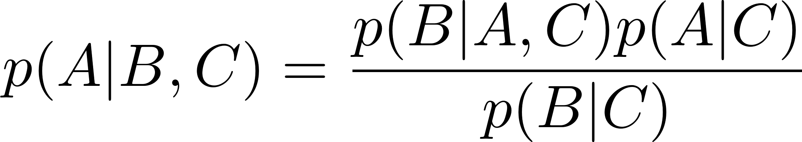

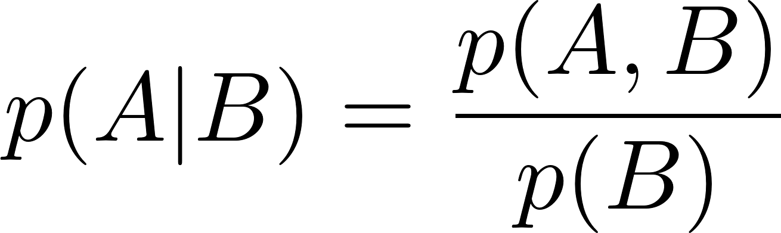 using the definition of conditional probability

Combine the following facts



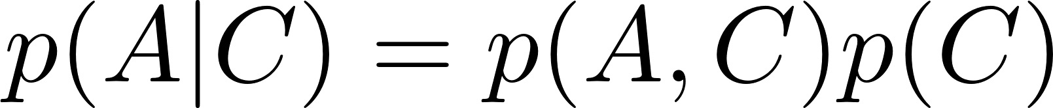

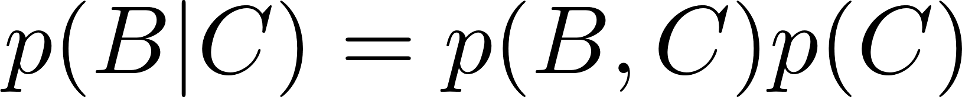

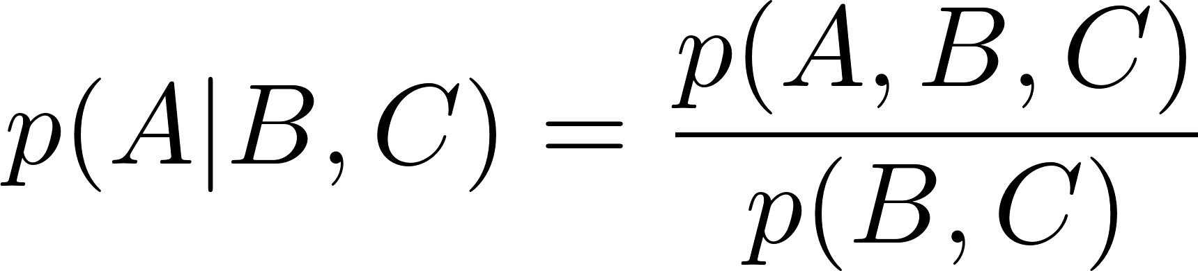

Q5. In the derivation of the occupancy grid mapping algorithm, the distribution

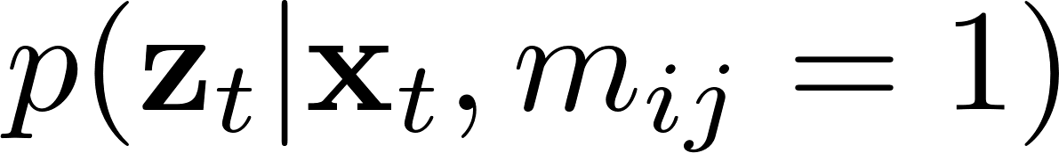

was easier to compute than the distribution

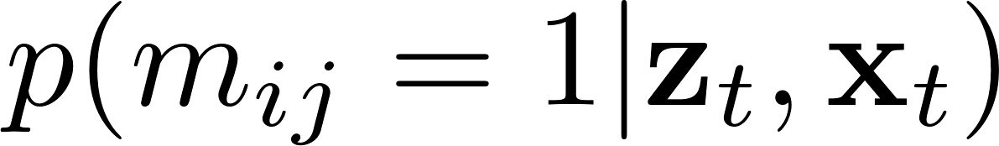

True or False?

FALSE. See slides on occupancy grid mapping.