BinarySearch:
Array must be sorted.
Time complexity: O(logN)
Space complexity: O(1)

Binary search composed of 3 main sections:
- Pre-processing (Sort if collection is unsorted)
- Binary Search (Using loop recursion to divide search space in half after each comparison)
- Post-processing (Determine viable candidates in the remaining space)

Template 1: (Basic one)
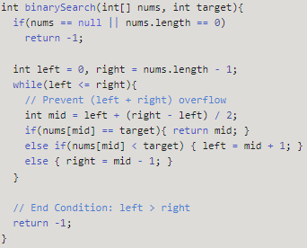

Template 2:
Used when need to accessing the current index and its immediate right neighbor's index.
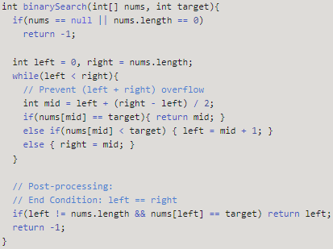

Post-processing required. Loop/Recursion ends when you have 1 element left. Need to assess if the remaining element meets the condition.

Template 3:
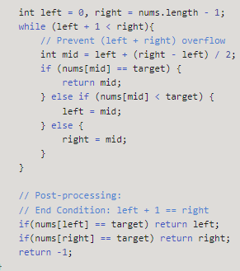
Template #3 is another unique form of Binary Search. It is used to search for an element or condition which requires accessing the current index and its immediate left and right neighbor's index in the array

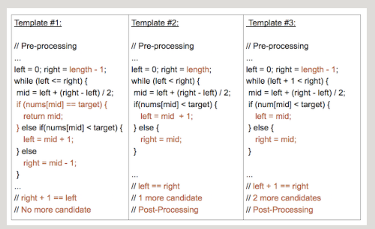

Template 1:
Search condition can be determined without comparing to the elements neighbors.
Tempate2:
Search condition needs to access the element's immediate right neighbor.
Use element's right neighbor to determine if condition is met and decide to go left or right.
Template 3:
Search condition needs to access element's immediate left and right neighbors.

