BFS
- Can traverse all vertices of a 'graph'
- Can traverse all paths between 2 vertices.
The most advantageous use case of using BFS is to efficiently find the shortest path between two vertices in a graph where all edges have equal and positive weights.

BFS finds shortest path without traversing all paths.

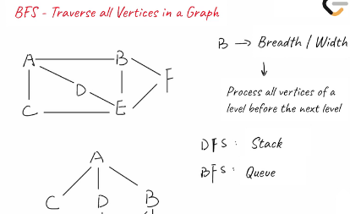

(Search layer by layer)
Layer 1: A
Layer2: C, D; B
Layer3: E, F
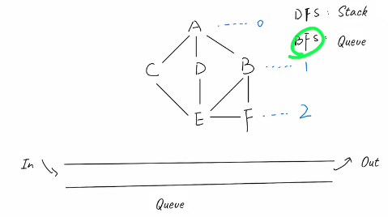

Take A
Put in Q
A marked as visited
BDC put in the Q
C get from the Q
Add A and E and so on.....

To traverse all edges:
Time complexity:
O(V + E), Here V represents the number of vertices.
E represents the number of edges.

Space complexity:
O(V): We check if vertex has been visited before adding to the Q.
The Q will use at most O(V) space. Keeping track of visited vertices will also require O(V) space.

