DFS: Traverse all Path
Depth-First Search
Used for example:
- Traverse all vertices in a 'graph'
- Traverse all paths between two vertices in a 'graph'

Depth: search a path until we can not go any further.

Time complexity:
O(V + E)
V: represents the number of vertices.
E: the number of edges.
(Need to check every vertex and traverse through every edge in the graph)

Space complexity:
O(V)
Created stack or the recursive call stack store up to V vertices.

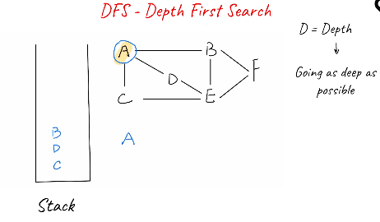

https://leetcode.com/explore/learn/card/graph/619/depth-first-search-in-graph/3848/
DFS: Traversing all paths between 2 vertices.
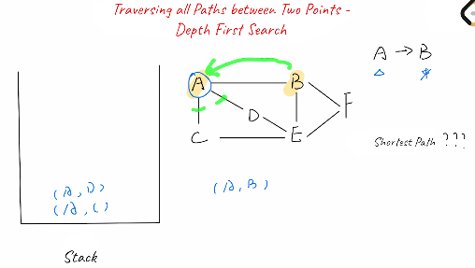

Find the shortest path between vertices A and B.

Example of problem to use DFS:
Finding whether a path exists from the source vertex to the target vertex on an undirect graph.

n is the number of edges

- Need to create an adjacentList
- Create a stack
- Create array to see if edges have been visited.
- Add edges to the stack from adjacentList

Directed acyclic graph
acyclic graph. The fact that the graph is guaranteed to be acyclic is a small but important distinction that allows us to not track which nodes have been visited.
, we do not need to mark which nodes have been visited since we are going back.
Instead we are looking if there are any other path from node 2. If other path, go to node 1
(Find all path from 0 to 3)
