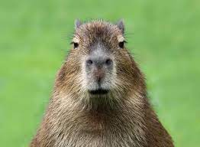

Example Document

**Simple docname**

List Example:

* Engine
  + Foo **ooF**
  + Bar **raB**
  + Baz **zaB**
* Gearbox
* Chassis

Table Example:

|  |  |  |  |  |
| --- | --- | --- | --- | --- |
| **Name** | **Surname** | **Position** | **Cars** | **Reserved** |
| Paul | Viberg | Engineer |  |  |
| Alex | Houser | CEO & Founder | 1. Mercedes-Benz C-Class S205 2. Lexus LX 570 | m1000x1000.jpg |

Another text block:

Passport NE0323 4456673

(enter text)

Repeated content:

Hello world!

|  |  |  |  |  |
| --- | --- | --- | --- | --- |
| Paul | Viberg | Engineer |  |  |
| Alex | Houser | CEO & Founder | 1. Mercedes-Benz C-Class S205 2. Lexus LX 570 |  |

Hi, word!!

Hello world!

|  |  |  |  |  |
| --- | --- | --- | --- | --- |
| Nathan | Anceaux | Music artist | 1. Peugeot 508 |  |
| Louis | Houplain | Music artist | 1. Range Rover Velar 2. Lada Vesta SW Sport |  |

Hi, word!!

This method adds a new paragraph for each text element. Works the same way as when you press enter

line 1

line 2

line 3

This method adds a newline. Works the same way as when you press SHIFT+enter

line 1  
  
line 2  
  
 line 3

Image replace test:



[My new link](https://www.youtube.com/)