



#### Degree in Informatics Engineering

#### Project IV Curricular Unit

**GESImoveis**

**Alexandre Santos, n.º 24585**

**António Gomes, n.º 26780**

#### 2023 - 2024

#### Supervised by: Prof. Doctor. Ricardo Freitas | rifreitas@estg.ipvc.pt

#### Supervised by: Eng. Miguel Guerra | geral@ftkode.com

Index

Illustration List 3

Introduction and objectives 4

2. Technologies, tools, libraries, methodology and project management 5

2.1 Programming Environment 5

2.2 Methodology and Project Management 6

2.3 Technologies and Architecture 6

2.3.1 HTML 6

2.3.2 Javascript 7

2.3.3 CSS 8

2.3.4 Bootstrap 9

2.3.5 Visual Studio Code 10

2.3.6 GitHub 11

2.3.7 Laravel 11

2.3.8 MySQL 12

3. Use Cases, ER Diagram and database schema 13

3.1 Use Case Diagram 13

3.2 ER Diagram 15

3.3. Database Schema 16

4. Developed features 18

5. Practical Case/Project Developed 18

6. Difficulties 20

7. Conlusions 21

8. Web References 22

## Illustration List

Figure 1 - Illustration of the MEAN Full Stack Developer Framework. 5

Figure 2 - Illustration of the project Architecture. 7

Figure 3 - Illustration of the users analysis. 15

Figure 4 - Illustration of the use case diagram. 16

Figure 5 - Illustration of the class diagram. 17

Figure 6 - Illustration of the database diagram. 18

Figure 7 - Illustration of the Web Services Diagram. 19

Figure 8 - Illustration of the web page of the functionality X. 20

# Introduction and objectives

This project was developed as part of Project IV in the third year of the Informatics Engineering degree (Computer Engineering) at the School of Technology and Management of the Polytechnic Institute of Viana do Castelo.

The primary goal was to create a web platform using the Laravel PHP framework. The scope of the project focused on developing this platform for IPVC and was proposed by Professor Ricardo Freitas in collaboration with FTKode, lda.

Our team designed a comprehensive real estate management application featuring an authentication system for user login. Once logged in, users can oversee buildings, contracts, tenants, payments, and their own profile information. The application allows users to perform operations such as creating, listing, editing, removing, and emailing documents.

To facilitate development, our methodology involved extensive research across various platforms to master new technologies. We explored similar projects on GitHub, followed tutorials and step-by-step guides on YouTube, and utilized GitHub Copilot, a cloud-based AI tool from GitHub and OpenAI, to assist in project development.

This report includes an introduction to the project, an explanation of the project's architecture, and details about the development process since the beginning of the semester. Additionally, it covers the main technologies, tools, and libraries employed.

# 2. Technologies, tools, libraries, methodology and project management

## 2.1 Programming Environment

The development environment for this project comprised a set of technologies, including Laravel—a PHP framework—MySQL for database management, and HTML, CSS, and JavaScript for frontend development.

This environment facilitated the creation of each component of the platform, encompassing both client-side and server-side development processes.

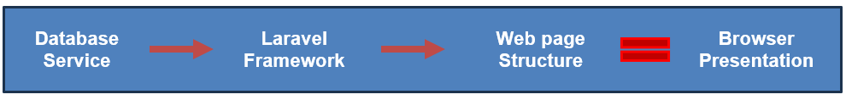

Figure 1 - Illustration of the development environment

**Used Technologies:**

* **MySQL:** Database used to store all the information used by the platform.
* **Laravel:** PHP framework used to develop the platform.
* **Rest API:** API developed by the company to make all the requests available.

## 2.2 Methodology and Project Management

In this project, we utilized Skype for communication with the supervising engineer, setting deadlines, and tracking tasks. Weekly meetings with the engineer ensured consistency in the development of functionalities.

For internal communication within the team, Discord was employed. This tool facilitated collaborative calls whenever we made project changes together. Additionally, we met weekly in the school library to work on the project.

To collaborate effectively, we relied on GitHub for sharing and managing our codebase.

## 2.3 Technologies and Architecture

### 2.3.1 HTML



HTML is a versatile computer language designed for creating websites that can be accessed by anyone connected to the Internet. It is known for its accessibility, with most people able to grasp the basics in a single session, yet powerful enough to enable the creation of complex web content. HTML continually evolves under the guidance of the W3C (World Wide Web Consortium), which oversees its design and maintenance to meet the evolving demands of the Internet audience.

Here are some important web links related to HTML:

* **W3 schools HTML:** <https://www.w3schools.com/html/>
* **Mdn web docs HTML:** <https://developer.mozilla.org/en-US/docs/Web/HTML>

This revision aims to provide a clearer and more concise description of HTML's capabilities and its role in web development, while also presenting the web links in a readable format.

### 2.3.2 Javascript



JavaScript is a versatile scripting and programming language essential for implementing dynamic features on web pages. Whenever a web page goes beyond displaying static information and includes elements like real-time content updates, interactive maps, animated graphics, or multimedia displays, JavaScript is often the underlying technology driving these functionalities. It plays a pivotal role as the third layer in the standard web technologies "layer cake," complementing HTML and CSS.

For more information about JavaScript, you can visit these important web links:

* **Javascript:** <https://www.javascript.com/>
* **Mdn web docs javascript:** <https://developer.mozilla.org/en-US/docs/Web/JavaScript>

This revised description aims to clearly convey JavaScript's capabilities in web development while providing accessible links for further exploration.

### 2.3.3 CSS

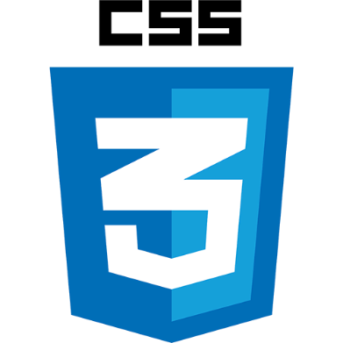

CSS, which stands for Cascading Style Sheets, focuses on "Style" in web development. While HTML structures a web document by defining elements like headings, paragraphs, and embedding media, CSS takes over to define the document's appearance. It dictates page layouts, colors, fonts, and other stylistic elements.

In analogy, HTML acts as the foundation of a house, providing structure that every web document requires. CSS, on the other hand, represents the aesthetic choices that distinguish different styles—just as a Victorian mansion differs significantly from a mid-century modern home.

This distinction highlights the complementary roles of HTML and CSS in web design and development, emphasizing CSS's role in enhancing the visual presentation and user experience of web pages.

Some important web links:

* **Hostinger CSS:** <https://www.hostinger.com.br/tutoriais/o-que-e-css-guia-basico-de-css>
* **W3 Schools CSS:** <https://www.w3schools.com/css/>

### 2.3.4 Bootstrap

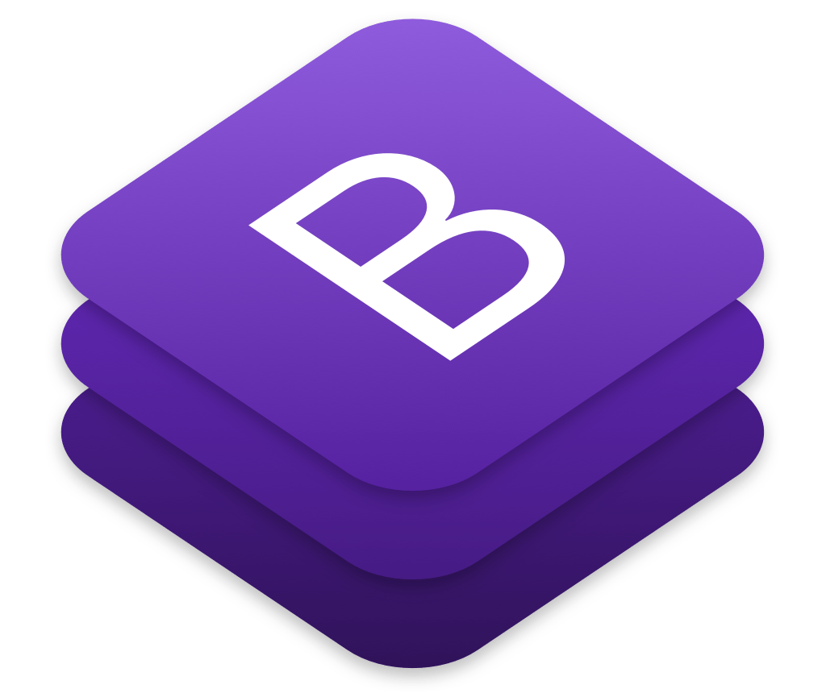

Bootstrap is a versatile, free, and open-source CSS framework designed for responsive, mobile-first front-end web development. It offers a collection of CSS- and optional JavaScript-based design templates tailored for typography, forms, buttons, navigation, and various interface components.

Unlike frameworks geared towards web applications, Bootstrap simplifies the creation of informative web pages. Its integration into a project aims to apply Bootstrap's predefined choices of colors, sizes, fonts, and layouts, which developers may find aesthetically pleasing. Once incorporated, Bootstrap standardizes the style definitions for all HTML elements, ensuring a consistent appearance across different web browsers. Moreover, developers can leverage Bootstrap's CSS classes to further customize their content's visual presentation.

For instance, Bootstrap includes features such as light and dark-themed tables, distinctive page headings, prominent pull quotes, and highlighted text. These capabilities empower developers to enhance the visual appeal and functionality of their web projects efficiently.

### 2.3.5 Visual Studio Code



Visual Studio Code (VS Code) is a popular open-source code editor developed by Microsoft. It is widely used by developers for various programming tasks, including web development, mobile app development, and more.

Some key features of Visual Studio Code:

* Cross-Platform: Visual Studio Code is available for Windows, macOS, and Linux, making it accessible to a wide range of developers regardless of their operating system.
* Extensible: VS Code has a rich ecosystem of extensions that enhance its functionality. These extensions cover a wide range of functionalities such as language support, debugging, source control integration, and more.
* Integrated Terminal: It comes with an integrated terminal that allows developers to run commands, scripts, and terminal-based tools directly within the editor, eliminating the need to switch between different applications.
* Debugging Support: VS Code offers built-in support for debugging various programming languages and frameworks. Developers can set breakpoints, inspect variables, and step through code to diagnose and fix issues efficiently.

### 2.3.6 GitHub



GitHub is a web-based platform that serves as a hub for software development collaboration, version control, and project management. It utilizes Git, a distributed version control system, to track changes in codebases, manage branches, and facilitate collaboration among developers

### 2.3.7 Laravel

Laravel is a powerful PHP framework known for its elegant syntax and developer-friendly features. It facilitates rapid web application development with a clean and expressive syntax that prioritizes simplicity and readability. Laravel follows the MVC (Model-View-Controller) architectural pattern, which separates application logic from presentation and data layers, enhancing code organization and maintainability.

Some important web links:

* **Laravel:** <https://laravel.com/>
* **Github Laravel:** <https://github.com/laravel/laravel>

Laravel's ecosystem includes robust community support, extensive documentation, and a thriving package ecosystem (via Composer), making it a preferred choice for developing scalable and maintainable web applications.

### 2.3.8 MySQL

MySQL is an open-source relational database management system (RDBMS) known for its speed, reliability, and ease of use. It's widely used in web development for storing and managing structured data, ranging from small-scale applications to large-scale enterprise systems. MySQL supports various platforms and operating systems, providing flexibility and scalability to meet diverse application requirements.

Key features of MySQL include:

* Relational Database: Organizes data into tables with predefined relationships, enabling efficient data retrieval and manipulation.
* SQL (Structured Query Language): Standardized language for querying and managing relational databases, offering powerful capabilities for data manipulation, transactions, and schema management.
* Indexes and Performance: Supports indexing mechanisms to optimize query performance, ensuring fast data access even with large datasets.
* Replication and High Availability: Built-in support for replication to create redundant copies of data across multiple servers, enhancing fault tolerance and scalability.
* Security: Implements robust security features such as authentication, encryption, and access controls to protect sensitive data.
* Community and Support: Benefits from an active community of developers and extensive documentation, ensuring reliable support and resources for developers.

# 3. Use Cases, ER Diagram and database schema

## 3.1 Use Case Diagram

This use case diagram depicts the interactions between various actors and the Laravel real estate management system. The actors in the system include:

* Tenants: Individuals who rent properties through the system.
* Admin: The person responsible for managing the system, including adding and editing properties, managing tenants, and creating invoices.
* Owner: The person who owns the properties being rented out.

The use case diagram outlines the following functionalities:

* CRUD (Create, Read, Update, Delete) Tenants: The admin can manage tenants by adding new tenants, viewing existing tenant information, updating tenant details, and deleting tenant records.
* CRUD Users: The system likely allows for managing user accounts, potentially including different user roles with varying access levels (not explicitly shown in the diagram).
* CRUD Properties: The admin can manage properties by adding new properties, viewing existing property information, updating property details, and deleting property records.
* Login/Logout: This use case represents the user login and logout functionality, allowing authorized users to access the system.
* Admin Edit Own Profile: The admin can update their own profile information within the system.
* CRUD Payments: The system might facilitate managing rental payments, potentially including recording payments made by tenants, viewing payment history, and managing any outstanding payments (not explicitly shown in the diagram).
* CRUD Contracts: The system might support managing rental contracts, including creating new contracts, viewing existing contracts, updating contract details, and potentially terminating contracts (not explicitly shown in the diagram).
* API Integration for Invoice Creation

With the platform, it’s also possible to execute the following activities:

* Generating invoices: The admin can create invoices for tenants, possibly including rent payments, late fees, or other charges.
* Sending invoices: The system might automate sending invoices to tenants via email or other channels (depending on the API's capabilities).

This invoice creation API integration streamlines the process of generating and delivering invoices to tenants, improving efficiency and potentially reducing manual work for the admin.

In summary, this use case diagram provides a high-level overview of the functionalities offered by the Laravel real estate management system with invoice creation API integration. It highlights the interactions between different actors and the system's core functionalities for managing properties, tenants, invoices, and potentially users and contracts.

Figure 2 - Use case Diagram

## 3.2 ER Diagram

The provided ER (Entity-Relationship) diagram illustrates the data model for the GESImoveis real estate management platform. This diagram outlines the key entities involved in the system and their relationships, providing a clear understanding of how data is structured and interconnected.

The Utilizador (User) entity serves as the core component, representing individuals using the platform. Each user can manage multiple properties (Imovel), which are detailed in the Imovel entity. This entity includes information about the property, such as its type (Tipo_Imovel), owner (linked to Utilizador), and various attributes like area, address, and purchase details.

Properties incur various expenses, which are tracked in the Despesa (Expense) entity. Each expense is associated with a property and a user and categorized by the type of expense (Tipo_Despesa).

The Fotos (Photos) entity allows for the storage of images related to properties, ensuring visual representation is linked to the corresponding Imovel.

The Inquilino (Tenant) entity contains information about individuals renting properties. Each tenant can have one or more rental contracts, managed in the Contrato (Contract) entity. Contracts detail the agreement between the tenant and the property, specifying terms such as start and end dates, rental amounts, and payment schedules. The type of contract is defined by the Tipo_Contrato entity.

Payments made by tenants are recorded in the Pagamento (Payment) entity, linked to specific contracts. This ensures a clear track of financial transactions related to property rentals.

The relationships between these entities are established through foreign keys, ensuring referential integrity and structured data flow. For instance, a user can manage multiple properties, each property can have multiple expenses and photos, and each tenant can have multiple contracts with associated payments.

Overall, this ER diagram encapsulates the comprehensive data model required to efficiently manage users, properties, tenants, contracts, expenses, and payments within the GESImoveis platform. It highlights the interconnected nature of real estate management operations and provides a solid foundation for implementing the platform's functionalities.

Figure 3 - ER Diagram

## 3.3. Database Schema

The provided database schema for the GESImoveis platform outlines a comprehensive and organized structure essential for efficient real estate management. This schema captures the relationships between various entities, facilitating seamless data management and user interactions within the platform.

The Users entity is central to the schema, representing individuals using the platform, including property owners, administrators, and tenants. Each user is assigned a role that defines their access level and permissions within the system.

Properties (Imovel) are a crucial aspect of the schema, detailing all relevant information about each property, such as ownership, type, and attributes. Properties are linked to users, indicating which properties a user owns or manages. Additionally, properties can be visually represented through images stored in the Photos (Fotos) entity, providing a richer user experience.

The Tenants (Inquilino) entity contains information about individuals renting properties. Each tenant can be associated with multiple Contracts (Contrato), which outline the terms of their rental agreements, including start and end dates, payment terms, and contract types. This structured approach ensures clear and organized tenancy management.

Financial transactions are meticulously tracked through the Expenses (Despesa) and Payments (Pagamento) entities. Expenses are recorded against specific properties, detailing the costs incurred, while payments are linked to rental contracts, ensuring accurate tracking of all tenant payments. This dual-entity approach supports comprehensive financial management for property owners and managers.

Supporting entities like Property Types (Tipo_Imovel), Expense Types (Tipo_Despesa), and Contract Types (Tipo_Contrato) provide categorization and standardization within the system. These entities enable the classification of properties, expenses, and contracts, simplifying data management and reporting.

The relationships between these entities are defined through foreign keys, ensuring referential integrity and structured data flow. For example, a property can have multiple expenses and photos, and a tenant can have multiple contracts with associated payments. These relationships highlight the interconnected nature of real estate management operations.

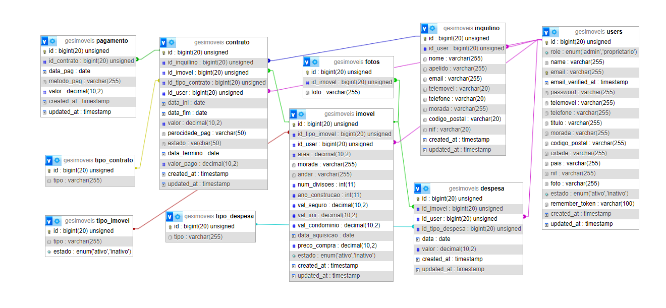

Figure 4 - Database schema

# 4. Developed features

…….explicar detalhadamente. Ao colocar imagens escrever um parágrafo sobre o que pretende descrever…

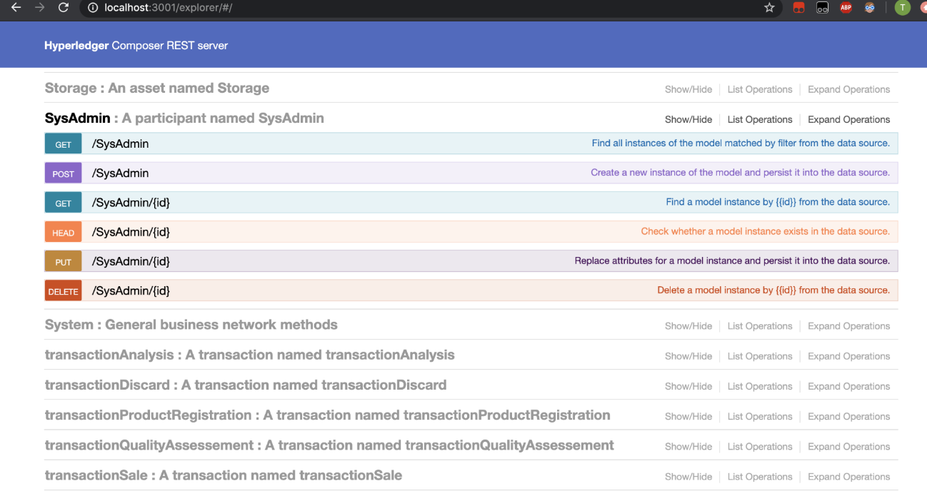

Figure 7 - Illustration of the Web Services Diagram.

…….

# 5. Practical Case/Project Developed

.. Esta secção é muito importante, pois reflecte o que realmente foi iimplementado…

…….explicar detalhadamente. Ao colocar imagens escrever um parágrafo sobre o que pretende descrever…

……. Explicar detalhadamente o que foi implementado no projeto, incluindo o maior número de screenshoots para potenciar o trabalho desenvolvido..

**…..**

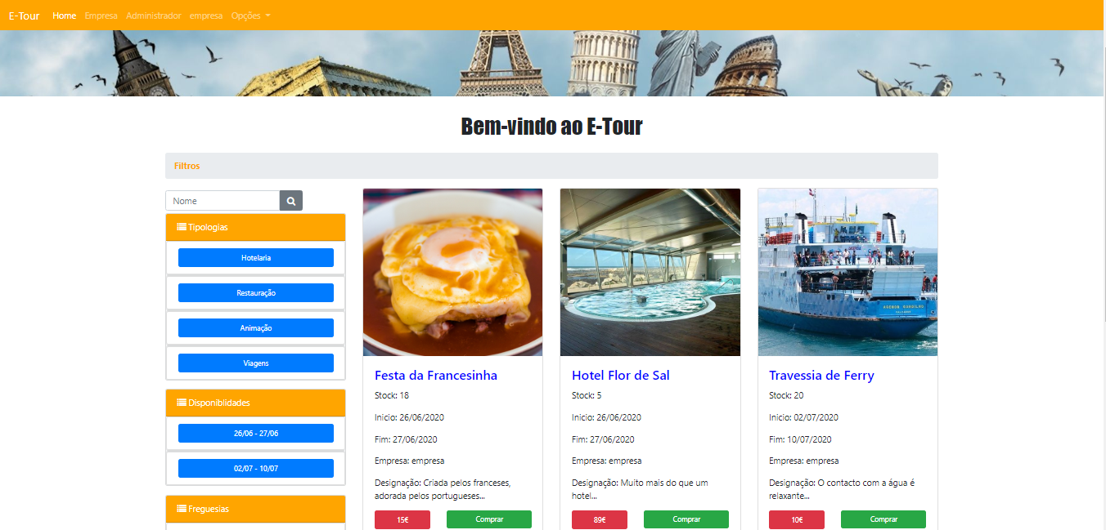

Figure 8 - Illustration of the web page of the functionality X.

**..**

**..**

# 6. Difficulties

Throughout the development of the GESImoveis platform, our team encountered several significant challenges. Initially, adapting to the new technology stack, particularly Laravel, required a period of learning and adjustment. We invested time in mastering Laravel's framework and its conventions to effectively leverage its capabilities in our project.

Another substantial challenge was implementing the layout template provided by the company. This task involved extensive customization and adjustments to harmonize functionality with visual appeal. Ensuring a seamless and user-friendly interface demanded meticulous attention to detail and iterative refinement.

Integrating with the GESFaturacao API posed additional complexities. Achieving reliable and secure data exchange necessitated thorough development and rigorous testing protocols. Overcoming these challenges required robust problem-solving skills and close collaboration with stakeholders.

Furthermore, incorporating the database into our Laravel project was a meticulous process. We meticulously managed data migration and ensured data integrity throughout the development lifecycle. This involved comprehensive testing and validation procedures to guarantee seamless operation.

Despite the challenges encountered, these experiences proved invaluable to our team's technical proficiency and professional growth. They equipped us with a deeper understanding of Laravel development, API integration complexities, and database management practices, ultimately enhancing our capabilities for future projects.

# 7. Conlusions

The development of the GESImoveis platform was instrumental in advancing our proficiency with the Laravel framework. By seamlessly integrating property management functionalities with GESFaturacao, we crafted an efficient solution tailored for property owners and managers. This project not only enhanced our technical capabilities but also provided invaluable experience in developing practical, real-world applications.

The seamless integration with GESFaturacao underscored the strategic benefits of API utilization in enriching software functionality and improving user experience. This experience deepened our understanding of API integration complexities and reinforced the importance of robust software architecture.

In conclusion, the GESImoveis project has equipped us with practical skills and insights crucial for our future careers in software engineering. It has prepared us to tackle diverse professional challenges with confidence and competence, setting a strong foundation for continued growth and innovation in the field.

# 8. Web References

* Laravel Documentation: <https://laravel.com/docs/11.x/readme>
* php documentation: <https://www.php.net/docs.php>
* Rentila Software: <https://www.rentila.pt/>
* Laracasts: <https://laracasts.com/>
* ChatGPT: <https://chatgpt.com/>
* StackOverflow: <https://stackoverflow.com/>
* Github Laravel: <https://github.com/laravel/laravel>