

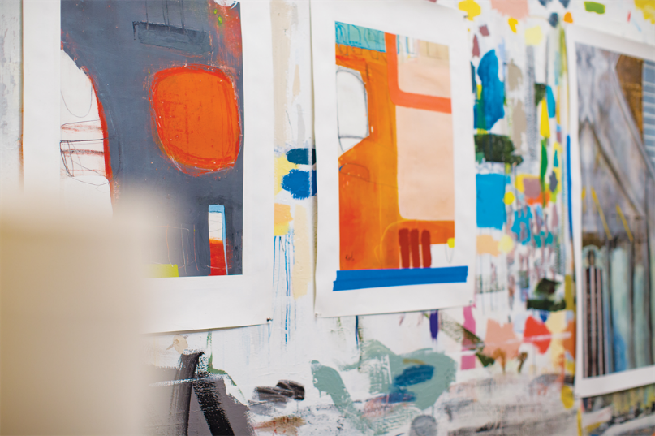

I love the coffee drinks here, but my favorite part is the local art they sell. There are many kinds of paintings and watercolors they showcase each week. I love checking out the new prints that they have, buying cards for friends, and getting a slice of pie while I work. Also did I mention that the wi-fi is excellent?

September 3, 2018