

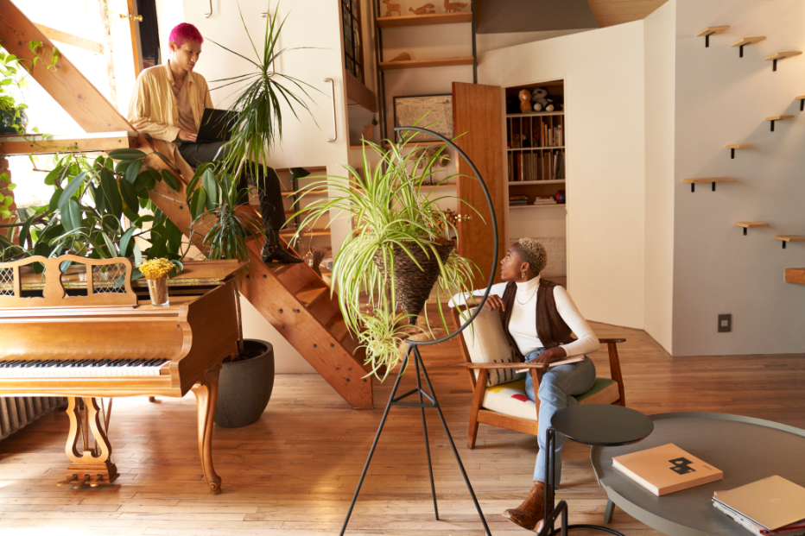

Review: My favorite part about going to Fourth Coffee is the atmosphere. It is both spacious and calming with warm light and plants. It’s a great place to go get a cup of coffee while working on your next business idea or with friends at school. It’s also right next to the University hub, which makes it so easy to access for students.

Date: September 1, 2018

Location: University Lane