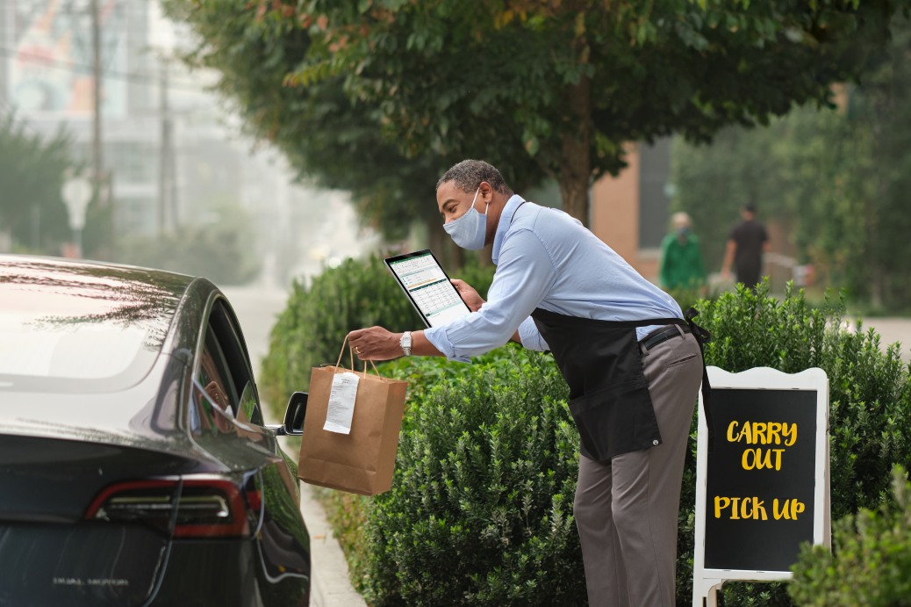

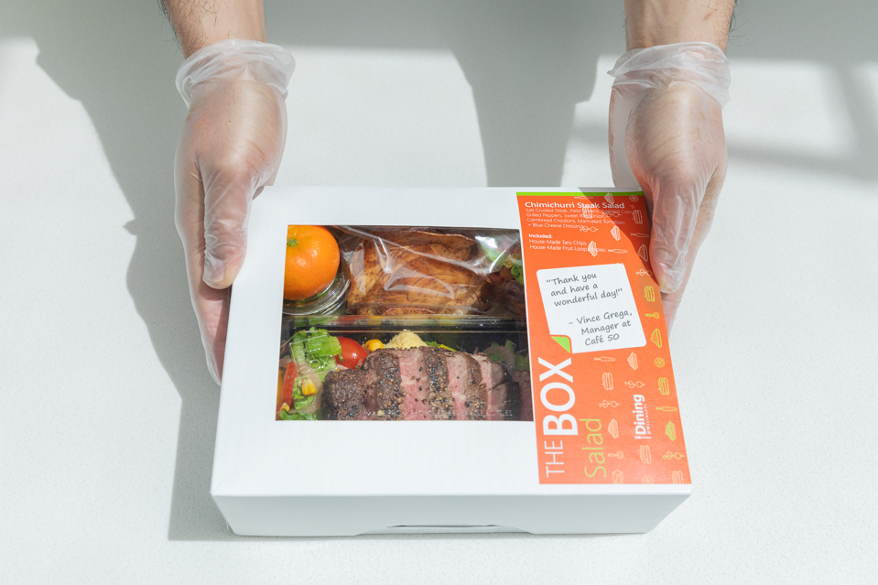

Review: Fourth Coffee has super options for food on the go. There is a big variety of boxed lunches that can be ordered in bulk as conference meals or purchased individually. My Mondays are always busy, and I like being able to get my meals to go with them. The only issue is they run out of the most popular menu items quickly, so be sure to order ahead!

Date: October 8, 2018

Location: Seattle, Washington