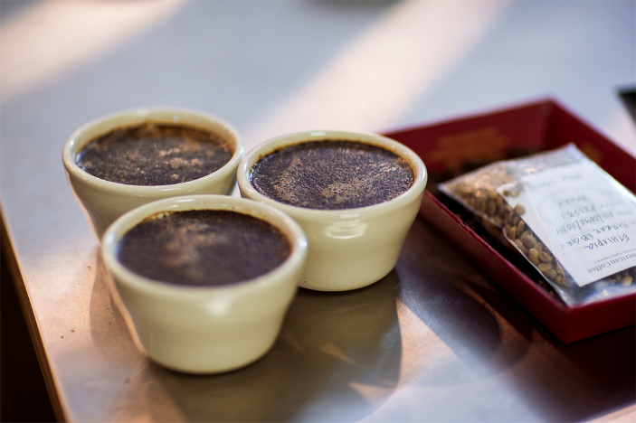



Review: The coffee tastings every Wednesday afternoon are so fun. Each month there is a new drink theme. You do need to book a spot in advance to attend. It is very worth it! I also love their local music. Fourth Coffee brings in rising artists every weekend. I like to head over there mid-afternoon on weekdays when it’s not too busy to get work done.

Date: August 13, 2018

Location: Sandy Isle