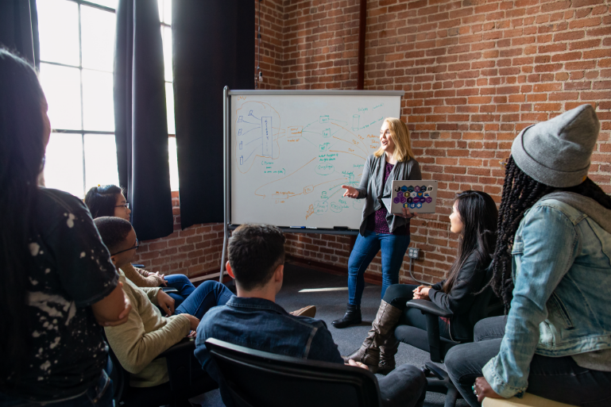



Review: The great thing about this Fourth Coffee location is that there’s an event space for talks. I went to one the other day that focused on giving students a place to present their latest research. The event room is also perfect for larger groups or clubs to meet up. Just be aware that weekends the space is used for art classes and live music.

Date: October 11, 2018

Location: University Lane