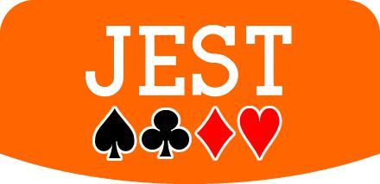

Brett J. Gilbert

3 or 4 players • 10 minutes

THE CARDS

The game contains 18 cards:

- 16 suit cards: Each of the 4 suits contains 4 cards: Ace, 2, 3 & 4. The Ace is a special card and can become a 5 in some circumstances.
- Joker: The Joker is here to cause trouble for the

players: Watch out for him!

- Reference card: Shows the hierarchy of the suits and the ways in which the card combinations score.

SETUP

Place the reference card face-up in the middle of the play area. Then shuffle the 16 suit cards and the Jester together face-down. Deal 2 cards face up beside the reference card: these cards are the trophies. Place the remaining cards face down as the draw deck.


The game is probably best with 3 players, but if playing with 4 players, deal only 1 face-up trophy.

AIM OF THE GAME

The player who collects a ‘Jest’ of cards that is worth the most points at the end of the game is the winner.

HOW TO PLAY

Each game is made up of a sequence of rounds. In each round each player receives 2 cards and makes an offer of these cards to the other players. In turn, players take 1 card from one of the offers on the table and adds this card to their face-down Jest.

At the end of the game, the players compare their Jests. Each of the trophies is awarded to the player whose Jest meets the trophy’s condition, shown in the orange band. The trophy will change the value of the Jest of the player who receives it — for better or worse!
Each round is played in three phases. 1: Deal cards,

2: Make offers, 3: Take cards.

1. Deal cards

In the first round, deal each player 2 cards face-down from the draw deck.

In later rounds, first collect up the cards not taken from the players’ offers in the previous round (each player will have 1 card remaining in front of them) and place these cards in a face-down stack. Then add to the stack a number of cards from the draw deck equal to the number of players. Shuffle this stack and deal 2 cards to each player.

2. Make offers

All players look at the two cards dealt to them. Each player first chooses 1 card to play face down. When everyone has done this, all players then reveal their other card face up beside the first card. The pair of cards in front of you — one face up, one face down — is your offer to the other players.

3. Take cards

Compare the face-up cards in each offer. The player whose face-up card has the highest face value takes the first turn. The Joker has a face value of 0. In this phase of the game, an Ace always has a face value of 1.


Breaking ties: If 2 or more players have equally valuable face-up cards in their offers, break the tie in favour of the player whose face-up card is in the strongest suit. Spades is the strongest suit, then Clubs, Diamonds and Hearts. The reference card illustrates this hierarchy.

On your turn you must take 1 card from another player’s complete offer and add it to your Jest. Keep the cards in your Jest face down, separate from any other cards in play.

- When you take a card from an offer, you can’t look at the face-down card before choosing.

- You may always check the cards in your own offer and Jest.
- You may not take a card from an incomplete offer. You must choose an offer that still contains 2 cards.
Next player

The player from whose offer you took a card goes next, unless, later in the round, that player has already had a turn and taken a card. In that case, compare the face-up cards in the offers of the remaining players. The player whose card has the highest face value goes next. Break ties as before, if necessary.

If you are the final player in a round and your own offer is the only one that still contains 2 cards, you must take a card from your offer. This is the only time that taking from your own offer is allowed!

End of the round

At the end of the round, each player will have added 1 card to their Jest, and 1 card from each player’s offer will remain on the table in front of them.

- If there are cards remaining in the draw deck, the game continues. Begin a new round.

- If there are no cards left in the draw deck, the game ends. All players must now take the 1 card remaining from their offer in the final round, add it to their Jest, and then reveal their cards.

END OF THE GAME

Before the winner is decided, compare everyone’s Jests to discover whose Jest meets the condition in the orange band of each trophy. Award both trophies simultaneously. If you win a trophy you must add it to your Jest.

The player who has the highest value Jest — after the trophies have been awarded — is the winner!
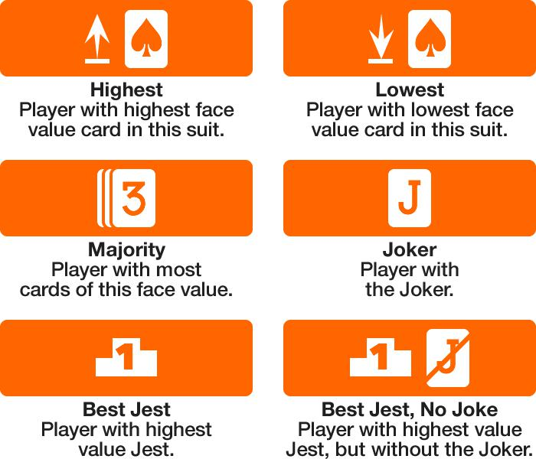

If 2 or more players tie when meeting a ‘Majority’ condition, award the trophy to the player with the card

of that face value in the strongest suit. If 2 or more players tie when meeting a ‘Best Jest’ condition, award the trophy to the player whose Jest contains the card with the highest face value (which, if also a tie, should be broken in favour of the card in the strongest suit).

JEST VALUE

The reference card summarizes how the different suits and card combinations affect the value of your Jest.

Suits

- Spades } and Clubs ] always increase the value of your Jest by their face value.

- Diamonds [ always reduce the value of your Jest by their face value.
- Hearts { are worth nothing unless you have the Joker.

Joker & Hearts

- If you have the Joker and no Hearts {, the Joker is worth a bonus 4 points.

- If you have the Joker and 1, 2 or 3 Hearts {, the Joker is worth nothing and every Heart reduces the value of your Jest by its face value.
- If you have the Joker and all 4 Hearts {, the Joker is worth nothing but every Heart increases the value of your Jest by its face value. (In a 4-player game, this score is only possible if the trophy is either the Joker or a Heart {.)

Aces

If you have an Ace which is the only card of that suit in your Jest, the card becomes a 5, with a face value of 5. Otherwise it remains an Ace, with a face value of 1.

Black pairs

If you have a Spade } and a Club ] with the same face value, the pair is worth a bonus 2 points in addition to the face values of the cards.

With thanks to the following playtesters:

Andrew Sheerin, John Turner, David Johnston, Matt Dunstan, Sam Mercer, Adam Harper, Richard Stokes.


Rules v1.0 • © 2013 Brett J. Gilbert

www.goodlittlegames.co.uk

