OPEN CLIMATE RISK
Website Documentation
Architecture, Visual Design & Page Structure
Version 1.0 | March 2026
http://localhost:8080

Table of Contents
1. Overview
2. Technical Specifications
3. Site Map & Information Architecture
4. Section 1 — Hero
5. Section 2 — Key Metrics
6. Section 3 — Features
7. Section 4 — Pipeline
8. Section 5 — Architecture
9. Section 6 — Data Sources
10. Section 7 — Hazard Modules
11. Section 8 — Roadmap
12. Section 9 — References
13. Section 10 — Call to Action & Footer
14. Design System

1. Overview
This document provides a comprehensive overview of the Open Climate Risk Platform website. It details the visual design, page architecture, section structure, and design system used throughout the site.
The website is a single-page application (SPA) built with vanilla HTML, CSS, and JavaScript. It presents the Open Climate Risk Platform — an open-source Python toolkit for physical climate risk screening using public datasets.

Purpose
- Present the project value proposition and capabilities
- Explain the 4-stage risk computation pipeline
- Document the modular Python package architecture
- Showcase multi-hazard coverage and roadmap
- Provide scientific references and credibility
- Drive users to the GitHub repository for installation

2. Technical Specifications
Property | Value
Type | Single-page static website
Framework | Vanilla HTML5 / CSS3 / JavaScript
Fonts | Inter (Google Fonts), JetBrains Mono
Responsive | Yes — breakpoints at 900px and 600px
Animations | Intersection Observer fade-in on scroll
Navigation | Fixed glassmorphic navbar with backdrop-filter blur
Total sections | 10 content sections + nav + footer
External deps | Google Fonts CDN only
File size | Single index.html (~28 KB)
Hosting | Any static server (python -m http.server)
Brand colors | #2525FF (OCR Blue), #18181B (Dark), #F4F4F5 (BG)

3. Site Map & Information Architecture
The website follows a linear narrative structure, guiding the user from value proposition through technical details to action. Each section is accessible via anchor links in the navigation bar.

# | Section | Content | Visual Style
1 | Hero | Tagline, CTA buttons, pip install, terminal mockup | Gradient BG, 2-col grid
2 | Stats Bar | 4 key metrics (135 GeoTIFFs, 5 GCMs, 9 RPs, 100% open) | White, centered numbers
3 | Features | 6 capability cards with icons | Grey BG, 3-col grid cards
4 | Pipeline | 4-step flow: Asset → Hazard → Damage → EAD | White, numbered circles
5 | Architecture | File tree + 5 module cards | Grey BG, dark terminal + cards
6 | Data Sources | Table: datasets, resolution, license | White, styled table
7 | Hazard Modules | 6 hazard cards with status badges | Grey BG, 2-col grid
8 | Roadmap | 5-item timeline (Now → 2027) | White, vertical timeline
9 | References | 5 peer-reviewed papers with DOIs | Grey BG, stacked cards
10 | CTA + Footer | Git clone instructions, GitHub link | Dark BG, terminal block

4. Section 1 — Hero
The hero is the first viewport visitors see. It uses a two-column grid layout: the left column contains the value proposition, CTA buttons, and a pip install command; the right column shows a terminal mockup with a realistic code example.
Background: Subtle gradient from white to blue-05 (#EDEDFF) with decorative concentric circle borders.
Badge: Version pill (v0.1) with "Open-source climate risk screening" label.
Terminal: Dark rounded card with macOS-style traffic lights, showing Python code with syntax highlighting.
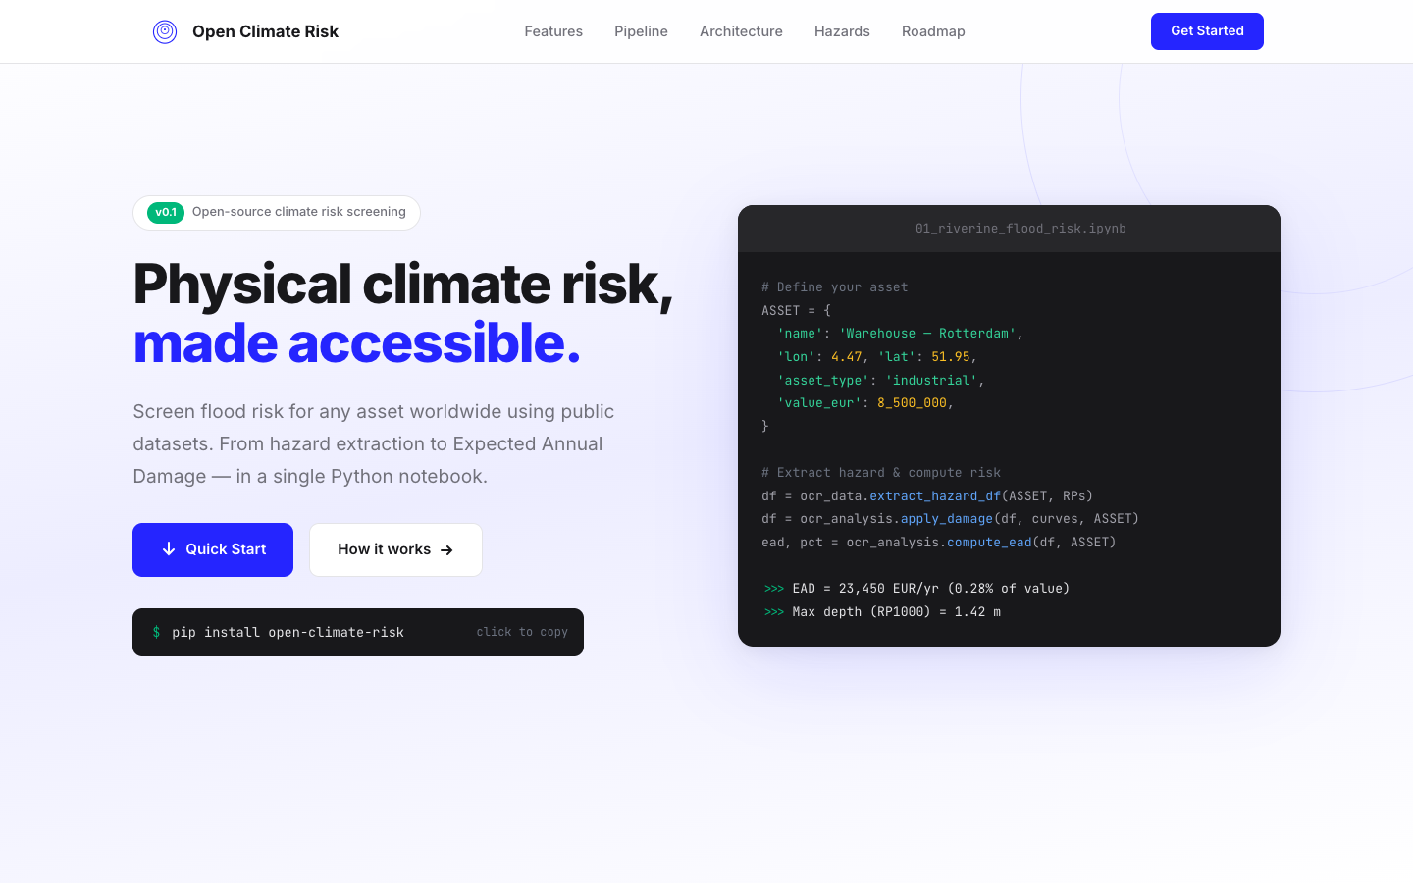
Figure 1 — Hero section at 1440px viewport width

5. Section 2 — Key Metrics
A compact stats bar immediately below the hero. Four key numbers communicate scale and credibility at a glance. Uses large blue numbers (#2525FF) with grey descriptive labels.
Layout: 4-column grid, centered text, white background with bottom border.
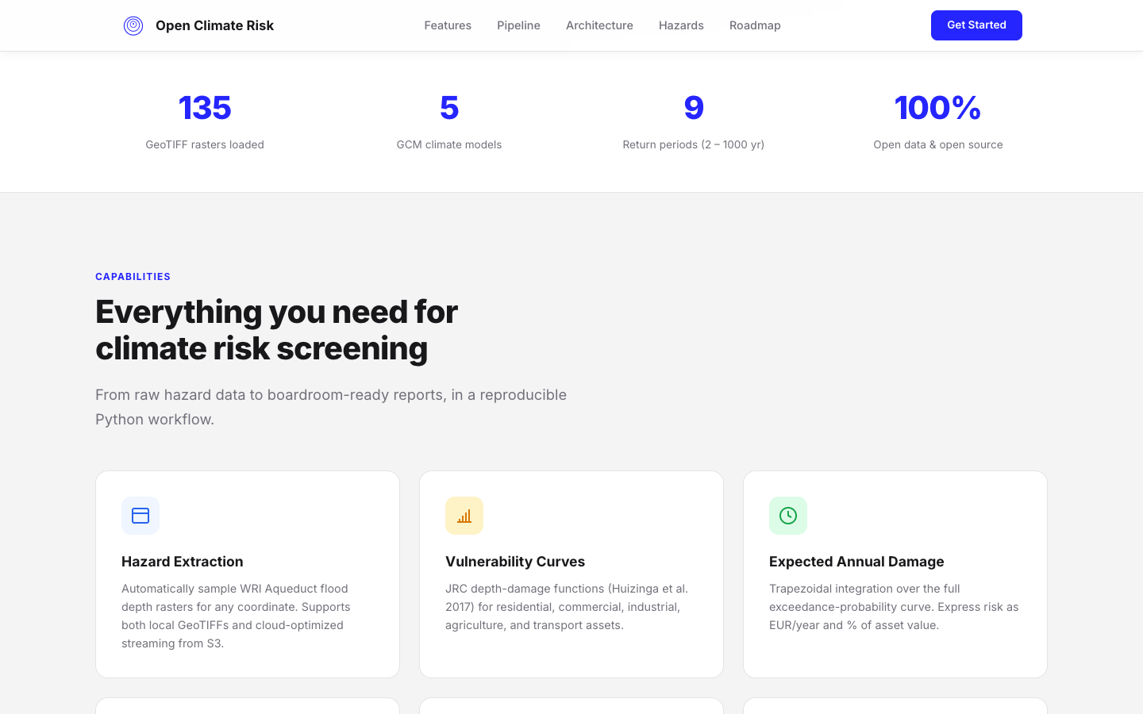
Figure 2 — Stats bar section

6. Section 3 — Features
Six feature cards in a 3-column grid, each with a colored icon container, title, and description. Cards have a white background, subtle border, and hover effect (border turns blue, slight elevation, upward translate).
Cards: Hazard Extraction, Vulnerability Curves, Expected Annual Damage, Climate Scenarios, Portfolio Analysis, Automated Reports.
Icons: SVG icons in colored rounded containers matching each feature’s theme.
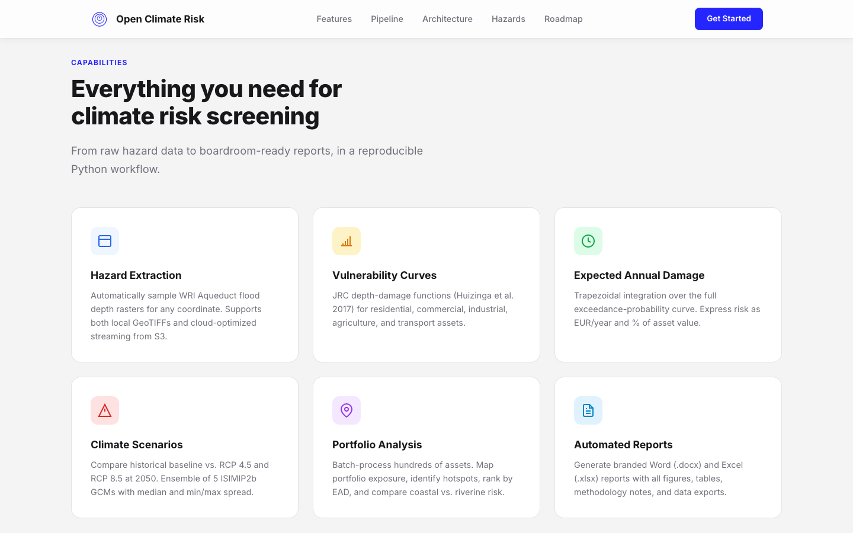
Figure 3 — Features section with 6 capability cards

7. Section 4 — Pipeline
A four-step horizontal flow showing the risk computation pipeline. Each step has a numbered circle connected by horizontal lines, a title, and a short description.
Steps: 1. Define Asset → 2. Extract Hazard → 3. Apply Damage → 4. Compute EAD
Visual: Blue circle numbers with blue-05 background, connected by blue-40 lines. Responsive: stacks to 2-col then 1-col.
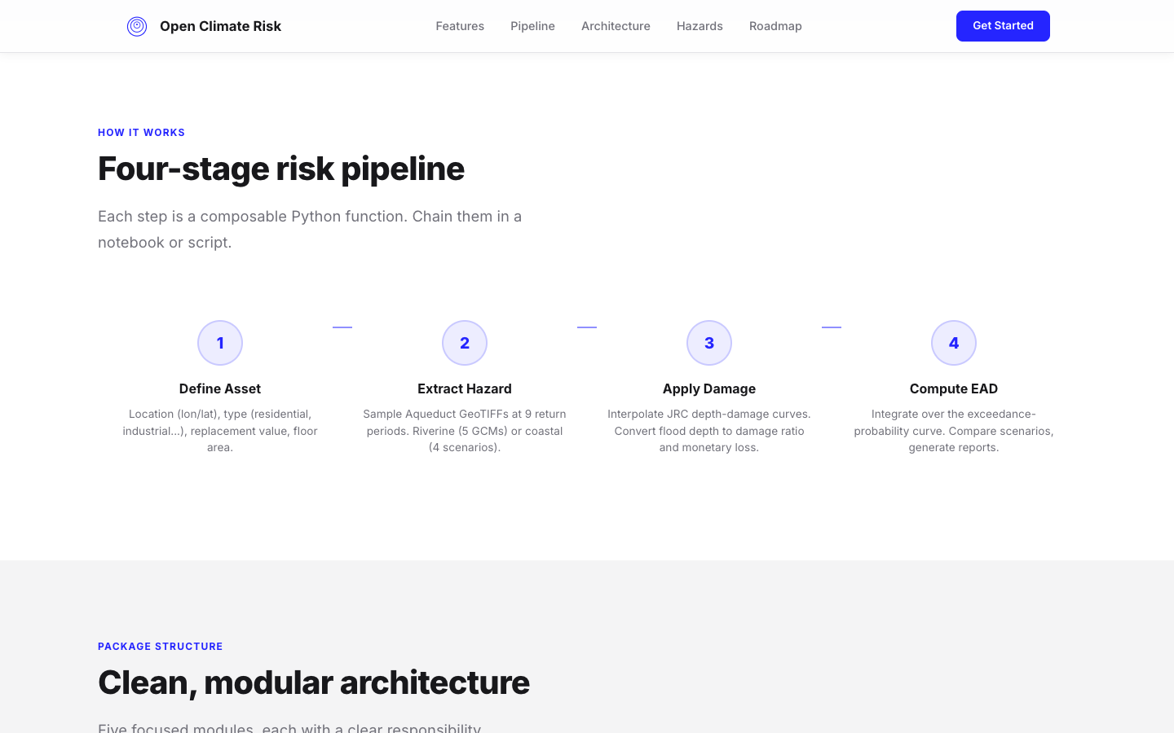
Figure 4 — Four-stage risk pipeline

8. Section 5 — Architecture
Two-column layout: left side shows a dark terminal-style file tree of the Python package; right side shows five module cards with colored left-accent borders.
File tree: Dark background (#18181B), monospace font, directories in blue-40, files in grey, comments in dark grey.
Module cards: White with left accent bar: blue (config), orange (data), red (analysis), green (plot), teal (report).
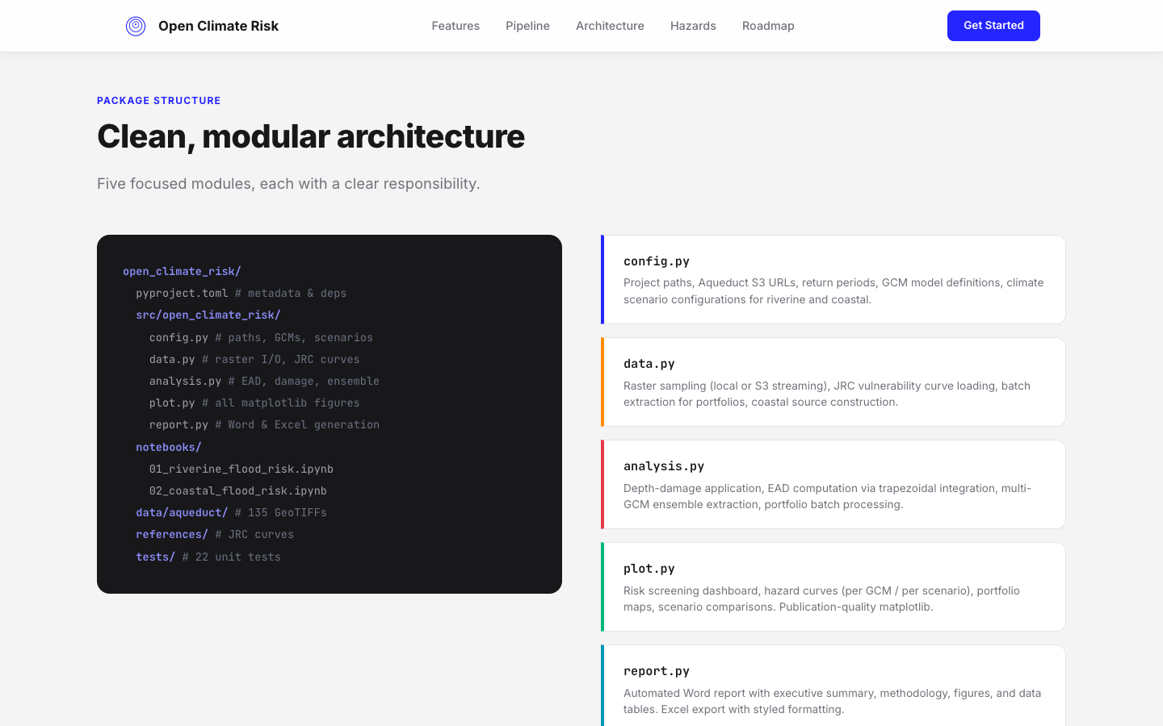
Figure 5 — Package architecture: file tree + module cards

9. Section 6 — Data Sources
A clean HTML table listing the four data sources: Riverine Hazard (WRI Aqueduct v2), Coastal Hazard, Vulnerability (JRC), and Climate Models (ISIMIP2b). Each row shows dataset, resolution, coverage, and license badge.
License badges: Green rounded pills ("CC BY 4.0", "Public domain").
Hover effect: Row highlights with blue-05 background.
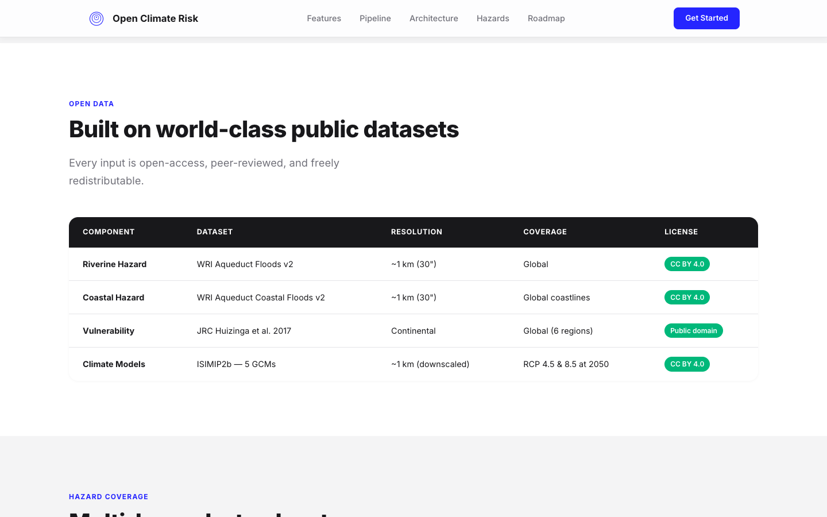
Figure 6 — Data sources table

10. Section 7 — Hazard Modules
Six hazard cards in a 2-column grid. Each card shows an SVG icon, hazard name, description, and a status badge indicating implementation status.
Live (green): Riverine Flood, Coastal Flood — currently implemented.
Next (amber): Heat Stress — planned for Q3 2026.
Planned (blue): Wildfire, Drought, Wind/Cyclone — 2027+.
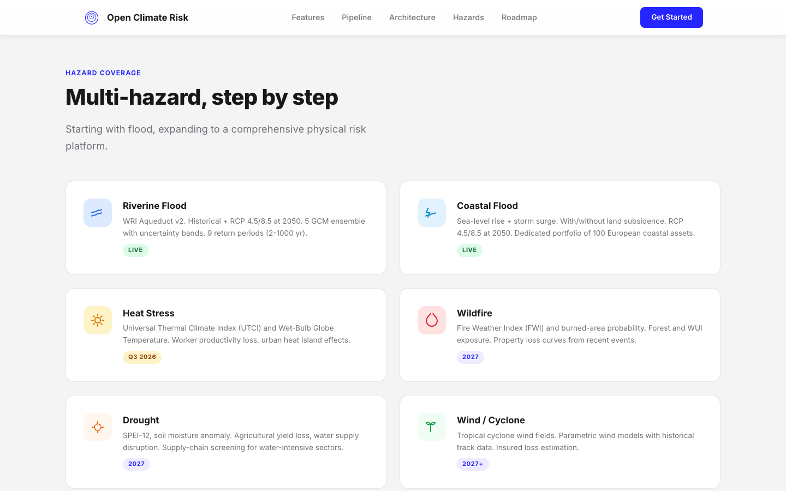
Figure 7 — Multi-hazard coverage with status badges

11. Section 8 — Roadmap
A vertical timeline with 5 milestones from Now through 2027. Each item has a dot on the timeline axis (filled for current, outlined for future), a date label in blue, title, and description.
Timeline: Vertical blue-15 line with positioned dots. Active dot is filled blue, future dots are outlined.
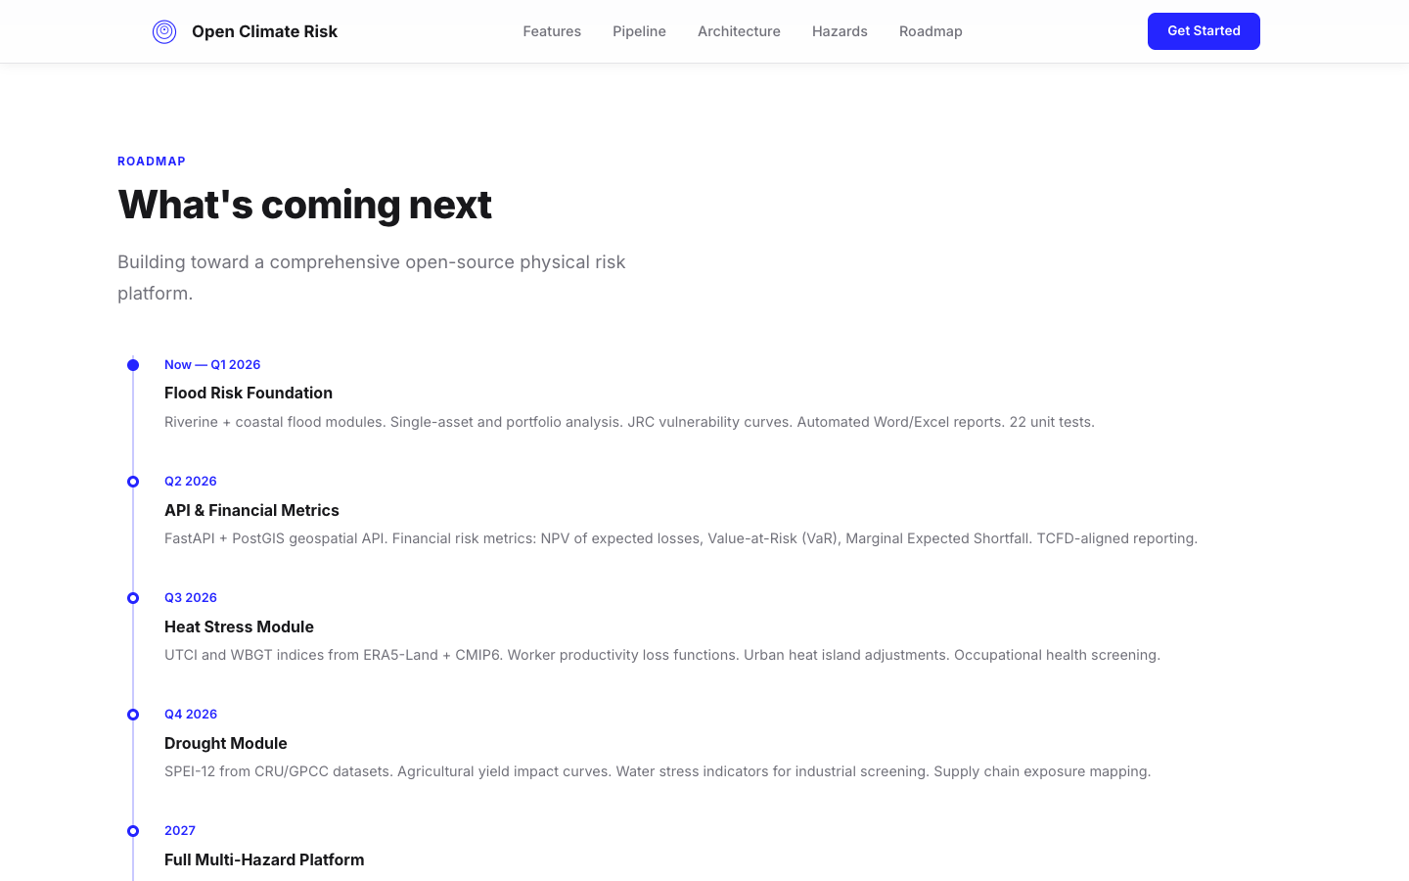
Figure 8 — Development roadmap timeline

12. Section 9 — References
Five peer-reviewed reference cards stacked vertically. Each contains author, year, title, journal, and DOI link. Clean white cards with grey border on grey-bg background.
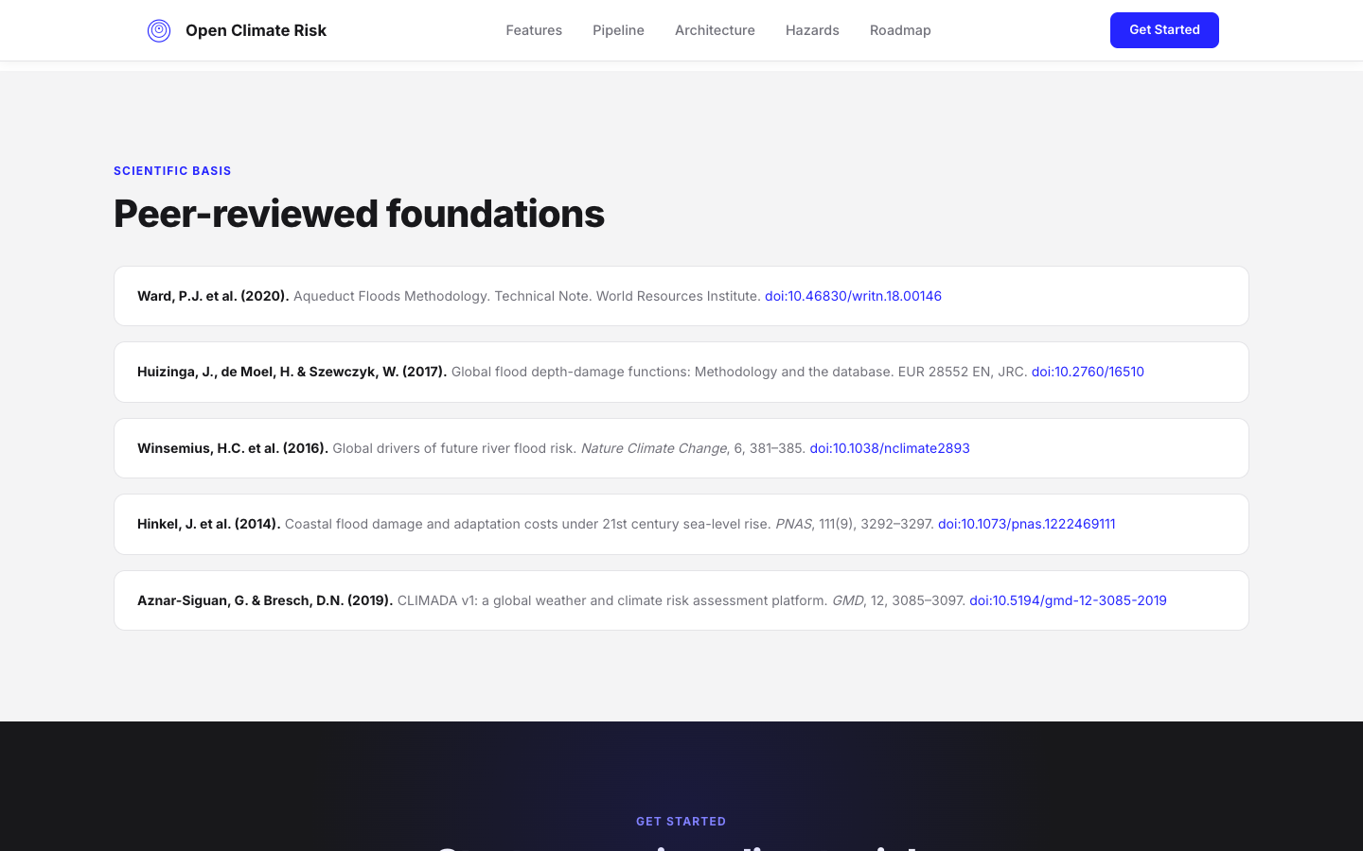
Figure 9 — Scientific references section

13. Section 10 — Call to Action & Footer
Dark section (#18181B) with a radial blue glow background effect. Contains the "Start screening climate risk in five minutes" headline, a terminal block with git clone commands, and a "View on GitHub" CTA button.
Footer: Minimal dark footer with logo, "MIT License" text, and navigation links (GitHub, Documentation, PyPI, Contact).
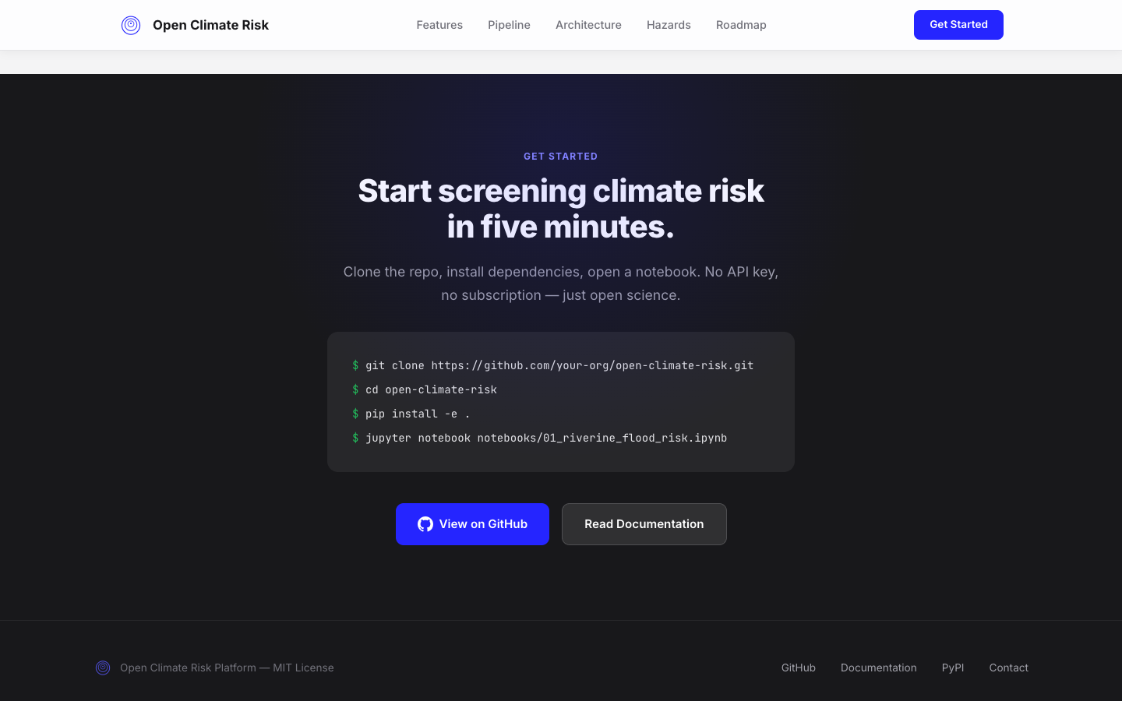
Figure 10 — Call to action and footer

14. Design System

Color Palette
Swatch | Name | Hex | Usage
████ | OCR Blue | #2525FF | Primary, links, accents, CTAs
████ | Blue 70 | #5858FF | Hover states
████ | Blue 40 | #8F8FFF | Decorative borders
████ | Blue 15 | #C9C9FF | Timeline, subtle borders
████ | Blue 05 | #EDEDFF | Hero gradient, hover bg
████ | Dark | #18181B | Headings, terminal bg, CTA bg
████ | Grey Text | #71717A | Body text, descriptions
████ | Grey Border | #E4E4E7 | Card borders, dividers
████ | Grey BG | #F4F4F5 | Alternating section bg
████ | Orange | #FF8C00 | Data module accent
████ | Red | #E63946 | Analysis module accent
████ | Green | #00B87A | Badges, terminal prompt
████ | Teal | #0096B4 | Report module accent

Typography
Element | Font | Weight | Size
Hero heading | Inter | 800 (ExtraBold) | 3.5rem (56px)
Section title | Inter | 800 (ExtraBold) | 2.5rem (40px)
Card title | Inter | 700 (Bold) | 1.1rem (17.6px)
Body text | Inter | 400 (Regular) | 0.9rem (14.4px)
Nav links | Inter | 500 (Medium) | 0.9rem (14.4px)
Code / terminal | JetBrains Mono | 400 (Regular) | 0.82rem (13px)
Section label | Inter | 700 (Bold) | 0.75rem (12px)
Badge / status | Inter | 700 (Bold) | 0.7rem (11.2px)

UI Components
Feature cards: White bg, 1px grey border, 16px border-radius. On hover: blue border, 8px box-shadow (rgba blue 8%), -2px translateY.
Section labels: Uppercase, 0.75rem, bold, 0.1em letter-spacing, OCR Blue color.
Buttons (primary): Blue bg (#2525FF), white text, 10px border-radius, 14px 28px padding, 600 weight. Hover: Blue-70 (#5858FF).
Buttons (secondary): White bg, grey border, 10px border-radius. Hover: blue-40 border.
Terminal mockup: Dark bg (#18181B), 16px border-radius, header bar (#27272A) with 3 traffic-light dots, monospace content with syntax-highlighted code.
Status badges: Rounded pill (100px radius), uppercase text, colored bg: green (#DCFCE7), amber (#FEF3C7), blue (#EDEDFF).
Data table: Dark header row, white body rows, grey borders, green license badges. Row hover highlights in blue-05.
Navigation: Fixed position, white bg with 85% opacity, 20px backdrop-filter blur. Adds shadow on scroll via JS class toggle.
Scroll animations: Elements with .fade-in class start at opacity:0, translateY:24px. IntersectionObserver adds .visible class at 10% threshold.

