
Portal inc.
Alexandria Lindsay
Proposal
Website Development
April 6, 2017

Proposal Contents

Introduction. . . . . . . . . . . . . . . . . . . . . . . . . . . . . . . . . . . . . . . . . . . . . . . . . . . . . . . . . . . . .1
Company Summary. . . . . . . . . . . . . . . . . . . . . . . . . . . . . . . . . . . . . . . . . . . . . . . . . . . . . . .3
About Us. . . . . . . . . . . . . . . . . . . . . . . . . . . . . . . . . . . . . . . . . . . . . . . . . . . . . . . . . . 4
Strategy Outline. . . . . . . . . . . . . . . . . . . . . . . . . . . . . . . . . . . . . . . . . . . . . . . . . . . . . . . . . 5
Website Structure. . . . . . . . . . . . . . . . . . . . . . . . . . . . . . . . . . . . . . . . . . . . . . . . . . .5
Website Assimilation. . . . . . . . . . . . . . . . . . . . . . . . . . . . . . . . . . . . . . . . . . . . . . . .5
Zoho Social. . . . . . . . . . . . . . . . . . . . . . . . . . . . . . . . . . . . . . . . . . . . . . . . . . . 5
Requirements & Deliverables. . . . . . . . . . . . . . . . . . . . . . . . . . . . . . . . . . . . . . . . . . . . . . .6
Goals & Objectives. . . . . . . . . . . . . . . . . . . . . . . . . . . . . . . . . . . . . . . . . . . . . . . . . . . . 6 - 7
Target Audience. . . . . . . . . . . . . . . . . . . . . . . . . . . . . . . . . . . . . . . . . . . . . . . . . . . . . . . . . 7
Implementation Timeline. . . . . . . . . . . . . . . . . . . . . . . . . . . . . . . . . . . . . . . . . . . . . . 9 - 10
Completion Date. . . . . . . . . . . . . . . . . . . . . . . . . . . . . . . . . . . . . . . . . . . . . . . . . . . . . . . 10
Terms of Agreement. . . . . . . . . . . . . . . . . . . . . . . . . . . . . . . . . . . . . . . . . . . . . . . . . . . . . . 8

Introduction Snapps Rehabilitation Center is proposing a project for the development of a website. Snapps has been a well known company since 2008 and is based around rescue services for snapping turtles all over the world, while enforcing the endangered species act. With a passionate team the company strives for excellence in aiding and rehabilitating snapping turtles, while educating others along the way.
Snapps would like to reflect their materials and new branding with a modernly designed website that will attract possible volunteers, donators, rescue teams and people that support the protection against the hunting of these primitive creatures. This proposal will include the steps necessary for our team to development a site that reflects the brand effectively and brings overall satisfaction to your team and audience.

Company Summary
About Us
Here at Portal Inc we strive for excellence to provide you with full websites that will enable you to grow in the digital economy with ease and style custom tailored to your needs. Your brand will be exposed to the core target markets through search engines and advertising which will help create company awareness and recognition in today's modern web. Portal Inc houses writers and developers hand picked for their creativity, dedication, and loyalty. In turn, our services are Superior in this regard because of our history and success with several brands and the 100% satisfaction and feedback we have received thus far.
In this proposal you will encounter our past work and success with, what we believe to be, our formula for an ideal comprehensive website which includes; Our delivery timeline, our projected costs, and our terms of agreement.
We look forward to working with you.

Strategy Outline Website Structure
At Portal Inc we build our websites using HTML5/CSS3, Java Script, and PHP which we have found to have superiority over old HTML. It provides ease of use for the consumer and provides the security your company requires. Once your website is launched you will have the ability to customize web content, images, and contact information. We at Portal Inc recommend that your website be hosted with our server. This will establish a foundation capable of handling high volume traffic while providing stability and security from unwanted malware.
Website Assimilation
Portal Inc will assimilate your site with our following Partners.
Zoho Social
By partnering with Zoho social we are able to provide, at an incredible discount, the best analytical software to record page views and performance. You will have the ability to read In-time what consumers are saying about your brand as well as gain meaningful insights on your brands social media footprints with clear conscious visual reports.

Requirements & Deliverables
Snapps Rehabilitation Center has noted the requirements that must be included in the finished website. The following includes:
- A modern design that matches the branding of the company
- Professional and organized content
- Evolution within the site
- User friendly interface and navigation
- ability to subscribe to newsletters
- Promotes donations and volunteering
- Social media integrated
- A database that will collect customer information and product orders

Goals & Objectives Our team of developers have identified the goals and objectives that Snapps Rehabilitation Center would like to meet. The following includes:
- An increase in volunteers
- An increase in donations
- More advertising for events
- An increase in trade and merchandise with other rescue groups

Targeted Audience
Primary Audience:
Rescue groups and exotic shelters is the primary audience for Snapps Rehabilitation Center. Snapps wants contact with rescue services to expand their company across the country.
Secondary Audience:
The secondary audience may be targeted at individuals that have a passion for volunteering and would consider contributing to the protection of snapping turtles.
Tertiary Audience:
Snapps Rehabilitation Center has advertisments on the radio as well as television. Individuals may have a peak of interest when viewing and listening to these advertisements.
User/Administer Web Pages A list of user/administer pages that will be included on the Snapps Rehabilitation Center's website.
User
- Register
- Login
- Products
- Checkout
- Payment Details
- Invoice

Administer
- Dashboard
- Search Records
- Login
- Add Records
- Edit Records
- Delete Records

Terms of Agreement
Portal Inc is providing services for Snaps Rehabilitation Center, as an independent contractor for a Business Website.
Fees will be paid in accordance of the above listed pricing table. Fees for monthly services will be invoiced on the !st business day of each calendar month. All payments will be made in Canadian Dollars.
Portal Inc reserves the right to assign outsourced contractors to ensure the job is completed in the above time frame.
Snaps Rehabilitation Center may be charged additional fees if the company decides to make changes to the current proposal.
Portal Inc declares that the performance contained in this venture will meet Snap Rehabilitation Centers requirements and that the execution will be error free.
In no event will Portal Inc be liable to Snap Rehabilitation Center or any third party for any damages, including loss of savings, profits, or other incidental damages arising out of the operation or inability to operate the website.

Implementation Timeline
Date | Task | Responsibility
March 1st | Planning starts | Developers
March 10th | Discover Documents Complete | Developers
March 10th | Internal Review of Discovered Documents | Developers
March 11th | Present Documents to Client | Developers
March 13th | Discover Documents Approval | Client
March 14th | Design Begins | Developer
March 14th | Content Development Begins | Developer
March 17th | Review of Design & Content | Developer
March 18th | Present Design & Content to client | Developer
March 18^{h} | Design & Content  Approval | Client
March 19th | Coding begins | Developer
March 20th | Validation complete | Developer
March 21st | Programing begins | Developer
March 24th | Testing complete | Developer
March 28th | Review site | Developer
March 30th | Present  Coding & programming to client | Developer
April 1st | Coding & Programming  Approval | Client
April 2nd | Launch/Maintenance begins | Developer
April 3rd | Setup hosting complete | Developer
April 4th | Testing complete | Developer
April 5th | Launch & maintenance  Approval | Client
April 5th | Launch live site | Developer
April 6th | Publish live site | Developer

Completion Date & Cost
Snapps Rehabilitation Center has asked that the development of the website should be published by September 6, 2017 and maintained under a server for additional for on going fees after the launch of the site. Website total will be calculated from the work back seen on page 17-18 since no price range has been specified.

Snapps Rehabilitation Center Website Development = $1500.00 CA

Site Map
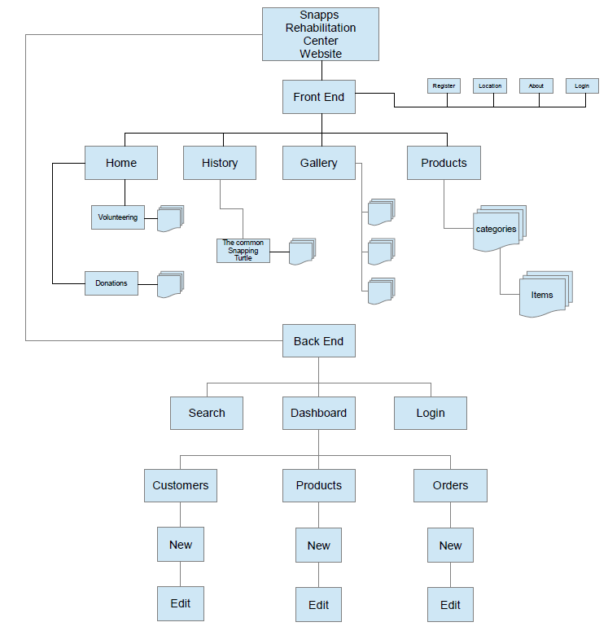
Data Model
This data model represents all of the possible tables that may relate to the company. Every table shows the relationship with one another.
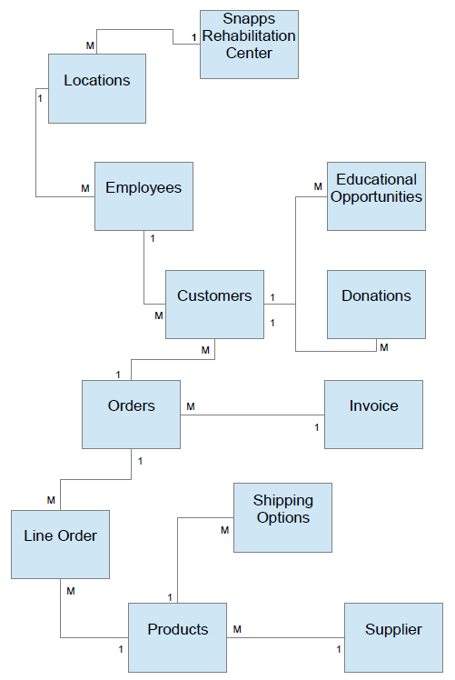
Entity Relationship Diagram
An ERD to represent the tables within the database of the snapps rehabilitation center's website. The database will include information of every product, customer information, orders and their line items.
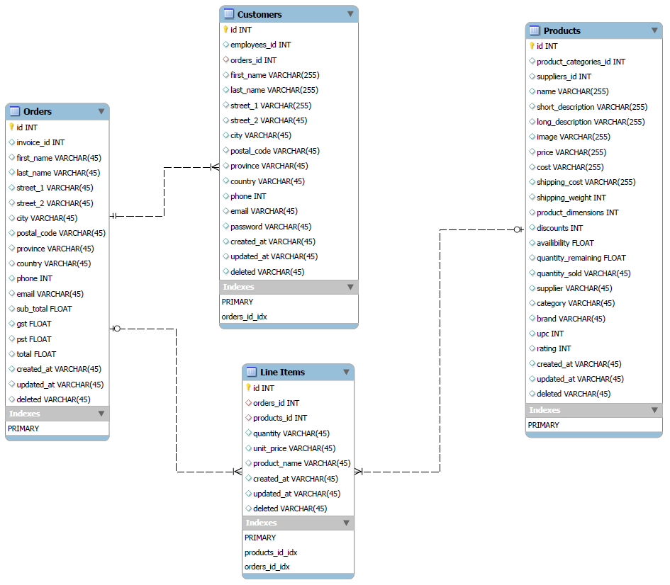

Block Composite A representation of how the website pages will be structured.

Header
Navigation
Main Content
Footer

