

|  |
| --- |
| Prototype1 |
| 24/09/18 00:17 |
| **Author:** John Doe  **File name:** Prototype1.vp  **Version** 1.0 |

|  |
| --- |
| Site Map |
|  |

|  |
| --- |
|  |

01. Site Map / Prototype1 

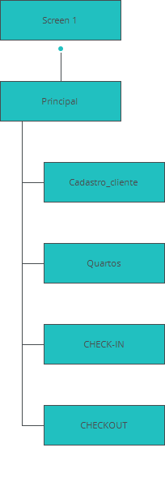

|  |
| --- |
| Screens |
|  |

|  |
| --- |
|  |

02. Screens / Prototype1 

Screen 1

|  |
| --- |
|  |

Interactions

|  |  |
| --- | --- |
| 1 | **on Click:** goes to 'Principal' 🡪 |

02. Screens / Prototype1 

Principal

|  |
| --- |
|  |

Interactions

|  |  |
| --- | --- |
| 2 | **on Click:** goes to 'Cadastro_cliente' 🡪 |
| 3 | **on Click:** goes to 'Quartos' 🡪 |
| 4 | **on Click:** goes to 'CHECK-IN' 🡪 |
| 5 | **on Click:** goes to 'Screen 1' 🡪 |
| 6 | **on Click:** goes to 'CHECKOUT' 🡪 |

02. Screens / Prototype1 

Cadastro_cliente

|  |
| --- |
|  |

Interactions

|  |  |
| --- | --- |
| 7 | **on Click:** goes to 'Principal' 🡪 |

02. Screens / Prototype1 

Quartos

|  |
| --- |
|  |

Interactions

|  |  |
| --- | --- |
| 8 | **on Click:** goes to 'Principal' 🡪 |

02. Screens / Prototype1 

CHECK-IN

|  |
| --- |
|  |

Interactions

|  |  |
| --- | --- |
| 9 | **on Click:** goes to 'Principal' 🡪 |

02. Screens / Prototype1 

CHECKOUT

|  |
| --- |
|  |

Interactions

|  |  |
| --- | --- |
| 10 | **on Click:** goes to 'Principal' 🡪 |

|  |
| --- |
| Templates |
|  |

|  |
| --- |
|  |

03. Templates / Prototype1 

960 grid - 12 columns

|  |
| --- |
|  |

03. Templates / Prototype1 

960 grid - 16 columns

|  |
| --- |
|  |

03. Templates / Prototype1 

Template 1

|  |
| --- |
|  |

|  |
| --- |
| Scenarios |
|  |

|  |
| --- |
|  |

04. Scenarios / Prototype1 

default

|  |
| --- |
|  |