**TUGAS 5 PRAKTIKUM PBO A**

**AGAVE YONATAN – 123180099**

**Input Data :**

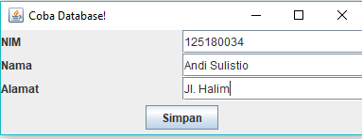

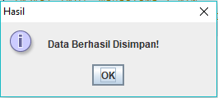

**Lihat Data :**

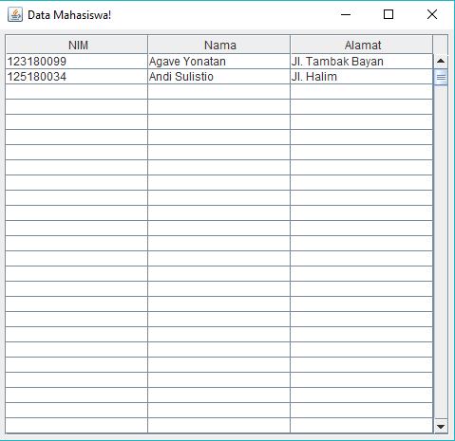

**PHPMyAdmin :**

