Volatility Modelling and Risk Analysis of Gold Futures in R, 2022 – April 2026

Chapter 1: set-up, data scraping and transformation
The set-up
The R.code file presents the required packages, of which ‘quantmod’ proves to be an essential part of an Econometric analysis.
Data Scraping
Setting from = “YYYY/MM/DD” and to = “YYYY/MM/DD” for commodity GC=F scrapes Gold future prices for a time period based upon recent market data. Two sets are acquired, a four-year dataset and another with all trading days since 2002.
In this case, the four-year set is written as a CSV called ‘data’. Users are encouraged to repeat using sys=Date for rolling data (up to the present).
Transformation
Log returns are taken for the data. This includes the four year and 24-year datasets. Such a transformation is calculated by taking the differenced log closing prices for Gold. It follows the following equation:
rt = Ln(Pt) – Ln(Pt-1) (1)
This transformation (log) is useful for its statistical tractability and returns are scale-free which makes comparison independent-of-currency. Comparing figures 1A and 2A, to 3A and 4A shows the merit in using log returns.
Stationarity test
The ADF (Augmented Dickey-Fuller) test checks for a unit root, helping determine whether a time series is Stationary.
Stationary series have stable statistical properties (e.g. constant mean and variance), which makes ARIMA analysis appropriate because lag relationships remain stable over time.
Weakly stationary Process refers to when a time series {Xt} or {GC=Ft} has statistical properties which are as follow:
1) Constant mean: E[Xt] is independent of time (t).
2) Cov(Xt, Xt-k) depends only on lag size ‘k’.
First ADF test on closing prices illustrates the merit of transformed metrics. Closing prices have a p-value of 0.9368. Resultingly, the null hypothesis of non-stationarity does not have sufficient grounds to be rejected. ARIMA modelling would be discouraged.
Second ADF test on log-returns was significant to 0.05 which provided sufficient evidence to reject Non-Stationarity at the 5% Confidence Interval. Reasonable grounds for Stationarity (alternative hypothesis). ARIMA modelling tools can be explored.
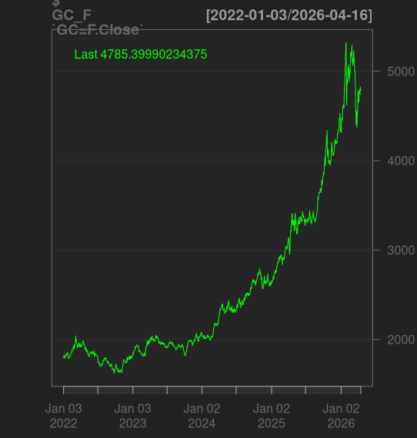
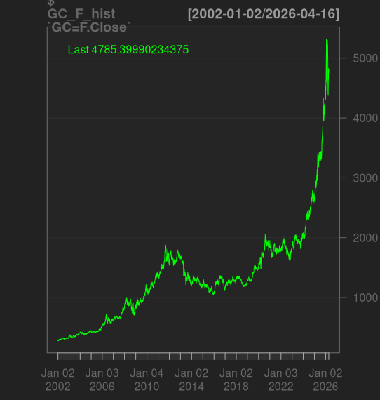
Figures 1A and 1B (24 year and four-year closing prices respectively)

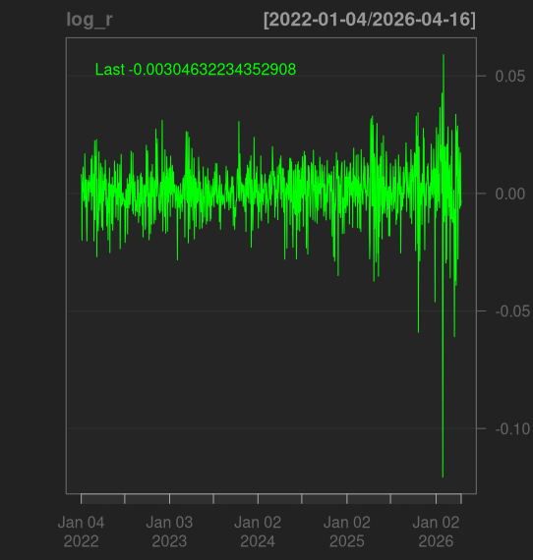
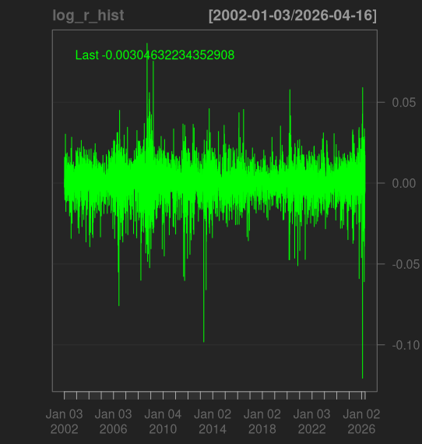
Figures 1C and 1D (24 year and four-year log returns respectively)

Visualisations also support the ADF test results since 1C and 1D graphs appear to have a stable mean around zero. The build-up to January 2026 appears dramatic in Figure 1D but in the full time-series shown in Figure 1C, similar turbulent periods occurred (2008 and 2021). Namely the ‘Credit-crunch’ and Covid crises.
Chapter 2: Distributive properties and VaR of log-returns
In the absence of trends, forecasting with ARIMA is possible (chapter 3). It may be tempting to skip but chapter 2 provides useful descriptive statistics for understanding the data. This is a quick grasp of evolving market behaviour in a set-period (01/Jan/2022 to 17/Apr/2026).
Table 1, log returns parameters
Sample Parameter | Value | Rounded (2sig-fig)
Mean | 0.000909 | 0.0010
Median | 0.00109 | 0.0011
Variance (Standard Deviation) | 0.001, 0.0118 | 0.0010, 0.012
Skewness | -1.265 | -1.3
Kurtosis - 3 | 9.31 | 9.30

VaR, Value at Risk (historic method)
For those wanting to understand more about VaR, please see (Investopedia):
Understanding Value at Risk (VaR): Explanation and Calculation Methods
Using the historical data, a level of certainty that losses will not exceed a given value can be determined. However, the VaR will not explain what occurs when losses exceed an unlikely threshold.
E.g. at 95% Confidence, what quantity losses reach is determined by a value represented within the worst 1/20 days. For 99% this is the worst 1/100 days.
Log returns (rt) can be converted to Regular returns (Rt)
Reversing log returns for interpretability is advised. This is simple and shows how a following ‘bad-day’ can hurt a Portfolio or Investment by showing the minimum amount (%) that can be expected to be lost up to some level of confidence based on historical returns.
Rt = e^(rt) - 1, (2)
ES, Expected Shortfall
ES covers what is missing from VaR which is a loss-quantity including even the worst of trading days. For those interested, a link to a good resource for Expected Shortfall is below:
Expected Shortfall: Definition, Calculation, Use Cases & Key Advantages —marketopia.org

Table 2, VaR
Loss level (%) | VaR | Conversion to returns, Rt (%)
Max loss (0, quantile) | -0.1207, worst day in data (Loss) | -0.1282
One percent (0.01, quantile) | -0.029, Worst 1/100 days (Loss) | -0.0290
Five percent (0.05, quantile) | -0.0171, Worst 1/20 days (Loss) | -0.0169
Ten percent (0.1, quantile) | -0.061, Worst 1/10 days (Loss) | -0.0623
Best day in data (1, quantile) | 0.0591, Highest return (Gain) | 0.0610

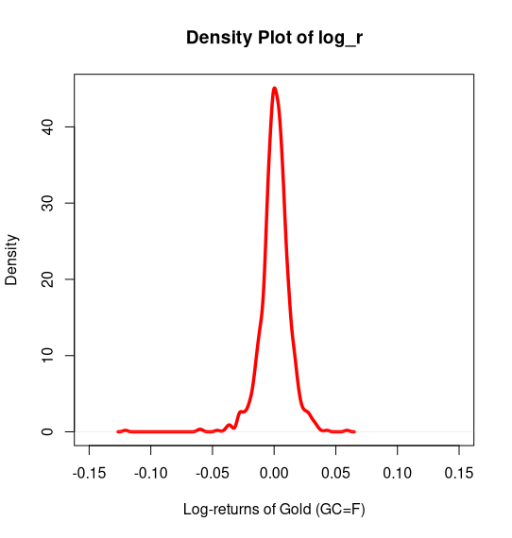
Figure 2A, VaR shown on density plot (log returns)

The density plot of Gold futures log-returns exhibits a pronounced central peak and relatively heavy tails, indicating a leptokurtic distribution, which is coherent with the chapter 2 results. This suggests that extreme price movements occur more frequently than would be expected under normality assumptions, a common characteristic of financial return series.
Chapter 3, Forecasting with AIC criterion
The appropriate ARIMA model can be constructed after investigating the Autocorrelation function (ACF) and Partial Autocorrelation function (PACF).
A rejection region is set automatically by R but it may be manually calculated as the following for the 95% Confidence Interval:
(1.96) / sqrt(n) (3)
Where n is the number of observations. In this case, 0.0597 or approximately 6%.
Then the ACF and PACF curves may be used to test against autocorrelations and see if there are significant lags.
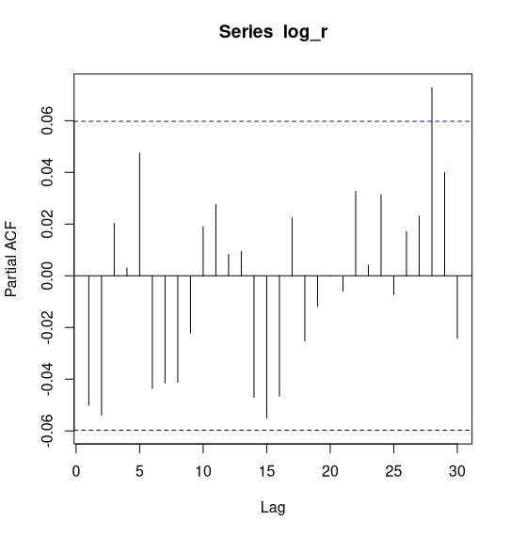
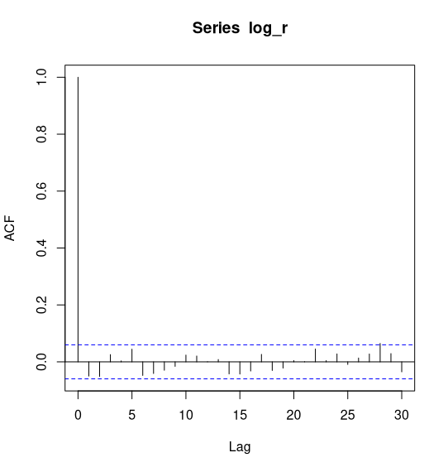
Figures 3A and 3B, ACF and PACF respectfully;
Autocorrelation function (3A) illustrates that the only relevant lag (lag 0 is always =1) was 28 which is most likely noise, unless some omitted 28-day seasonal effect is omitted. Partial ACF (3B) is coherent with only one lag significant which is 28. With 30 lags and 0.05 chance of error, then there may be 0.05*30 = 1.5 meaning one-to-two false positives (Type I errors) concluding that not much attention should be paid to lag-28. These results suggest that an ARIMA(0,0,0) should be most appropriate.
Nevertheless, three models are fitted and tested using Akaike’s Information Criterion.
- Moving Average (p = 0, I = 0, q = 1) = ARIMA(0,0,1)
- Autoregressive (p = 1, I = 0, q = 0) = ARIMA(1,0,0)
- Mean-average (p = 0, I = 0, q = 0) = ARIMA(0,0,0)
Akaike’s Information Criterion:
Balanced assessment of the fit versus complexity trade-off. Overfly complex models risk overfitting and poor generalisability. A deeper explanation can be found below.
AIC = 2k – 2ln(L) (4)

K represents the number of parameters, -L is the likelihood where lower is indicative of better-fit.
Low AIC scores are a sign of good fit for the level of complexity, near-values are equivalent. Explained by the larger spread between -2ln(L) and 2k.

Table 3, AIC ARIMA scores
Model | AIC score
Autoregressive, ARIMA (1,0,0) | -6461.70
Moving-Average, ARIMA (0, 0, 1) | -6492.02
White Noise Process, ARIMA (0,0,0) | -6491.01

Despite the results suggesting that Gold log returns follow a White Noise Process, the best model fit under AIC was ARIMA(0,0,1) followed by ARIMA(1,0,0). However, these fits are marginally better and considering that simpler models such as the ARIMA(0,0,0) effectively have the same fit, this may be considered the most appropriate model.
These results motivate the next section addressing Volatility. Despite the log return values being almost entirely unpredictable based on prior lags, this does not interpolate to Volatility which may still be closely associated with its previous values.
Chapter 4, Volatility modelling
ARCH(1), introduced by Robert F. Engle in 1982, was developed to model time-varying Volatility in financial time series where the assumption of homoskedasticity is violated. In such processes, the conditional variance is not constant over time and periods of high Volatility tend to cluster together. Clustering raises the question of whether market shocks dissipate rapidly or persist over extended periods. Extending Engle’s framework, Tim Bollerslev proposed the GARCH(1,1) model in 1986, allowing current Volatility to depend on both past squared innovations and previous conditional variances
Upon fitting the GARCH(1,1) model, the volatility coefficients α0, α1 and β1 are shown to all be significant to the 0.1% Significance level with respective coefficients at 0.00000323, 0.08885 and 0.8905.
- α0 illustrates the level of Volatility that is constant which is small relative to dynamic volatility of ARCH α1 and GARCH β1 which combined are almost 0.97 or 1 illustrating that Volatility is highly persistent and effects decay slowly.
- α1 covers the impact of new market innovations/information. Such as the news which has long been understood as a component of Volatility (Mindell, 1961).
- β1 shows how Volatility is subdued and depends highly on previous periods.
σt^2​ = α0 + α(εt-1)^2 + β(σt-1)^2 (5)
​The ARCH term α1 and GARCH term β1 combine to almost 1. This result, along with all three terms individually is of high interest as it demonstrates the behaviour of market turbulence. These outcomes should be compared to out of sample periods to investigate how robust these results are during different periods in the Economic cycle.
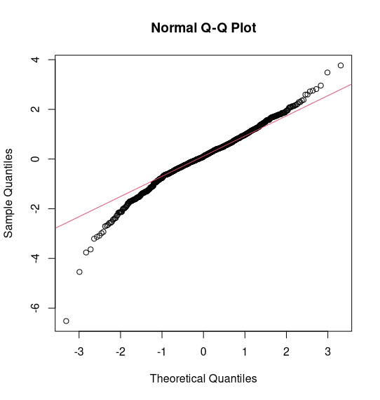
Figure 4A, Normal QQ-plot of GARCH(1,1) residuals

The Normal Q-Q plot indicates substantial departures from Normality in the tails of the distribution. While the central quantiles align reasonably closely with the theoretical normal line, the extreme quantiles diverge significantly, illustrating the excess kurtosis in chapter 2 of 9.31. Such characteristics imply a greater probability of extreme market movements than predicted by the normal distribution.

Chapter 5: Suggestions/Limits
A suggestion is to model with the Student-t distribution. Which is adapted for analysis on heavier tailed distributions. This was apparent from the excess Kurtosis results in chapter 2. At 9.31, this was noticeably different from zero.
Another suggestion is to account for the asymmetries present in the Skewness of chapter 2 at -1.265 which demonstrated that the distribution was not symmetrical. Otherwise Skewness is equal to zero, and since this was not the case, the GARCH(1,1) model failed to account for the ‘leverage effect’, when negative news has a larger impact than positive news/innovations (Braun et al,. 1995). This would mean that adapted versions of the GARCH family such as EGARCH (Nelson, 1991) and GJR-GARCH (Glosten, 1993) are suggested for addressing the asymmetries of the log-returns.
Historical Value at Risk (VaR) would capture some natural variability but may be prone to overfitting on new data. Overfitting can hinder robustness, especially if out-of-sample results show that VaR is very different in other historical periods. Additionally, VaR does not account for losses beyond the Confidence Interval. For this reason, Expected Shortfall (ES) would be a valuable tool.

Links and Citations
Value at Risk, Investopedia website (25, November, 2025): https://www.investopedia.com/articles/04/092904.asp
Expected Shortfall, Marketopedia website, (21, April, 2026):
https://www.marketopia.org/blog/expected-shortfall/
Bollerslev, T., 1986. Generalized autoregressive conditional heteroskedasticity. Journal of econometrics, 31(3), pp.307-327.
Braun, P.A., Nelson, D.B. and Sunier, A.M., 1995. Good news, bad news, volatility, and betas. The Journal of Finance, 50(5), pp.1575-1603.
Engle, R.F., 1982. Autoregressive conditional heteroscedasticity with estimates of the variance of United Kingdom inflation. Econometrica: Journal of the econometric society, pp.987-1007.
Glosten, L.R., Jagannathan, R. and Runkle, D.E., 1993. On the relation between the expected value and the volatility of the nominal excess return on stocks. The journal of finance, 48(5), pp.1779-1801.
Mindell, J., 1961. How news affects market trends. Financial Analysts Journal, 17(1), pp.31-34.
Nelson, D.B., 1991. Conditional heteroskedasticity in asset returns: A new approach. Econometrica: Journal of the econometric society, pp.347-370.

