Network Registration:
AT+CREG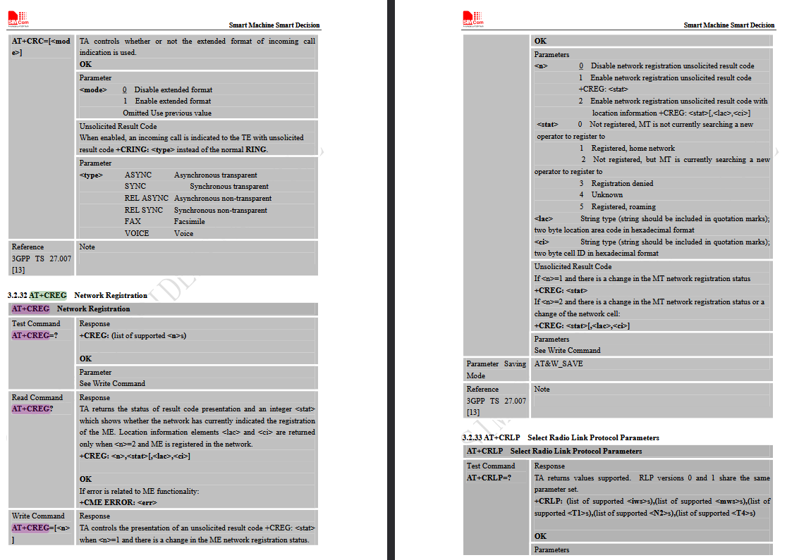

AT+CGREG
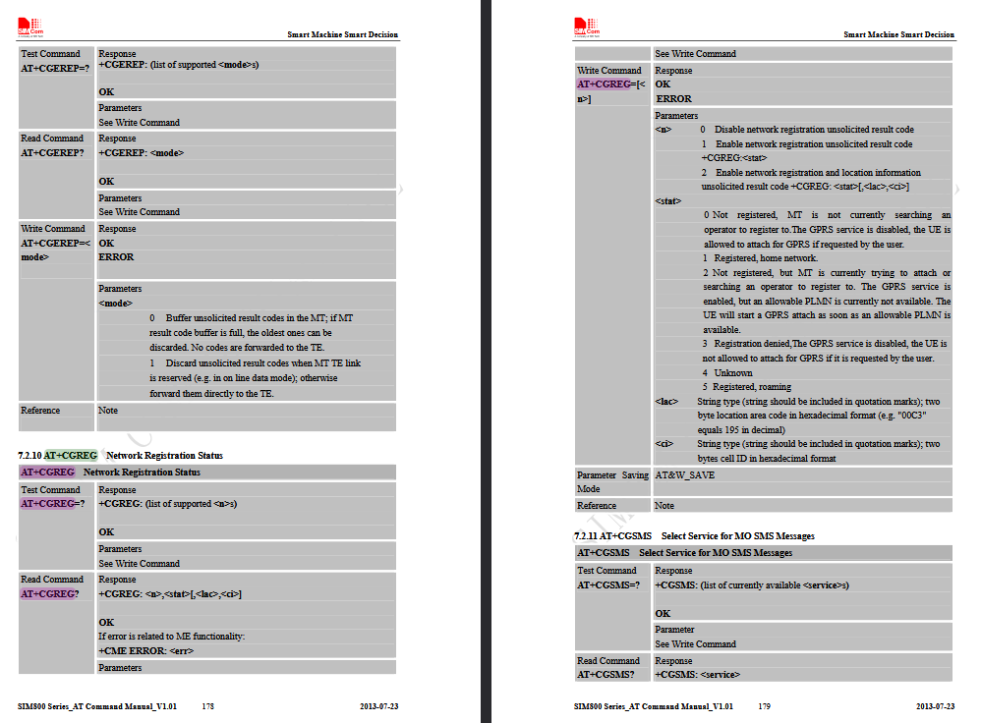

Settings Bearer IP Application
AT+SAPBR 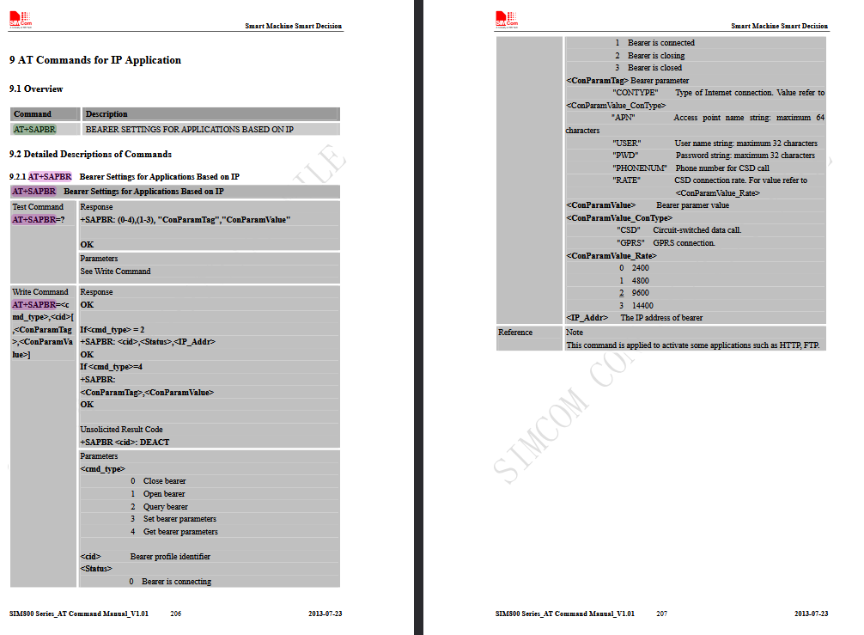

AT+HTTPINIT
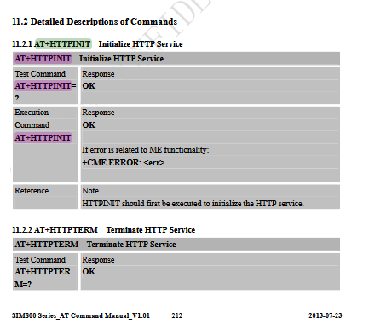

AT+HTTPPARA
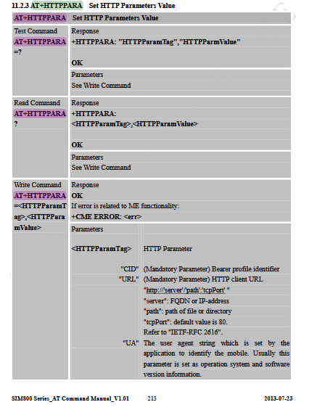

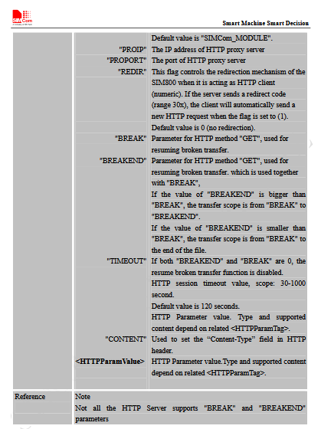
AT+HTTPDATA
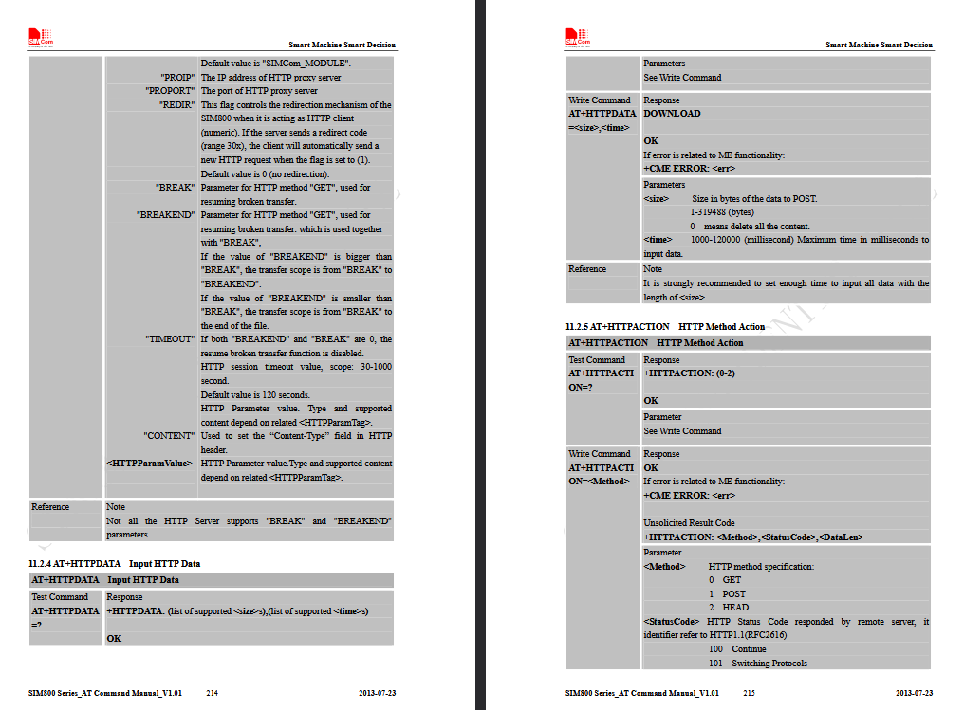

AT+HTTPREAD
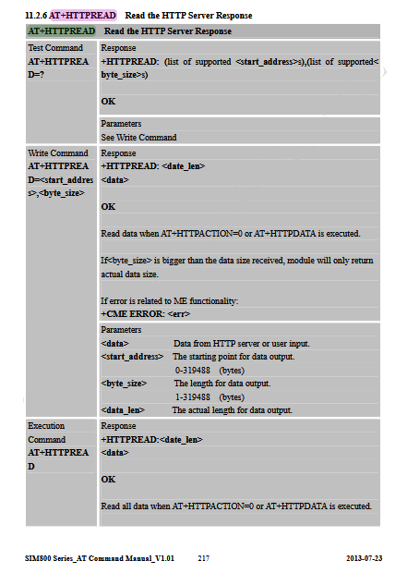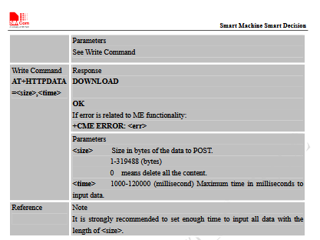
AT+HTTPACTION
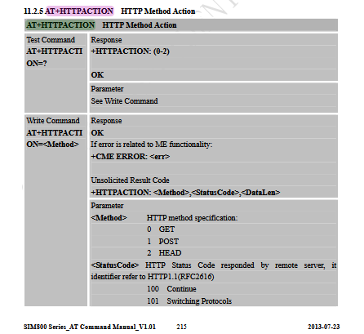
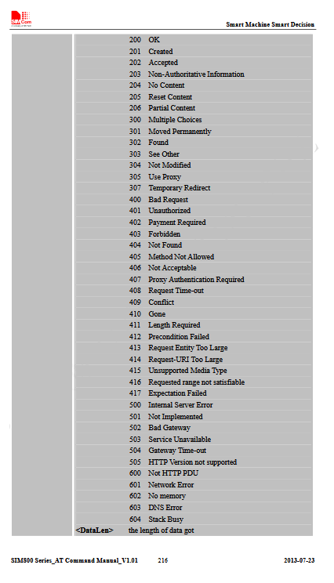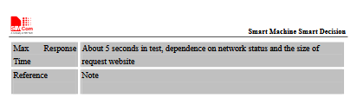

AT+HTTPTERM
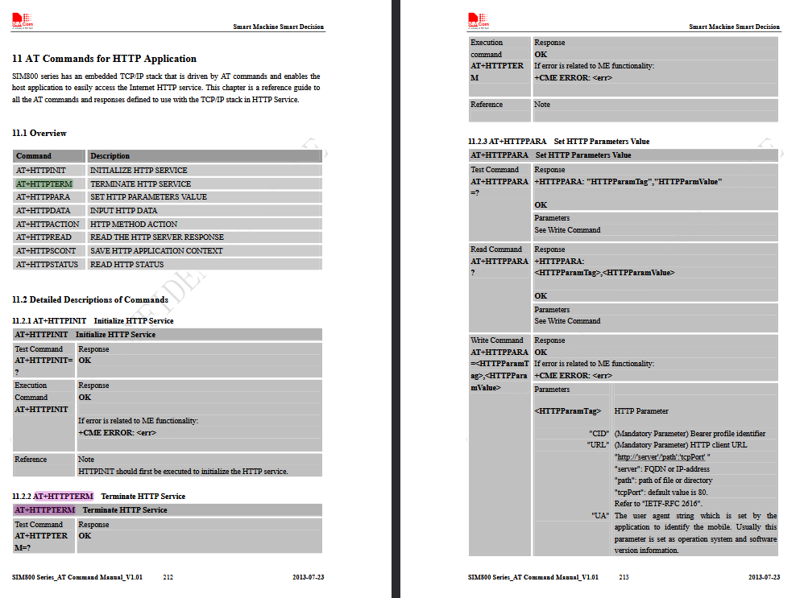

Select SMS Message Format
AT+CMGF
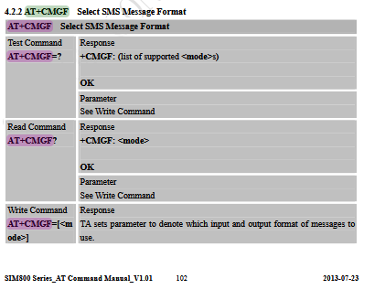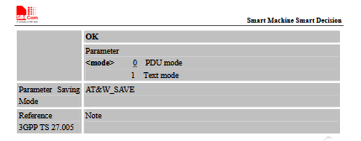
Send SMS
AT+CMGS
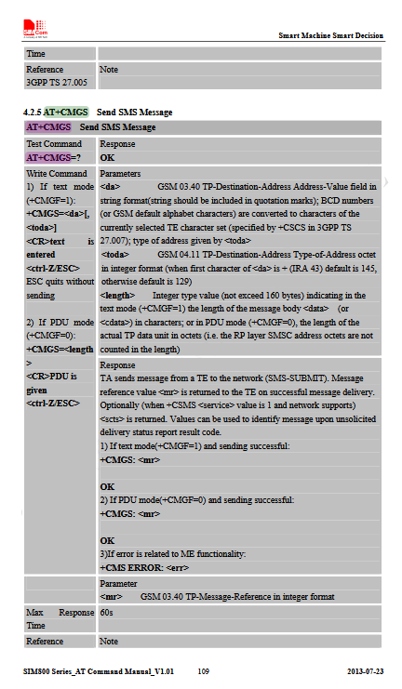
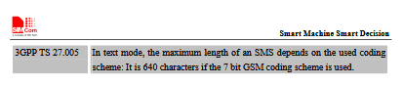

Battery: AT+CBC
Charging, Percent, MilliVolts

Network:

Network Registration Status:
AT+CREG? (AT+CGREG (2G oderso))
+CREG 0,1-> (Sucht nicht), (Home Network)
Bearer Info
AT+SAPBR=2,1 (2 get info, 1. Bearer)
+SAPBR: 1,3,"0.0.0.0" (1. Bearer, 3 Closed)
AT+SAPBR=1,1 (1 öffnen, 1. Bearer)
+SAPBR: 1,1,"10.42.71.191" (1. Bearer, 1 Offen, ip)
AT+SAPBR=4,1 (2 get AP info, 1. Bearer)
+SAPBR:
CONTYPE: GPRS
APN:
PHONENUM:
USER:
PWD:
RATE: 2

HTTP
AT+HTTPINIT
AT+HTTPPARA="URL","http://google.com" (Setzt URL)
AT+HTTPPARA="CID",1 (Setzt 1. Bearer)
AT+HTTPACTION=0 (0 – HTTP Get)
+HTTPACTION: 0,301,219 (301 moved, 219 – Data Len)
+HTTPACTION: 0,200,18618 (200 OK, 18618 – Data Len
AT+HTTPREAD
<!Doctype HTML> etc…. </html>
AT+HTTPTERM (Beendet HTTP Mode)
AT+SAPBR=0,1 (0 Close, 1. Bearer)

POST DATA
Wie in Network:
AT+HTTPDATA=<DataLen>,<WaitForInputTimeMs>
AT+HTTPDATA=10,10000
DOWNLOAD (Von Sim geschickt)
TEST (Post Data)
AT+HTTPACTION=1 (1-Post)
+HTTPACTION: 1,603,0 (1-Post, 603 Fehlercode DNS (HTTPS geht nicht), 0-Length)
+HTTPACTION: 1,200,360 (1, 200 OK, 360 – Length Data)
AT+HTTPREAD
{
"args": {},
"data": "TEST\nTEST\n",
"files": {},
"form": {},
"headers": {
"Accept": "*/*",
"Content-Length": "10",
"Host": "httpbin.org",
"User-Agent": "SIMCOM_MODULE",
"X-Amzn-Trace-Id": "Root=1-67b5fc86-2c27111747bdae5175fc23dd"
},
"json": null,
"origin": "80.187.87.72",
"url": "http://httpbin.org/post"
}

OK
AT+HTTPTERM

SMS:

AT+CMGF=? (Get List of Supported Formats)
+CMGF: (0,1) (0 pdu, 1 text)
AT+CMGF? (Get active Text Mode)
+CMGF: 0 (0 PDU Mode) (Binary Bit Stream vllt interessant)
AT+CMGF=1 (Set Text Mode)
AT+CMGS="+4915739119874" (Receiver Number)
Message
CTRL+Z (Send with Code: 0x1a)
+CMGS: 6 (6 <da> ? Kein Ahnung, fortlaufende Nummer irgendwie)

