


Group Assignment EPL 231
Winter Semester
(Tree Structures)
Version No 1.0
September 2025

Table of Contents
Introduction to EMOS 4
Day Schedule Workflow of an EMOS Application 5
STEP 1 Child Application 7
User Log-In (Desktop Icon Pop-Up) 8
Production Forecasting (Child Application) 8
Viewing Data (Steps 1,2,3) 9
Production Forecasting (Processing) 11
Saving and Exit Production Forecasting Child Application 12
Non availability declaration 12
Production Forecasting Reason Code (Child Application) 13
Proceeding to the main Application 14
STEP 2 Demand Forecasting 15
Demand Forecasting Selecting a customer 16
Checking customer numbers 17
Approving the Forecast & Completing Demand Forecasting 19
In Between Step (Demand Forecasting and Balancing) 20
STEP 3 Balancing and Forward Nominations 21
Calculating each portfolio’s surplus/deficit 22
Navigate to Forward Nominations 23
Concluding Balancing and Forward Nominations 25
STEP 4 Physical Delivery Nominations & RES Injections 26
Physical Delivery Nominations 27
Supplier Tab (Physical Delivery Nominations) 28
STEP 5 Day Ahead Market (DAM) Energy Offers & Bids 29
DAM Energy Offers & Bids 30
Summary of DAM Energy Offers & Bids 31
STEP 6 Downward Balancing Energy Offers 32
Downward Balancing Energy Offers 33
STEP 7 Day Ahead Market (DAM) Reconciliation 34
Day Ahead Market Reconciliation 35
Day Ahead Market Reconciliation Summary 36
STEP 8 Market Schedule Processing & Monthly Settlements 37
Market Schedule Processing & Monthly Settlements 38
Final Part of Market Schedule 39
Application Completed 39
Conclusion EMOS User Manual 40

Table Of Figures

Introduction
In the framework of class EPL 231, under the guidance of our Professor Mr Hadjipollas we undertook a project that required the design, implementation, and experimental evaluation of advanced tree-based data structures, the Trie and the Compressed Trie with hash. Our objective was to build a complete word-processing system that supports autocompletion, prefix-based statistical analysis. More specifically, we were asked to implement two structures: a classical Trie and a Compressed Trie enhanced with hashing, and then to compare their performance in terms of memory usage using synthetic datasets.
In the first part of the assignment, we implemented a dictionary using a Compressed Trie with hashing (Robin Hood Hashing), where each node contains an importance counter representing the frequency of a word. We developed a full preprocessing pipeline that loads all dictionary words from an input file, converts them to lowercase to ensure non–case-sensitive behavior, and inserts them into the trie. A second text file is then processed: as each candidate token is extracted, cleaned from punctuation, and normalized to lowercase, we check whether it exists in the trie, and if so, we increment the corresponding importance counter. By the end of this stage, every dictionary word stored in the trie carries accurate frequency information derived from the input corpus. To ensure efficiency in these tasks, we integrated additional data structures such as min-heaps for selecting the top-k words and used prefix-guided traversal strategies to aggregate frequencies and analyze child-node statistics.
The second part of our work focused on a quantitative comparison of memory usage between the classical Trie and the Compressed Trie. To conduct this evaluation systematically, we generated synthetic dictionaries under different scenario-fixed-length words and variable-length words using realistic distributions for word lengths and letter frequencies. We then applied a consistent theoretical memory-cost model to both structures which we will get to eventually in this report, considering the number of pointers, characters, and integers stored in each node MANUALLY like the professor asked. By executing multiple trials for various dictionary sizes and averaging the results, we produced to trie to create (haha see what I did there?) meaningful and comparable measurements which we hope can provide further insight on the comparison between a trie and a compressed trie for the storing and searching of Dictionaries. These measurements are visualized graphically at the midpoint of our Report, enabling us to identify trends, analyze the conditions under which each data structure is more space-efficient, and understand the impact of common prefixes on memory reduction. (fingers crossed)
Through this project, we gained deeper insight into the interplay between data structure design, algorithmic efficiency, and real-world application performance. Our implementation and experiments demonstrate how compression and hashing can significantly improve both effectiveness and memory usage in prefix-based text processing systems!!

Figure 1: Google Example

Chapter 1
Theoretical Background
In this section, we present the theoretical foundations of the two main data structures studied in our Labs. The classical Trie and the Compressed Trie our implementation uses RobinHood Hashing, a hashing method we learned in our Labs. Understanding their structure, behavior, and theoretical guarantees is essential for evaluating their performance both in practice and through the memory-usage analysis required by the assignment.

Trie Data Structure
A Trie is a tree-based data structure used to store strings in a way that exploits shared prefixes. Each edge represents a single character, and each node corresponds to the prefix formed by the path from the root to that node. The Trie supports efficient operations on sequences of characters. Our implementation is from our Labs, yet we find it is a standardized learning procedure.
A typical Trie node contains:
- A set of outgoing child pointers (one per character in the alphabet),.
- A Boolean flag indicating whether the node terminates a valid word.
Given an alphabet of size σ (e.g., 26 for lowercase English letters), a naïve implementation uses an array of σ pointers at every node. While this enables constant-time child lookup we believe not yet proven from our calculation as we will further try to conclude that it also leads to significant memory overhead.
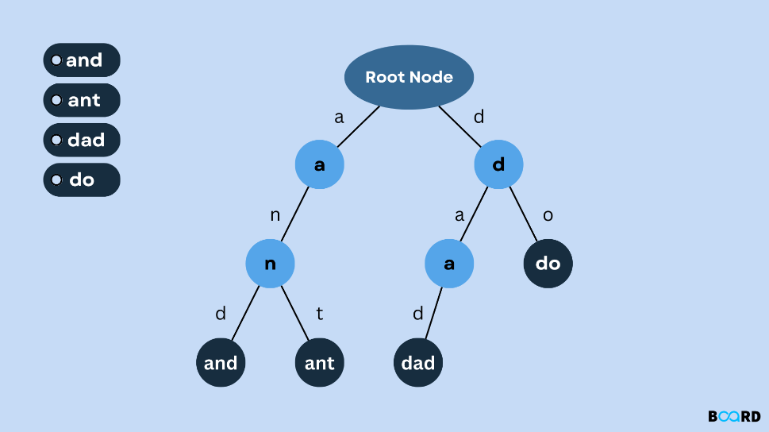
Figure 2: Trie Data Structure
Time Complexity:
- Insert: O(L), where L is length of the word
- Search: O(L)
- Prefix search: O(L + k), where k words match the prefix
These operations are efficient since they depend only on the prefix length, not on the size of the stored dictionary.

Compressed Trie Data Structure
A Compressed Trie is an optimization of the classical Trie that reduces the number of nodes by compressing chains of single-child nodes into a single edge containing a substring rather than a single character our implementation has to explicitly do with the implementation we have done at EPL 231 Labs
Instead of storing one character per edge, the compressed structure stores entire paths (substrings) along a single edge. This drastically reduces the number of nodes and pointers needed, especially for datasets where long prefixes or word stems are common.
Our Compressed Trie node contains:
- Each edge carries a string label rather than a single character.
- A node appears only at branching points or at word endings.
- Common prefixes are shared as in a classical Trie, but long non-branching paths are merged.
This results in a significantly more compact structure, particularly when words share long common prefixes (e.g., “compute”, “computer”, “computing”, “computation”).
Time Complexity
- Insert: O(L) in the worst case, but often faster due to fewer nodes.
- Search: O(L), matching substrings along edges.
- Prefix search: O(L + k), like Trie, but traversing fewer nodes.
Although substring comparisons can add minor overhead, the overall structure is shallower and typically faster in practice.
The following is a Patricia Tree with a Hash something quite similar to our Data Structure.
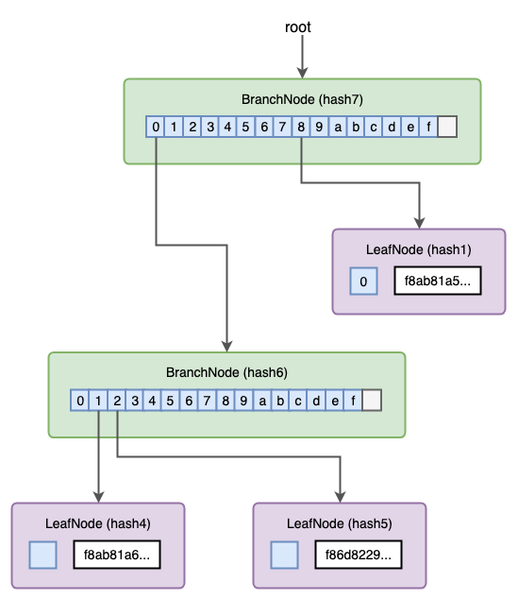
Figure 3: Patricia Tree with Hash

Memory Characteristics
Trie:
We think that the Trie has a memory usage problem and here is why!
- A Trie has one node per character of every word.
- With little prefix overlapping, the number of nodes approaches the total number of characters in the dictionary.
- Each node stores an array of pointers, most of which remain unused.
This leads to high memory consumption, especially for large dictionaries or low prefix sharing. We somehow envision it like a long chain, our professor Mr Hadjipollas mentioned something in the sense that its height gets taller as such -> more memory.
Compressed Trie with Hashing:
The Compressed Trie’s primary advantage is memory efficiency:
- It eliminates long chains of nodes.
- It reduces pointer overhead drastically.
- It stores only as many nodes as necessary for branching structure.
- It minimizes duplicate storage of repeated characters.
In our implementation, we further reduce memory by replacing the classical pointer array with Robin Hood Hashing at each node, ensuring:
- dynamic child storage
- no wasted pointers for unneeded characters,
- more compact and adaptive memory usage than fixed-size arrays.
Here is something we reckon should be correct and we theorize before going through the actual implementation and proving of the matter through different insightful means! We’ll hopefully figure something out before the deadline!
Property | Classical Trie | Compressed Trie
Node count | proportional to total characters | proportional to branching points
Edge labels | single characters | substrings
Pointer storage | fixed σ pointers per node | dynamic (hash table)
Memory usage | high | low
Insert/search time | O(L) | O(L) (substring matching)
Preferred when | alphabet small, speed prioritized | memory critical, large datasets
Figure 4: Memory Characteristics

Chapter 2
Data Structures
In this section, we describe the data structures that we implemented for the purposes of our autocompletion system and experimental memory analysis. Our project relies entirely on data structures taught during the course ΕΠΛ231, and all structures have been implemented by us from scratch, following the constraints of the assignment. We will proceed to present each structure separately to provide a better idea of our structure.
- ImportanceMinHeap.java
- Main.java
- RobinHoodHashing.java
- SinglyLinkedList.java
- Trie.java
- UserInterface.java
- MemoryDrainage.java
- CompressedTrieNodeWithHash.java
- CompressedTrieWithRobinHoodHash.java
- EdgeForHashing.java
We’ll start the explanation starting from the cleanest way possible!

Trie
The Trie structure (implemented in Trie.java) is a tree where each node corresponds to a single character in a word. Each path from the root to a leaf (or marked node) represents a stored word from the dictionary. We used the classical Trie mainly for Part 2 of the assignment, where we compare its memory usage to that of the compressed version.
Each Trie node contains:
- an array of 26 child pointers (children),
- a boolean flag isEndOfWord,
- an integer importance, used to track word frequencies.

Robin Hood Hash Table
We implemented Robin Hood hashing in RobinHoodHashing.java to store the children of each Compressed Trie node dynamically.
How It Works:
Instead of storing a fixed-size array of 26 pointers:
- Each node has a hash table
- insertions follow the Robin Hood displacement rule
- searches rely on maximum probe length tracking
- deletions trigger backward-shift repairs to maintain optimal structure
Each hash entry stores an Element, which wraps:
- an EdgeForHashing
- a probe length
- metadata needed for proper hashing behavior
The following is an example from the Labs we stop when we find maxProbeLenght
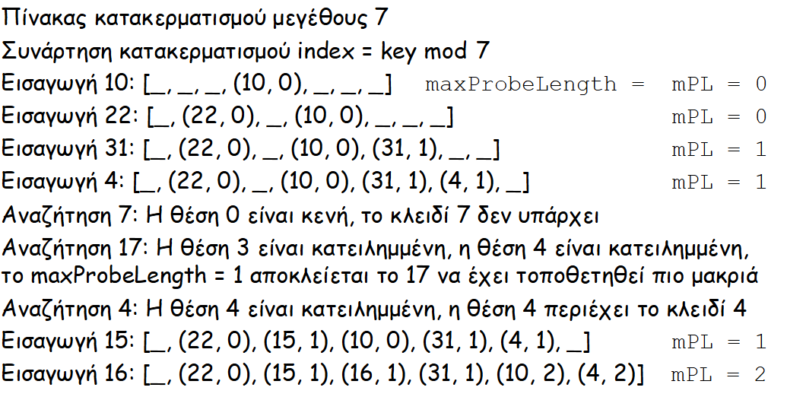
Figure 5: Robin Hood Hash Example
Here is also a great Link
https://www.geeksforgeeks.org/dsa/robin-hood-hashing/

Edge Structure
Edges are represented by the class EdgeForHashing.java.
Each edge stores:
- a label (a substring of one or more characters)
- a pointer to the next compressed trie node
Edges allow the compressed trie to bypass single-character nodes, enabling substring-level traversal.

Compressed Trie with Hashing
Our primary data structure for the application is the Compressed Trie implemented in
CompressedTrieWithRobinHoodHash.java and CompressedTrieNodeWithHash.java.
Motivation (well truth be told its mandatory)
Compressed Tries reduce memory consumption by merging long chains of nodes into a single edge labeled with a substring. This structure is essential for large dictionaries, because it drastically reduces the number of nodes and redundant pointers in the tree.
However, instead of using a linked list or an array to store node children, we used Robin Hood Hashing, which minimizes wasted space and accelerates child lookups.
Structure:
- a Boolean flag marking the end of a word,
- an integer importance,
- a RobinHoodHashing table to store its outgoing edges,
- children represented by EdgeForHashing objects (label + child pointer).

Min-Heap for Ranking
To implement the “top-k most important words” operation, we designed a custom min-heap in ImportanceMinHeap.java.
Purpose:
During prefix queries (e.g., “top k suggestions starting with ‘ap’”), we perform:
- DFS traversal of all relevant words
- Insert importance values into the heap
- Maintain the k most significant entries
Output them in descending order
Why a Min-Heap?
- Efficient for keeping only k best elements
- Faster than sorting the full result set
- Required by the assignment specification

We also have a User Interface and a main for Testing
The user interface is responsible for loading the dictionary, updating the importance counters, handling user queries, managing the menu loop, and printing the corresponding results.

Memory Drainage Class ( to be filled )

Chapter 3
Experiment Methodology
In this chapter, we describe the methodology we followed to evaluate and compare the memory usage of the classical Trie and the Compressed Trie with hashing. Since the assignment requires a theoretical memory model rather than OS-level profiling, our experiments are based on controlled synthetic datasets and manually computed memory estimates. We ensured that all experiments were repeatable, consistent, and aligned with the specifications of the course.

Overview of the Experimental Approach
Our memory study was performed in three major stages:
- Generating synthetic dictionaries of various sizes and structural characteristics.
- Building both data structures (Trie and Compressed Trie with hashing) using the generated input.
- Computing theoretical memory usage using our MemoryDrainage.java tool.
To ensure fairness, both structures were constructed using the exact same set of words for each experiment.

Synthetic Dictionary Generation
The assignment requires us to perform experiments using artificially generated word lists rather than real dictionaries. We generated multiple dictionaries of increasing size typically ranging from a few thousand words to tens of thousands, allowing us to observe how memory consumption grows as the dataset scales.
We tested two different generation models, as required:
(A) Fixed-length words
In this scenario, every word has the same predetermined length (e.g., 6 letters).
Letters are selected according to a frequency distribution to simulate natural text.
This model helps isolate how memory behaves when:
- Word lengths are uniform,
- Prefix overlap is less random,
- Compression arises mainly from character coincidences.
(B) Variable-length words
Here, each word’s length is drawn from a realistic distribution around a mean (e.g., mean length 7–9).
This approach more closely reflects natural language, where words vary in length and structure.
This scenario highlights:
- The effect of longer shared prefixes,
- The increased potential for compression,
- How variable structure affects hashing efficiency.

Frequency and Character Distributions
To introduce realistic diversity in the words we generated, we created a letter frequency distribution based on typical usage frequencies in English (e.g., vowels more common than consonants).
This ensures:
  - fair representation of common letters,
  - natural clustering of similar prefixes,
  - a more realistic compression effect, especially in the Compressed Trie.
Randomness was controlled through consistent seeding, allowing experiments to be repeated reliably.

Memory Drainage Calculation
To estimate the memory usage, we built our own analytical tool:
MemoryDrainage.java.
This tool computes theoretical memory consumption using a fixed model:
- char → 2 bytes
- int → 4 bytes
- pointer/reference → 8 bytes
- Java object header → ~12 bytes
The tool then sums the memory contributions of:
- nodes,
- edges,
- labels,
- hash table elements,
- array sizes,
- importance counters,
- Boolean flags (rounded for alignment).
This process ensures that measurements for both structures are consistent and unbiased.

Experimental Protocol
To ensure reliable results, we repeated each experiment multiple times:
- Generate and store wordlist
- Construct data structures
- Run memory calculator
- Record total memory usage
- Repeat for larger dictionary sizes
We tested dictionary sizes such as:
- 10,000 words
- 100,000 words
- 1,000000 words
Each configuration was run at least three times, and the average memory usage was recorded to eliminate anomalies from random word generation.

Chapter 4
Results & Analysis

Demand Forecasting Selecting a customer

Chapter 5
Appendices

Usage of AI and Bibliography

Usage of AI:
Hello Alex, here and I am writing in first person now because this is a more non-scripted part of the report. So, we could not fully use LLMs for these exercises as we were lead to bugs all the time, could be that we used LLMs wrong and we didn’t provide them with enough training for them to be helpful. One time we tried using them for the hashing and we spent more time debugging than doing it firsthand. I mostly used LLM models for polishing this report into certain sectors and a bit for grammatical and contextual reasons. I used a bit of Chatgpt 5.1 and then changed it at the end. I also used it for experimental procedures as I felt I needed a bit more guiding. Vasilis was very much against it and as such he didn’t use it almost at all. Talking to him on the phone as I am writing this he was really frustrated and just hardcoded most stuff on his own although we used it for commenting and polishing code looks wise.

Bibliography:
- Lab 7 Trie
- Lab 8 Compressed Trie
- Lab 9 Robin Hood Hash
- Geeks for Geeks Robin Hood Hash
- Patricia Tree Geeks for Geeks I looked a bit into it
- Lab 10 Exercise Help from Mr Hadjipollas

Conclusion
Group 27 Project
Finalizing
The EMOS User Manual serves as a complete, guided pathway for managing every stage of market operations from initial forecasting to the final settlement of each trading day. It is designed to walk the user through the EMOS environment step by step, ensuring that every process is executed in the correct order and within the designated market timeframes. By following the procedures described in this manual, users can confidently carry out all essential activities related to energy forecasting, nominations, market participation, and reconciliation with precision and compliance.
Throughout the manual, each section represents a key operational milestone. It begins with the Production and Demand Forecasting stages, where users generate and validate forecasts for RES generation and consumption. These forecasts form the foundation upon which all subsequent actions are based. The next stages, Balancing and Forward Contract Nominations, translate these forecasts into actionable positions, helping the user minimize imbalance risks while adhering to regulatory deadlines.
Once the forecasting and balancing processes are complete, the manual guides the user through Day-Ahead Market (DAM) submissions, including the preparation and validation of energy offers and bids, followed by Downward Balancing Energy Offers to ensure operational flexibility. Each step outlines the precise time window and interface elements to be used transforming what could be a complex technical process into a predictable daily routine.
In the later sections, the manual details the Reconciliation and Market Schedule procedures, where users import Market Clearing Prices (MCPs), review approved schedules, and finalize indicative dispatches. These actions ensure that market results align with the physical and financial expectations of the day. Finally, the Monthly Settlement procedures close the operational cycle, providing a transparent and verifiable record of all market activities.
In essence, this manual is a structured tutorial that mirrors the chronological flow of the energy market day. Each chapter corresponds to a real-time operational phase, guiding the user from early morning forecasting tasks, through midday trading activities, to evening reconciliations and monthly reporting. By following the steps in sequence, the user effectively “runs” EMOS from start to finish, ensuring accuracy, traceability, and full compliance with market procedures.
For any kind of questions please contact:
Team Members:
Alexandros Christinakis
Vasil Vasilev
Professors
George Hatzipolas
Goerge Pallis

