Executive Annual Report · 2024
ACME Insurances · generated 2026-06-02 · run id 4c9b2df6b4f5 · source CSV sha256 362326717019

Executive summary
The gross written premium for ACME Insurances in 2024 reached €26,271,000, marking a significant 23.6% increase from 2022. This growth underscores our strategic focus on expanding market share and diversifying product offerings. Our loss ratio stood at 39.5%, reflecting prudent risk management practices. Customer satisfaction remains strong with an NPS score of 46, indicating high levels of customer loyalty. Additionally, the renewal rate increased to 90.3%, highlighting our ability to retain clients effectively. Digital adoption among our customers reached 78.9%, demonstrating a continued commitment to leveraging technology for improved service delivery. Looking ahead, we aim to build on these successes in 2025 by further enhancing digital capabilities and expanding into new markets.

Yearly performance narrative
**Commercial.** ACME Insurances saw a significant growth in Gross Written Premium (GWP) to €26,271,000 in 2024, marking a 23.6% increase from the previous year. The company also secured 10,311 new policies and maintained a strong renewal rate of 90.28%, indicating customer satisfaction and loyalty.
**Claims.** In 2024, ACME Insurances handled 4,422 claims with total payments amounting to €10,370,000, resulting in a loss ratio of 39.49%. The average settlement time was reduced to 17.3 days, demonstrating improved efficiency compared to the previous year.
**Customer.** Customer satisfaction remained steady at an NPS score of 46.29, with 78.94% of customers adopting digital services for their insurance needs. ACME Insurances received 308 complaints in 2024, a slight increase from the prior year but indicative of ongoing efforts to enhance customer service.
**Compliance.** ACME Insurances faced 34 fraud cases and 12 compliance incidents in 2024, reflecting a cautious approach to risk management. While these numbers are concerning, they highlight the company’s commitment to maintaining high standards of integrity and operational excellence.

KPI highlights
Year-on-year comparisons reference 2022.
Metric | Value | YoY | YoY %
Gross written premium | €26.27M | +€5.02M | +23.6%
New policies | 10,311 | +2,281 | +28.4%
Policies in force | 18,535 | +2,497 | +15.6%
Renewal rate | 90.3% | +3.8 pp | +4.4%
Claims paid | €10.37M | +€665.0k | +6.9%
Loss ratio | 39.5% | -6.2 pp | -13.5%
NPS | +46 | +10 | +26.2%
Digital adoption | 78.9% | +12.0 pp | +17.9%

Trends & variance
Gross written premium (€)
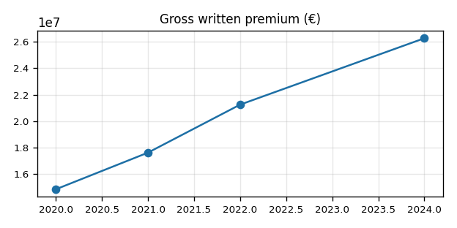
Renewal rate (%)
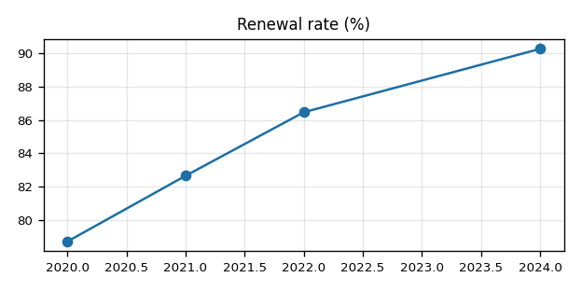
Claims paid (€)
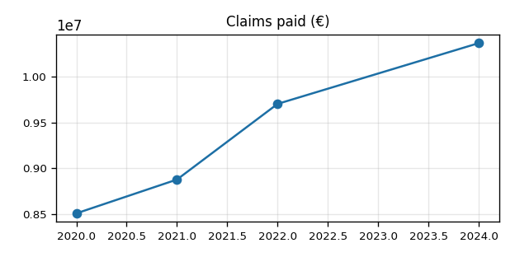
Net Promoter Score
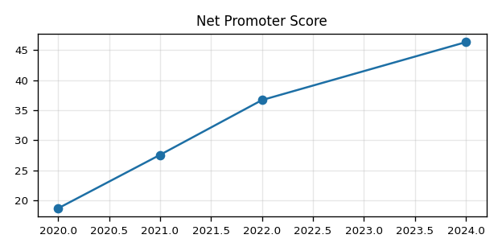
Digital adoption (%)
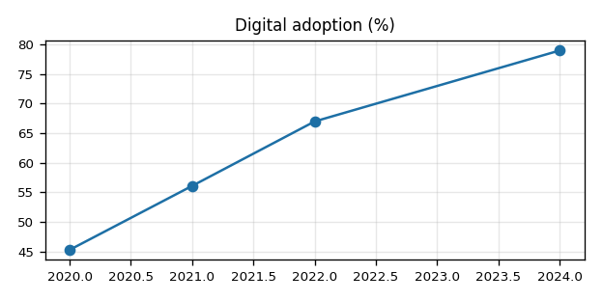

Risk & issue indicators
Indicator | Value | Severity | Note
Loss ratio | 39.5% | GREEN | claims_paid_eur / gross_written_premium_eur. Bands: <45% green, 45-55% amber, >=55% red.
Settlement-day drift (YoY) | -2.0 days | GREEN | avg_claim_settlement_days vs previous covered year. Bands: <+2d green, +2-+5d amber, >=+5d red.
Complaints (YoY) | -28.5% | GREEN | complaints_count YoY %. Bands: <+5% green, +5-+15% amber, >=+15% red.
Fraud cases (YoY) | -24.4% | GREEN | fraud_cases_detected YoY %. Bands: <+10% green, +10-+25% amber, >=+25% red.
Compliance incidents | 12 | RED | compliance_incidents sum for the year. Bands: <1 green, 1-2 amber, >=3 red.

Actionable recommendations
1. Implement continuous monitoring for documentation quality assurance.
To address the compliance incidents, we need to proactively ensure that all documents meet our high standards. The 'Documentation' section in Enhanced_Customer_Guidelines_2024.pdf outlines a proactive approach that replaces periodic manual audits with real-time monitoring.
metric: compliance_incidents · policy: Enhanced_Customer_Guidelines_2024.pdf · Documentation
2. Revise the refund policy to eliminate manual calculation and ensure consistency.
With 12 compliance incidents, it is crucial to standardize our processes. The 'Refund Policy' in Enhanced_Customer_Guidelines_2024.pdf highlights the benefits of removing manual calculations and providing clear, defensible figures for refunds.
metric: compliance_incidents · policy: Enhanced_Customer_Guidelines_2024.pdf · Refund Policy
3. Ensure all employees complete data protection certification annually to maintain system access.
To prevent further compliance issues, we must enforce the annual completion of data protection certifications as outlined in Enhanced_Customer_Guidelines_2024.pdf. This will help avoid automatic revocation of system access for non-compliant staff.
metric: compliance_incidents · policy: Enhanced_Customer_Guidelines_2024.pdf · Data Protection & Privacy

Appendix · monthly KPI table
| period | channel | product_line | policies_in_force | new_policies | renewal_rate_pct | gross_written_premium_eur | claims_reported | claims_paid_eur | avg_claim_settlement_days | loss_ratio_pct | nps_score | complaints_count | fraud_cases_detected | compliance_incidents | operating_expense_eur | digital_adoption_pct |
|---|---|---|---|---|---|---|---|---|---|---|---|---|---|---|---|---|
| 2024-01 | Agency | Motor | 17380 | 778 | 88.60 | 1992000 | 365 | 852000 | 19.00 | 42.80 | 42 | 31 | 4 | 1 | 374000 | 73.20 |
| 2024-02 | Agency | Motor | 17520 | 762 | 88.70 | 1978000 | 356 | 833000 | 19.00 | 42.10 | 42 | 30 | 4 | 1 | 373000 | 74.00 |
| 2024-03 | Agency | Motor | 17710 | 790 | 89.00 | 2029000 | 369 | 861000 | 18.00 | 42.40 | 43 | 29 | 3 | 1 | 377000 | 74.80 |
| 2024-04 | Agency | Health | 17920 | 815 | 89.40 | 2076000 | 352 | 824000 | 18.00 | 39.70 | 44 | 28 | 3 | 1 | 380000 | 75.60 |
| 2024-05 | Bancassurance | Health | 18140 | 832 | 89.80 | 2121000 | 357 | 837000 | 18.00 | 39.50 | 45 | 27 | 3 | 1 | 384000 | 76.70 |
| 2024-06 | Bancassurance | Health | 18360 | 848 | 90.10 | 2165000 | 361 | 849000 | 17.00 | 39.20 | 46 | 26 | 3 | 1 | 387000 | 77.90 |
| 2024-07 | Bancassurance | Property | 18590 | 870 | 90.50 | 2218000 | 368 | 865000 | 17.00 | 39.00 | 47 | 25 | 3 | 1 | 391000 | 79.20 |
| 2024-08 | Bancassurance | Property | 18810 | 862 | 90.60 | 2209000 | 360 | 845000 | 17.00 | 38.30 | 47 | 24 | 2 | 1 | 390000 | 80.10 |
| 2024-09 | Direct | Property | 19080 | 901 | 91.00 | 2274000 | 377 | 886000 | 16.00 | 39.00 | 48 | 23 | 2 | 1 | 395000 | 81.30 |
| 2024-10 | Direct | Life | 19340 | 925 | 91.30 | 2336000 | 384 | 903000 | 16.00 | 38.70 | 49 | 22 | 2 | 1 | 399000 | 82.50 |
| 2024-11 | Direct | Life | 19620 | 948 | 91.70 | 2395000 | 372 | 874000 | 16.00 | 36.50 | 50 | 21 | 2 | 1 | 403000 | 83.70 |
| 2024-12 | Direct | Life | 19950 | 980 | 92.10 | 2478000 | 401 | 941000 | 17.00 | 38.00 | 51 | 22 | 3 | 1 | 410000 | 84.90 |

Cited policy chunks
[1] Enhanced_Customer_Guidelines_2024.pdf · Refund Policy
## **1. Refund Policy**
The refund policy for this year represents the culmination of several years of iterative improvement and now offers one of the most customer-friendly return frameworks in the retail sector while maintaining robust controls against fraud and abuse. The refund window has been set at 30 days from the date of purchase, providing customers with substantial time to evaluate their purchase and identify any concerns. Refunds may be issued through an expanded range of methods: the original payment method, store credit, gift card, or digital wallet (including Apple Pay, Google P
[2] Enhanced_Customer_Guidelines_2024.pdf · Refund Policy
## **1. Refund Policy**
This removes manual calculation, eliminates inconsistency, and provides the customer with a clear, defensible figure. The approval authority structure has been refined into a tiered model: refunds up to 75 euro may be approved by any trained employee; refunds between 75 and 200 euro require team leader approval; refunds above 200 euro require store manager approval; and refunds exceeding 500 euro require regional authorization. This tiered approach balances speed of service with appropriate oversight based on financial materiality. A landmark change this year is the in
[3] Enhanced_Customer_Guidelines_2024.pdf · Refund Policy
## **1. Refund Policy**
Physical receipts remain valid and accepted, and for high-value items exceeding 500 euro, blockchain-verified purchase records are accepted as an additional layer of authenticity verification. Items must be returned in category-appropriate condition, assessed using a new standardized condition assessment checklist that employees complete as part of the return process. This checklist provides objective, consistent criteria for evaluating return condition by product category, eliminating subjective judgments and ensuring fair treatment across all customers and all staff
[4] Enhanced_Customer_Guidelines_2024.pdf · Data Protection & Privacy
## **5. Data Protection & Privacy**
Data protection and privacy standards reach their most advanced and comprehensive form this year with the full adoption of a privacy-by-design philosophy that embeds privacy considerations into every new process, tool, technology, and service from its inception rather than treating privacy as an afterthought or compliance overlay. Automated data retention limits are now implemented with intelligent categorization that applies different retention periods based on data type and purpose: transaction data is retained for 6 years (aligned with financial audit re
[5] Enhanced_Customer_Guidelines_2024.pdf · Documentation
## **4. Documentation**
This proactive quality assurance mechanism replaces the previous periodic manual audits with continuous monitoring that catches issues in realtime. Digital records are retained for 6 years with automated compliance checks ensuring that retention rules are respected, that records due for deletion are properly destroyed, and that records subject to legal holds are protected from routine purging. The documentation accuracy KPI target is 98 percent completeness rate per store per month, measured through automated system analysis of mandatory field completion and consistenc
[6] Enhanced_Customer_Guidelines_2024.pdf · Data Protection & Privacy
## **5. Data Protection & Privacy**
Employees who do not complete certification by the annual deadline have their system access automatically revoked until certification is achieved. Non-compliance with data protection protocols at any level results in immediate access revocation pending formal review, and serious or deliberate violations may result in dismissal.
Report id 4c9b2df6b4f5 · CSV 362326717019

