International Journal of Machine Learning and Cybernetics (2022) 13:293–308 https://doi.org/10.1007/s13042-021-01402-9

**ОРИГИНАЛЬНАЯ СТАТЬЯ**



**Нечеткий выбор портфелей активов, основанный на теории принятия трехсторонних решений и совокупной теории перспектив**

**Сян Ван1 · Бо Ван1** **· Шу Лю2 · Хуасюн Ли1 · Тяньсин Ван1 · Дзюнзо Ватада3**

Получена: 3 февраля 2021 / Принята: 27 июля 2021 / Опубликована онлайн: 9 августа 2021

© Автор(ы), по эксклюзивной лицензии Springer-Verlag GmbH Germany, часть Springer Nature 2021

**Аннотация**

Цель нечеткого выбора портфеля активов — создать сочетание ценных бумаг, которое может максимизировать доходность или минимизировать риск. Большинство существующих исследований предполагают, что перед оптимизацией портфеля активов у инвестора на руках все его наличные, а позиция по ценным бумагам отсутствует, что подчас не соответствует действительности. Кроме того, многие исследования основаны на теории ожидаемой полезности, что противоречит поведению некоторых инвесторов, а также может приводить к чрезмерной концентрации капитала. Вследствие этого, в данном докладе, мы предлагаем модель нечеткого выбора портфеля активов, основанную на теории принятия трехсторонних решений и совокупной теории перспектив, что может смягчить два вышеупомянутых недочета. В этой модели каждому действию в наборе действий для ценных бумаг-кандидатов присваивается потенциальная ценность, что делает возможным построить тройное разделение ценных бумаг-кандидатов в соответствии с теорией принятия трехсторонних решений. Для подтверждения эффективности нашего подхода, мы применили его к двум тематическим исследованиям на основе реальных рыночных данных. Экспериментальные результаты подтвердили, что применение теории принятия трехсторонних решений и совокупной теории перспектив повышает доходность инвестиций и, в то же время, снижает риск для инвестора.

**Ключевые слова** Нечеткий выбор портфелей активов · Трехстороннее решение · Совокупная теория перспектив · Теория ожидаемой полезности

**1  Введение**

Теория выбора портфелей активов началась с основополагающей работы Марковица [27], основным вопросом которой была максимизация доходности или минимизация риска. В Источнике [27] Марковиц использовал среднее значение

**\***\ Бо Ван

\ bowangsme@nju.edu.cn

\ Сян Ван

\ thisiswangxianhe@gmail.com

\ Шу Лю

\ liushusue65@gmail.com

\ Хуасюн Ли

\ huaxiongli@nju.edu.cn

\ Тяньсин Ван

\ wangtianxing@smail.nju.edu.cn

\ Дзюнзо Ватада

\ junzow@osb.att.ne.jp

1\ Школа менеджмента и инжиниринга, Наньцзинский университет, Наньцзин 210093, Китай

2\ Школа финансов, Чжуннаньский университет экономики и права, Ухань 430073, Китай

3\ Школа информации, производства и систем, Университет Васэда, Фукуока 808‑0135, Япония

в качестве показателя доходности, а дисперсию — в качестве показателя риска. В отличие от модели Марковица, которая основана на случайных переменных, Чен [ 3] использовал нечеткие переменные для обозначения неопределенности будущей доходности и риска и получил оптимальное распределение активов с помощью нечеткой оптимизации портфелей активов. В последние годы многие исследователи предлагали различные метрики доходности и риска для улучшения и совершенствования моделей нечеткого выбора портфелей активов [11, 12, 19, 34]. Работы этих исследователей значительно улучшили теоретическую и прикладную ценность выбора портфелей активов, однако большинство существующих исследований все еще подвержены двум недостаткам.

Первый недостаток заключается в том, что их модели предполагают, что перед оптимизацией портфеля активов у инвестора на руках все его наличные, а позиция по ценным бумагам отсутствует. Это предположение подчас противоречит действительности, что в определенной степени препятствует практическому применению моделей выбора портфелей активов. Вследствие этого, ряд стратегий выбора портфелей активов предлагает устранить этот недостаток. Причем большинство из них является онлайн-стратегиями, включая следование за победителем, следование за проигравшим, метаобучение, сопоставление с образцом и т.д. [18]. Развитие искусственного интеллекта значительно повысило практическую ценность онлайн-стратегий выбора портфелей активов. Однако онлайн-стратегии выбора портфелей активов направлены на проблемы очень краткосрочных инвестиций, например, высокочастотной

1 3

\294 International Journal of Machine Learning and Cybernetics (2022) 13:293–308

торговли. И насколько нам известно, существуют отдельные исследования, решающие проблемы выбора долгосрочных портфелей активов, учитывающие вышеупомянутый недостаток. Основываясь на предположении, что уже владеет ценными бумагами в долгосрочной инвестиции, модель выбора портфелей активов в этом докладе разработана путем применения теории принятия трехсторонних решений (three-way decision theory, 3WD), что, как ожидается, обеспечит всестороннюю поддержку принятия решений. Поскольку инвестор может проявить нерешительность ввиду недостатка информации на рынке капитала, на этот раз отложенное решение, вдохновленное 3WD, может быть лучшим вариантом, чем решение, принятое в спешке.

3WD [42], разработанная из теории грубых множеств, предложенной Павляком, вызвала большой интерес в академических кругах и отраслях промышленности, связанных с принятием решений, грубыми множествами [40], гранулированными вычислениями, уменьшением атрибутов [45]. Основной концепт 3WD заключается в разделении пространства решений на три непересекающихся области (положительная (positive), граничная (boundary) и отрицательная (negative) области) с помощью двух пороговых значений, *α* и *β*. Основываясь на принципе минимизации байесовского риска, правила принятия решений для 3WD формируются из трех непересекающихся областей, включающих принятие (acceptance), воздержание (non-commitment) и отказ (rejection). В случае недостатка информации, воздержание рассматривается как отложенное решение,что соответствует процессу принятия решений человеком. И в последние годы 3WD была применена во множестве сфер, включая обучение с учетом издержек классификации [13], распознавание изображений [20], формирование когнитивных понятий [21], рекомендательные системы [ 24], медицинскую диагностику [41] и инкрементную кластеризацию [43]. Трехсторонние правила, сформированные положительной, граничной и отрицательной областями, могут соответствовать решениям о покупке (buy), отсрочке (deferment) и продаже (sell) в выборе портфелей активов. Таким образом, можно видеть, что процедуры 3WD по своей сути совпадают с выбором портфелей активов.

Кроме того, можно ожидать, что внедрение 3WD при выборе портфелей активов также позволит застраховаться от неопределенности будущей доходности ценных бумаг. Чжан [44] предложил теоретико-игровые затененные множества, основанные на нечеткой энтропии, трехстороннюю аппроксимацию нечетких множеств, чтобы найти метод баланса для двух видов неопределенностей. А Мансур [26] отметил, что доходности по ценным бумагам содержат много аспектов неопределенности, таких как двусмысленность (ambiguity) и расплывчатость (vagueness). Для того, чтобы описать степень случайности и волатильность рынка ценных бумаг, многие исследователи используют случайные или нечеткие переменные для прогнозирования тенденции доходности ценных бумаг [1, 17, 31]. Независимо от того, насколько продвинуты методы прогнозирования, прогнозируемые результаты всегда будут содержать некоторые субъективные элементы, такие как выбор функции распределения вероятности/принадлежности и оценка связанных параметров, таких как среднее значение и дисперсия. Неизбежным фактом является то, что эти прогнозы не всегда могут быть корректными и точными [11 ]. Чрезмерная зависимость от результатов прогноза может привести к избыточной концентрации риска. Более того, большинство существующих методов включают только покупку и продажу ценных бумаг. Использование же 3WD, особенно рассматривание граничной операции, напротив, может в определенной степени

лучше застраховать от неопределенности прогнозирования. Вследствие этого, может иметь смысл в создании модели выбора портфелей активов на основе 3WD.

Второй недостаток большинства существующих исследований в том, что они полностью основаны на теории ожидаемой полезности (expected utility theory, EUT). В течение длительного времени EUT доказала свою эффективность при выборе портфелей активов [2, 6]. Однако, Канеман и Тверски обнаружили, что поведение некоторых инвесторов при принятии решений в условиях риска и неопределенности не согласуется с EUT, и эти сведения легли в основу теории перспектив (prospect theory, PT) [15]. Следуя работе Квиггина [29] и Шмейдлера [30], Тверски и Канеман расширили PT для случая неопределенных и рискованных перспектив со множеством исходов, и представили совокупную теорию перспектив (cumulative prospect theory, CPT) [33]. В CPT предполагается, что перспективная ценность сценария количественно определяется с помощью весовой функции вероятности и функции ценности. CPT обобщает феномены неприятия потерь и уменьшающейся чувствительности. И лицо, принимающее решения, всегда будет останавливаться на решении с наибольшей перспективной ценностью среди всех доступных вариантов. Эффективность CPT при характеризации поведения инвесторов было подтверждено большим количеством экспериментов. Вследствие этого, многие исследователи применяли CPT для выявления предпочтений лиц, принимающих решения, касательно риска [8, 16, 39]. В этом докладе CPT используется совместно с EUT для оценки предпочтений лиц, принимающих решения, касательно каждого возможного исхода.

Основываясь на вышеприведенном анализе, в этом докладе предлагается новаторская модель нечеткого выбора портфелей активов, основанная на 3WD и CPT. Прежде всего, предполагается, что инвесторы уже имеют позицию по ценным бумагам до начала оптимизации выбора портфелей активов. Затем рассчитывается перспективная ценность ценных бумаг для каждого возможного исхода. В соответствии с результатами вычислений, ценные бумаги можно классифицировать разбиением на три непересекающихся области 3WD. Наконец, в соответствии с результатами классификации, оптимальное решение об инвестировании можно получить, решив данную модель выбора портфелей активов.

Основной вклад данного доклада включает следующее: (1) 3WD рассматривается как способ справляться с неточными результатами прогнозирования доходности инвестиций и проблемами долгосрочных инвестиций с ценными бумагами на руках. Экспериментальные результаты демонстрируют, что применение 3WD в выборе портфелей активов гарантирует разнообразие распределения капитала и достигает снижения риска; (2) CPT применяется совместно с EUT для достижения баланса между максимизацией перспективной ценности и ожидаемой доходности. Экспериментальные результаты подтверждают эффективность комбинации CPT и EUT в выборе портфелей активов.

Остальная часть этого доклада организована следующим образом. Раздел 2 описывает предварительные сведения, используемые в этом докладе. Раздел 3 определяет правила классификации ценных бумаг, основываясь на 3WD и CPT. Раздел 4 демонстрирует создание четырех моделей выбора портфелей активов и представляет алгоритм решения. В разделе 5 демонстрируются два тематических исследования, основанные на реальных рыночных данных, проведенные для обоснования эффективности предложенных методов. Наконец, в разделе 6 представлено заключение доклада.

1 3

|  |  |  |  |  |  |
| --- | --- | --- | --- | --- | --- |
| International Journal of Machine Learning and Cybernetics (2022) 13:293–308\ |  |  |  | 295 |  |
|  |  |  |  |  |  |
| **2 Предварительные сведения** | **Таблица 1** Матрица функции |  |  |  |  |
|  |  | *C* |  |
|  | потерь | |  |  |  |
| В этом разделе будут представлены некоторые предварительные |  |  | *P* | *PN* |  |
| сведения из теории нечетких множеств, 3WD и CPT. | *A* | | *PP* |  |
|  |  | *B* | *BN* |  |
|  | *A* | | *BP* |  |
|  | *A* | | *NP* | *NN* |  |
|  |  |  | *N* |  |  |

**2.1  Теория нечетких множеств**

Для того, чтобы описать волатильность и нестатистические признаки рынка ценных бумаг, широкое применение получили нечеткие переменные для представления возможной доходности ценных бумаг в будущем. В контексте нечеткости, наиболее часто употребляемая мера — это возможность. Однако, сложно показать уровень вероятности наступления нечеткого события, поскольку мера возможности не является самодвойственной. Для построения двойственной меры в теории нечетких множеств, Лю и Лю [23] определили самодвойственную функцию множества, т.н. меру достоверности.

Предположим, что *ξ* является нечеткой переменной с функцией членства(*x*) . Для любого действительного числа *R* ∈ ℜ, достоверность события *r* определяется Лю и Лю [23] как:

принадлежит состоянию X, а соответствующие значения *PN* , *BN* , *NN* представляют собой потери, вызванные принятием тех же действий, в то время как элемент не принадлежит состоянию X.

Для объекта *o*, *p*( [*o*]) и *p*( *C* [*o*]) обозначают вероятности *o*, принадлежащего или не принадлежащего состоянию X, соответственно. Затем, для объекта *o* ожидаемые потери от предпринятия различных действий рассчитываются по формуле:

|  |  |
| --- | --- |
| R(*P* [*o*]) = *PP* × *p*( [*o*]) + *PN* × *p*( *C* [*o*]), |  |
| R(*B* [*o*]) = *BP* × *p*( [*o*]) + *BN* × *p*( *C* [*o*]), | (4) |
| R(*N* [*o*]) = *NP* × *p*( [*o*]) + *NN* × *p*( *C* [*o*]). |  |

|  |  |  |  |  |  |  |  |  |  |  |  |  |  |  |  |  |  |  |  |  |  |  |  |  |  |  |
| --- | --- | --- | --- | --- | --- | --- | --- | --- | --- | --- | --- | --- | --- | --- | --- | --- | --- | --- | --- | --- | --- | --- | --- | --- | --- | --- |
| Cr{ | ≤ *r*} = | | 1 | [sup (*x*) + 1 − sup (*x*)]. | | | | | | | | (1) | В соответствии с Байесовскими правилами принятия решений, принципы | | | | | | | | | | | | |  |
|  | минимальных потерь могут быть вычислены следующим образом: | | | | | | | | | | |  |  |  |
|  |  |  | 2 ≤*r* | |  |  |  | *>r* | |  |  |  |  |  |
| Лю и Лю [23] также определили ожидаемое значение нечеткой переменной | | | | | | | | | | | | | (P0) IF R(*P* [*O*]) ≤ R(*B* [*O*]) AND R(*P* [*O*]) ≤ R(*N* [*O*]), | | | | | | | | | | | | |  |
|  |  |  | ∈ | ( | ) |  |  |  |  |  |  |  |  |
| *ξ* как: | |  |  |  |  |  |  |  |  |  |  |  | THEN |  |  |  |  |  |  |  |
|  |  |  |  |  |  |  |  |  |  |  |  |  |  | DECIDE | *O* |  | POS | | , |  |  |  |  |  |  |  |
|  | +∞ | | | |  | 0 | | |  |  |  |  | (B0) IF R(*B* [*O*]) | | | | ≤ R(*P* [*O*]) AND R(*B* [*O*]) ≤ R(*N* [*O*]), | | | | | | | | |  |
|  |  |  |  |  | (2) |  |  |  |  | ( |  |  |  | |  |  |  |  |  |
| E[ ] = �0 | |  | Cr{ | | ≥ *r*}*dr* − �−∞ Cr{ ≤ *r*}*dr*. | | | | | | | THEN |  | ∈ | ) | |  |  |  |  |
|  |  |  |  |  |  |  |  |  |  |  |  |  |  | DECIDE | *O* |  | BND | | , |  |  |  |  |  |  |  |
| Мера достоверности — самодвойственная функция, т.е., | | | | | | | | | | | | | (N0) IF R(*N* | | [*O*]) | | ≤ R(*P* [*O*]) AND R(*N* | | | |  | [*O*]) ≤ R(*B* | | | [*O*]), |  |
| THEN |  |  | ∈ NEG( ). | | | |  |  |  |  |  |  |
|  | *r*} =1−Cr{ *>r*}. Кроме того, мера достоверности | | | | | | | | | | | |  | DECIDE | *O* |  |  | |  |  |  |  |  |  |  |  |
| Cr{ |  |  |  |  |  |  |  |  |  |  |  |  |  |  |
| удовлетворяет аксиомам о монотонности, максимальности, | | | | | | | | | | | | |  |  |  |  |  |  |  |  |  |  |  |  |  |  |
| субаддитивности и нормальности. И для любого действительного числа | | | | | | | | | | | | | **2.3 Совокупная теория перспектив** | | | | | | | | | | |  |  |  |
| ∈ (0, 1), обозначение *γ*-уровневого среза множества нечетких переменных *ξ* | | | | | | | | | | | | |  |  |  |
| определяется как [38]: | | | | |  |  |  |  |  |  |  |  | Чтобы предоставлять рациональное объяснение, почему инвесторы делают-- | | | | | | | | | | | | |  |
| [ (*x*)] = {*x* | |  |  |  |  |  |  | , |  |  |  | (3) |  |
| (*x*) | | | } = {*x* | [ | *x* | *x* |  | ]}. | те или иные решения в условиях неопределенности и конфликта рисков, | | | | | | | | | | | | |  |
|  |  |  |  |  |  |  |  |  |  |  |  |  |
|  |  |  |  |  |  |  |  |  |  |  | с помощью классических экономических теорий, Тверски и Каннеман | | | | | | | | | | | | |  |
|  |  |  |  |  |  |  |  |  |  |  |  |  | предложили PT [15] and CPT [33]. Предположим, есть M | | | | | | | | | | | | |  |
|  |  |  |  |  |  |  |  |  |  |  |  |  | вариантов, из которых можно выбирать. Каждый вариант | | | | | | | | | | | | |  |
| **2.2  Теория принятия трехсторонних решений** | | | | | | | | | | | |  | может вести к *k*исходов, количественно определяемых через *x*1, *x*2, …, *xk* . Вероятность | | | | | | | | | | | | |  |
|  |  |  |  |  |  |  |  |  |  |  |  |  | исхода *xi* | | | | | | | - *pi* . В классической EUT лица, - | | | | | |  |
| Основные понятия и правила 3WD представил | | | | | | | | | | | | | принимающие решения, всегда выбирают вариант с наибольшим | | | | | | | | | | | | |  |
| ожидаемым значением, т.е. максимизируют | | | | | | | | | | *k* | × *pi*. | |  |
| Яо [42]. Предположим набор состояний задается как *U* = { , *C*}, | | | | | | | | | | | | | *i*=1 *xi* |  |
| из этого следует, принадлежит элемент состоянию X или нет, | | | | | | | | | | | | | Однако, Тверски и Каннеман выяснили, что ожидание | | | | | | | | | | | | |  |
| соответственно. И набор действий задается как A = {*aP* , *aB* , *aN* | | | | | | | | | | | | }, | инвесторов относительно прибыли и убытков не линейны. | | | | | | | | | | | | |  |
| в котором *aP* , *aB* , *aN* указывают как классифицировать элементы в три | | | | | | | | | | | | | И прибыль, и убытки - не абсолютные значения, они | | | | | | | | | | | | |  |
| непересекающиеся области: положительную (POS( )), граничную (BND( )) и | | | | | | | | | | | | | рассчитываются относительно исходной точки. Инвесторы будут | | | | | | | | | | | | |  |
| отрицательную (NEG( )) области соответственно. Функции потерь | | | | | | | | | | | | | разыгрывать неприятие потерь, пока противостоят одинаковой степени | | | | | | | | | | | | |  |
| выписаны в Таблице 1 по предпринимаемым действиям в разных состояниях, | | | | | | | | | | | | | прибыли и убытков. Параллельно, они выяснили, что вероятности | | | | | | | | | | | | |  |
| где *PP* , *BP* , *NP* представляют собой | | | | | | | | | | | | | будут конвертироваться в вес решения, и инвесторы- | | | | | | | | | | | | |  |
| потери, соответствующие принятию действий *aP* , *aB* , *aN* в то время, как элемент | | | | | | | | | | | | | будут преувеличивать низко вероятное событие и преуменьшать | | | | | | | | | | | | |  |

1 3

\296 International Journal of Machine Learning and Cybernetics (2022) 13:293–308

высоко вероятное событие. Вышесказанное сформировало два наиболее важных математических аппарата в CPT: функция ценности и весовая функция вероятности. Прототипные примеры этих двух функций, выведенных Тверски и Каннеманом, определены Формулами (5) и (6).

|  |  |  |  |  |  |  |  |  |  |  |  |
| --- | --- | --- | --- | --- | --- | --- | --- | --- | --- | --- | --- |
|  |  | (*x* − *x* ) , | | | | |  |  | *x > x* , | (5) |  |
|  |  | − ∗ (*x*0 − *x*) , | | | | |  |  | *x* ≤ *x*0. |  |
| *v*(*x*) = | |  | 0 | | |  | 0 | | |  |  |
|  |  |  |  |  |  |  |  |  |  |
|  |  |  |  |  |  | *p* |  |  |  |  |  |
| *w*+(*pg*) = | |  |  |  | *g* |  |  | , |  |  |
|  |  |  |  | 1 | |  |  |
|  |  |  | (*pg* + (1 − *pg*) ) | | | | | | (6) |  |
|  |  |  |  |  | *l* | *pl* |  |  |  |  |
|  |  |  |  |  |  |  |  |  |  |  |
|  | *w*−(*pl*) = | |  |  |  |  |  | , |  |  |  |
|  |  |  |  | 1 |  |  |  |
|  |  |  |  |  |  |  |  |  |  |  |  |
|  |  |  | (*p* + (1 − *pl*) | | | | ) | | |  |  |
|  |  |  |  |  |

где обычно предполагается, что = 0.88 , = 0.88 ,

= 2.25, = 0.61, = 0.69, и значение *θ* указывает степень неприятия потерь. Кроме того, *x*0 - это исходная точка, в то время как *pg* и *pl* - это вероятности прибыли и убытков. Графические представления функции ценности и весовой функции вероятности показаны на Рис. 1 и 2. Комбинация функции ценности и весовая функция вероятности дает разумное объяснение, почему лица, принимающие решение, всегда стараются рискнуть, сталкиваясь с высоко вероятными потерями и низко вероятной прибылью, и стараются не рисковать, встречаясь с высоко вероятной прибылью и низко вероятными убытками.

В CPT предпочтение того или иного варианта оценивается перспективной ценностью соответствующего значения. Чтобы вычислить перспективную ценность варианта X , лицо, принимающее решение, сначала отсортирует все возможные исходы у варианта X по возрастанию: от самой большой потери до самой большой прибыли, как

(*x*−*m*, *x*−*m*+1 … *x*−1, *x*1 … *xn*−1, *xn*) , где отрицательные индексы означают потери, положительные индексы - прибыль.

Предположим, что вектор вероятности исхода -

(*p*−*m*, *p*−*m*+1 … *p*−1, *p*1 … *pn*−1, *pn*), тогда вес решения для каждого исхода вычисляется по формуле:

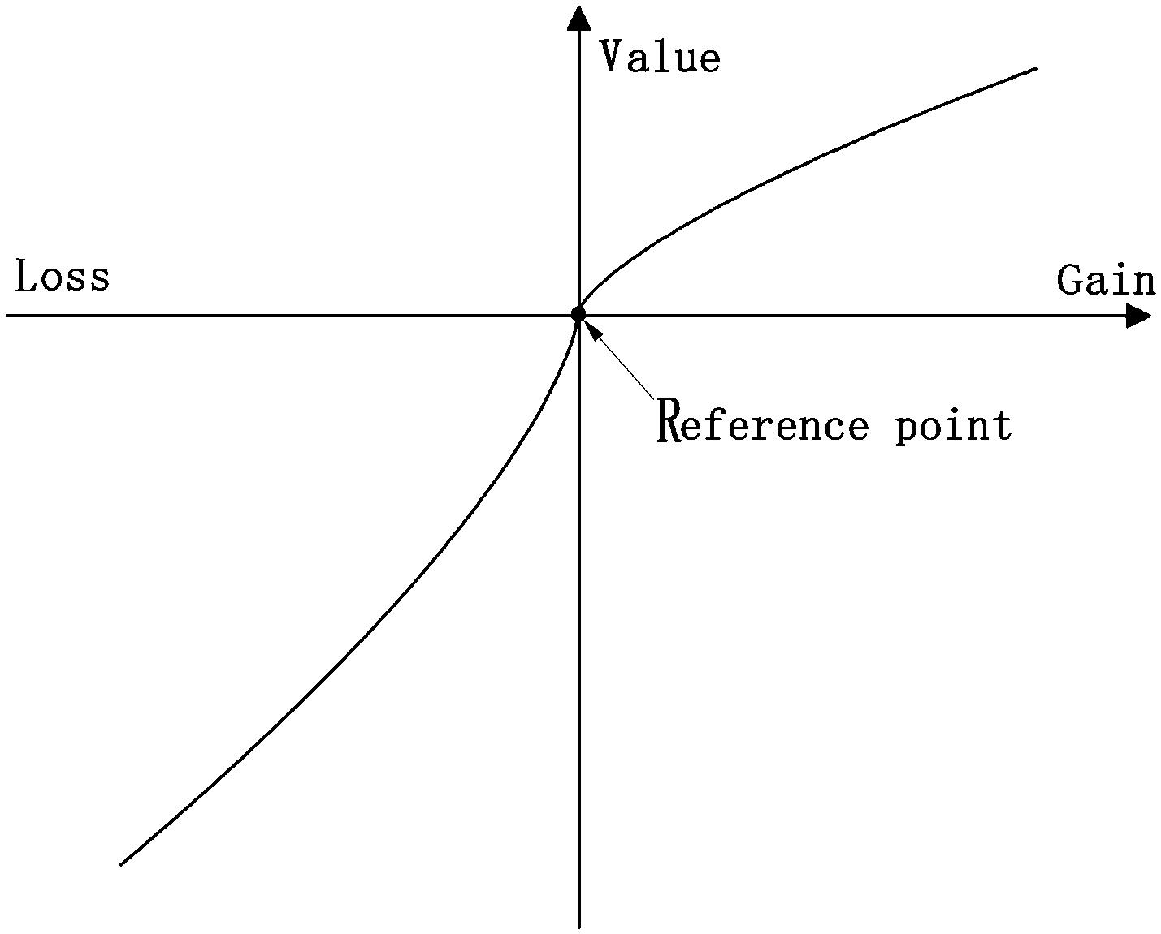

**Рис. 2** Пример весовой функции

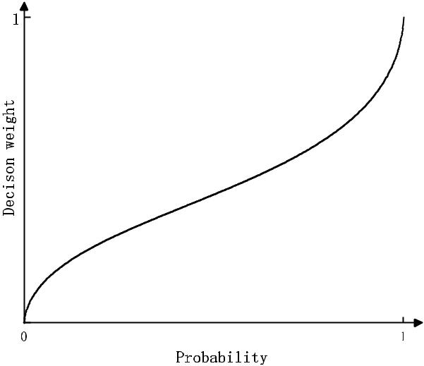

|  |  |  |  |  |  |  |  |  |  |  |  |  |  |
| --- | --- | --- | --- | --- | --- | --- | --- | --- | --- | --- | --- | --- | --- |
|  | *w*−(*p* | | | | ), |  |  |  |  |  |  | i=-m, |  |
|  |  |  |  | −*m* |  |  |  |  |  |  |  |  |  |
|  |  | −( | |  | + ⋯ + ) − *w*−(*p* | | | | + ⋯ + *p* |  | ), | -m<i<0, |  |
| (*xi*) = | + |  | *p*−*m* |  | *pi* |  |  | −*m* | *i*−1 |  |  |  |
| *w*+ | |  |  | + |  |  | 0<i<n, |  |
|  | *w* |  | (*pi* + ⋯ + *pn*) − *w* | | | |  | (*pi*+1+⋯+*pn* ), | |  |  |  |
|  |  |  |  |  |  |  |  |  |  |  |  |  |  |
|  | *w* (*pn*), | | | |  |  |  |  |  |  |  | i=n. |  |
|  |  |  |  |  |  |  |  |  |  |  |  |  |  |
|  |  |  |  |  |  |  |  |  |  |  |  | (7) |  |
| Наконец, перспективная ценность варианта X вычисляется по формуле: | | | | | | | | | | | | |  |
|  | *n* | |  |  |  |  |  |  |  |  |  |  |  |
|  | *i m* | | | |  |  |  |  |  |  |  | (8) |  |
| V(X) = | |  |  | (*xi*) × *v*(*xi*). | | |  |  |  |  |  |  |

=−

**2.4  Теория принятия трехсторонних решений, основанная на совокупной теория перспектив.**

Учитывая широкое распространение приложений и успех CPT в принятии решений, Ван [37] объединил CPT с теорией 3WD, чтобы получить модель CPT-3WD. Эта модель по-прежнему состоит из набора состояний *U* = { , *C*} и набора действий A = {*a* , *a* , *a* }.

*P* *B* *N*

Кроме того, элементы набора состояний и элементы набора действий в CPT-3WD используют одни и те же значения с соответствующими элементами в 3WD. В CPT, исходы используются, чтобы оценивать итоговое денежное состояние инвестора. Исходы отражают изменение денежного состояния лица, принимающего решения, которые возникли в результате вышеупомянутых мер в соответствующих состояниях, и Таблица 2 - это матрица исходов

|  |  |  |  |  |  |
| --- | --- | --- | --- | --- | --- |
|  | **Таблица 2** Матрица исходов |  |  |  |  |
|  |  |  | *C* |  |
|  |  |  |  |  |  |
|  | *A* | | *PP* | *PN* |  |
|  |  |  | *P* |  |  |
|  | *A* | | *BP* | *BN* |  |
|  |  |  | *B* |  |  |
| **Рис. 1** Пример функции ценности. | *A* | | *NP* | *NN* |  |
|  |  | *N* |  |  |
|  |  |  |  |  |

1 3

|  |  |
| --- | --- |
| International Journal of Machine Learning and Cybernetics (2022) 13:293–308\ | 297 |
|  |  |

*ij* (*i* = *P*, *B*, *N*, and *j* = *P*, *N*) в разных состояниях. Предполагается, что следующие состояния могут произойти в реальном мире [37]:

|  |  |  |  |
| --- | --- | --- | --- |
| *NP < BP* | *PP* | , |  |
| *PN < BN* | ≤ *NN* | . | (9) |

Согласно CPT, каждый исход приносит ценность решения и показывает свое влияние на процесс принятия решения. Эта ценность решения зависит от выбора точки отсчета. Suppose that the reference point has been pre-selected as

, where if the outcome *ij* *>* (*i* = *P*, *B*, *N*, and *j* = *P*, *N*), the decision-maker will regard it as a gain, and vice versa.



Substituting these outcomes and the reference point into the value function (in Formula (5)) yields Table 3 as below.

Following CPT, the conditional probabilities will be twisted into decision weights by the weight function (in Formula (7)), and then play a role in the decision-making process. Suppose the conditional probability of object *o* belongs to state is *p*( [*o*]), and *p*( *C* [*o*])denotes the conditional probabilityof object *o* does not belong to state . Furthermore, the degree to which conditional probabilities are twisted varies accord-ing to gains or losses. By comparing the values of *viP* with *viN* , all the conditions of the weight function *i*(*p*( [*o*]))and *i*(*p*( *C* [*o*])) (*i* = *P*, *B*, *N*) are written as follows:

V(*P* [*o*]) = *vPP* × *P*(*p*( [*o*])) + *vPN* × *P*(*p*( *C* [*o*])),

V(*B* [*o*]) = *vBP* × *B*(*p*( [*o*])) + *vBN* × *B*(*p*( *C* [*o*])), (11) V(*N* [*o*]) = *vNP* × *N* (*p*( [*o*])) + *vNN* × *N* (*p*( *C* [*o*])).

Eventually, the decision rules in CPT-3WD which are called the maximum-prospect-value rules are expressed below:

|  |  |  |  |  |  |  |  |  |  |  |  |  |  |  |  |  |  |  |  |
| --- | --- | --- | --- | --- | --- | --- | --- | --- | --- | --- | --- | --- | --- | --- | --- | --- | --- | --- | --- |
| (P1) |  |  |  |  | ∈ |  | [*O*]) | | | |  | [*O*]) | | |  | [*O*]), | | |  |
| IF V(*P* | [*O*]) | | | | V(*B* | AND V(*P* | V(*N* |  |
| THEN | DECIDE *O* | | | |  | POS( ), | | | | |  | |  |  |  | |  |  |  |
| (B1) |  | |  |  | ∈ |  | |  |  |  |  |  | [*O*]), | |  |
| IF V(*B* |  | [*O*]) ≥ V(*P* | | | |  | [*O*]) AND V(*B* | | | |  | [*O*]) ≥ V(*N* | | |  |  |
| THEN | DECIDE *O* | | | |  | BND( ), | | | | |  |  |  | [*O*]) ≥ V(*B* | | |  |  |  |
| (N1) IF V(*N* | |  |  | [*O*]) ≥ V(*P* | | |  |  | [*O*]) AND V(*N* | | | |  |  | [*O*]), |  |
| THEN |  | | |  | ∈ NEG( | | | |  | ). |  |  | |  |  | | |  |  |
|  | DECIDE *O* | | | |  |  |  |  | |  |  |  |  |  |  |  |  |  |  |

**3  Security classification based on three‑way decision and cumulative prospect theory**

Based on the assumption that the investor already holds securities prior to the portfolio optimization, we proposed the portfolio selection model based on 3WD and CPT to achieve the goal of asset diversification and hedging against the uncertainties of future returns.

*w*+(*p*(**�**[*o*])),

1 − *w*+(*p*( *C***�**[*o*])),

1 − *w*−(*p*( *C***�**[*o*])),

*i*(*p*( **�**[*o*])) = *w*−(*p*( **�**[*o*])), *w*+(*p*(**�**[*o*])),

*w*−(*p*(**�**[*o*])),

|  |  |  |  |  |  |  |  |  |
| --- | --- | --- | --- | --- | --- | --- | --- | --- |
|  |  | − |  | *C* |  | **�** |  |  |
|  | 1 − *w*+(*p*( | | | | | [*o*])), |  |
|  | *w*+(*p*( *C* [*o*])), | | | | | |  |
|  |  | *w* (*p*( | |  | **�** | [*o*])), | |  |
| *i*(*p*( *C* [*o*])) = |  | + | − | *C* | **�** |  |  |
|  |  |  |  | [*o*])), |  |
| **�** |  | 1 − *w* (*p*( | | | | |  |
|  |  |  |  | **�** |  |  |  |
|  |  |  |  |  |  |  |
|  | *w*−(*p*( *C***�**[*o*])), | | | | | |  |
|  |  | *w* (*p*( | |  | **�** | [*o*])), | |  |
|  |  |  |  |  |
|  |  |  |  |  |  |  |  |  |

|  |  |  |
| --- | --- | --- |
| 0 | ≤ *viN* ≤ *viP*, | |
| 0 | ≤ *viP* *<* *viN* , | |
| *viN* ≤ *viP <* 0, | | |
| *viP < viN <* 0, | | |
| *viN <* 0 | | ≤ *viP*, |
| *viP <* 0 | | ≤ *viN* , |
| 0 | ≤ *viN* ≤ *viP*, | |
| 0 | ≤ *viP* *<* *viN* , | |
| *viN* ≤ *viP <* 0, | | |
| *viP < viN <* 0, | | |
| *viN <* 0 | | ≤ *viP*, |
| *viP <* 0 | | ≤ *viN* . |

(10)

Figure 3 shows how this portfolio selection model is built and solved in this paper. In Fig. 3, each rectangle color block represents a security and the area of each rec-tangle represents the investment proportion on the secu-rity. Step 1 is the calculation of the prospect value of the security for each listed action. And each security is painted with the color of the action corresponding to the maximum prospect value. Step 2 is the classification of securities into the three disjoint areas, and different actions will be per-formed on different areas. Step 3 is solving the portfolio selection model based on the classification results, where an optimal investment decision can be obtained.

First of all, our proposed portfolio selection model com-plies with the following premises. Supposing the future closing price of security *i* is estimated as fuzzy variable *pi* , and the present price is *pi* , the security *i* pays a divi-dend of *di* . So the return rate of security *i* in the given time

*p* +*d* −*p*�

The prospect values of taking different actions in the action set A = {*aP*, *aB*, *aN* } are listed below:

|  |  |  |  |  |
| --- | --- | --- | --- | --- |
| **Table 3** The value function |  |  |  |  |
|  |  | *C* |  |
| потерь |  |  |  |  |
| *A* | | *VPP* = *V*( *PP* ) | *VPN* = *V*( *PN* ) |  |
|  |  | *P* |  |  |
| *A* | | *VBP* = *V*( *BP* ) | *VBN* = *V*( *BN* ) |  |
|  |  | *B* |  |  |
| *A* | | *VNP* = *V*( *NP* ) | *VNN* = *V*( *NN* ) |  |
|  |  | *N* |  |  |

horizon is defined by fuzzy variable *i* = *i* *i*� *i* . Suppos-



*pi*

ing that the membership function of fuzzy variable *i* is *i*(*x*) , and the *γ*-level cut set of fuzzy variable *i* is:

[ *i*(*x*)] = {*x* *i* (*x*) } = {*x* [*x* , *x* ]}. Then the condition, *X <* 0 *< X* , should be satisfied, which means the security

price may rise or fall in the future.

For the portfolio selection, supposing there are two states to indicate whether a security is worth investing, where means it is worth investing and *C* is not. Вероятность

1 3

\298 International Journal of Machine Learning and Cybernetics (2022) 13:293–308

**Fig. 3** Steps of portfolio selec-tion based on 3WD and CPT

|  |  |  |  |  |
| --- | --- | --- | --- | --- |
| Investmentproportion |  |  |  |  |
| 1 | 2 | 3 | ***Ċ*** | k |
|  |  |  |  | Secuity |
|  |  |  |  | number |

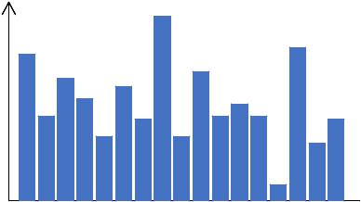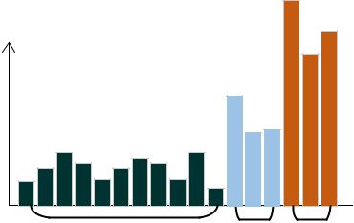

|  |
| --- |
| onpropor |

|  |
| --- |
| Investment |

|  |  |  |
| --- | --- | --- |
| Nega ve ***Ċ*** | Boundary Posi ve | |
| area | area | area |

|  |  |  |  |  |  |  |  |
| --- | --- | --- | --- | --- | --- | --- | --- |
| Investmentproporon |  |  |  |  |  |  |  |
| Step 1 |  |  |  |  |  |  |  |
| Prospect value |  |  |  |  |  |  |  |
| calcula on |  |  |  |  |  |  |  |
|  | 1 | 2 | 3 | Securies | ***Ċ*** | k |  |
|  |  |  | classificaon | 2Step | **Secuity number** |  |
|  |  |  |  |  |  |  |
| Step 3 | Investment | proporon |  |  |  |  |  |
|  |  |  |  |  |  |  |
| Por olio |  |  |  |  |  |  |  |
| op miza on |  |  |  |  |  |  |  |

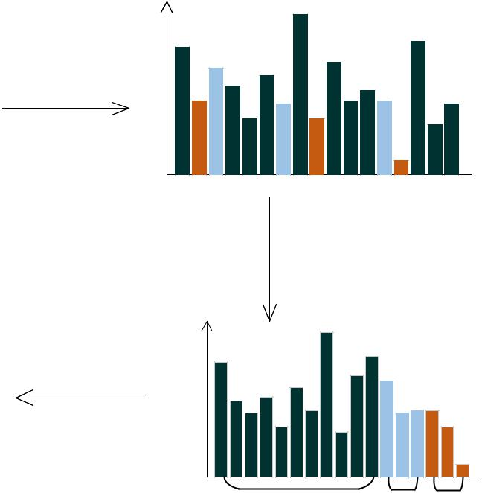

|  |  |  |
| --- | --- | --- |
| Nega ve ***Ċ*** | Boundary Posi ve | |
| area | area | area |

|  |  |  |  |  |
| --- | --- | --- | --- | --- |
| **Table 4** The outcome matrix for |  |  |  |  |
|  |  | *C* |  |
| portfolio selection |  |  |  |  |
| *A* | |  |  |  |
|  | *P* | *PP* | *PN* |  |
| *A* | |  |  |  |
|  | *B* | *BP* | *BN* |  |
| *A* | |  |  |  |
|  | *N* | *NP* | *NN* |  |
|  |  |  |  |  |

decision-maker uses a return rate *x*0 as the reference point to evaluate whether a security is worth investing. *x*0 can be assigned to any reasonable value such as 0 or the risk-free rate. Then is the state while *x x*0 , and *C* is the state while *x* *<* *x*0 . The action set of portfolio selection is rep-resented by A = {*aP*, *aB*, *aN* }, where *aP* means to classify the security into the buying region (POS( )), while *aN* means to classify the security into the selling region (NEG( )). Furthermore, *aB* means to classify the security into the waiting region (BND( )) . Which denotes that the security should neither be bought or sold, i.e., the decision-maker w i l l w a i t a n d s e e . A n d t h e o u t c o m e �*ij* (*i* = P,B,N, and *j* = P,N) represents the investor’s

wealthy change by taking listed actions to the security in corresponding states. Thus the outcome matrix for portfo-lio selection is presented in Table 4.

Since the outcome *PP* denotes the outcome of classifying the security into the buying region in state , it is reasonable to use the weighted average from interval *x* *>* *x*0 to represent the *PP*. Same to this, *PN* can be represented by the weighted average from interval *x x*0 . To calculate the weighted

average from fuzzy interval, Dong [5] proposed a compu-tational algorithm based on *γ*-level cut of fuzzy set theory and interval analysis, which is called fuzzy weighted aver-age. This discretization method is capable to find an exact solution in a simple and efficient manner while containing the ambiguous information represented by the fuzzy variable as much as possible. Such that, this method is adopted by us, then the outcomes *PP* and *PN* are calculated as follow:

|  |  |  |  |  |  |  |  |  |  |  |  |
| --- | --- | --- | --- | --- | --- | --- | --- | --- | --- | --- | --- |
|  |  |  |  |  | + *x*0 | | |  |  |  |  |
|  | � | = | *x* | | , | |  |  |
| *PP* | 2 | | | |  | (12) |  |
|  |  |  |  |  |  |
|  |  |  |  |  |  |  |
| � | | = | *x* + *x* | | | | 0 | | . |  |
|  |  |  |  |  |  |
|  |  |  |  |  | |  |  |
|  | *PN* |  | 2 | | | |  |  |  |  |  |
|  |  |  |  |  |  |  |  |

Besides the outcomes *NP* and *NN* denote the outcomes of classifying the security into the selling region in state and *C* respectively, so it’s sound to let the following equationshold:

|  |  |  |  |  |  |  |  |  |  |  |  |  |  |  |  |
| --- | --- | --- | --- | --- | --- | --- | --- | --- | --- | --- | --- | --- | --- | --- | --- |
|  |  |  |  |  |  |  |  |  | + *x*0 | | |  |  |  |  |
|  |  | � | = − |  | � | = − | *x* | | , | |  |  |
| *NP* |  | *PP* |  | 2 | | | |  | (13) |  |
|  |  |  |  |  |  |  |  |  |
|  |  |  |  |  |  |  |  |  |  |  |
|  |  | � = − | |  | � = − | | *x* + *x* | | | | 0 | | . |  |
| *NN* |  |  |  |  |  |  |  |
|  |  |  |  |  |  | |  |  |
|  |  |  | *PN* | |  | 2 | | | |  |  |  |  |  |
|  |  |  |  |  |  |  |  |  |  |  |  |

As mentioned before, *aB* represents the action of classify-ing the security into the waiting region, which will result in the investment proportion of the security remaining unchanged. Meanwhile, *aP* represents the action of classify-ing the security into the buying region, which will result

1 3

|  |  |
| --- | --- |
| International Journal of Machine Learning and Cybernetics (2022) 13:293–308\ | 299 |
|  |  |

|  |  |  |  |  |  |  |  |  |  |  |  |  |  |  |  |  |  |  |  |  |  |  |  |  |  |  |  |  |  |  |  |  |  |  |  |  |  |  |  |  |  |  |  |  |  |  |  |  |  |  |  |  |  |  |  |  |  |  |  |  |  |  |  |  |  |  |  |  |  |  |  |  |  |  |  |  |  |  |  |
| --- | --- | --- | --- | --- | --- | --- | --- | --- | --- | --- | --- | --- | --- | --- | --- | --- | --- | --- | --- | --- | --- | --- | --- | --- | --- | --- | --- | --- | --- | --- | --- | --- | --- | --- | --- | --- | --- | --- | --- | --- | --- | --- | --- | --- | --- | --- | --- | --- | --- | --- | --- | --- | --- | --- | --- | --- | --- | --- | --- | --- | --- | --- | --- | --- | --- | --- | --- | --- | --- | --- | --- | --- | --- | --- | --- | --- | --- | --- | --- |
| in the increasing to the investment proportion of the secu- | | | | | | | | | | | | | | | | | | | | | | | | | | | | | |  |  |  |  |  |  |  |  |  |  | − *x*0 | | | | | | | | | |  |  |  | | |  |  |  |  |  |  |  |  |  |  |  |  |  |  |  |  |  |  |  |  |  |  |  |  |  |
| � | = *v*( | |  | � | ) = | |  |  | *x* |  |  |  |  |  |  |  |  |  |  |  |  |  |  |  |  |  |  |  |  |  |  |  |  |  |  |  |
| rity. It is plausible to assume a proportional relationship | | | | | | | | | | | | | | | | | | | | | | | | | | | | | | *v* | *PP* |  |  |  |  |  |  |  |  |  |  |  |  |  |  |  |  | , | | |  |  |  |  |  |  |  |  |  |  |  |  |  |  |  |  |  |  |  |  |  |  |  |  |  |
|  |  |  |  |  |  | 2 | |  |  |  |  |  |  |  |  |  |  |  |  |  |  |  |  |  |  |  |  |  |  |  |  |  |  |  |  |  |  |  |  |  |
| *PP* |  |  |  |  |  |  |  |  |  |  |  |  |  |  |  |  |  |  |  |  |  |  |  |  |  |  |  |  |  |  |  |  |  |  |  |  |  |  |  |  |  |  |  |  |  |  |
| exists between the outcomes of *aB* with *aP* | | | | | | | | | | | | | | | | | | | | | | | . Furthermore, | | | | | | | *PN* |  |  | *PN* | |  |  |  |  |  |  |  |  | **�** | | | | *x* | | |  | − *x*0 | | | | **�** | | |  | |  |  |  |  |  |  |  |  |  |  |  |  |  |  |  |  |  |  |  |  |
| this assumption has been verified to be | | | | | | | | | | | | | | | | | | effective by Gao [7]. | | | | | | | | | | | |  |  |  |  |  |  |  |  |  |  |  |  |  | 2 | | | |  |  |  |  |  |  |  |  |  |  |  |  |  |  |  |  |  |  |  |  |  |  |  |
|  |  | |  |  |  |  |  |  |  |  |  |  |  |  |  |  |  |  |  |  |  |  |  |  |  |  |  |  |  |  |  |  |  |  |  |  |  |  |  |  |  |  |  |  |  |  |  |  |  |  |
| Based on this assumption, the outcomes | | | | | | | | | | | | | | | | | | |  |  |  |  |  | and |  | could | | | | *v*� | = *v*( �) = − × | | | | | | | | | | | | | | | |  |  |  |  |  |  |  |  |  |  |  | , | | |  |  |  |  |  |  |  |  |  |  |  |  |  |  |  |  |  |  |  |
|  |  |  |  |  |  |  |  |  |  |  |  |  |  |  |  |  |  |  |  |  |  |  |  |  |  |  |  |  |  |  |  |  |  |  |  |
|  |  |  |  |  |  |  |  |  |  |  |  |  |  |  |  |  |  |  |  |  |  |  |  |  |  |  |  |  |  |  |  |  |  |  |  |
|  |  | *BP* | |  | *BN* |  |  |  |  |  |  |  |  | **�** | | |  |  |  |  |  |  |  |  | |  |  |  |  |  |  |  |  |  |  |  |  |  |  |  |  |  |  |  | |  |  |  |  |  |  |  |  |  |  |
|  |  |  |  |  |  | follows: | | | | | | |  |  |  |  |  |  |  |  |  |  |  |  |  |  |  |  |  |  |  |  |  |  |  |  |  | × | | | | |  | |  | + ( − 2) × *x*0 | | | | | | | | | | | | | | | |  |  |  |  |  |  |  |  |  | |  |
|  |  |  |  |  |  |  |  |  |  |  |  |  |  |  |  |  |  |  |  |  |  |  |  |  |  |  |  |  |  |  | *x* | |  |  |  |  |  |  |  |  | � | |  |
| be assigned as | | | | | |  | |  | | | |  | | | | | | | | | | | | | | | | | | | | � | |  | | |  |  | | | | | | | | | | | | | | | | | | | | | | | | | **�** | | , | | |  | | | | | | | *BP* *>* *x*0 , |  |
|  | | � | | | | | | | | | | | | | | | | | | | = *v*( | ) = | | | 2 | | | | | | | | | | | | | | | | | | | | | | | | |  | | | | | | |  |
|  | � |  | | | � |  | | | | | | |  | |  | | | | | | | | | | | | | | | *v* |  | |  | | | | | | | | | | | | | | | | | | | | | | | | | | | | | | | | | | | | | | | | |  |
|  |  | | |  | | | | | | | | | | | | | | | | | | | | | | | |  | |  | | | | | | | | | | | | | | | | | | | | | | | | | | | | | | | | | | | | | | | | |  |
| *BP* | | = × *PP* | | | | = | |  |  |  |  | × (*x* + *x*0), | | | | | |  |  |  |  |  |  |  |  |  |  |  |  | *BP* |  |  | *BP* |  |  |  |  |  |  |  |  |  |  |  |  |  |  |  |  | (2 − ) × *x*0 − × | | | | | | | | | | | | | | | | | | | | |  |  |  |  |  |  |  |  |  |
|  |  |  |  |  |  |  |  |  |  |  |  |  |  |  |  |  |  |  |  |  |  |  |  |  |  |  |  |  |  |  |  |  | *x* | |  |  |  | � |  |
| *BN* � | | = × *PN* � | | | |  | = |  |  | | | × (*x* + *x* ), | | | | | |  |  |  |  |  |  |  |  | (14) | | | |  |  |  |  |  |  |  |  | − × | | | | | | | | | **�** | | |  |  |  |  |  |  |  |  |  |  |  |  |  |  |  |  |  |  |  |  |  |  |  |  | **�** | , |  | *BP* ≤ *x*0 , | |  |
|  |  |  |  |  |  |  |  |  |  |  |  |  |  |  |  |  |  |  |  |  |  |  |  |  |  |  |  |  | 2 |  |  |  |  |  |  |  |  |  |  |  |  |  |
| 2 | | | | | | | | | | | | | | | | | | | | | | | | | | | | | | | | | | | | | |  | | | | | | | | | | | | | | | | | | | | | | | | | | | |  |  |
|  | | | | | | | | | |  | |  | | | | | 0 |  | | | | | | | | | | | | | | | | | | |  |  | | | | | | | | | | | | | | | | | | | | | | | | | | | | | | | | | | | | | | | | |  |
|  | | | | | | | | 2 | | | |  | |  | |  |  | | | | | | | | | | | | | | | | | | |  | | | | | | | | | | | | | | | | | | | | | | | | | | × *x* | | | | | |  |  | | |  |  | | | |  |
|  | | | | | | | |  | | | | |  | | | | | | | | | | | | | | | | | | |  | | | | | | | | | | | | | | | | | | | | | | | | | |  | | |  | | | |  |
|  | | | | | | | | | | | | | | | | | | | | | | | | | | | | | | � |  | | | � | |  |  |  | | | | | | | | | (2 − ) × *x*0 − | | | | | | | | | | | | | | | | |  | | | | | | | | |  |
|  | | | | | | | | | | | | | | | | | | | | | | | | | | | | | |  | | |  |  | | | | | | | | |  | | | | |  |  | | | | | | | | |  |
| where (0 *< <* 0.5 is a risk control coefficient. The larger | | | | | | | | | | | | | | | | | | | | | | | | | | | | | | *vBN* | = *v*( *BN* | | | |  | ) = − × **�** | | | | | | | | | | |  |  |  |  |  |  |  |  |  |  |  |  |  | | |  |  |  |  |  |  |  |  |  |  | **�** , | | |  |  |  |  |  |
|  |  |  |  |  |  |  |  |  |  |  |  | 2 | | | |  |  |  |  |  |  |  |  |  |  |  |  |  |  |  |
| the coefficient is, the more knowledge about the securities | | | | | | | | | | | | | | | | | | | | | | | | | | | | | | � | = *v*( *NP*�) = − × **�** | | | | | | | | | | | | | | | | 3 × *x*0 + *x* | | | | | | | | | | | | |  |  |  | |  |  |  |  |  |  |  |  |  |  |  |  |  |  |  |  |
| market the decision-maker acquires. | | | | | | | | | | | | | | | | | |  |  |  |  |  |  |  |  |  |  |  |  | *vNP* |  |  |  |  |  |  |  |  |  |  |  |  |  | **�** , | | | |  |  |  |  |  |  |  |  |  |  |  |  |  |  |  |  |
|  |  |  |  |  |  |  |  |  |  |  |  |  |  |  |  |  | 2 | | |  |  |  |  |  |  |  |  |  |  |  |  |  |  |  |  |  |  |  |  |  |
|  | In portfolio selection, the conditions, *x* | | | | | | | | | | | | | | | | | | | | |  | | *<* 0 | *x*0 |  | | | , |  | | | | | | | | | | | | | | | | | | | | | | | | | | | | | | | | | | | | | | | | | | | | | | | | |  |
|  |  |  | *<* | *x* |  |  | = *v*( *NN*�) = **�** | | | | | | | | | | |  |  |  |  |  |  |  |  |  |  |  |  |  |  |  |  | **�** | | |  | | |  |  |  |  |  |  |  |  |  |  |  |  |  |  |  |  |
| should be satisfied when the value of *γ* is | | | | | | | | | | | | | | | | | | | |  | | sufficiently small. | | | | | | | |  | − | | *x* | − 3 × *x*0 | | | | | | | | | | | | |  |  |  |  |  |  |  |  |  |  | � |  |  |  |  |  |
| Only in this way, the value of the reference point *x*0 makes | | | | | | | | | | | | | | | | | | | | | | | | | | | | | |  |  |  |  |  |  |  |  |  |  | | |  |  |  |  |  |  | , |  |  |  |  |  |  |  |  |  |  | *NN* *>* *x*0 | | | | , |  |  |
| *v*� |  |  |  |  |  |  |  |  | 2 | | | |  |  |  |  |  |  |  |  |  |  |  |  |  |  |  |  |
| sense to the investor. Then the following formulas can be | | | | | | | | | | | | | | | | | | | | | | | | | | | | | | *NN* |  |  |  |  |  |  |  | |  |  |  |  |  |  |  |  |  |  |  |  |  |  | *x* +3× *x*0 | | | | | | | | | | |  |  | |  |  |  |  |  |  |  | � |  |  |  |  |  |
|  | | | | | | | | | | | | | | | | | | | | | | | | | | | | | | | | | | | | | | | | | | | | | | | | | | | | |  |  | | | | | | | | | | | | | | | | | | | | | | | | |  |
| easily obtained: | | | | | | | |  | | | | | | | | | | | | | | | | | | | | | | | | | | | | |  | | − × | | | | | | | | | | |  | | |  | | | | | | | | | | **�** | |  | | , |  | | | | | *NN* ≤ *x*0 . | | | | |  |  |
|  |  |  |  |  |  |  |  |  |  |  |  |  |  |  |  |  |  |  |  |  |  |  |  |  |  |  |  |  |  |  |  |  |  | 2 | | | |  |  |  |  |  |  |  |  |  |  |  |  |  |
| **�** | | | | | | | | | | | | | | | | | | | | | | | | | | | | | | | | | | | | | | | | | | | | | | |  | | | |  | | | | | | | | | | | | | |  |
|  | | | | | | | | | | | | | | | | | | | | | | | | | | | | | | | | | | | | | | | | | | | | | | | | | | | | | | | | | | | | | | | | | | | | | | | | | | | | | | |  |
| *PP* | | *> x*0 *> PN* | | | | | , | | | | | | | | | | | | | | | | | | | | | | | | | | | | | | | | | | | | | | | | | | | | | | | | | | | | | | | | | | | | | | | | | | | | | | | (17) |  |
| *BP* | | *> BN* | |  | , |  |  |  |  |  |  |  |  |  |  |  |  |  |  |  |  |  |  |  |  |  |  |  |  | On the other side, conditional probabilities are essential in | | | | | | | | | | | | | | | | | | | | | | | | | | | | | | | | | | | | | | | | | | | | | | | | |  |
| *x*0 *> BN* , | | | |  |  |  |  |  |  |  |  |  |  |  |  |  |  |  |  |  |  |  |  |  |  | (15) | | | | the decision procedures of CPT-3WD, however, Mehlawat | | | | | | | | | | | | | | | | | | | | | | | | | | | | | | | | | | | | | | | | | | | | | | | | |  |
|  | *>* | | *NP* | , | |  |  |  |  |  |  |  |  |  |  |  |  |  |  |  |  |  |  |  |  |  |  |  |  | pointed out that it is convincing to use the credibility in fuzzy | | | | | | | | | | | | | | | | | | | | | | | | | | | | | | | | | | | | | | | | | | | | | | | | |  |
|  | *NN* |  |  |  |  |  |  |  |  |  |  |  |  |  |  |  |  |  |  |  |  |  |  |  |  |  |  |  | set theory to denote the conditional probability of an event | | | | | | | | | | | | | | | | | | | | | | | | | | | | | | | | | | | | | | | | | | | | | | | | |  |
| *x*0 *> NP* . | | | |  |  |  |  |  |  |  |  |  |  |  |  |  |  |  |  |  |  |  |  |  |  |  |  |  |  |  |
|  |  |  |  |  |  |  |  |  |  |  |  |  |  |  |  |  |  |  |  |  |  |  |  |  |  | happening [28]. So the probability of security *i* belongs to | | | | | | | | | | | | | | | | | | | | | | | | | | | | | | | | | | | | | | | | | | | | | | | | |  |
| According to CPT, each outcome brings a decision value and | | | | | | | | | | | | | | | | | | | | | | | | | | | | | | state is taken for Cr{*x x*0}, and the probability of secu- | | | | | | | | | | | | | | | | | | | | | | | | | | | | | | | | | | | | | | | | | | | | | | | | |  |
| rity *i* belongs to state *C* is taken for Cr{*x* *<* *x*0}. Such that | | | | | | | | | | | | | | | | | | | | | | | | | | | | | | | | | | | | | | | | | | | | | | | | |  |
| shows the impact in the decision process. The decision val- | | | | | | | | | | | | | | | | | | | | | | | | | | | | | | the decision weights of | | | | | | | | | | | | | | | | | | | |  | *i*(Cr( [*o*])) and | | | | | | | | | | | | | | | | | | | |  | *i*(Cr( | | | | *C* |  | [*o*])) are |  |
| ues of outcomes | | | | | | | |  |  | � | | (*i* = P,B,N, and *j* = P,N) are calculated | | | | | | | | | | | | | | | | | |  |  |  |  |  |
| *ij* | | | |  |  |  |  |  |  |  |  |  |  |  |  |  |  |  |  |  |  |  |  |  |  |  |  |  |  |  |  |  |  |  |  |  |  |  | | | and | | | | | | *V* | | (*i* = *P*, *B*, *N*) : | | | |  |
| by the following equations: | | | | | | | | | | | | | | | | | |  |  |  |  |  |  |  |  |  |  |  |  | calculated as follow by | | | | | | | | | | | | | | | | | | | |  | comparing *v* *P* | | | | | | | | | | | | | | | |  | *IN* |  |
|  |  |  |  |  |  |  |  |  |  |  |  |  |  |  |  |  |  |  |  |  |  |  | |  |  | *i* | | |  |  |  |  |  |  |  |  |  |  |  |  |  |

|  |  |  |  |  |  |  |  |  |  |  |
| --- | --- | --- | --- | --- | --- | --- | --- | --- | --- | --- |
|  |  |  | ( � | − *x* | ) , | � | *> x* , | |  |  |
| *v*�= *v*(� | | ) = | *ij* | 0 |  | *ij* | 0 |  |  |  |
|  |  |  |  | ≤ *x*0 |  | (16) |  |
| *ij* | *ij* |  | − × (*x*0 − *ij*�) , | | | *ij*� | , |  |

where = 0.88, = 0.88, = 2.25.

Therefore, the value function matrix for portfolio selection can be obtained and presented in Table 5.

In which,

|  |  |  |  |  |
| --- | --- | --- | --- | --- |
| **Table 5** The value function |  |  |  |  |
|  |  | *C* |  |
| matrix for portfolio selection |  |  |  |  |
| *A* | | *V* | *V* |  |
|  | *P* | *PP* | *PN* |  |
| *A* | | *V* | *V* |  |
|  | *B* | *BP* | *BN* |  |

*w*+(Cr(**�**[*o*])),

1 − *w*+(Cr( *C***�**[*o*])),

1 − *w*−(Cr( *C***�**[*o*])),

*i*(Cr( **�**[*o*])) = *w*−(Cr( **�**[*o*])), *w*+(Cr(**�**[*o*])),

*w*−(Cr(**�**[*o*])),

|  |  |  |  |  |  |  |  |  |  |
| --- | --- | --- | --- | --- | --- | --- | --- | --- | --- |
|  |  | − |  |  | *C* |  | **�** |  |  |
|  | 1 − *w*+(Cr( | | | | | | [*o*])), |  |
|  | *w*+(Cr( *C* [*o*])), | | | | | | |  |
|  |  | *w* (Cr( | | |  | **�** | [*o*])), | |  |
| *i*(Cr( *C* [*o*])) = |  | + | − |  | *C* | **�** |  |  |
|  |  |  |  |  | [*o*])), |  |
| **�** |  | 1 − *w* |  | (Cr( | | | |  |
|  |  |  |  |  | **�** |  |  |  |
|  |  |  |  |  |  |  |  |
|  | *w*−(Cr( *C***�**[*o*])), | | | | | | |  |
|  |  | *w* (Cr( | | |  | **�** | [*o*])), | |  |
|  |  |  |  |  |
|  |  |  |  |  |  |  |  |  |  |

|  |  |  |  |
| --- | --- | --- | --- |
| 0 ≤ *v*� | | ≤ *v*� | , |
|  | *iN* | *iP* |  |
| 0 ≤ *v*� | | *< v*� | , |
|  | *iP* | *iN* |  |
| *v*� | ≤ *v*� | *<* 0, | |
| *iN* | *iP* | |  |
| *v*� | *< v*� | *<* 0, | |
| *iP* | *iN* | |  |
| *v*� | *<* 0 | ≤ *v*� | , |
| *iN* |  | *iP* |  |
| *v*� | *<* 0 | ≤ *v*� | , |
| *iP* |  | *iN* |  |
| 0 ≤ *v*� | | ≤ *v*� | , |
|  | *iN* | *iP* |  |
| 0 ≤ *v*� | | *< v*� | , |
|  | *iP* | *iN* |  |
| *v*� | ≤ *v*� | *<* 0, | |
| *iN* | *iP* | |  |
| *v*� | *< v*� | *<* 0, | |
| *iP* | *iN* | |  |
| *v*� | *<* 0 | ≤ *v*� | , |
| *iN* |  | *iP* |  |
| *v*� | *<* 0 | ≤ *v*� . | |
| *iP* |  | *iN* |  |
|  |  | (18) | |

|  |  |  |  |
| --- | --- | --- | --- |
| *A* | | *V* | *V* |
|  | *N* | *NP* | *NN* |
|  |  |  |  |

Therefore, the following formulas can be obtained based on the conclusions in Formulas (15), (17) and (18):

1 3

\300 International Journal of Machine Learning and Cybernetics (2022) 13:293–308

|  |  |  |  |  |  |  |  |  |  |  |  |  |  |  |  |  |  |  |  |  |  |  |  |  |  |  |
| --- | --- | --- | --- | --- | --- | --- | --- | --- | --- | --- | --- | --- | --- | --- | --- | --- | --- | --- | --- | --- | --- | --- | --- | --- | --- | --- |
|  | *P* | (Cr( [*o*])) = *w*+ | | | | | | | (Cr( ) [*o*]), | | | | | | | | | |  |  |  |  |  |  |  |  |
|  |  |  |  |  |  |  |  |  |  |  |  |  |  |  |  |  |  |  |  |  |  |  |  |  |  |
|  |  |  | *C* | | |  |  |  | − |  |  | *C* | |  |  |  |  | ]) | |  |  |  |  |  |  |  |
| *P*(Cr( | | |  |  |  | [*o*])) = *w* | | |  | (Cr( | | − ) | |  |  | [*oC* | | | , | |  | � |  | � |  |  |
|  |  |  |  |  |  |  |  |  | 1 − *w* Cr( | | | | | | | | | |  | [*o*]), | *v* ≤ *v <* 0, | | | | |  |
| *B*(Cr( [*o*])) = | | | | | | | |  |  |  |  |  |  |  | |  |  |  |  |  |  | *BN* |  | *BP* |  |  |
| − |  | + |  |  |  |  |  |  |  |  |  | � |  |  | � |  |
|  |  |  |  |  |  |  |  |  |  |  |  |  | | [*o*])), | | | | | | *vBN* | | *<* 0 *< vBP*, | | |  |
|  |  |  |  |  |  |  | *w* (Cr( | | | | | | |  |  |
| *B*(Cr( *C* [*o*])) = *w*−(Cr( *C* [*o*])), | | | | | | | | | | | | | | | | | | | | |  |  |  |  |  |  |
|  |  |  |  |  | [*o*])) = *w* | | |  |  |  | ( [ ])) | | | | | | |  |  |  |  |  |  |  |  |  |
| *N* (Cr( | | | |  |  | (Cr+ | | |  | *o C* | | | |  | , |  |  | � |  |  |  | � |  |
| *N* (Cr( *C* | | | | | |  |  |  |  | *w* Cr( | | | | |  |  |  | |  |  | *v <* 0 *< v* , | | | | |  |
|  | [*o*])) = |  |  |  |  |  | [*o*]), | | |  |
|  |  |  |  | − |  |  |  |  |  |  |  |  |  | � |  | � |  | *NN* |  |
|  |  |  |  |  |  |  | *w* (Cr( *C* [*o*])), | | | | | | | | | | | | | | *NP* | |  |  | ≤ 0. |  |
|  |  |  |  |  |  |  | *vNP < vNN* | | | |  |
|  |  |  |  |  |  |  |  |  |  |  |  |  |  |  |  |  |  |  |  |  |  |  |  |  | (19) |  |

Then according to Sect. 2.4, the prospect values of taking different actions are listed below.

|  |  |  |  |  |  |  |  |  |  |  |  |  |
| --- | --- | --- | --- | --- | --- | --- | --- | --- | --- | --- | --- | --- |
| V�(*P* | | [*i*]) = *v*� | | × (Cr( [*i*])) + *v*� | | | × (Cr( *C* | |  | [*i*])), |  |  |
|  |  |  | *PP* | *P* |  | *PN* | *P* |  | |  |  |  |
|  |  |  |  |  |  |  |  |  |
| V�(*B* [*i*]) = *v*� | | | | × | (Cr( [*i*])) + *v*� | | × | (Cr( *C* |  | [*i*])), |  |  |
|  |  | | *BP* | *B* |  | *BN* | *B* |  |  | | (20) |  |
|  |  |  |  |  | *C* |  |
| � | (*N* |  | � | × *N* (Cr( | | � |  |  |  |  |  |
| V |  | [*i*]) = *vNP* | [*i*])) + *vNN* | × *N* (Cr( [*i*])). | | | |  |  |

Finally, the candidate securities can be classified into the POS( ) , BND( ) , NEG( ) areas. The classification rules are listed below:

loss in the worst-case scenario. Theoretically, VaR is more sensitive to general investors [ 36]. Suppose fuzzy variable L*i* denotes the loss of security *i* that an investor may suffer, then the VaR of L*i* under confidence level (1 − ) is:

|  |  |
| --- | --- |
| VaR1− (L*i* ) = sup{ Cr(L*i*)}. | (21) |

Most of existing studies assumed that all the capital is in cash and no securities are held before the portfolio optimi-zation. Unfortunately, this assumption sometimes contradict reality, and investors may already own securities. Suppose there are *n* securities for the investor to choose from. The investment proportion of each security before the portfo-lio optimization is *xi* , and the investment proportion after implementing an investment decision is *xi*. Fuzzy variable *i* represents the future return rate of security *i* and its expected value is *E*( *i*), and fuzzy variable L*i* represents the possi-ble loss of security *i* in the future, obviously, L*i* = − *i* for

* = 1, 2, …*n*.

Then in Sect. 4.2 , four portfolio selection models are proposed. All of the four models are based on the assump-tion that the investor put the safety of their investment first, so only when VaR is less than a predefined constraint

|  |  |  |  |  |  |  |  |  |  |  |  |  |  |
| --- | --- | --- | --- | --- | --- | --- | --- | --- | --- | --- | --- | --- | --- |
| (P3) if V�(*P* [*i*]) | | V�(*B* [*i*]) and V�(*P* [*i*]) | | V�(*N* [*i*]), then decide *i* ∈ POS( ) , | | | | | | | |  |  |
|  | V� | V� | V� | V�( | [ | | ]) |  | ∈ |  | ( ) |  |  |
| (B3) if | �(*B* [*i*]) ≥ | �(*P* [*i*]) and | �(*B* [*i*]) ≥ | � *N* |  | *i* |  | , then decide *i* |  | BND |  | , |  |
|  |  |  |  |  | | [*i*]), then decide *i* ∈ NEG( ) . | | | | | | |  |
| (N3) if V (*N* [*i*]) ≥ V (*P* [*i*]) and V (*N* [*i*]) ≥ V (*B* | | | | |  |  |

**4  Mathematical modeling and solution algorithm**

Based on the classification results, the work of portfolio optimization could be done. In this section, four portfolio selection models are proposed and the algorithm to solve these models is introduced. This section also covers some background descriptions.

level *S* will they chase to maximize returns. Of course, the model can be transformed without difficulty to mini-mize the VaR subjects to a given expected return level, we omit this part due to space limits. Finally, in Sect. 4.3, the algorithm to solve the four portfolio selection models is introduced. For the sake of simplicity, transaction costs are not considered in this paper.

**4.1 Background descriptions**

Following the works of [ 34], we use the expected value of fuzzy variables as the revenue metric, and the fuzzy Value-at-Risk (VaR) as the risk metric. Specifically, VaR is defined as the maximum possible loss that an investor may suffer over a certain period of time, given a predefined confidence level. This indicator expresses the risk that an investor faces as a specific number for greater clarity [14]. In contrast to other risk metrics such as variance, entropy and semi-variance, investors could specify different con-fidence levels and then use VaR to obtain the possible

**4.2  Portfolio selection modeling**

In this subsection, four portfolio selection models are intro-duced, including Buy&Hold, Expected value-VaR, model based on classical 3WD and model based on 3WD and CPT.

**4.2.1  Buy&Hold portfolio selection model (B&H‑PS)**

B&H-PS is often used as a benchmark model in portfo-lio selection [10]. In this model, no change will happen to the investment proportion of securities held by the investor. Because of its simplicity, B&H-PS is often used to compare performance with other models. The mathematical model of B&H-PS is:

1 3

|  |  |  |  |  |  |  |  |  |  |  |  |  |  |  |  |  |  |  |  |  |  |  |  |  |  |  |  |  |  |  |  |  |  |  |  |  |  |  |  |  |  |  |  |  |  |  |  |
| --- | --- | --- | --- | --- | --- | --- | --- | --- | --- | --- | --- | --- | --- | --- | --- | --- | --- | --- | --- | --- | --- | --- | --- | --- | --- | --- | --- | --- | --- | --- | --- | --- | --- | --- | --- | --- | --- | --- | --- | --- | --- | --- | --- | --- | --- | --- | --- |
| International Journal of Machine Learning and Cybernetics (2022) 13:293–308\ | | | | | | | | | | | | | | | | | | | | | | | |  |  |  |  |  |  |  |  |  |  |  |  |  |  |  |  |  |  |  |  |  |  | 301 |  |
|  |  |  |  |  |  |  |  |  |  |  |  |  |  |  |  |  |  |  |  |  |  |  |  |  | | | | | | | | | | | | | | | | | | | | | |  |  |
|  | max E[*x*1 × 1 + *x*2 × 2 + ⋯ + *xn* × *n*] | | | | | | | | | | | | | | | | | | | | | | | **4.2.4  Portfolio selection model based on three‑way** | | | | | | | | | | | | | | | | | | | | | |  |  |
|  |  |  | **decision and cumulative prospect theory** | | | | | | | | | | | | | | | | | | | |  |  |
| s.t. | |  |  |  |  |  |  |  |  |  |  |  |  |  |  |  |  |  |  |  |  |  |  |  |  |  |  |
| *xi* = *xi*�≥0, *i* =1, 2… *n* | | | | | | | | | | | | | | | |  |  |  |  |  |  |  |  | **(3WD&CPT‑PS)** | | | | | | | | | |  |  |  |  |  |  |  |  |  |  |  |  |
|  |  |  |  |  |  |  | (22) |  |  |  |  |  |  |  |  |  |  |  |  |  |  |  |  |  |  |  |  |  |  |  |  |
|  |  |  | *n* | |  |  |  |  |  |  |  |  |  |  |  |  |  |  |  |  |  |  | Following the security classification rules in Sect. 3, the | | | | | | | | | | | | | | | | | | | | | | |  |
|  |  |  |  |  |  |  |  |  |  |  |  |  |  |  |  |  |  |  |  |  |  |  |  |  |
|  |  |  |  |  | *xi* | | | = 1. | | | |  |  |  |  |  |  |  |  |  |  |  |  | mathematical model of 3WD&CPT-PS is: | | | | | | | | | | | | | | | | | | | | | |  |  |
|  |  | *i*=1 | | | |  |  |  |  |  |  |  |  |  |  |  |  |  |  |  |  |  |  |  | max E[*x*1 × 1 + *x*2 × 2 + ⋯ + *xn* × *n*] | | | | | | | | | | | | | | | | | | | | |  |  |
|  |  | **�** | | | |  |  |  |  |  |  |  |  |  |  |  |  |  |  |  |  |  |  |  |  |  |
|  |  |  |  |  |  |  |  |  |  |  |  |  |  |  |  |  |  |  |  |  |  |  |  |  |  |  |  |  |  |  |  |  |  |  |  |  |  |  |  |  |  |  |  |  |  |  |  |
|  |  |  |  |  |  |  |  |  |  |  |  |  |  |  |  |  |  |  |  |  |  |  |  |  | s.t. | |  |  |  |  |  |  |  |  |  |  |  |  |  |  |  |  |  |  |  |  |  |
| **4.2.2  Expected value‑VaR portfolio selection model (EV‑PS)** | | | | | | | | | | | | | | | | | | | | | | | |  | VaR1− [*x*1 × L1 + *x*2 × L2 + | | | | | | | | | | | | | | | | ⋯ | + *xn* × L*n*] *<* *S* | | |  |  |
|  |  |  |  |  |  |  |  |  |  |  |  |  |  |  |  |  |  |  |  |  |  |  |  |  |  |  |  |  |
| In conventional fuzzy portfolio selection models, the goal is | | | | | | | | | | | | | | | | | | | | | | | |  |  | *x* | | *i* | ≥ | | 0, | |  | *i* =1, 2… *n* | | | | | | |  |  |  |  |  |  |  |
|  |  |  |  |  |  |  |  |  |  |  |  |  |  |  |  |  |  |  |  |  |  |  |
| to maximize the investment returns at a given level of risk. | | | | | | | | | | | | | | | | | | | | | | | |  |  |  |  |  | *n* |  |  |  |  |  |  |  |  |  |  |  |  |  |  |  |  | (25) |  |
| In [36], Wang proposes a novel fuzzy portfolio selection | | | | | | | | | | | | | | | | | | | | | | | |  |  |  |  |  |  | *xi* =1 | | | | |  |  |  |  |  |  |  |  |  |  |  |  |
|  |  | *i*=1 | | | | |  |  |  |  |  |  |  |  |  |  |  |  |  |  |  |  |  |
| model with Value-at-Risk, which is adopted by us and used | | | | | | | | | | | | | | | | | | | | | | | |  |  | **�** | | | | | � | |  | ≥ 0, | |  |  |  |  |  |  |  |  |  |  |  |  |
| to show the potential effectiveness of 3WD and CPT. So the | | | | | | | | | | | | | | | | | | | | | | | |  |  | (*xi* − *xi* ) | | | | | | |  | *i* ∈POSC( ) | | | | | |  |  |  |  |  |  |
|  |  | ( |  |  |  | − | �) = | | | |  |  | ∈ | |  |  | ( ) | |  |  |  |  |  |
| mathematical model of EV-PS is: | | | | | | | | | | | | | | | | | |  |  |  |  |  |  |  |  |  | *xi* | | |  | *xi* | |  | ≤ | 0, | *i* |  |  |  | BNDC |  |  |  |  |  |  |  |
|  |  |  |  |  |  |  |  |  |  |  |  |  |  |  |  |  |  |  |  |  |  |  |  |  |  | (*xi* | | | | − *x*�) | | |  | 0, | *i* ∈NEGC( ), | | | | | | |  |  |  |  |  |
|  | max E[*x* | | | |  | × | | | |  | + *x* | | × | |  | + ⋯ + *x* | |  | × | | |  | ] |  |  |  |  |  |  |  | *i* | |  |  |  |  |  |  |  |  |  |  |  |  |  |  |  |
| s.t. | |  |  |  | 1 |  |  |  |  | 1 |  | 2 |  |  | 2 |  |  | *n* |  |  |  | *n* |  |  |  |  |  |  |  |  |  |  | ), BNDC( | | | | |  | | ) and NEGC | | | ( |  | ) are three disjoint | |  |
|  |  |  |  |  |  |  |  |  |  |  |  |  |  |  |  |  |  |  |  |  |  | where POSC( | | | | | | | |  |  |  |  |  |
| VaR1− [*x*1 × L1 + *x*2 × L2 + ⋯ + *xn* × L*n*] *<* *S* | | | | | | | | | | | | | | | | | | | | | |  |  |  |  |  |  |  |  |  |  |  |  |  |  |  |  |  |  |  |  |  |  |  |  |
|  |  | areas in 3WD based on CPT. | | | | | | | | | | | | | | | | |  |  |  |  |  |  |  |
|  |  |  |  |  |  |  |  |  |  |  |  |  |  |  |  |  |  |  |  |  |  |  |  |  |  |  |  |  |  |  |  |  |  |  |  |  |  |  |  |  |  |  |  |  |  |  |  |
|  |  | *xi* | | ≥ 0, | | | | |  |  | *i* =1, 2… *n* | | | | | |  |  |  |  |  |  | (23) | **4.3** | | **Solution algorithm** | | | | | | | | | | | | | |  |  |  |  |  |  |  |  |
|  |  |  | *n* | |  |  |  |  |  |  |  |  |  |  |  |  |  |  |  |  |  |  |  |  |  |  |  |  |  |  |  |  |  |  |  |  |  |  |  |  |  |  |  |  |  |  |  |
|  |  |  |  |  |  |  |  |  |  |  |  |  |  |  |  |  |  |  |  |  |  |  |  |  |  |  |  |  |  |  |  |  |  |  |  |  |  |  |  |  |  |  |  |  |  |  |  |
|  |  |  |  |  | *xi* | | | = 1. | | | |  |  |  |  |  |  |  |  |  |  |  |  | At | | Sect. | | | | 4.1, | | | | we | | discussed the | | | | | | | definition of | | | VaR |  |
|  |  | *i*=1 | | | |  |  |  |  |  |  |  |  |  |  |  |  |  |  |  |  |  |  | and how to calculate VaR of a single fuzzy vari- | | | | | | | | | | | | | | | | | | | | | | |  |
|  |  | **�** | | | |  |  |  |  |  |  |  |  |  |  |  |  |  |  |  |  |  |  |  |
|  |  |  |  |  |  |  |  |  |  |  |  |  |  |  |  |  |  |  |  |  |  |  |  | able. However, since the future returns of candidate | | | | | | | | | | | | | | | | | | | | | | |  |
|  |  |  |  |  |  |  |  |  |  |  |  |  |  |  |  |  |  |  |  |  |  |  |  | securities | | | | | | | may | | | | be | not | | | totally independent, it is | | | | | | | not |  |
| **4.2.3  Portfolio selection model based on classical** | | | | | | | | | | | | | | | | | | | | | | | | appropriate to use the aforementioned method to cal- | | | | | | | | | | | | | | | | | | | | | | |  |
|  |  | **three‑way decision (3WD‑PS)** | | | | | | | | | | | | | | | | |  |  |  |  |  |  |
|  |  |  |  |  |  |  | culate VAR1− [*X*1 × L1 + *X*2 × L2 + ⋯ + *XN* × L*N*] | | | | | | | | | | | | | | | | | | | | | | and |  |
|  |  |  |  |  |  |  |  |  |  |  |  |  |  |  |  |  |  |  |  |  |  |  |  |  |
| To make a comparison with the portfolio selection model | | | | | | | | | | | | | | | | | | | | | | | | E[*x*1 × 1 + *x*2 × 2 + ⋯ + *xn* × *n*]. To solve this problem, | | | | | | | | | | | | | | | | | | | | | | |  |
| Liu and Iwamura [22] and Liu and Liu [23] proposed a dis- | | | | | | | | | | | | | | | | | | | | | | |  |
| based on 3WD and CPT, we also adopt the model based on | | | | | | | | | | | | | | | | | | | | | | | |  |
| cretization method named fuzzy simulation to obtain an | | | | | | | | | | | | | | | | | | | | | | |  |
| classical 3WD. The mathematical model of 3WD-PS is: | | | | | | | | | | | | | | | | | | | | | | | |  |
| approximation of VaR and expected value, which can be | | | | | | | | | | | | | | | | | | | | | | |  |
|  |  |  |  |  |  |  |  |  |  |  |  |  |  |  |  |  |  |  |  |  |  |  |  |  |
|  | max E[*x*1 × 1 + *x*2 × 2 + ⋯ + *xn* × *n*] | | | | | | | | | | | | | | | | | | | | | | | adopted in this paper. | | | | | | | | | | | | |  |  |  |  |  |  |  |  |  |  |  |
| s.t. | |  |  |  |  |  |  |  |  |  |  |  |  |  |  |  |  |  |  |  |  |  |  |  | Besides, the proposed models are complicated nonlinear | | | | | | | | | | | | | | | | | | | | | |  |
|  |  |  |  |  |  |  |  |  |  |  |  |  |  |  |  |  | ⋯ | |  |  |  | optimization which cannot be solved directly by conven- | | | | | | | | | | | | | | | | | | | | | | |  |
|  |  | VaR1− [*x*1 × L1 + *x*2 × L2 + | | | | | | | | | | | | | | | | |  |  | + *xn* × L*n*] *<* *S* | | | tional methods or existing softwares. Hakli [9] proved that | | | | | | | | | | | | | | | | | | | | | | |  |
|  |  | *x* | | ≥ | |  | 0, | |  |  | *i* =1, 2… *n* | | | | | |  |  |  |  |  |  |  | heuristic algorithms could be efficient to solve sophisticated | | | | | | | | | | | | | | | | | | | | | | |  |
|  |  |  | *i* |  |  |  |  |  |  |  |  |  |  |  |  |  |  |  |  |  |  |  |  |  |
|  |  |  | *n* | |  |  |  |  |  |  |  |  |  |  |  |  |  |  |  |  |  |  |  | optimization problems and be capable of obtaining suffi- | | | | | | | | | | | | | | | | | | | | | | |  |
|  |  |  |  |  | *xi* | | | = 1 | | | |  |  |  |  |  |  |  |  |  |  |  | (24) | ciently accurate solutions. Among them, the particle swarm | | | | | | | | | | | | | | | | | | | | | | |  |
|  |  | *i*=1 | | | |  |  |  |  |  |  |  |  |  |  |  |  |  |  |  |  |  |  | optimization (PSO) algorithm explores the search space | | | | | | | | | | | | | | | | | | | | | | |  |
|  |  | **�** | | | |  |  |  |  |  |  |  |  |  |  |  |  |  |  |  |  |  |  |  |
|  |  |  |  |  |  |  | � |  |  |  |  | *i* ∈POS( ) | | | | |  |  |  |  |  |  | and obtains the optimal solution by adjusting the speed and | | | | | | | | | | | | | | | | | | | | | | |  |
|  |  | (*xi* − *xi* ) ≥ 0, | | | | | | | | | | |  |  |  |  |  |  |  |
|  |  | ( |  | − | | |  | �) = | | | |  |  | ∈ | |  | ( ) | |  |  |  |  |  | position of the particles according to the population intelli- | | | | | | | | | | | | | | | | | | | | | | |  |
|  |  |  | *xi* |  |  |  | *xi* | |  |  |  | 0, | *i* |  |  | BND |  |  |  |  |  |  |  |  |
|  |  | (*xi* | | − *x*�) ≤ | | | | | | | | 0, | *i* ∈NEG( ), | | | | | |  |  |  |  |  | gence. Due to its easy-implementation and fast convergence | | | | | | | | | | | | | | | | | | | | | | |  |
|  |  |  |  |  |  |  |  | *i* |  |  |  |  |  |  |  |  |  |  |  |  |  |  |  | features, PSO has been widely-used in many optimization | | | | | | | | | | | | | | | | | | | | | | |  |
|  |  |  |  |  |  | ( ) | | |  |  |  |  | ( ) |  |  |  | ( ) | | |  |  |  |  | problems [4, 25, 32]. | | | | | | | | | | | |  |  |  |  |  |  |  |  |  |  |  |  |
| where POS | | | | | |  |  |  | , BND | | | |  | and NEG | | | |  |  | are three disjoint areas | | | |  |  |  |  |  |  |  |  |  |  |  |  |  |  |  |  |  |  |  |  |  |  |  |  |
|  |  |  |  |  |  |  |  |  |  |  |  |  | Recently, to overcome the local convergence problem | | | | | | | | | | | | | | | | | | | | | |  |
| in 3WD. | | | |  |  |  |  |  |  |  |  |  |  |  |  |  |  |  |  |  |  |  |  |  |  |
|  |  |  |  |  |  |  |  |  |  |  |  |  |  |  |  |  |  |  |  |  |  |  |  | of conventional PSO, Wang proposed an improved PSO | | | | | | | | | | | | | | | | | | | | | | |  |

by employing the particle restart position and escape

1 3

\302 International Journal of Machine Learning and Cybernetics (2022) 13:293–308

speed [35]. Considering the feasibility and effectiveness of this improved PSO algorithm to solve portfolio selec-tion issues has been proved, so this algorithm is used in this paper to obtain the solutions of the proposed models. The solution process of this algorithm can be summarized as follows:

**[Step 1]** Particle initialization: A swarm of*m*particles areinitialized, and the *k*th particle P*k* is a *n* × 1 real- valued matrix which represents the position of particle *k* in vir-tual *n*-dimensional space that indicates the portfolio deci-sion in portfolio selection:

|  |  |
| --- | --- |
| P*k* → [*x*1,*k*, *x*2,*k*, … , *xn*,*k*]T, | (26) |
| where ∀*k* , *i*=1 *xi*,*k* = 1, *xi*,*k* | 0 and *xi*,*k* represents the |
| *n* |  |

investment portion of security *i*.

**[Step 2]** Particle adjustment: The randomly generatedparticles probably can not satisfy the constraints of VaR values. Therefore, each unqualified particle is revised to meet the VaR value constraints by the following iterative approach.

[*Step 2.1*] *k* = 1

[*Step 2.2*] Fuzzy simulation is used to calculate

VaR1− [*x*1,*k* × L1 + *x*2,*k* × L2 + ⋯ + *xn*,*k* × L*n*]. If this

value is greater than the upper limit *S*, then go to Step 2.3, else go to Step 2.4.

[*Step 2.3*] The *k*th particle is infeasible, the position of

this particle is re-initialized and go to Step 2.2

[*Step 2.4*] If *k* = *m*, these *m* particles are feasible and

go to Step 3 for subsequent optimization, else *k* = *k* + 1

and go to Step 2.2.

**Table 7** Predetermined parameter values for case study 1

|  |  |  |
| --- | --- | --- |
| Symbol | Meaning | Value |
|  |  |  |
| *S* | The upper limit of VaR | 0.1 |
| 1 − | The confidence level of VaR | 0.9 |
| *ω* | The risk control coefficient | 0.05 |
| *γ* | The -level cut for fuzzy variable | 0.003 |
| *X*0 | The reference return rate | 0.02 |

**[Step 3]** Fitness calculation: Using fuzzy simulation tocalculate the objective function to acquire the fitness value of each particle. Then we initialize personal best position P*bests*, personal best fitness value P*value*, global best position G*bests* and global best fitness value G*value*. **[Step 4]** Particle update: Based on theP*bests*andG*bests*in Step 3, each particle position can be updated as follow:

|  |  |  |
| --- | --- | --- |
| V*K* | = × V*K* + *C*1 × *RAND*(0, 1) × (P*BESTS* − P*K* ) |  |
|  | + *C*2 × *RAND*(0, 1) × (G*BESTS* − P*K* ), | (27) |
| P*K* | = P*K* + V*K* , |  |

where V*k* represents the velocity of particle *k*, *ω* is the inertia weight, *C*1 and *C*2 are the swarm learning rates and *rand*(0, 1) denotes a randomly generated value in (0, 1).**[Step 5]** Feasibility check: Every newly generated particleis checked to see if it meets the constraints in its port-folio selection model and regenerate invalid ones using Formula (27).

**[Step 6]** Swarm iteration: Step 3 5 are iterated for a pre-defined number of times. After the last iteration, G*value* is taken as the optimal result of the whole problem, and its corresponding position G*bests* is the final portfolio deci-sion.

**Table 6** Fuzzy forecast of stocks returns

|  |  |  |  |  |  |  |  |
| --- | --- | --- | --- | --- | --- | --- | --- |
| Stock no. | Abbreviation | Fuzzy returns | Expected value | Stock no. | Abbreviation | Fuzzy returns | Expected value |
|  |  |  |  |  |  |  |  |
| 1 | UNH | (− 0.121, − 0.013, 0.031, | 0.007 | 11 | DIS | (− 0.132, 0.145, 0.300) | 0.090 |
|  |  | 0.130) |  |  |  |  |  |
| 2 | HD | (− 0.116, − 0.032, 0.017, | 0.006 | 12 | WBA | (− 0.177, − 0.037, 0.213) | − 0.027 |
|  |  | 0.155) |  |  |  |  |  |
| 3 | MCD | (− 0.063, − 0.010, 0.009, | 0.001 | 13 | AXP | (− 0.105, − 0.003, 0.191) | 0.004 |
|  |  | 0.065) |  |  |  |  |  |
| 4 | MSFT | (− 0.098, 0.019, 0.036, 0.125) | 0.020 | 14 | TRV | (− 0.127, − 0.009, 0.204) | − 0.002 |
| 5 | GS | (− 0.164, − 0.037, 0.006, | − 0.026 | 15 | AAPL | (− 0.161, 0.074, 0.536) | 0.086 |
|  |  | 0.092) |  |  |  |  |  |
| 6 | V | (− 0.171, − 0.041, 0.201) | 0.011 | 16 | CSCO | (− 0.223, 0.102, 0.603) | 0.096 |
| 7 | MMM | (− 0.136, 0.025, 0.170) | 0.007 | 17 | PFE | (− 0.157, − 0.067, 0.271) | − 0.028 |
| 8 | BA | (− 0.081, 0.063, 0.381) | 0.075 | 18 | JPM | (− 0.131, 0.017, 0.201) | 0.009 |
| 9 | CAT​ | (− 0.062, − 0.002, 0.117) | 0.003 | 19 | KO | (− 0.185, 0.042, 0.211) | 0.010 |
| 10 | JNJ | (− 0.144, − 0.061, 0.090) | − 0.052 | 20 | IBM | (− 0.321, 0.107, 0.801) | 0.107 |
|  |  |  |  |  |  |  |  |

1 3

|  |  |
| --- | --- |
| International Journal of Machine Learning and Cybernetics (2022) 13:293–308\ | 303 |
|  |  |

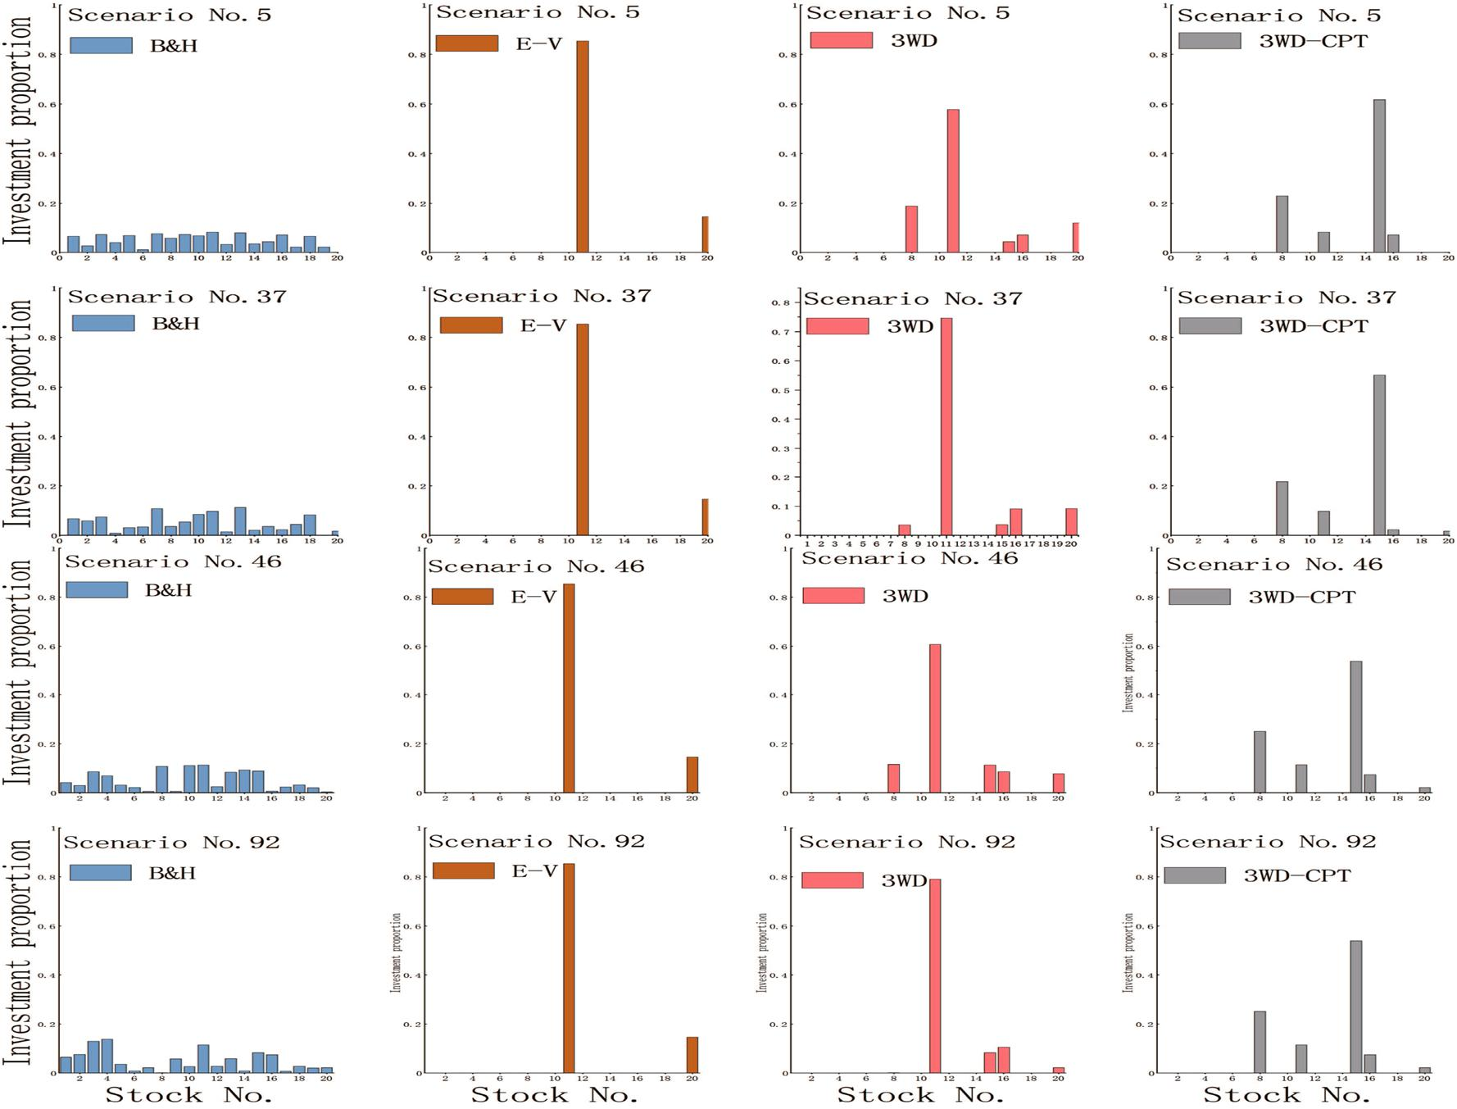

**Fig. 4** Stocks position in case study 1

The readers may refer to [35] for the details of the algorithm.

**5 Numerical examples**

In this section, two cases are studied to show the effective-ness of the proposed 3WD&CPT portfolio selection model. All the experiments were implemented with Python on a Dell U8S9M95 3.2 GHz personal computer.

**5.1  Case study 1**

In this case, 20 stocks were randomly selected from the Dow Jones Industrial Average. Based on the observation of his-torical data as well as experts knowledge, the future returns of candidate stocks described as fuzzy variables are listed in Table 6, where (*a*, *b*, *c*) denotes triangular fuzzy variables and (*a*, *b*, *c*, *d*) indicates trapezoidal fuzzy variables. And the time span is from 01-01-2019 to 03 -31-2019, including 60 trading days. Furthermore, there are a number of parameters whose values need to be predetermined by investors and are listed in Table 7.

In Table 7, the values of *S* and 1 − vary from person to person, which express the risk appetite of a specific deci-sion-maker. And we set *S* = 0.1, 1 − = 0.9, which follow the suggestion given in [36].

Besides, the risk control coefficient *ω* is set as 0.05, which is based on the historical data as well as experts knowledge. The value of *γ* in the *γ*-level cut is set as 0.003 after a number of trails. Finally, the value of the reference return rate *x*0 is set as 0.02, which is based on experts knowledge and the prediction of the average rate of return in the stock market in the given time horizon.

Note that the initial capital allocation *xi*� (*i* = 1, 2 … *n*) (i.e., the investment proportion of each stock before the port-folio optimization) is important to the optimal result, which however, differs from case to case. Therefore, without losing generality, we generate 100 stochastic capital allocation sce-narios via Python programs, each of which represents a stock position before the portfolio optimization. Then each initial capital allocation scenario is considered as the input of the four portfolio selection models described in Sect. 4.2, thus four optimal investment decisions are obtained by the inves-tors respectively. Four initial capital allocation scenarios are randomly selected among them, and the corresponding

1 3

\304 International Journal of Machine Learning and Cybernetics (2022) 13:293–308

**Fig. 5** The error band chart ofinvestment return rates in case study 1

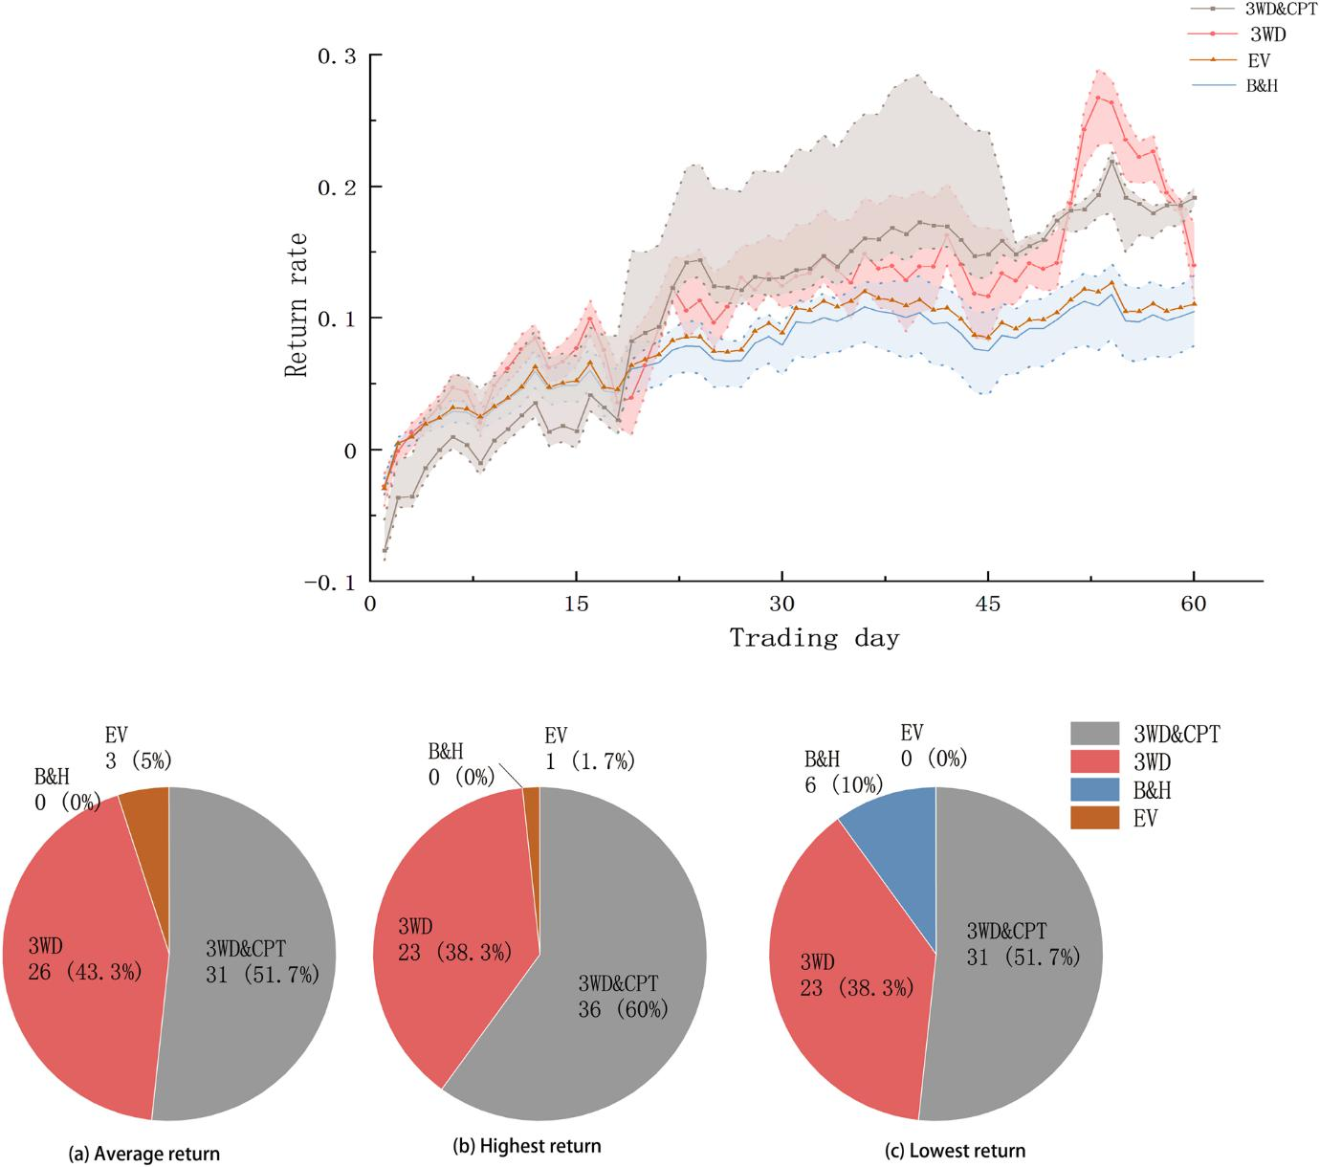

**Fig. 6** Number of days has best performance on three indicators in case study 1

optimal investment decisions obtained by the proposed port-folio selection models are plotted in Fig. 4.

As can be seen from Fig. 4, compared to B&H-PS which spreads the capital over all the stocks, EV-PS concentrates all the capital on two stocks, i.e., stock No.11 and 20, which leads to high risk as well as high returns. By contrast, the stocks position of 3WD- PS and 3WD&CPT-PS show that the using of 3WD avoids excessive concentration of capital allocation, thus reducing the investment risk. At the same time, the introduction of CPT changes the investors’ prefer-ence for stocks.

Then we place the all the optimal investment decisions on the real stock market to get their return performances. And we plot the return performances of the four portfolio

selection models on an error band chart, as depicted in Fig. 5.

The x-axis of Fig. 5 represents the trading day and y-axis represents the return rate. Each color block rep-resents the investment performance of the corresponding portfolio selection model in the real stock market, where the solid line represents the average return, the dashed line at the upper border represents the maximum return, and the dashed line at the lower border represents the mini-mum return. Particularly, since the EV-PS yields the same optimal investment decision regardless of the initial capital allocation scenarios, the return rate of the EV-PS is a solid line with no blocks of color.

1 3

|  |  |
| --- | --- |
| International Journal of Machine Learning and Cybernetics (2022) 13:293–308\ | 305 |
|  |  |

**Fig. 7** The error band chart ofinvestment return rates in case study 2

**Table 8** Predetermined parameter values for case study 2

|  |  |  |  |
| --- | --- | --- | --- |
|  | Symbol | Meaning | Value |
|  |  |  |  |
|  | S | The upper limit of VaR | 0.1 |
| 1 − | | The confidence level of VaR | 0.9 |
|  | *ω* | The risk control coefficient | 0.1 |
|  | *γ* | The -level cut for fuzzy variable | 0.003 |
|  | *X*0 | The reference return rate | 0.08 |
|  |  |  |  |

In Fig. 5, all four models do not lose money most of the time because the 20 stocks in the stock pool rose over the given time horizon. The B&H-PS has the lowest aver-age return because it did not make any optimization on the initial investment proportion. The EV-PS has a higher average return than B&H- PS because EV-PS achieved a concentration of capital on the high return stocks. By con-trast, the investment performances of both 3WD-PS and 3WD&CPT-PS are better than B&H-PS and EV- PS owing to the diversification of investment options, risk reduction and return enhancement achieved by classifying stocks.

To make a detailed comparison of the four models, we count the number of days in which the four models appear to have the greatest average return rate, plotted as the pie chart in Fig. 6a. We also count the number of days in which the four models appear to have the greatest highest return and greatest lowest return rate likewise, as shown in Fig. 6b, c, respectively.

The average return and the highest return could be viewed as the portfolio profit-chasing evaluation index, meanwhile the lowest return could be viewed as a portfolio risk-avoidance evaluation index. So from the perspective of

the indicator average return and highest return, Fig. 6 dem-onstrates that the EV-PS achieves higher return rate than B&H-PS, meanwhile the indicator of lowest return shows that the EV-PS also results in risk concentration. And the 3WD&CPT-PS and 3WD-PS perform better than the B&H-PS and EV-PS, so it can be concluded that the introduction of 3WD with portfolio selection achieves risk reduction and returns enhancement simultaneously. Furthermore, Fig. 6 demonstrates that the proposed 3WD&CPT-PS has the best investment performance on all the three indicators, which shows that the use of CPT leads to capital focusing on the better stocks, i.e., security No.8 and 15. Therefore, it can be conclude that the combination of 3WD and CPT with portfolio selection is effective.

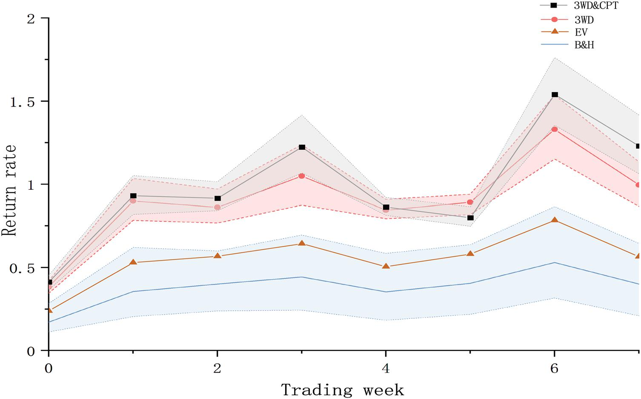

**5.2  Case study 2**

In case study 2, a portfolio selection problem consisting of a group of 10 stocks from the New York Stock Exchange is discussed, the forecast return of the stocks in the time span of 8 weeks are described as triangular or Gaussian ( *i* , *i* ) fuzzy variables, which are listed in [34]. Similarly, there are a number of parameters whose values need to be prede-termined by investors and are listed in Table 8. Generally, the values of these parameters follow the same settings in case study 1.

Again we first generate 100 stochastic initial capital allo-cation scenarios via Python program, then the same works as to case study 1 are done in case study 2. Four initial capital scenarios are randomly selected, and Fig. 7 depicts the opti-mal investment decisions obtained from the four portfolio selection models. Fig. 7 demonstrates that compared to the

1 3

\306 International Journal of Machine Learning and Cybernetics (2022) 13:293–308

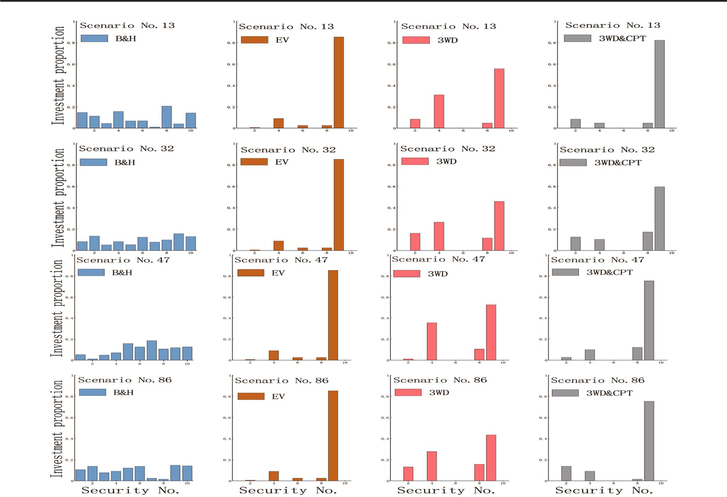

**Fig. 8** Stocks position in case study 2

capital concentration of EV-PS, in which the investment proportion of stock No.9 is greater than 80% , the classifica-tion capabilities realized by the use of 3WD achieve capital diversification and risk reduction further.

And Fig. 8 is the error band chart of the investment per-formances in the real stock market of the four portfolio selection models. Since it’s only accessible to the closing price of the stock every Friday, the error band chart contains only 8 time nodes. It is clearly that the investment perfor-mances of the 3WD-PS and 3WD&CPT-PS are better than the B&H-PS and EV-PS on each time node.

Similar to case study 1, we count the number of weeks in which the four portfolio selection models appear to have the greatest average return, the greatest highest return and the greatest lowest return in case study 2. On all three indicators, the same results emerge, with 3WD&CPT-PS performing the best at seven time nodes, accounting for 87.5%. Mean-while, 3WD- PS performs best at one time node, accounting for 12.5% on all three indicators. Therefore, it can be con-cluded that the combination of 3WD and CPT is effective.

It can be found that the volatility of case study 2 is much greater than that of case study 1 by observing the stock mar-ket data. The experimental results prove that the portfolio

selection model based on three-way decision and cumulative prospect theory is effective in both these two cases. There-fore, it might be concluded that our model is stable to dif-ferent investment problems.

**6 Conclusion**

Based on the assumption that investors already hold secu-rities in hand in long-term portfolio selection, three-way decision and cumulative prospect theory are used to build the portfolio selection model in this paper. Three-way deci-sion theory is used to classify candidate securities into the three disjoint regions (buying, selling and waiting regions), different actions (buy, sell and wait) are implemented into each corresponding region. And cumulative prospect theory is used together with expected utility theory to assess the investors’ preference toward the candidate securities. Two case studies on the basis of real stock market data prove that the introduction of three-way decision theory meets the goal of effectiveness diversification of investment. The real market experiments results prove that the proposed portfolio selection model based on three-way decision and cumulative

1 3

|  |  |
| --- | --- |
| International Journal of Machine Learning and Cybernetics (2022) 13:293–308\ | 307 |
|  |  |

prospect theory can increase investment return while reduc-ing investment risk, so the proposed portfolio selection model is effective.

Since the future trends of securities prices are reflec-tions of various factors, viewing the risk/expected-return level as a static value may not fit well with some investors’ behavior. So it is obliged to update the forecast of securi-ties return rate by the investment result of last period, and adjust the portfolio to these forecast results. Therefore, it would be an interesting and important research direction to combine three-way decision and cumulative prospect theory with multi-period portfolio selection. Besides, con-sidering the inherent similarity between portfolio selec-tion, the method proposed in this paper may be useful to applied in these fields, such as energy planning and medical diagnosis.

**References**

\ 1.\ Carlsson C, Fullér R, Majlender P (2002) A possibilistic approach to selecting portfolios with highest utility score. Fuzzy Sets Syst 131(1):13–21

\ 2.\ Chang JH, Sun L, Zhang B et al (2020) Multi-period portfolio selection with mental accounts and realistic constraints based on uncertainty theory. J Comput Appl Math 377:112892

\ 3.\ Chen LH, Huang L (2009) Portfolio optimization of equity mutual funds with fuzzy return rates and risks. Expert Syst Appli Â 36(2):3720–3727

\ 4.\ Chen W, Zhang WG (2010) The admissible portfolio selection problem with transaction costs and an improved PSO algorithm. Phys A 389(10):2070–2076

\ 5.\ Dong WM, Wong FS (1987) Fuzzy weighted averages and implementation of the extension principle. Fuzzy Sets Syst 21(2):183–199

\ 6.\ Fahrenwaldt MA, Sun CF (2020) Expected utility approximatio-nand portfolio optimisation. Math Econ Insur 93:301–314 Math Econ Insurance 93:301-314.

\ 7.\ Gao Y, Li DS, Zhong H (2020) A novel target threat assessment method based on three-way decisions under intuitionistic fuzzy multi-attribute decision making environment. Eng Appl Artif Intell 87:103276

\ 8.\ Häckel B, Pfosser S, Tränkler T (2017) Explaining the energy efficiency gap-expected utility theory versus cumulative prospect theory. Energy Policy 111:414–426

\ 9.\ Hakli H, Kiran MS (2020) An improved artificial bee colony algo-rithm for balancing local and global search behaviors in continu-ous optimization. Int J Mach Learn Cybern 11(9):2051–2076

\10.\ Hao G, An ZY (2019) A local adaptive learning system for online portfolio selection. Knowl Based Syst 186:104958

\11.\ Huang XX (2008) Mean-entropy models for fuzzy portfolio selec-tion. IEEE Trans Fuzzy Syst 16(4):1096–1101

12\.\ Huang XX (2008) Mean-semivariance models for fuzzy portfolio selection. J Comput Appl Math 217(1):1–8

\13.\ Jia XY, Li WW, Shang L (2019) A multiphase cost -sensitive learning method based on the multiclass three-way decision-theoretic rough set model. Inf Sci 485:248–262

\14.\ Jorion P (1997) Value at risk: the new benchmark for controlling market risk. The McGraw-Hill companies, New York

\15.\ Kahneman D, Tversky A (1979) Prospect theory: an analysis of decision under risk. Econometrica 47(2):263–292

\16.\ Kairies-Schwarz N, Kokot J, Vomhof M et al (2017) Health insurance choice and risk preferences under cumulative prospect theory-an experiment. J Econ Behav Organ 137:374–397

17\.\ Katagiri H, Uno T, Kato K et al (2014) Random fuzzy bilevel linear programming through possibility-based value at risk model. Int J Mach Learn Cybern 5(2):211–224

18\.\ Li B, Hoi SCH (2014) Online portfolio selection: a survey. ACM Comput Surv CSUR 46(3):1–36

\19.\ Li HQ, Yi ZH (2019) Portfolio selection with coherent Investor’s expectations under uncertainty. Expert Syst Appl 133:49–58

20\.\ Li HX, Zhang LB, Huang B et al (2016) Sequential three-way decision and granulation for cost-sensitive face recognition. Knowl Based Syst 91:241–251

21\.\ Li JH, Huang CC, Qi JJ et al (2017) Three-way cognitive concept learning via multi-granularity. Inf Sci 378:244–263

\22.\ Liu BD, Iwamura K (1998) Chance constrained programming with fuzzy parameters. Fuzzy Sets Syst 94(2):227–237

23\.\ Liu BD, Liu YK (2002) Expected value of fuzzy variable and fuzzy expected value models. IEEE Trans Fuzzy Syst 10(4):445–450

24\.\ Liu D, Ye XQ (2020) A matrix factorization based dynamic granu-larity recommendation with three-way decisions. Knowl Based Syst 191:105243

25\.\ Liu W, Wang Z, Zeng N et al (2021) A novel randomised particle swarm optimizer. Int J Mach Learn Cybern 12:529–540

\26.\ Mansour N, Cherif MS, Abdelfattah W (2019) Multi-objective imprecise programming for financial portfolio selection with fuzzy returns. Expert Syst Appl 138:112810

\27.\ Markowitz Harry (1952) Portfolio selection*. J Finance 7(1):77–91

28\.\ Mehlawat MK, Gupta P, Kumar A et al (2020) Multi-objective fuzzy portfolio performance evaluation using data envelopment analysis under credibilistic framework. IEEE Trans Fuzzy Syst 28(11):2726–2737

29\.\ Quiggin J (1982) A theory of anticipated utility. J Econ Behav Organ 3(4):323–343

\30.\ Schmeidler D (1989) Subjective probability and expected utility without additivity. Econometrica. J Econ Soc 57(3):571–587

31\.\ Tanaka H, Guo P, Türksen IB (2000) Portfolio selection based on fuzzy probabilities and possibility distributions. Fuzzy Sets Syst 111(3):387–397

32\.\ Tian N, Lai CH (2014) Parallel quantum-behaved particle swarm optimization. Int J Mach Learn Cybern 5(2):309–318

\33.\ Tversky A, Kahneman D (1992) Advances in prospect theory: cumulative representation of uncertainty. J Risk Uncertain 5(4):297–323

\34.\ Wang B, Li Y, Wang SM et al (2018) A multi- objective portfolio selection model with fuzzy value-at-risk ratio. IEEE Trans Fuzzy Syst 26(6):3673–3687

\35.\ Wang B, Li Y, Watada J (2017) Multi-period portfolio selection with dynamic risk/expected-return level under fuzzy random uncertainty. Inf Sci 385:1–18

\36.\ Wang B, Wang SM, Watada J (2011) Fuzzy-portfolio-selection models with value-at-risk. IEEE Trans Fuzzy Syst 19(4):758–769 \37.\ Wang TX, Li HX, Zhang LB et al (2020) A three-way decision

model based on cumulative prospect theory. Inf Sci 519:74–92 38\.\ Wang YM, Elhag TMS (2006) Fuzzy TOPSIS method based on

alpha level sets with an application to bridge risk assessment. Expert Syst Appl 31(2):309–319

39\.\ Wu YN, Ke YM, Xu CB et al (2019) An integrated decision-making model for sustainable photovoltaic module supplier selec-tion based on combined weight and cumulative prospect theory. Energy 181:1235–1251

1 3

\308 International Journal of Machine Learning and Cybernetics (2022) 13:293–308

\40.\ Yang B, Li J (2020) Complex network analysis of three-way deci-sion researches. Int J Mach Learn Cybern 11:973–987

\41.\ Yao JT, Azam N (2014) Web-based medical decision support sys-tems for three-way medical decision making with game-theoretic rough sets. IEEE Trans Fuzzy Syst 23(1):3–15

\42.\ Yao YY (2010) Three-way decisions with probabilistic rough sets. Inf Sci 180(3):341–353

43\.\ Yu H, Chen Y, Lingras P et al (2019) A three-way cluster ensem-ble approach for large-scale data. Int J Approx Reason 115:32–49 44\.\ Zhang QH, Gao M, Zhao F, Wang GY (2020) Fuzzy-entropy-based game theoretic shadowed sets: a novel game perspective from uncertainty. IEEE Trans Fuzzy Syst. [https://doi.org/10.1109/](https://doi.org/10.1109/TFUZZ.2020.3042250)

[TFUZZ.2020.3042250](https://doi.org/10.1109/TFUZZ.2020.3042250)

45\.\ Zhang QH, Huang ZK, Wang GY (2021) A novel sequential three-way decision model with autonomous error correction. Knowl Based Syst 212:106526. [https://doi.org/10.1016/j.knosys.2020.](https://doi.org/10.1016/j.knosys.2020.106526) [106526](https://doi.org/10.1016/j.knosys.2020.106526)

**Publisher’s Note** Springer Nature remains neutral with regard tojurisdictional claims in published maps and institutional affiliations.

1 3