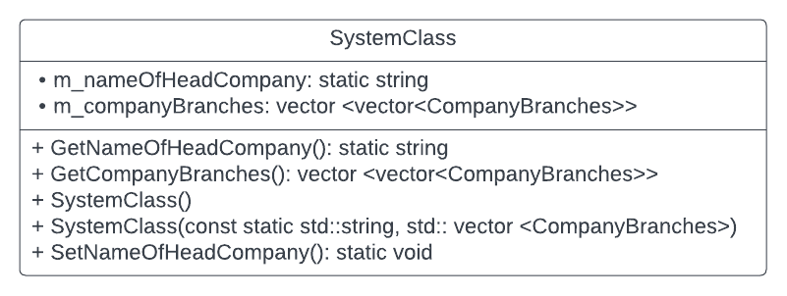Reprezentarea grafica a claselor

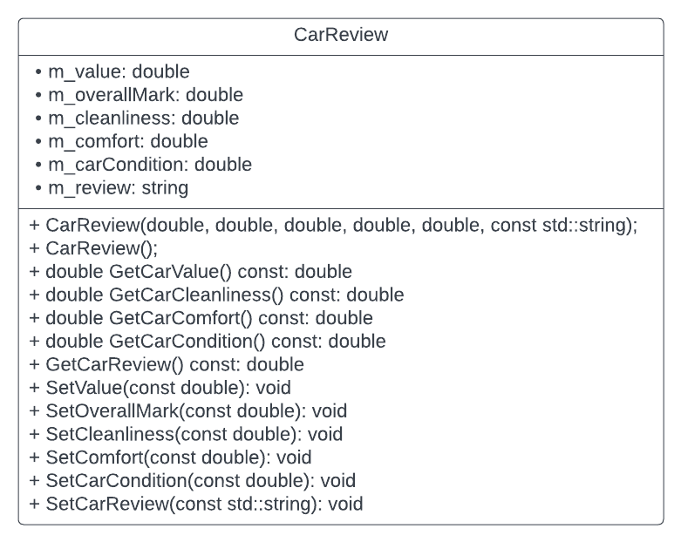

Structura proiect:

**System Class**

* company’s name – static member
* **Company’s locations - array**
  + Branch Name
  + Country
  + City
  + Number of cars available
  + Mark (extracted from the reviews)
  + Review
  + **Customers - array**
    - First name
    - Last name
    - Email
    - Telephone
    - CNP
    - ID card series
    - ID card number
    - Mark for the company branch
    - **Rental Process Class**
      * **RentalStartDate**
        + Start day
        + Start month
        + Start year
        + **Start Time**

Hour

Minutes

* + - * **RentalEndtDate**
        + End day
        + End month
        + End year
        + **EndTime**

Hour

Minutes

* + - **Driving license Class**
      * **StartDate**
        + Start day
        + Start month
        + Start year
      * **EndDate**
        + End day
        + End month
        + End year
      * Is the person able to drive? (yes - true/no - false)
    - **Customers’s home address**
      * Country
      * City
      * Postal code
      * Street
      * Number
    - **Date of birth Class**
      * Day
      * Month
      * Year
  + **Car Class**
    - Make
    - Color
    - Brake horsepower
    - Engine
    - Doors
    - Seats
    - Transmission (automatic/manual)
    - Consumption
    - Availability (if during a certain period, the car is available for rental)
    - Price per day
    - Deposit
    - Payment in advance
    - Type (economy/medium/premium)
    - **Car’s review Class**
      * Value considering the price
      * Car cleanliness
      * Comfort
      * Car condition
      * Overall mark
      * Review (very good/ good/ awful)
  + **Location’s address Class**
    - Street
    - Number
    - Postal code
  + **Contact Class**
    - Telephone
    - Email
    - Manager name

EndTime

StartTime

DrivingLicenseStartDay

DrivingLicenseEndDay

RentalEndDate

RentalStartDate

RentalSchedule

DrivingLicense

IdentificationsInfos

CustomerHomeAdress

DateOfBirth

CarReview

LocationAdress

Customer

Car

ContactClass

CompanyBranches

SystemClass