Algorithms & Data Structures
Prim & Kruskal
Name: Alexandru Cardas
ID: C17504869
Class: DT228
Year: 2nd

Table of Contents
Introduction 3
Starting Graph for Kruskal and Prim 3
Prim 4
Adjacency Lists 4
Diagram 4
Traversal 5
Depth-First Search 5
Steps 6
Breadth-First Search 7
Steps 8
$ java PrimGraph 9
Heap 14
Kruskal 15
Definition 15
Efficiency 15
First Move 16
Second Move 17
Third Move 18
Fourth Move 19
Fifth Move 20
Sixth Move 21
Seventh Move 22
Eight Move 23
Ninth Move 24
Tenth Move 25
Eleventh Move 26
Twelfth Move 27
Thirteenth Move 28
Fourteenth Move 29
Complete Graph 30
Prim 31

Introduction
Graph theory for creating minimum spanning trees.
Green for traversing | Blue for visited | Red for ignored

Starting Graph for Kruskal and Prim
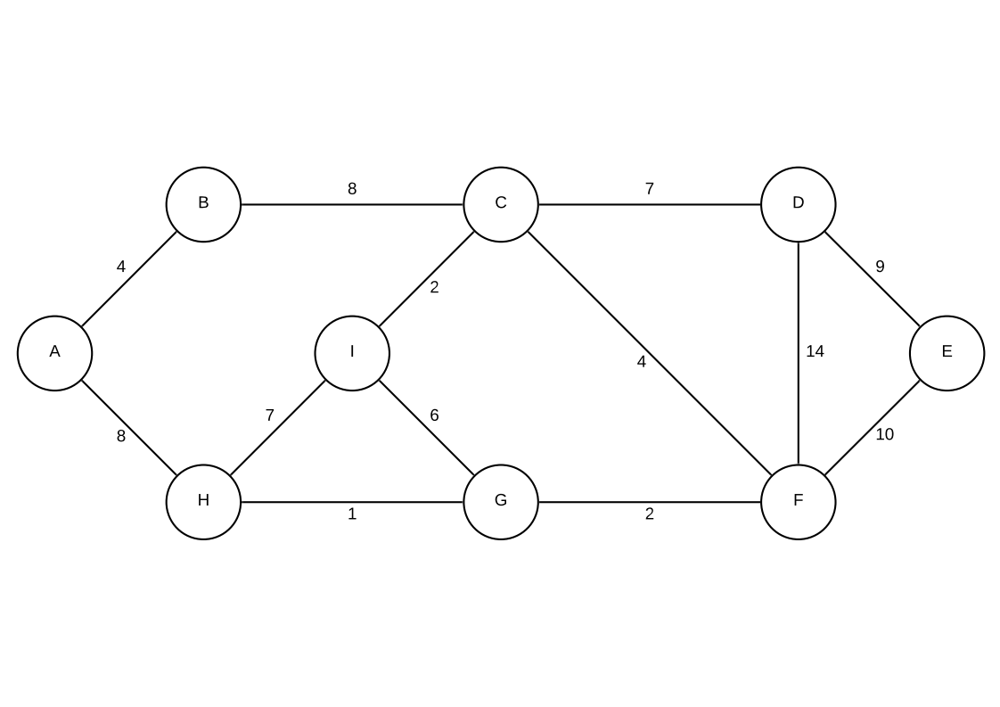

Prim
For this assignment, vertex C is picked for demonstrating purposes.

Adjacency Lists
Using the document headers we can create lists of edges, the first parameter takes in account the amount of vertices and the second parameter accounts for the number of edges.

Diagram
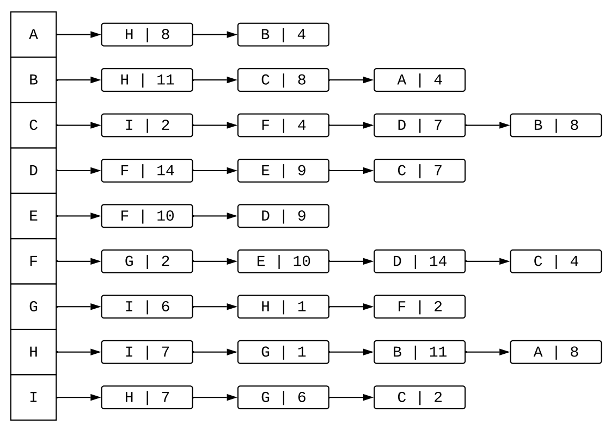
Once we have established the amount of vertices we can create the array that holds the head of each linked lists, hence creating the adjacency list. Using a for loop that iterates through all the edges, we assign each parameter accordingly. First parameter is the first vertex, the second is the second vertex which both combined gives us the edge and the third parameter is the weight of the edge. Creating the edge object code is the same for a linked list, we add an element to the head of the original vertex and re-establish the link between the previously added vertex and the new one.

Traversal

Depth-First Search
/**
* This class doesn't use a stack, but it does use recursion which resembles a stack for operations.
* Everything surrounded by square brackets constitutes the final traversal. ex: [A] marked as visited
*
* @param s used as the starting node for the graph traversal
*/
void dfsRecursive(int s)
{
// we create a clone of adjacency list because we do not want to modify anything from the original adj
adj = adjacencyList.clone();
boolean[] visited = new boolean[vertexAmount + 1];
System.out.println("Add root " + toChar(s));
dfsVisit(s, visited);
}
private void dfsVisit(int v, boolean[] visited)
{
// every vertex that gets passed into the method and is also inserted into visited array
visited[v] = true;
System.out.println("\n///// [" + toChar(v) + "] marked as visited /////\n");
// check the children of that vertex
while (!isEmpty(adj[v]))
{
// get the immediate child
int destination = adj[v].vertex;
System.out.println("Point to the next vertex connected to " + toChar(v));
// go to the next vertex
adj[v] = adj[v].next;
if (visited[destination])
{
System.out.println("\t" + toChar(destination) + " has already been visited so ignore");
}
// check if the current vertex has been visited
if (!visited[destination])
{
// make a recursive call
System.out.println("--- Make recursive call with " + toChar(destination) + " ---");
dfsVisit(destination, visited);
}
}
}

Steps
- Add root C and mark C as visited.
- Make a recursive call with the first child of C which is I.
- Mark I as visited.
- Make a recursive call with the first child of I which is H.
- Mark H as visited.
- I has been visited so ignore, make a recursive call with the second child of H which is G.
- Mark G as visited.
- I has been visited so ignore, H has been visited so ignore, make a recursive call with the third child of G which is F.
- ...Now the steps keep repeating until all the vertices are visited and the rest can be ignored.

Breadth-First Search
/**
* This method will print out the traversal and the correct order is drawn from the vertices that have been visited.
* Everything surrounded by square brackets constitutes the final traversal. ex: [A] marked as visited
*
* @param s starting vertex from where the traversal begins
* @throws MyExceptions for demo purposes
*/
void breadthFirstSearch(int s) throws MyExceptions
{
// create a clone of the adjacency list because we do not want to modify anything from the original adj
Node[] adj = adjacencyList.clone();
int v;
boolean[] visited = new boolean[vertexAmount + 1];
// put the starting node on the queue
System.out.println("Enqueue root " + toChar(s));
queue.enQueue(s);
// run until queue is empty
while (!queue.isEmpty())
{
// remove the vertex from the queue and traverse to his children
v = queue.deQueue();
System.out.println("--- Dequeue vertex " + toChar(v) + " ---");
if (visited[v])
{
System.out.println("\t" + toChar(v) + " has already been visited so ignore");
}
// check if the current vertex has been visited
if (!visited[v])
{
// mark the current vertex as visited
visited[v] = true;
System.out.println("\n///// [" + toChar(v) + "] marked as visited /////\n");
// check the vertices attached to the current one
while (!isEmpty(adj[v]))
{
if (!visited[adj[v].vertex])
{
// put the child onto the queue
System.out.println("Enqueue the connected vertex " + toChar(adj[v].vertex));
queue.enQueue(adj[v].vertex);
}
// go to the next node linked to it
adj[v] = adj[v].next;
}
}
}
}

Steps
These steps do not include the duplicated values inside the queue unlike the output of the actual algorithm. Also in the code implementation, we queue the vertices and when we remove them from the queue, that’s when we also mark them as visited and start exploring the connected vertices.
- Start exploring at C, put C on the queue.
- Visit the first connected vertex of C which is I, put I on the queue.
- Visit the second connected vertex of C which is F, put F on the queue.
- Visit the third connected vertex of C which is D, put D on the queue.
- Visit the fourth connected vertex of C which is B, put B on the queue.
- C has been fully explored and so we remove it from the queue.
- Start exploring at I, I is already in the queue.
- Visit the first connected vertex of I which is H, put H on the queue.
- Visit the second connected vertex of I which is G, put G on the queue.
- C has been visited so ignore.
- I has been fully explored and so we remove it from the queue.
- Start exploring the first vertex in the queue which is F.
- G has been visited so ignore.
- Visit the second connected vertex of F which is E, put E on the queue.
- D has been visited so ignore.
- C has been visited so ignore.
- F has been fully explored and so we remove it from the queue.
- Start exploring the first vertex in the queue which is D.
- D has been fully explored so we remove it from the queue.
- Start exploring the first vertex in the queue which is B.
- H has been visited so ignore, C has been visited so ignore, visit the third connected vertex of B which is A, put A on the queue.
- All vertices have been visited, but queue is not empty.
- B has been fully explored and so we remove it from the queue.
- Start exploring the first vertex in the queue which is H.
- H has been fully explored so we remove it from the queue.
- Start exploring the first vertex in the queue which is G.
- G has been fully explored so we remove it from the queue.
- Start exploring the first vertex in the queue which is E.
- E has been fully explored so we remove it from the queue.
- Start exploring the first vertex in the queue which is A.
- A has been fully explored so we remove it from the queue.
- Queue is now empty, terminate the breadth-first search.

Terminal Output
I used the terminal to run Prim’s algorithm which includes the adjacency lists, the traversal and the Prim itself.

$ java PrimGraph
9 vertices 14 edges

///// Adjacency List /////

Adj ||| Connects to
[A] --> [H|8]--[B|4]
[B] --> [H|11]--[C|8]--[A|4]
[C] --> [I|2]--[F|4]--[D|7]--[B|8]
[D] --> [F|14]--[E|9]--[C|7]
[E] --> [F|10]--[D|9]
[F] --> [G|2]--[E|10]--[D|14]--[C|4]
[G] --> [I|6]--[H|1]--[F|2]
[H] --> [I|7]--[G|1]--[B|11]--[A|8]
[I] --> [H|7]--[G|6]--[C|2]

||| ================================================================ |||

///// Breadth-First Search /////

Enqueue root C
--- Dequeue vertex C ---

///// [C] marked as visited /////

Enqueue the connected vertex I
Enqueue the connected vertex F
Enqueue the connected vertex D
Enqueue the connected vertex B
--- Dequeue vertex I ---

///// [I] marked as visited /////

Enqueue the connected vertex H
Enqueue the connected vertex G
--- Dequeue vertex F ---

///// [F] marked as visited /////

Enqueue the connected vertex G
Enqueue the connected vertex E
Enqueue the connected vertex D
--- Dequeue vertex D ---

///// [D] marked as visited /////

Enqueue the connected vertex E
--- Dequeue vertex B ---

///// [B] marked as visited /////

Enqueue the connected vertex H
Enqueue the connected vertex A
--- Dequeue vertex H ---

///// [H] marked as visited /////

Enqueue the connected vertex G
Enqueue the connected vertex A
--- Dequeue vertex G ---

///// [G] marked as visited /////

--- Dequeue vertex G ---
G has already been visited so ignore
--- Dequeue vertex E ---

///// [E] marked as visited /////

--- Dequeue vertex D ---
D has already been visited so ignore
--- Dequeue vertex E ---
E has already been visited so ignore
--- Dequeue vertex H ---
H has already been visited so ignore
--- Dequeue vertex A ---

///// [A] marked as visited /////

--- Dequeue vertex G ---
G has already been visited so ignore
--- Dequeue vertex A ---
A has already been visited so ignore

||| ================================================================ |||

///// Depth-First Search /////

Add root C

///// [C] marked as visited /////

Point to the next vertex connected to C
--- Make recursive call with I ---

///// [I] marked as visited /////

Point to the next vertex connected to I
--- Make recursive call with H ---

///// [H] marked as visited /////

Point to the next vertex connected to H
I has already been visited so ignore
Point to the next vertex connected to H
--- Make recursive call with G ---

///// [G] marked as visited /////

Point to the next vertex connected to G
I has already been visited so ignore
Point to the next vertex connected to G
H has already been visited so ignore
Point to the next vertex connected to G
--- Make recursive call with F ---

///// [F] marked as visited /////

Point to the next vertex connected to F
G has already been visited so ignore
Point to the next vertex connected to F
--- Make recursive call with E ---

///// [E] marked as visited /////

Point to the next vertex connected to E
F has already been visited so ignore
Point to the next vertex connected to E
--- Make recursive call with D ---

///// [D] marked as visited /////

Point to the next vertex connected to D
F has already been visited so ignore
Point to the next vertex connected to D
E has already been visited so ignore
Point to the next vertex connected to D
C has already been visited so ignore
Point to the next vertex connected to F
D has already been visited so ignore
Point to the next vertex connected to F
C has already been visited so ignore
Point to the next vertex connected to H
--- Make recursive call with B ---

///// [B] marked as visited /////

Point to the next vertex connected to B
H has already been visited so ignore
Point to the next vertex connected to B
C has already been visited so ignore
Point to the next vertex connected to B
--- Make recursive call with A ---

///// [A] marked as visited /////

Point to the next vertex connected to A
H has already been visited so ignore
Point to the next vertex connected to A
B has already been visited so ignore
Point to the next vertex connected to H
A has already been visited so ignore
Point to the next vertex connected to I
G has already been visited so ignore
Point to the next vertex connected to I
C has already been visited so ignore
Point to the next vertex connected to C
F has already been visited so ignore
Point to the next vertex connected to C
D has already been visited so ignore
Point to the next vertex connected to C
B has already been visited so ignore

Enter starting vertex: ex# ## #3
Vertices = 9 Edges = 14
Vertex[1] -- Vertex[2] (weight)
Reading edges from text file
A--B(4)
A--H(8)
B--C(8)
B--H(11)
C--D(7)
C--F(4)
C--I(2)
D--E(9)
D--F(14)
E--F(10)
F--G(2)
G--H(1)
G--I(6)
H--I(7)

adj[A] -> |H | 8| -> |B | 4|
adj[B] -> |H | 11| -> |C | 8| -> |A | 4|
adj[C] -> |I | 2| -> |F | 4| -> |D | 7| -> |B | 8|
adj[D] -> |F | 14| -> |E | 9| -> |C | 7|
adj[E] -> |F | 10| -> |D | 9|
adj[F] -> |G | 2| -> |E | 10| -> |D | 14| -> |C | 4|
adj[G] -> |I | 6| -> |H | 1| -> |F | 2|
adj[H] -> |I | 7| -> |G | 1| -> |B | 11| -> |A | 8|
adj[I] -> |H | 7| -> |G | 6| -> |C | 2|

Weight of MST = 37

Minimum Spanning tree parent array is:
A -> H
B -> A
C
D -> C
E -> D
F -> C
G -> F
H -> G
I -> C

Heap
Prim’s heap is implemented via an adjacency list and Kruskal’s heap is implemented using a simple array.

Kruskal

Definition
Kruskal’s algorithm finds a safe edge to add to the growing forest by finding, of all the edges that connect any two trees in the forest, an edge of least weight. Kruskal’s algorithm qualifies as a greedy algorithm because at each step it adds to the forest an edge of least possible weight. Our implementation of Kruskal’s algorithm is like the algorithm to compute connected components from the following diagrams. It uses a disjoint-set data structure to maintain several disjoint sets of elements. Each set contains the vertices in one tree of the current forest. The operation FIND-SET returns a representative element from the set that contains a vertex. Thus, we can determine whether two vertices origin and destination belong to the same tree by testing whether FIND-SET A equals FIND-SET B. To combine trees, Kruskal’s algorithm calls the UNION procedure.

Efficiency
The running time of Kruskal’s algorithm for a graph G = (V, E) depends on how we implement the disjoint-set data structure. We assume that we use the disjoint-set-forest implementation of S with the union-by-rank and path-compression heuristics, since it is the asymptotically fastest implementation known. Initializing the set A in line 1 takes O(1) time, and the time to sort the edges in line 4 is O(E lg E). (We will account for the cost of the |V| MAKE-SET operations in the for loop of lines 2–3 in a moment.) The for loop of lines 5–8 performs O(E) FIND-SET and UNION operations on the disjoint-set forest. Along with the |V| MAKE-SET operations, these take a total of O((V + E) alpha (V)) time, where alpha is the very slowly growing function. Because we assume that G is connected, we have |E| >= |V| - 1, and so the disjoint-set operations take O(E set V)time. Moreover, since alpha(|V|) = O(lg V) = O(lg E) the total running time of Kruskal’s algorithm is O(E lg E). Observing that |E| < |V ^ 2| , we have lg |E| = O(lg V) and so we can restate the running time of Kruskal’s algorithm as O(E lg V).

First Move
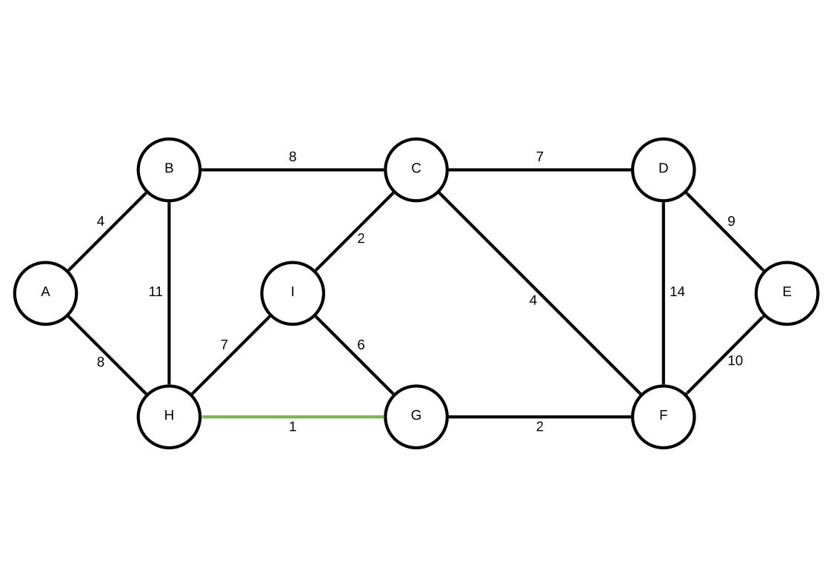

Second Move
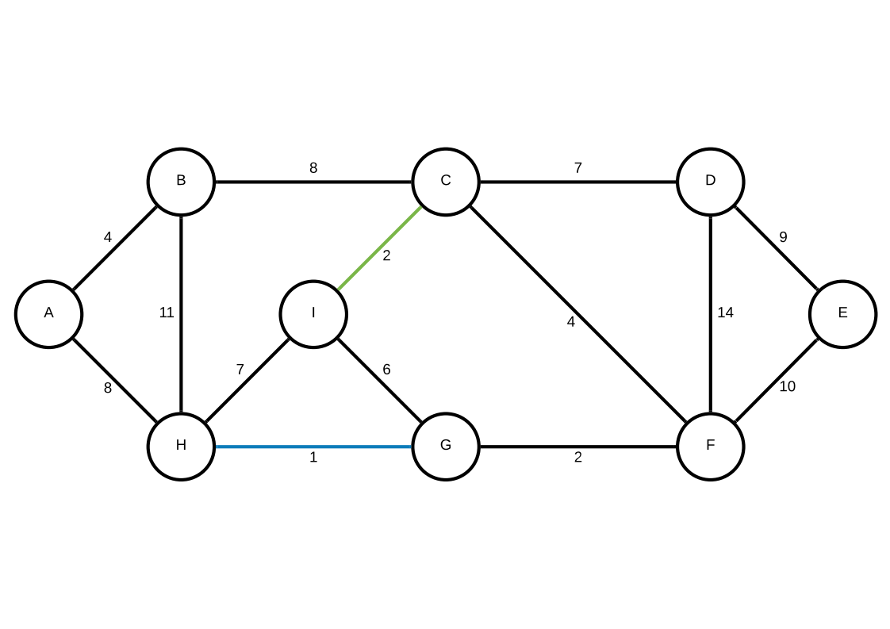

Third Move
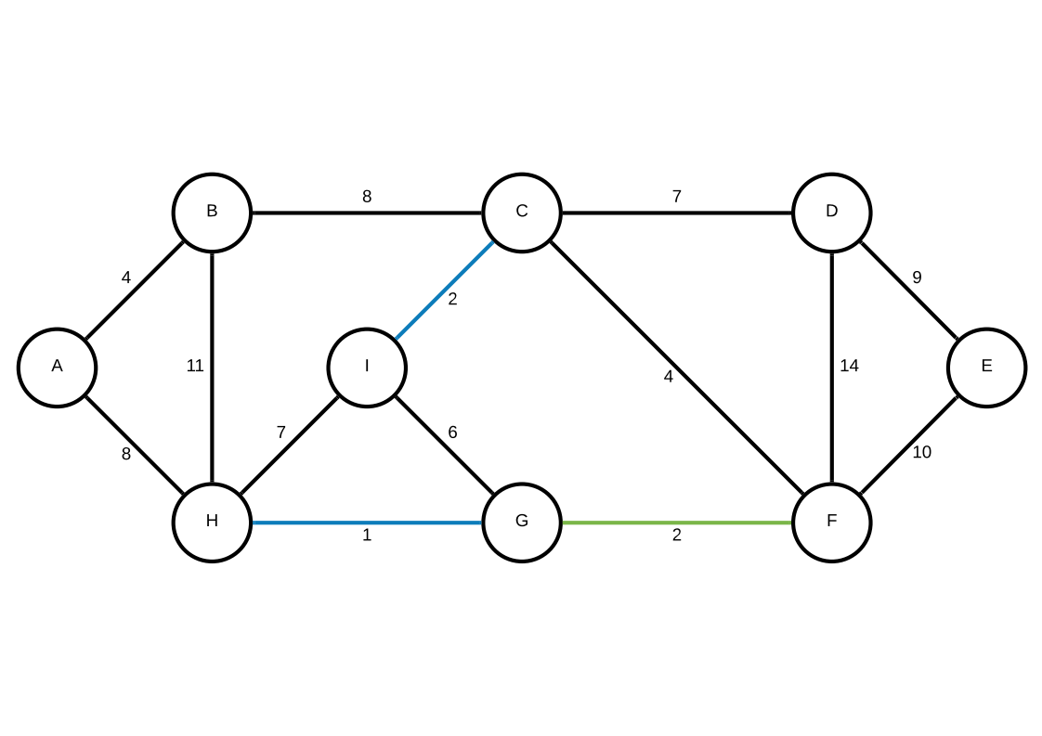

Fourth Move
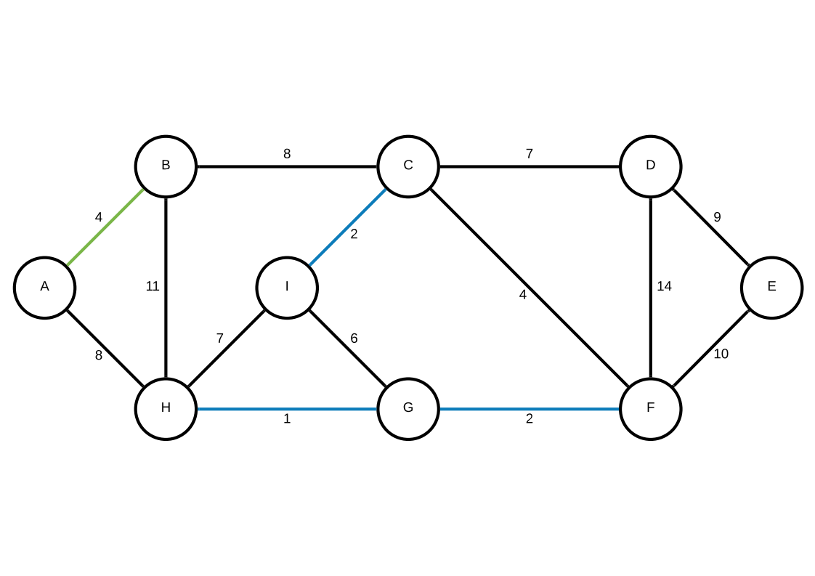

Fifth Move
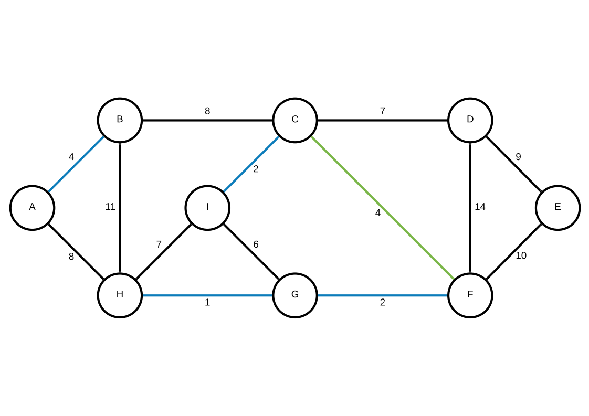

Sixth Move
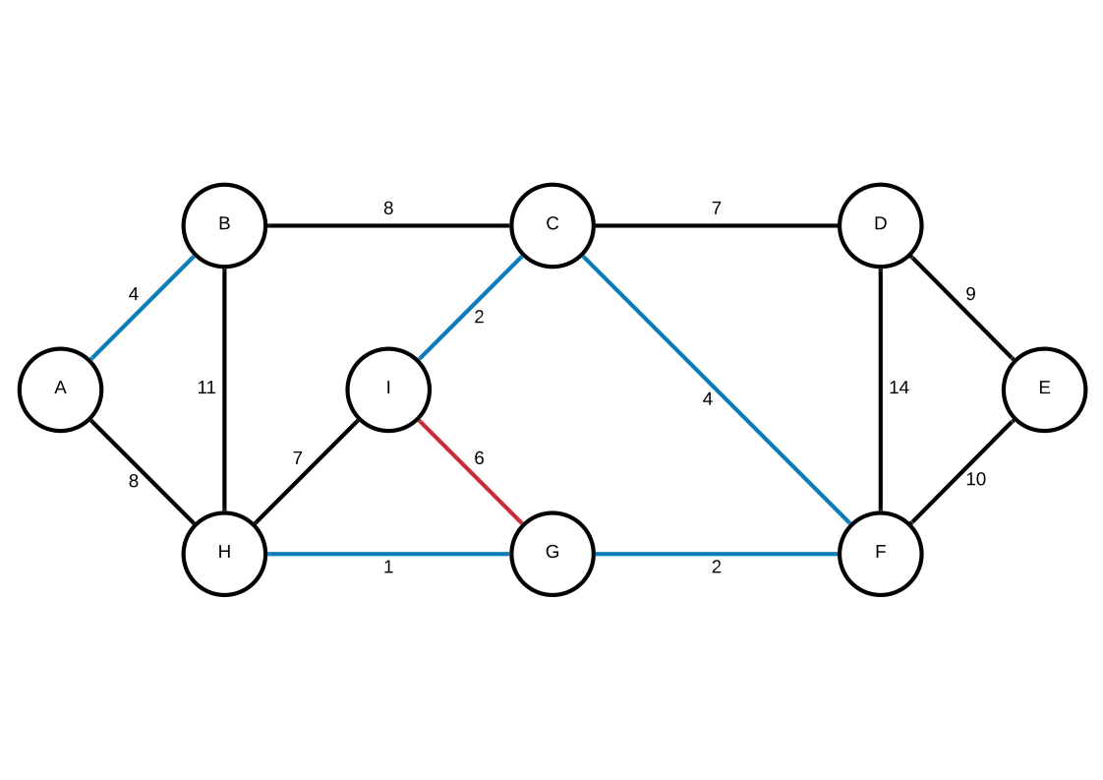

Seventh Move
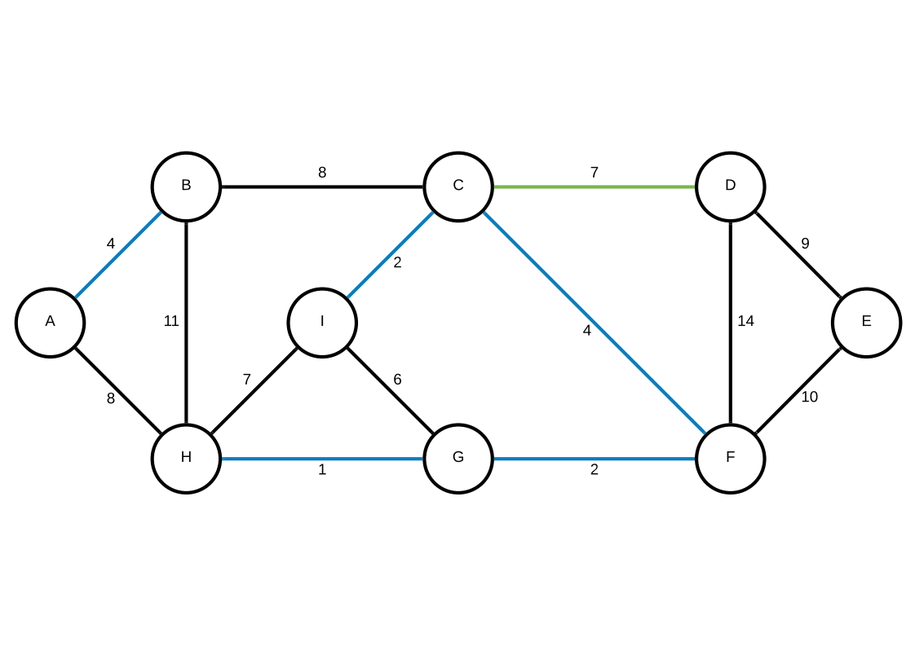

Eight Move
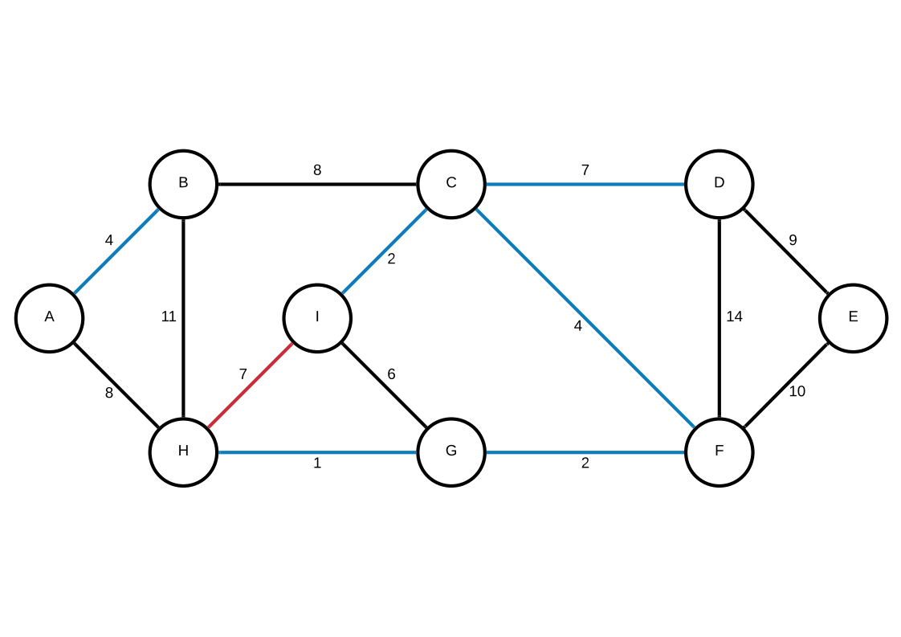

Ninth Move
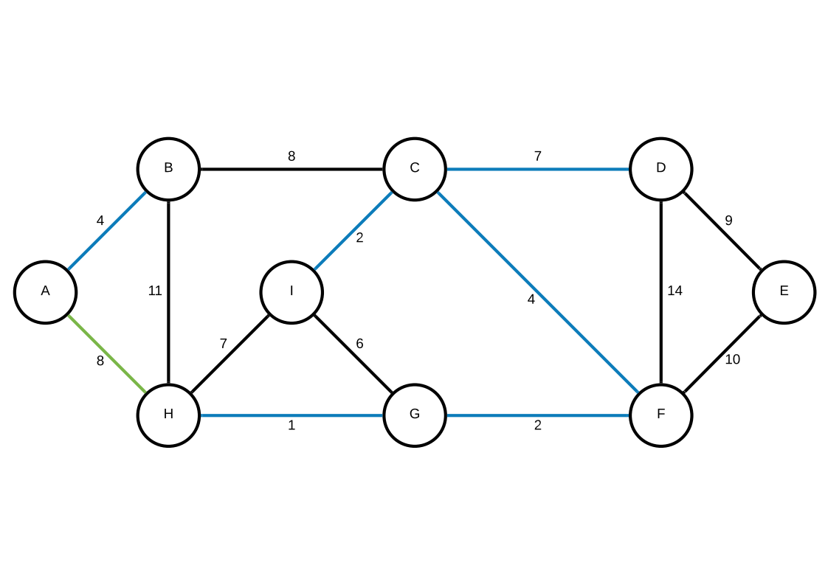

Tenth Move
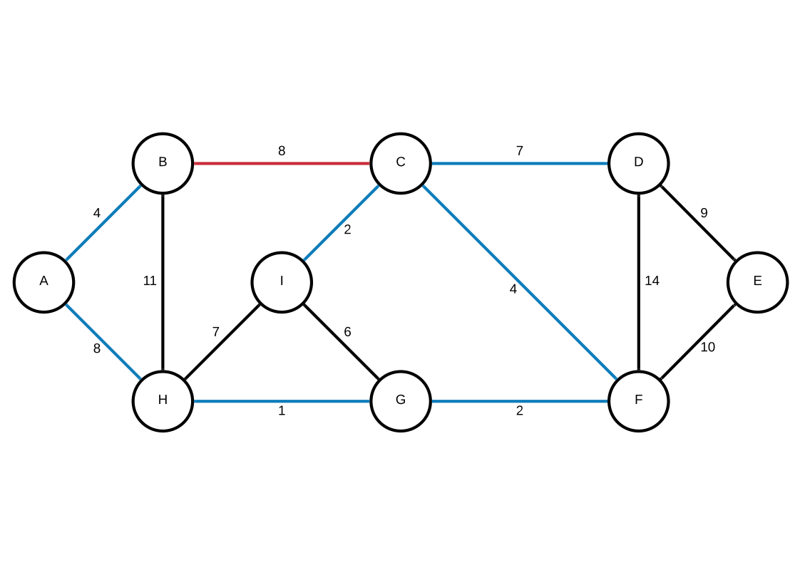

Eleventh Move
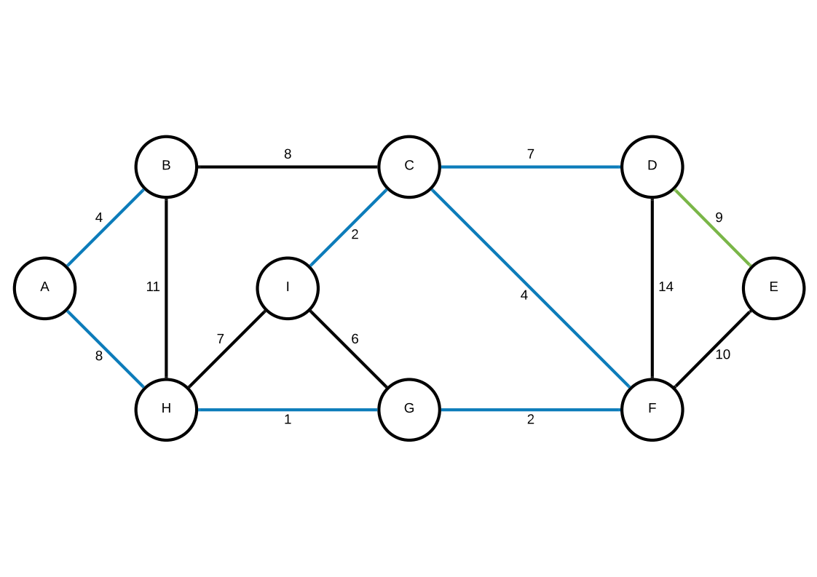

Twelfth Move
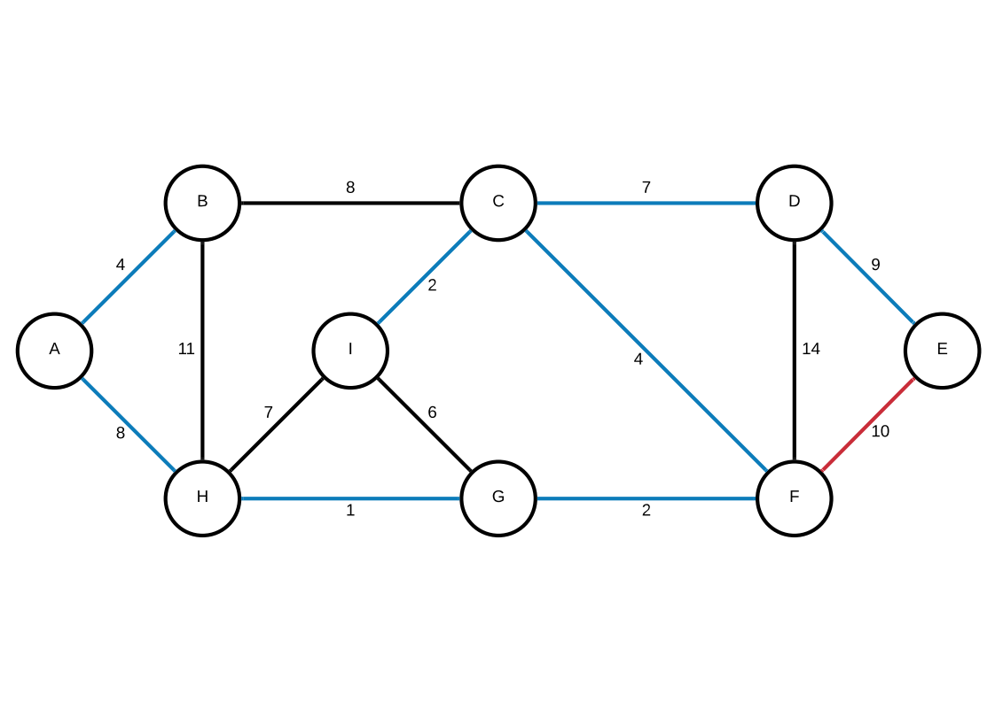

Thirteenth Move
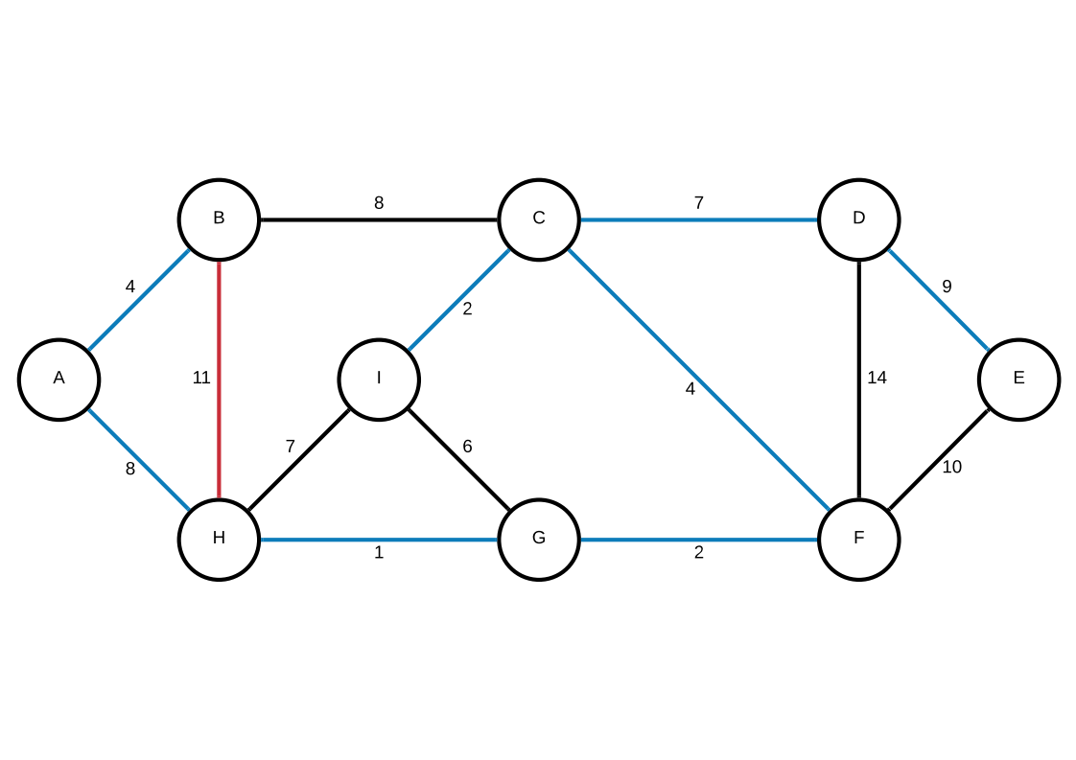

Fourteenth Move
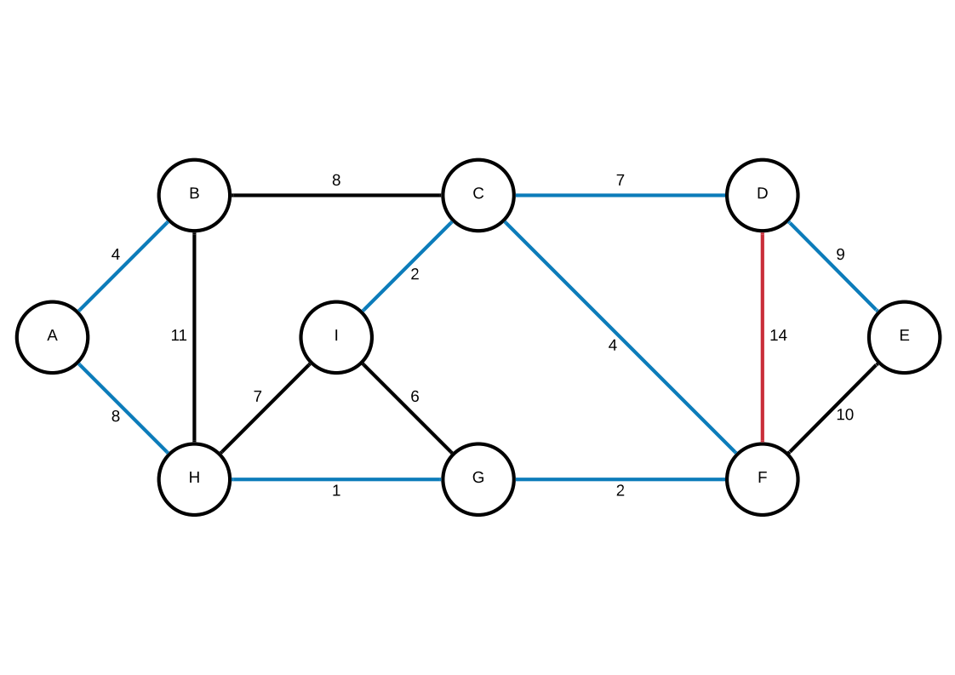

Complete Graph
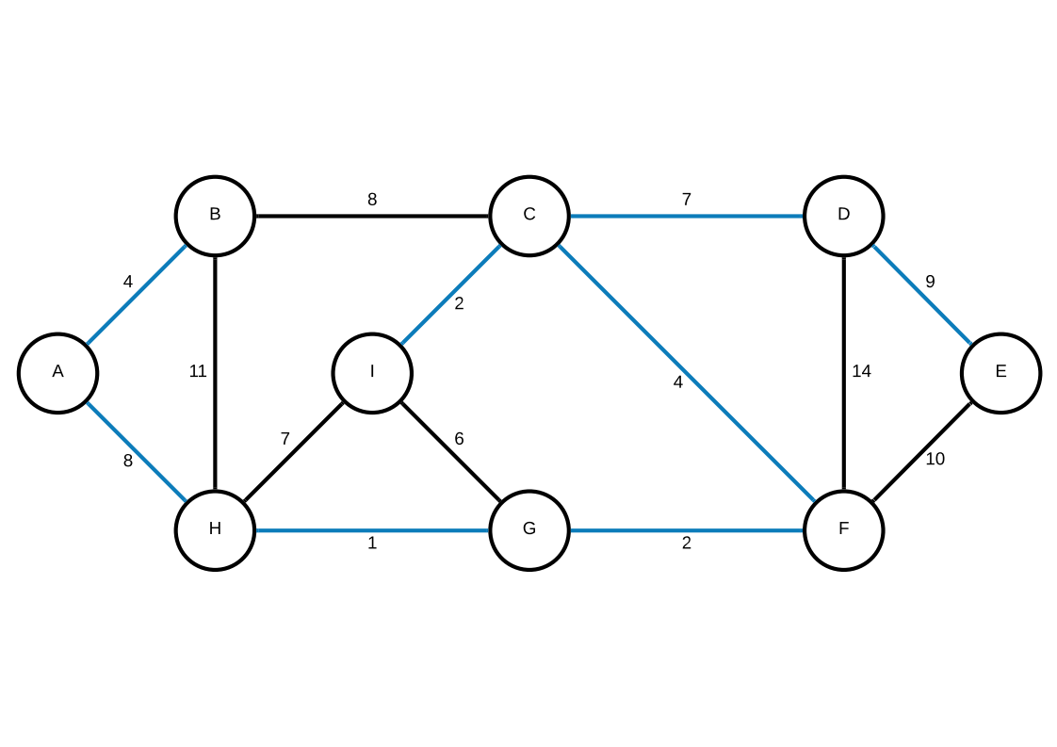

Prim

