**Mobile Devices Homework**

**Team:**

**Popescu Vlad**

**Pelcaru Alexandru**

**Badea Bianca**

**Group 1231 E**

1. **Introduction**

The purpose of the homework is to create an application for mobile devices, using Android programming language. The application allows the user to register an account and login into it with a username and a password. Every user together with all information about him will be stored in a database. For this purpose we will use Parse Database. In the application the user can see the current weather for a selected location and can enter in his profile. There, he can change the password or other information that he desires.

We chose to work on Android platform, being the world’s most popular and used mobile platform. The application was created using Android Studio.

1. **Specifications**
2. The application will display a login interface, with 2 buttons, one for login and the other one for register.
3. The authenticated user can see a home screen, which is also the interface for weather. There he can introduce the name of the city where he wants to find the temperature.
4. In the home screen, the authenticated user can see a list of hotlinks, and launch them directly from the application.
5. The authenticated user can enter his profile from the home screen.
6. The authenticated user can modify his profile, having the data stored in the Parse database.
7. **Prerequisites**
8. We developed the application for the minimum required SDK of 4.0 (IceCream Sandwich), with a minimum SDK of 4.0.
9. The mobile device that runs the application should be connected to the internet in order to receive information about weather.
10. The application should compile with Android 4.4 KitKat Wear version.
11. Google play services should be installed on the mobile device in order for the application to run.
12. **Implementation**

The application is implemented in the main project com.example.mobiledev, which has the following java classes:

1. MainApp – it makes the connection between the application and the Parse database.
2. RegisterActivity – it provides methods for the registration of a user.
3. MainActivity – it is used to provide the methods for the successful login of a user.
4. HomeActivity – this class is used to provide the responsible methods to retrieve the weather conditions. It also checks for internet connection and it displays a corresponding message on screen if the connection does not exist. The weather is retrieved with AsyncTask in form of a JSON, the method for parsing that JSON Response and for specifying the condition type. Moreover, in HomeActivity class we created the method for displaying the hotlinks.
5. ProfileActivity – the user can see all details about his profile that are stored in the database. If the user has no details stored, nothing is displayed. He can also modify the information and save the changes.
6. ChangePassActivity – provides the required method in order for the user to change his password.
7. LinkModel – is a model class for links, used to describe a link.
8. JSONParser – the class where we parsed the JSON.
9. AdapterLinks – we set up the links in the list view, using a custom adapter
10. **User flow**

In this part we are going to test the application, from the user’s point of view.

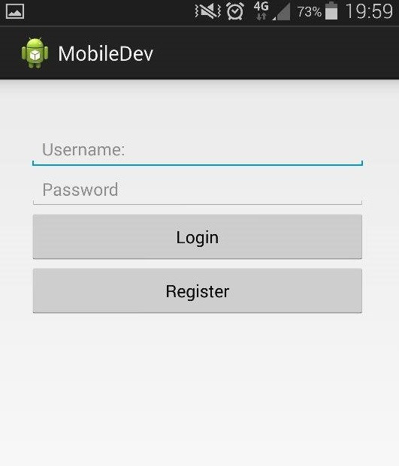 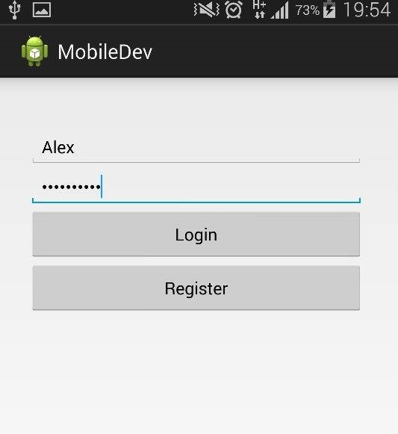

When launching the application, the user is presented with a login screen, where, obviously, he can login with an existing account via the “Login” button, or he can choose to create a new account pressing the “Register” button.

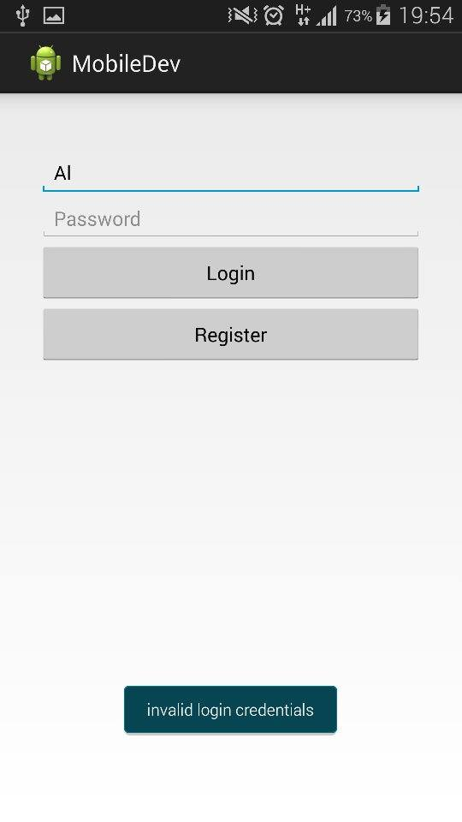 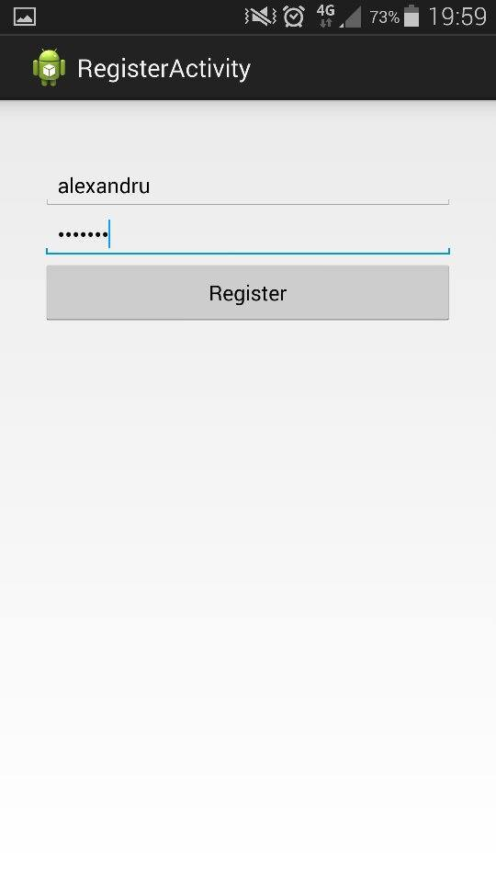

If the user does not write anything in one of the fields for “user” or “password”, or if he writes incorrect information, than the corresponding “invalid login credentials” will appear.

Upon pressing the “Register” Button, the application will switch to the Register Screen where the user has to insert a desired username and a password. By pressing the register button in here, the user will be taken to the Login Screen, where he will type his username and password and will launch the Home screen.

In this home screen, the user can enter his profile, can add the hotlinks from the database that open a new page in the browser and he can see the weather conditions for a desired city.

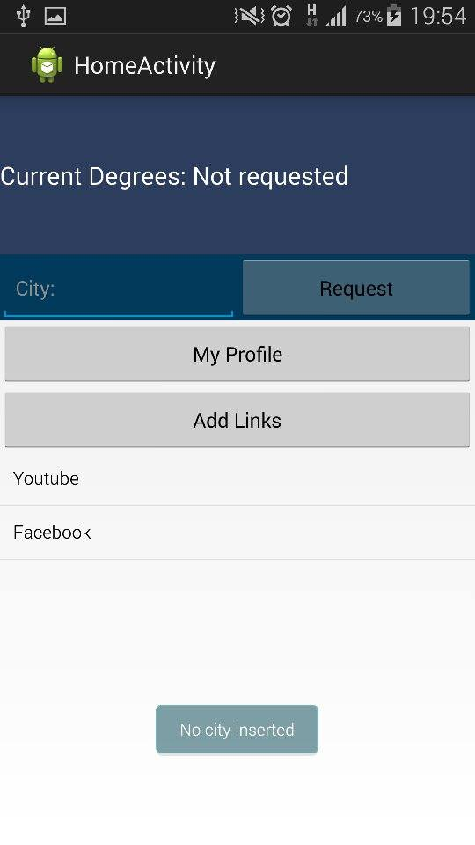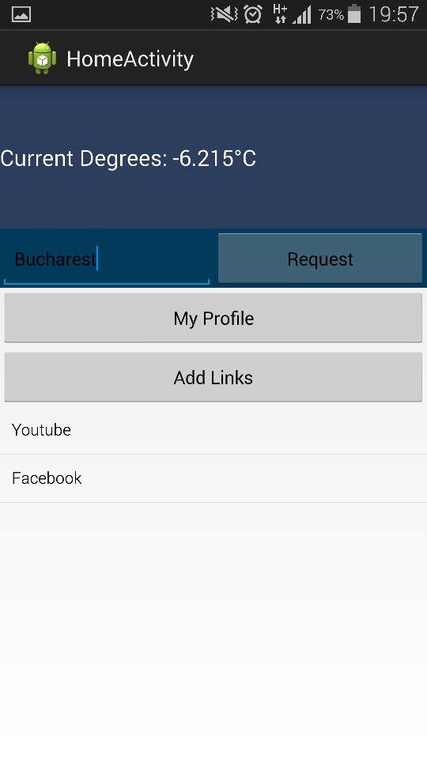

If he presses the “Request” button, but does not introduce a city or if there is no network connection, two different corresponding error messages will appear: “No city inserted” and “No internet connection”.

Otherwise, if the conditions are fulfilled, this meaning that there is internet connection, the user can introduce the city where he wants to find out the temperature, press “Request” button and at the top of the page, the current temperature will be displayed in degrees Celsius.

When he presses “MyProfile” button, the user enters into his profile. If there is nothing stored about him in the Parse database, the user can introduce the information that he wants, such as first name, last name, address, age and gender. When he will press “Save changes”, this information will be stored in the database and they will appear next time he logs in.

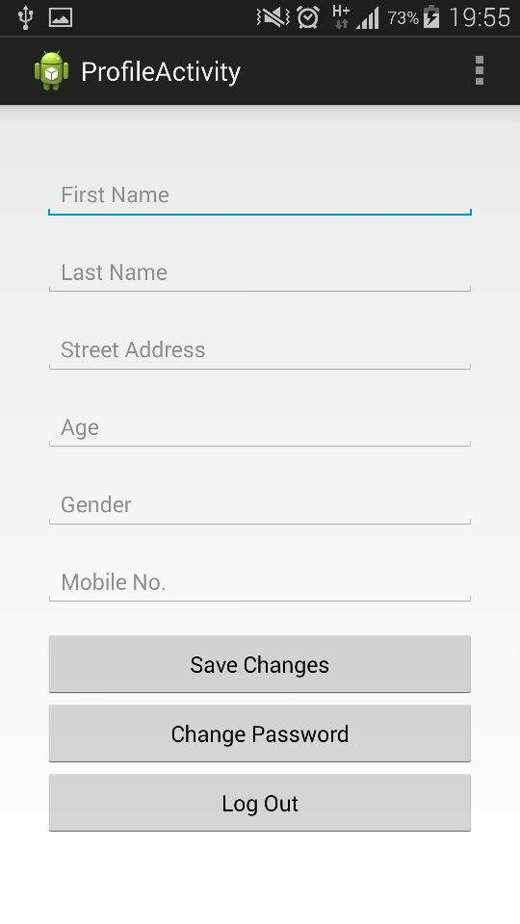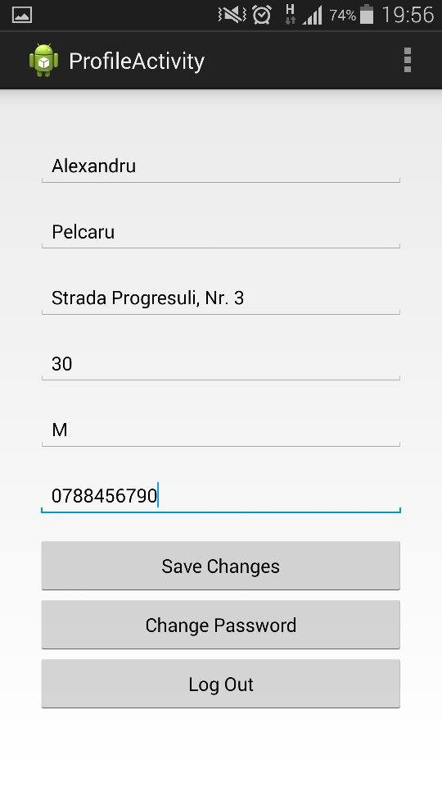

In his profile, the user has the option to modify his password, by pressing “Change Password” button, which advances him into another screen. There he can see three fields that usually appear when anyone changes the password for any account: old password, new password, repeated new password. We added three conditions: the old password should match the user’s current password, the new password should not be the same as the old password and the new password have to match the retyped new password. If the conditions are not fulfilled, three corresponding error messages will appear, announcing the user what is wrong. Obviously, the new password is changed when the user presses “Save New Password”.

Finally, the “Log Out” button simply logs out the user and takes him back to the login screen.

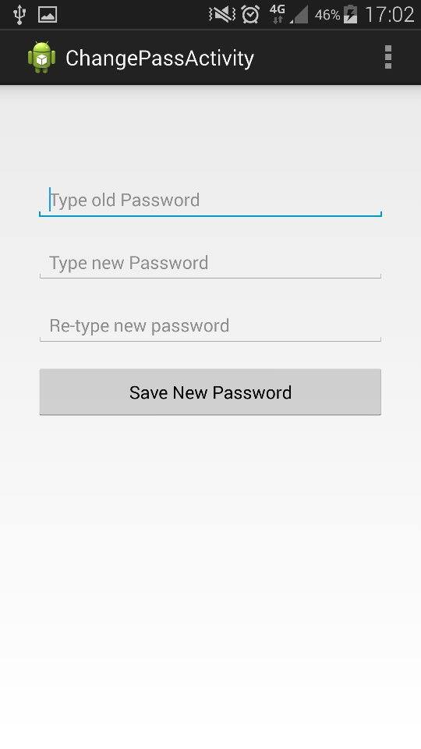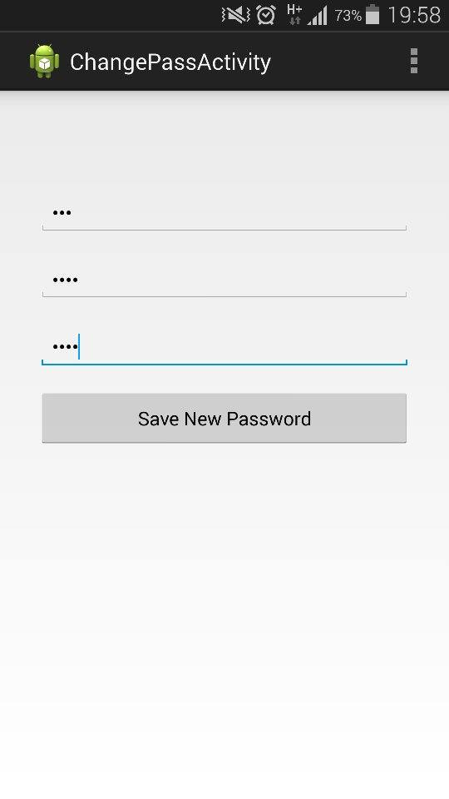

1. **Possible Improvements**

Even though we have created a working version of the application, there could be some things that need to be improved. We should work more on the aspect of the application, for example add a background image. More importantly, there are some bugs when the same user wants to display the weather condition for two different cities (the temperature does not change). The user has to log out from the application and to log in again in order to find the temperature for another location.

1. **Conclusions**

Mobile applications can be one of the best ways to keep consumers engaged with a brand as they are on the move. With the increase in demand for smart phones and efficiency of wireless networks, the demand for mobile applications has increased incredibly. Android is one of the most popular open source platforms that offer developers full access to the framework API’s so as to build innovative applications.

The main aim of this project is to build an Android application that helps the user register or login into a home screen where he can see the weather conditions in any desired location and also to enter, view, modify and save changes into his profile. At this moment, we have a working version of the application and it has been implemented and tested on real devices.

1. **References**
2. Android Developer Guide

<http://developer.android.com/index.html>

1. Android Coding

<http://stackoverflow.com>

1. Parse tutorials

<https://parse.com/tutorials>

1. JSON Formatter

<http://jsonformatter.curiousconcept.com/>