Vadan Alexandru

Link: https://www.tinkercad.com/things/3khT7gWOTCY-frantic-hango-snaget/editel?sharecode=HvrQXybZ8hRNkwp7eMwnDzIBP-GkvfyDtXYmfHChbFI

Componente:

- Arduino Uno

- 2 led-uri

- 1 LCD

- 1 servomotor

- 1 difuzor

- 3 butoane

Cerințe

Când se alimentează sistemului se va aprinde LED-ul roșu.

Când se apasă pe primul buton sistemul va face următoarele:

- Se va aprinde LED-ul verde

- Pe LCD se va afișa un mesaj de pornire

Cand se va apasa pe al doilea buton servomotorul se va deplasa spre stanga, iar difuzorul va cânta un **anumit cântec**

Cand se va apasa pe al treile buton servomotorul se va deplasa spre drepta, iar difuzorul va canta un **alt cântec**

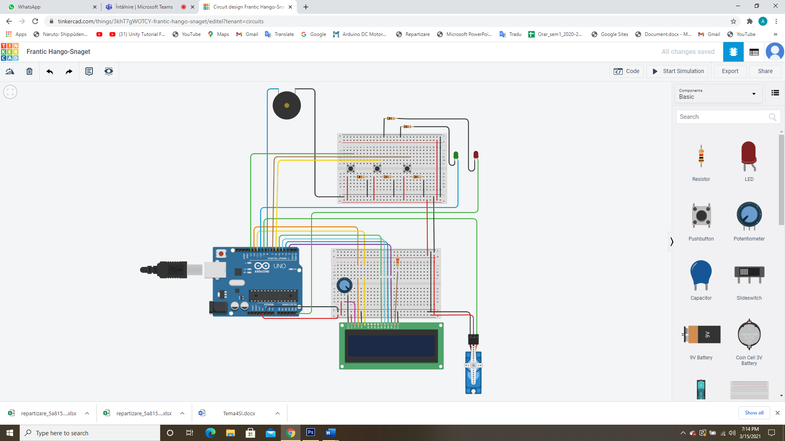

Cod sursa:

//LCD START

#include <LiquidCrystal.h>

//LCD END

//DIF START

#define NOTE_C4 262

#define NOTE_G3 196

#define NOTE_A3 220

#define NOTE_B3 247

#define NOTE_C4 262

int melody[] = {

NOTE_C4, NOTE_G3, NOTE_G3, NOTE_A3, NOTE_G3, 0, NOTE_B3, NOTE_C4

};

int noteDurations[] = {

4, 8, 8, 4, 4, 4, 4, 4

};

//DIF END

//SERVO START

#include <Servo.h>

int pos1=0;

int pos2=0;

Servo servo_9;

//SERVO END

//INIT

int button1 = 13;

int button2 = 6;

int button3 = 7;

int ledRosu = A5;

int ledVerde = 10;

//END INIT

LiquidCrystal lcd(12, 11, 5, 4, 3, 2);

void setup() {

lcd.begin(16, 2);

pinMode(ledRosu, OUTPUT);

pinMode(ledVerde, OUTPUT);

pinMode(button1, INPUT);

pinMode(button2, INPUT);

pinMode(button3, INPUT);

analogWrite(ledRosu,255);

servo_9.attach(9,500,2500);

}

void loop() {

if (digitalRead(button1) == HIGH) {

lcd.print("Hello Worls!");

digitalWrite(ledVerde,HIGH);

}

else if(digitalRead(button2) == HIGH){

for (int thisNote = 0; thisNote < 8; thisNote++) {

int noteDuration = 1000 / noteDurations[thisNote];

tone(8, melody[thisNote], noteDuration);

int pauseBetweenNotes = noteDuration * 1.30;

delay(pauseBetweenNotes);

noTone(8);

}

for(pos1=0;pos1<=180;pos1+=1){

servo_9.write(pos1);

delay(15);

}

}

else if(digitalRead(button3) == HIGH){

for (int thisNote = 8; thisNote > 0; thisNote--) {

int noteDuration = 1000 / noteDurations[thisNote];

tone(8, melody[thisNote], noteDuration);

int pauseBetweenNotes = noteDuration * 1.30;

delay(pauseBetweenNotes);

noTone(8);

}

for(pos2=180;pos2>=0;pos2-=1){

servo_9.write(pos2);

delay(15);

}

}

}