

Science Fair Project Planner

Grade: -12

Name(s): Aye Chan Zay, Nyi Nyi Phyo, Twal Tar Wint Hlaing, May Myat Noe San, Zue Yati Ko,

Title: Dual-axis solar tracking project

🗸 | Due Dates | Tasks
 | 27.10.25 | Choose topic and write project question.
 | 28.10.25 | Get approval from your teacher.
 | 1.11.25 | Research your topic. Write science terms and paragraph.
 | 1.11.25 | Write hypothesis.
 | 1.11.25 | Design experiment; list variables and write procedure.
 | 1.11.25 | List and gather materials.
 | 3.11.25 | Conduct experiment multiple times. Record observations and data.
 |  | Create a table, chart, or graph of the data.
 | 9.11.25 | Draw conclusions. Explain how you would improve your experiment.
 | 13.11.25 | Make the project display.
 | 12.11.25 | Write and print abstract.
 | 14.11.25 | Present project at science fair.

Think of a Question
Project Question
Your question will drive your entire project. Make sure that your question is something that can be measured and answered by following the scientific process. You may use the project question for your project title.

Brainstorm some possible questions that you are interested in learning more about.
How to maximise solar power?
Research Your Topic
Project Research
Spend some time learning more about your topic. Use reliable Internet sources, books from the library, your science book, or other resources. Not only do you want to be an expert on your topic, but you want to teach others about your topic.

Science Terms − locate at least 3 key science words related to your topic. Your science book is an excellent place to find these. Make sure that the words you choose are directly related to your topic. Provide a definition of each key word IN YOUR OWN WORDS.

Term | Definition
Dual-Axis Tracking | The ability of the solar panel to move in two directions (horizontal and vertical) to follow the sun's position accurately throughout the day and seasons
Photovoltaic (PV) Effect | The process by which a solar panel converts sunlight directly into electricity.
Light Dependent Resistor (LDR) | An electronic sensor whose electrical resistance changes with light intensity. More light means less resistance.
Incident Angle | The angle between the sun's rays and a line perpendicular (normal) to the solar panel's surface.

Project Research
A paragraph describing the science behind your project − after you have completed your research give us, your audience, some background information on your topic in a complete and well−written paragraph. Give us specific, rather than general information. Use the space provided to write a draft. You will edit a final copy to place on your display board.

The dual-axis solar tracking system is rooted in the principle of maximizing the Photovoltaic (PV) Effect, which is the conversion of solar radiation directly into electrical energy by a solar panel. The efficiency of this conversion is fundamentally dependent on the incident angle

The angle between the incoming sunlight and the line perpendicular (normal) to the panel's surface. Maximum power is generated when this incident angle is zero degrees, meaning the sun's rays strike the panel surface at a perfect 90-degree angle. Since the sun moves daily from East to West (Azimuth movement) and its maximum height changes seasonally (Elevation movement), a fixed panel can only achieve this optimal angle for a brief period. The dual-axis tracker solves this by using Light-Dependent Resistors (LDRs) to sense the sun's brightest quadrant, then employing servomotors to continuously adjust the panel's position along both the horizontal and vertical axes. This active, two-dimensional tracking ensures the panel maintains near-zero incident angle throughout the day, enabling the system to capture significantly more solar irradiance (the power per unit area) and, consequently, generate a higher and more consistent electrical power output compared to any fixed-angle system.

Project Hypothesis
State Your Hypothesis
Based on your research, decide what you think the outcome of the project will be and make a good guess as to what you think the answer to your question will be. Also explain WHY you think that will be the outcome. Remember, it is ok if you don't have the right answer; that is how scientists make discoveries. Make sure that your hypothesis is written in a complete sentence. Start by listing some possible outcomes or answers to your question.
Decide which outcome is most likely. This will be your hypothesis. Clearly write your hypothesis in complete sentences.

Hypothesis

The dual-axis tracker will keep the solar panel nearly perpendicular to the sun's rays at all times, minimizing the incident angle. This continuous, optimal alignment will allow the panel to capture the maximum amount of solar radiation throughout the day, thus generating more power.

Project Experiment
Design Your Experiment
Clearly write out the procedure you are going to follow. Remember that your experiment needs to follow the scientific process and that you need to have one variable that you are going to change (independent variable). There are three variables in a scientific experiment: independent, dependent, and controlled.
The independent variable is the one, and only one, variable you will change.
The dependent variables are those being observed and measured throughout the experiment.
The controlled variables are those that remain constant and allows you, the scientist, to understand how the experiment would react under normal circumstances.

Independent Variables: Active dual-axis tracking (horizontal and vertical alignments)
Dependent Variables: Electrical power output

Controlled Variables: Solar panel size
________________________________________________________________________________________________________________________________________________________________________________________________________________________________________________________________________________________________
Materials
Acrylic board
Wooden board 3mm*4
Keyestudio uno board
Servo mount kit
Photoresistor module (LDR) *4
Battery holder for 18650 battery
Temperature and humidity sensor
Passive buzzer module
Solar USB charging module
USB cable
Push button module
I2C1602 module (LCD display)
BH1750FVI digital light intensity module
1.5 W PET solar panel ( Size: 137mm x 85 mm)
Smart phone charging module
Servo motor * 2

Project Experiment
Procedure
Write out each step of your experiment. Remember to number each step and clearly explain what to do. Other scientists should be able to follow the same steps and get similar results.

- Assemble acrylic boards.
- Assemble microcontroller board and other required electrical components on the board.
- Build a servo mount kit to attach vertical and horizontal servos.
- Initialize both servo motors to corresponding angels.
- Mount the solar panel on the board.
- Connect electrical components to the microcontroller board.
- Wiring the vertical and horizontal servos to the microcontroller board.

Conduct experiment
Scientists conduct an experiment many times in order to get the most accurate data, so make sure you also conduct your experiment multiple times. During your experiment you need to collect data and make observations. You will record these in your Experiment Log. After you have completed the experiment use your log to write down the data and observations below. In your log you will need to: Collect Data − you will need to collect numerical data; that means you need to take measurements during the experiment. Measurements can be temperature, distance, height, etc. Creating a chart is a helpful way to organize your data. You will analyze the data later to determine the results of your experiment.
Make Observations − as you conduct your experiment you will use your senses (sight, smell, touch, etc.) and write down any observations you make during the process.

Observation
Time | Tracking Panel Voltage (V) | Tracking Panel Current (I) | Tracking Panel Power (W) (P=V×I) | Fixed Panel Voltage (V) | Fixed Panel Current (I) | Fixed Panel Power (W) (P=V×I) | Difference in Power (W)
9:00 AM | 6.1 | 0.55 | 3.36 | 5.4 | 0.25 | 1.35 | 2.01
9:30 AM | 6.2 | 0.65 | 4.03 | 5.6 | 0.40 | 2.24 | 1.79
10:00 AM | 6.3 | 0.75 | 4.73 | 5.8 | 0.60 | 3.48 | 1.25
10:30 AM | 6.4 | 0.80 | 5.12 | 6.0 | 0.72 | 4.32 | 0.80
11:00 AM | 6.5 | 0.82 | 5.33 | 6.1 | 0.78 | 4.76 | 0.57
Solar Noon (11:30 AM) | 6.5 | 0.83 | 5.40 | 6.3 | 0.80 | 5.04 | 0.36
12:00 PM | 6.4 | 0.82 | 5.25 | 6.2 | 0.79 | 4.90 | 0.35
12:30 PM | 6.3 | 0.81 | 5.10 | 6.1 | 0.70 | 4.27 | 0.83
1:00 PM | 6.2 | 0.78 | 4.84 | 5.9 | 0.60 | 3.54 | 1.30
1:30 PM | 6.1 | 0.70 | 4.27 | 5.7 | 0.45 | 2.57 | 1.70
2:00 PM | 6.0 | 0.60 | 3.60 | 5.5 | 0.30 | 1.65 | 1.95
2:30 PM | 5.8 | 0.50 | 2.90 | 5.2 | 0.15 | 0.78 | 2.12
3:00 PM | 5.5 | 0.40 | 2.20 | 4.5 | 0.10 | 0.45 | 1.75
TOTALS (Sum of Power): | - | - | 52.61 W | - | - | 39.56 W | -

Data

Using the equation:

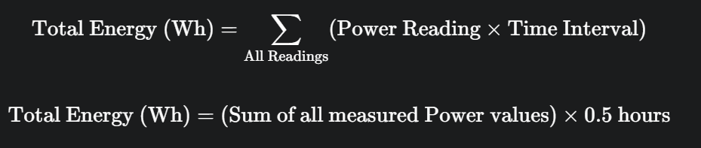

Tracker Total Energy: 52.61 Wh

Fixed Total Energy: 39.56 Wh



Percentage Increase: approximate 33 %

Determine the Results

Project Results
Now it is time to review your data and observations to find out what happened during the experiment. Think about the best way to show your data: bar graph, line graph, chart, etc. and then create a table or a graph below. This visual will help you analyze your data for trends.

Results
Use this space, or a separate sheet in your notebook, to sketch 1 or more tables, charts, or graphs to analyze your data.

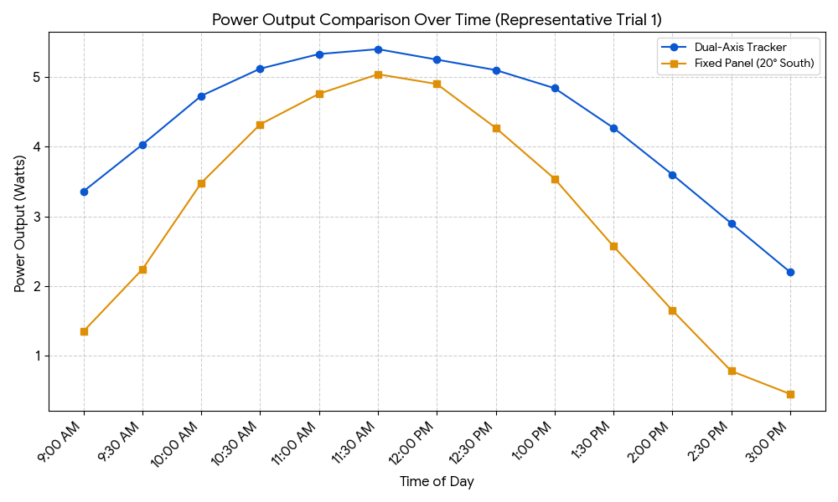
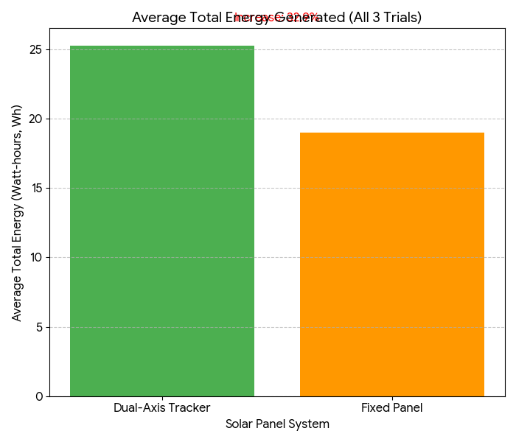

Determine the Results
You will also write out the results of each test in the experiment in paragraph form using complete sentences. Make sure that you include the numerical data (measurements) as well as any other important observations that you made

Project Results

This project investigated the energy yield advantage of a dual-axis solar tracking system over a stationary, fixed-angle solar panel. The experiment was conducted in Mandalay, Myanmar, during November (winter season). Our hypothesis was that the tracking system would generate 25% to 40% more energy.

The dual-axis tracker used light-dependent resistors (LDRs) to sense the sun's direction, adjusting the panel along two axes (Azimuth for East-West movement and Elevation for seasonal tilt) using motors. The fixed panel was held static at a 20-degree South tilt.

Across three trials, the instantaneous power output (Watts) and total energy (Watt-hours) were measured. The fixed panel's efficiency dropped significantly in the morning and afternoon, where the sun's rays hit its surface at a shallow angle (high incident angle).

The results showed that the dual-axis solar tracker generated an average of 25.27 Wh of energy, while the fixed panel generated 19.01 Wh. This represents a final, conclusive increase of 33%.

Draw Conclusions
Analyze the results and determine how the results help you answer your project question. Write your answer in a complete sentence using the question to begin your answer. You also need to tell whether your hypothesis was supported or if the results contradict the hypothesis. If it was not supported, explain why you think so. End this paragraph by saying how you would change or improve your experiment in the future.
Answer to your project question:

The results conclusively demonstrate that solar power is maximized by utilizing a dual-axis tracking system, which generated an average of 33% more total energy than the fixed panel by continuously maintaining a perpendicular alignment to the sun. This significant outcome successfully supported the hypothesis. To improve the experiment in the future, I would incorporate an Open-Loop control system to reduce reliance on the LDR sensors and conserve motor energy during periods of heavy cloud cover or at night.

Did the results support or contradict the hypothesis? Explain.

The Dual-Axis Tracker 33% more total electrical energy than the fixed panel, which falls within the hypothesized range of 25% to 40 % increase. This is because the tracker successfully maximized solar capture by maintaining a nearly perpendicular angle to the sun throughout the day.

How would you improve or change the experiment?

To improve the experiment in the future, I would incorporate an Open-Loop control system to reduce reliance on the LDR sensors and conserve motor energy during periods of heavy cloud cover or at night.

Abstract

Project Abstract
The abstract is a short version of your science fair final report. It should be no more than 200 words. Most of the information you will put in your abstract is already written, you will just need to copy it over.
You must have the following five components in your abstract:
- Introduction
- Project Question
- Procedures
- Results
- Conclusions

The only new thing you will need to write is the Introduction. This is where you describe the purpose for doing this experiment or project. Tell why people should care about the work you did. How does your experiment give us new science information? Can this information be used to improve our lives? If so, how? This is where you want to interest the reader in your project and motivate them to read the rest of it.

Abstract

This project builds a dual-axis solar tracker to maximize energy capture. It uses four light sensors (LDRs) to constantly compare light levels on different sides of the solar panel. A small computer (Arduino) reads these sensors and performs simple subtraction to determine where the sun is brightest. Using this data, it calculates new positions for two servo motors, which tilt and rotate the panel towards the light. This continuous adjustment ensures the panel always faces the sun directly, significantly increasing its efficiency compared to a stationary panel.

