Submission Report
- Submission generated at 09/03/2025 at 03:25:00
- Machine info: Linux pkrvm7jw40e0xgp 6.11.0-1018-azure #18~24.04.1-Ubuntu SMP Sat Jun 28 04:46:03 UTC 2025 x86_64 x86_64 x86_64 GNU/Linux

Build Output
make[1]: Entering directory '/home/runner/work/makefile-project/makefile-project'
mkdir -p build/debug
cc -g -O0 -DDEBUG -fno-omit-frame-pointer -fsanitize=address -c src/main.c -o build/debug/main.c.o
mkdir -p build/debug
cc -g -O0 -DDEBUG -fno-omit-frame-pointer -fsanitize=address -c src/lab.c -o build/debug/lab.c.o
cc -g -O0 -DDEBUG -fno-omit-frame-pointer -fsanitize=address build/debug/main.c.o build/debug/lab.c.o -o build/debug/myapp_d -fsanitize=address
make[1]: Leaving directory '/home/runner/work/makefile-project/makefile-project'
make[1]: Entering directory '/home/runner/work/makefile-project/makefile-project'
mkdir -p build/release
cc -Wall -Wextra -O2 -fPIE -MMD -MP -Wformat -Wformat=2 -Wconversion -Wsign-conversion -Wimplicit-fallthrough -fstack-protector-strong -Werror=format-security -Werror=implicit -Werror=incompatible-pointer-types -Werror=int-conversion -c src/main.c -o build/release/main.c.o
mkdir -p build/release
cc -Wall -Wextra -O2 -fPIE -MMD -MP -Wformat -Wformat=2 -Wconversion -Wsign-conversion -Wimplicit-fallthrough -fstack-protector-strong -Werror=format-security -Werror=implicit -Werror=incompatible-pointer-types -Werror=int-conversion -c src/lab.c -o build/release/lab.c.o
cc -Wall -Wextra -O2 -fPIE -MMD -MP -Wformat -Wformat=2 -Wconversion -Wsign-conversion -Wimplicit-fallthrough -fstack-protector-strong -Werror=format-security -Werror=implicit -Werror=incompatible-pointer-types -Werror=int-conversion build/release/main.c.o build/release/lab.c.o -o build/release/myapp
make[1]: Leaving directory '/home/runner/work/makefile-project/makefile-project'
make[1]: Entering directory '/home/runner/work/makefile-project/makefile-project'
mkdir -p build/tests
cc -g -O0 -DTEST -fprofile-arcs -ftest-coverage -c src/main.c -o build/tests/main.c.o
mkdir -p build/tests
cc -g -O0 -DTEST -fprofile-arcs -ftest-coverage -c src/lab.c -o build/tests/lab.c.o
mkdir -p build/tests/
cc -g -O0 -DTEST -fprofile-arcs -ftest-coverage -c tests/lab-test.c -o build/tests/lab-test.c.o
mkdir -p build/tests/harness/
cc -g -O0 -DTEST -fprofile-arcs -ftest-coverage -c tests/harness/unity.c -o build/tests/harness/unity.c.o
cc -g -O0 -DTEST -fprofile-arcs -ftest-coverage build/tests/main.c.o build/tests/lab.c.o build/tests/lab-test.c.o build/tests/harness/unity.c.o -o build/tests/myapp_t -fprofile-arcs -ftest-coverage
make[1]: Leaving directory '/home/runner/work/makefile-project/makefile-project'
make[1]: Entering directory '/home/runner/work/makefile-project/makefile-project'
mkdir -p build/debug-test
cc -g -O0 -DDEBUG -DTEST -fno-omit-frame-pointer -fsanitize=address -c src/main.c -o build/debug-test/main.c.o
mkdir -p build/debug-test
cc -g -O0 -DDEBUG -DTEST -fno-omit-frame-pointer -fsanitize=address -c src/lab.c -o build/debug-test/lab.c.o
mkdir -p build/debug-test/
cc -g -O0 -DDEBUG -DTEST -fno-omit-frame-pointer -fsanitize=address -c tests/lab-test.c -o build/debug-test/lab-test.c.o
mkdir -p build/debug-test/harness/
cc -g -O0 -DDEBUG -DTEST -fno-omit-frame-pointer -fsanitize=address -c tests/harness/unity.c -o build/debug-test/harness/unity.c.o
cc -g -O0 -DDEBUG -DTEST -fno-omit-frame-pointer -fsanitize=address build/debug-test/main.c.o build/debug-test/lab.c.o build/debug-test/lab-test.c.o build/debug-test/harness/unity.c.o -o build/debug-test/myapp_td -fsanitize=address
make[1]: Leaving directory '/home/runner/work/makefile-project/makefile-project'
Builds completed. You can run the application with: ./build/release/myapp
You can run the debug build with: ./build/debug/myapp_d
You can run the test build with: ./build/tests/myapp_t
You can run the debug-test build with: ./build/debug-test/myapp_td

Coverage Report
Setting up tests...
Tearing down tests...
tests/lab-test.c:56:test_get_greeting:PASS
Setting up tests...
Tearing down tests...
tests/lab-test.c:57:test_add:PASS
Setting up tests...
Tearing down tests...
tests/lab-test.c:58:test_subtract:PASS
Setting up tests...
Tearing down tests...
tests/lab-test.c:59:test_product:PASS
Setting up tests...
Tearing down tests...
tests/lab-test.c:60:test_badSum:PASS
-----------------------
5 Tests 0 Failures 0 Ignored
OK
./build/tests/myapp_t
Setting up tests...
Tearing down tests...
tests/lab-test.c:56:test_get_greeting:PASS
Setting up tests...
Tearing down tests...
tests/lab-test.c:57:test_add:PASS
Setting up tests...
Tearing down tests...
tests/lab-test.c:58:test_subtract:PASS
Setting up tests...
Tearing down tests...
tests/lab-test.c:59:test_product:PASS
Setting up tests...
Tearing down tests...
tests/lab-test.c:60:test_badSum:PASS
-----------------------
5 Tests 0 Failures 0 Ignored
OK
mkdir -p ./build/report/html
mkdir -p ./build/report/txt
gcovr -r . --html --html-details --exclude-directories build/tests/harness --exclude '.*main\.c$' --exclude '.*test\.c$' -o ./build/report/html/coverage_report.html
(INFO) Reading coverage data...
(INFO) Writing coverage report...
gcovr -r . --txt --exclude-directories build/tests/harness --exclude '.*main\.c$' --exclude '.*test\.c$'
(INFO) Reading coverage data...
(INFO) Writing coverage report...
------------------------------------------------------------------------------
GCC Code Coverage Report
Directory: .
------------------------------------------------------------------------------
File Lines Exec Cover Missing
------------------------------------------------------------------------------
src/lab.c 16 16 100%
------------------------------------------------------------------------------
TOTAL 16 16 100%
------------------------------------------------------------------------------

Address Sanitizer Report
Setting up tests...
Tearing down tests...
tests/lab-test.c:56:test_get_greeting:PASS
Setting up tests...
Tearing down tests...
tests/lab-test.c:57:test_add:PASS
Setting up tests...
Tearing down tests...
tests/lab-test.c:58:test_subtract:PASS
Setting up tests...
Tearing down tests...
tests/lab-test.c:59:test_product:PASS
Setting up tests...
Tearing down tests...
tests/lab-test.c:60:test_badSum:PASS
-----------------------
5 Tests 0 Failures 0 Ignored
OK

Source File: lab.c
#include "lab.h"
#include <stdio.h>
#include <stdlib.h>
int add(int a, int b) {
return a + b;
}
int subtract(int a, int b) {
return a - b;
}
int product(int a, int b) {
return a * b;
}
int badSum(int a, int b) {
// int *evilVariable = malloc(100);
return (a + b) + 1;
}
char *get_greeting(const char *restrict name)
{
if (name == NULL)
{
return NULL;
}
// Allocate memory for the greeting message
int length = snprintf(NULL, 0, "Hello, %s!", name);
if (length < 0) // GCOVR_EXCL_START
{
return NULL; // snprintf failed
} // GCOVR_EXCL_STOP
//Casting is safe here because we know length is non-negative
size_t alloc_size = (size_t) length + 1; // +1 for the null terminator
char *greeting = malloc( alloc_size);
if (greeting == NULL) // GCOVR_EXCL_START
{
return NULL; // Memory allocation failed
} // GCOVR_EXCL_STOP
// Create the greeting message
snprintf(greeting, alloc_size, "Hello, %s!", name);
return greeting;
}

Source File: lab.h
#ifndef LAB_H
#define LAB_H
/** * @brief Returns a greeting message.
*
* This function returns a string that contains a greeting message.
* The string is allocated with malloc and should be freed by the caller.
* @param name The name to include in the greeting.
* @return A greeting string.
*/
char* get_greeting(const char* restrict name);
/** * @brief Adds two integers.
*
* This function adds two integers and returns the result.
* @param a The first integer.
* @param b The second integer.
* @return The sum of a and b.
*/
int add(int a, int b);
/** * @brief Subtracts two integers.
*
* This function subtracts the second integer from the first and returns the result.
* @param a The first integer.
* @param b The second integer.
* @return The result of a - b.
*/
int subtract(int a, int b);
/** * @brief Multiplies two integers.
*
* This function multiplies both numbers and returns the result.
* @param a The first integer.
* @param b The second integer.
* @return The result of a * b.
*/
int product(int a, int b);
/** * @brief Incorrectly adds two integers.
*
* This function adds both numbers and returns the result.
* @param a The first integer.
* @param b The second integer.
* @return An incorrect result of a + b.
*/
int badSum(int a, int b);
#endif // LAB_H

Source File: main.c
#include "lab.h"
#include <stdio.h>
#include <stdlib.h>
#ifdef TEST
#define main main_exclude
#endif
int main(void)
{
//These variables are EVIL!!
//Dont trust them
// int *evilVariable = NULL;
// *evilVariable = 1;
// int *evilVariable2 = malloc(100);
int result_add = add(5, 3);
int result_subtract = subtract(5, 3);
int result_product = product(5, 3);
int result_badSum = badSum(1, 1);
printf("Addition Result: %d\n", result_add);
printf("Subtraction Result: %d\n", result_subtract);
printf("Multiplication Result: %d\n", result_product);
printf("Bad Sum result: %d\n", result_badSum);
char *greeting = get_greeting("World");
if (greeting) {
printf("%s\n", greeting);
free(greeting); // Free the allocated memory for the greeting
} else {
printf("Failed to create greeting.\n");
}
return 0;
}

Test Files

lab-test.c
#include <stdlib.h>
#include <stdio.h>
#include "harness/unity.h"
#include "../src/lab.h"
void setUp(void) {
printf("Setting up tests...\n");
}
void tearDown(void) {
printf("Tearing down tests...\n");
}
void test_add(void) {
TEST_ASSERT_EQUAL(8, add(5, 3));
TEST_ASSERT_EQUAL(-2, add(-5, 3));
TEST_ASSERT_EQUAL(0, add(0, 0));
}
void test_subtract(void) {
TEST_ASSERT_EQUAL(2, subtract(5, 3));
TEST_ASSERT_EQUAL(-8, subtract(-5, 3));
TEST_ASSERT_EQUAL(0, subtract(0, 0));
}
void test_product(void) {
TEST_ASSERT_EQUAL(15, product(5, 3));
TEST_ASSERT_EQUAL(-10, product(-5, 2));
TEST_ASSERT_EQUAL(0, product(0, 0));
}
void test_badSum(void) {
TEST_ASSERT_NOT_EQUAL(2, badSum(1, 1));
TEST_ASSERT_NOT_EQUAL(5, badSum(3, 2));
TEST_ASSERT_NOT_EQUAL(0, badSum(0, 0));
}
void test_get_greeting(void) {
char *greeting = get_greeting("Alice");
TEST_ASSERT_NOT_NULL(greeting);
TEST_ASSERT_EQUAL_STRING("Hello, Alice!", greeting);
free(greeting); // Free the allocated memory for the greeting
greeting = get_greeting(NULL);
TEST_ASSERT_NULL(greeting);
greeting = get_greeting("");
TEST_ASSERT_NOT_NULL(greeting);
TEST_ASSERT_EQUAL_STRING("Hello, !", greeting);
free(greeting);
}
int main(void) {
UNITY_BEGIN();
RUN_TEST(test_get_greeting);
RUN_TEST(test_add);
RUN_TEST(test_subtract);
RUN_TEST(test_product);
RUN_TEST(test_badSum);
return UNITY_END();
}

README
# Makefile Project Template
This is a simple Makefile project template that can be used to build, test, and
debug C projects. It includes support for debug builds, sanitizers, and code
coverage.
## Tools and Dependencies
- GNU Make
- GCC or Clang
- Address Sanitizer (ASan) for memory error detection
- gcov and lcov for code coverage
- gcovr for generating coverage reports
- pandoc for generating docx reports (optional)
## Test Harness
This project uses the Unity Test Framework for unit testing. Refer to the
[Unity Getting Started Guide](https://github.com/ThrowTheSwitch/Unity/blob/master/docs/UnityGettingStartedGuide.md) for more information on how to write and run tests.
## Example Usage
To build the project run:
```bash
make release
To run the executable:
./build/release/myapp
To run the unit tests:
make check
To see all the configurations, run make help
Usage: make [target]
Available targets:
debug - Build the application in debug mode (default)
release - Build the application in release mode
test - Build the unit tests
all - Builds debug, release, and test targets
check - Run tests and check results
report - Generate coverage report after running tests
leak - Check for memory leaks in debug mode
clean - Remove build artifacts
print - Print build variables for MakeFile debugging
help - Show this help message

VS Code Integration
This project is designed to work well with Visual Studio Code. Configurations for debugging the application and unit tests are provided. Read about how to use the debugger in the VS Code documentation.

Features
- Build targets for debug and release modes
- Support for Address Sanitizer (ASan)
- Code coverage support and report generation
- Simple structure for organizing source files and build artifacts
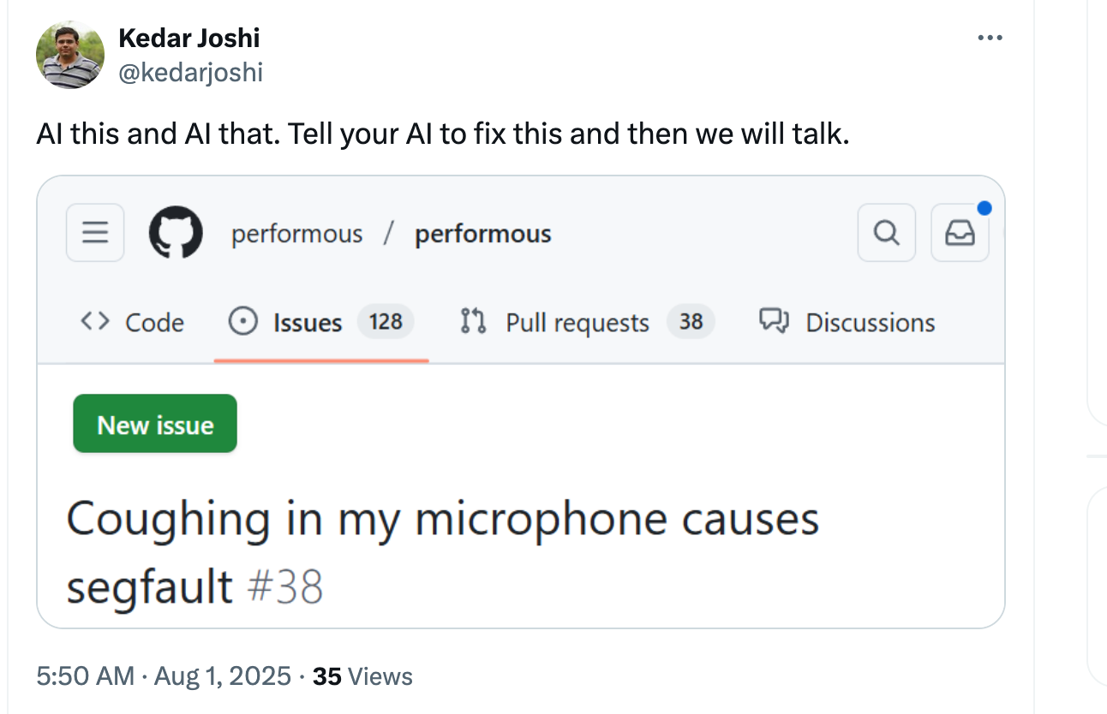 ```

End of Report
Report generated on 09/03/2025 at 03:25:02

GitHub Info
- GitHub repo name: Alexedani/makefile-project
- The repository visibility is public.
- The workflow was triggered by Alexedani
Hash is committed to repo as submission-report-hash.txt
c46609bd615841d064286645b38c88ee53f6c6f9d51a490b8d282c6dfdf7996a submission-report.md

