Agnico-Eagle Mines case
1.0 Executive Summary
Agnico-Eagle Mines Ltd. (AEM), a Canadian gold producer with over 30 years of mining experience, faced critical decisions in April 2002 after its stock price fell by nearly $1 in a single day. Dan Acker, a senior portfolio manager at National Securities, held substantial AEM shares in his portfolio and needed to assess whether the decline indicated further risks or was an opportunity to hold or increase his position.
AEM’s operations were centered around its LaRonde mine in Quebec, one of the largest gold deposits in Canada, featuring significant reserves of gold and by-products like zinc, copper, and silver. Recent investments, including the Penna Shaft, have enhanced production capacity, positioning AEM for increased output and lower production costs.
With gold prices stabilizing above $300/oz and AEM’s expanded capacity at LaRonde, the company appeared well-positioned for future growth. However, AEM’s financial risks and performance gaps compared to peers raised concerns about its valuation and long-term competitiveness.
Acker needed to evaluate AEM’s intrinsic equity value by combining traditional DCF methods with real options valuation to account for unmined reserves. This analysis would guide his decision to hold, sell, or increase exposure to AEM, balancing potential rewards against the inherent risks of a single-mine operator.

2.0 Dan Acker’s Concern About AEM’s Stock
Dan Acker's concerns about Agnico-Eagle Mines Ltd. (AEM) stem from several factors. The immediate worry is the sharp decline in AEM's stock price, which raises questions about whether this signals a broader issue or a temporary market overreaction. Additionally, while AEM has shown strong recent performance, there are concerns that the stock may have become overvalued relative to its fundamental metrics. AEM's reliance on its single-mine operation at LaRonde heightens operational risk, as any disruptions at this site could severely impact the company. Financially, AEM's high dividend payout ratio reduces the capital available for reinvestment, putting it at a disadvantage compared to competitors that focus on growth and reinvestment. Moreover, AEM's relatively high leverage compared to its peers increases financial risk, particularly in a volatile market environment. Finally, AEM's unhedged exposure to gold price fluctuations amplifies earnings volatility, as its performance is closely tied to the unpredictable movements of gold prices. These concerns collectively highlight the need for a detailed valuation and risk assessment to determine whether the stock's decline is justified.
Valuation Using DCF: To value AEM using the Discounted Cash Flow (DCF) method, we estimate free cash flows by adjusting earnings before interest and taxes (EBIT) for non-cash items (like depreciation and amortization), subtracting changes in working capital, and deducting capital expenditures to arrive at the total free cash flow. From AEM’s projected financials, the gross cash flow and capital expenditures are key components in calculating the free cash flow.

The Terminal Value (TV) is calculated by taking the NOPLATPA for the final forecast year (2008 in this case), adjusting it for the expected growth rate (g), and then dividing it by the WACC (K).

This formula assumes that the company's operating profits will grow at a constant rate g indefinitely after 2008. The result of this formula is the value of all future cash flows from 2008 onward, assuming that the company grows at a constant rate forever

Appropriate Discount Rate: Appropriate Discount Rate: The discount rate should be the Weighted Average Cost of Capital (WACC), which considers AEM’s cost of debt and cost of equity. The WACC for AEM is based on historical capital structure weights. The cost of equity can be estimated using the Capital Asset Pricing Model (CAPM), while the cost of debt is based on the company’s bond yields and credit rating. The discount rate to use for discounting the future cash flows is the WACC provided by A-G Financial Consulting. They used an adjusted beta of 1.05, and the WACC represents a comprehensive estimate that accounts for the cost of equity and debt specific to AEM’s capital structure.

3.0 Enterprise Value Calculation
To calculate the enterprise value (EV) of AEM, we begin by estimating the value of the firm’s operations using the DCF model as outlined above. The Enterprise Value (EV) is the sum of the value of operations plus the non-operating assets and liabilities:
Non-Operating Assets: These include excess cash, marketable securities, and any investments not directly tied to AEM's operations.
Non-Operating Liabilities: These include the market value of AEM’s debt, pension liabilities, and any environmental obligations or deferred taxes. Tax Loss and development expense carryforwards are crucial here.
- Tax Loss Carryforwards: Tax loss carryforwards represent accumulated losses from prior years that can be used to reduce future taxable income. In AEM's case, tax loss carryforwards can be applied until they are fully utilized, which is expected to be by 2008 as mentioned. These carryforwards create a tax shield that lowers the future tax burden, effectively increasing the free cash flow available to the company. The tax-shield for tax loss carry forward is $ 9,164.83.
- Development Expense Carryforwards: After the tax loss carryforwards have been exhausted (expected by 2008), development expense carryforwards can be used for a further eight years. Similar to tax loss carryforwards, these allow AEM to reduce its taxable income, providing a tax shield that improves the free cash flow available to equity holders. The Development Expense Carryforwards is $39,742.98million
The tax shields resulting from tax loss carryforwards and development expense carryforwards can be incorporated by calculating their present value using the cost of debt as the discount rate. This is because the tax shields carry a similar risk to that of debt, and the cost of debt is a reasonable approximation for the discount rate in this context.

Incorporate into Enterprise Value:
Add the Present Value of Tax Shields to Enterprise Value: The calculated present value of tax shields is then added to the enterprise value derived from DCF which give us an Enterprise value of $ 199,889million
Adjustment to Free Cash Flows: The impact of tax shields is effectively included in the free cash flows (FCF) used in the DCF model. Each year’s free cash flows should be adjusted for the tax shields provided by the carryforwards.

4.0 Real Option Valuation - Unmined Gold

The unmined gold is treated as a real option, which gives AEM the flexibility to decide when to extract the gold, depending on market conditions such as the price of gold. To value this real option, the Black-Scholes option pricing model can be used.

Key steps and considerations for valuing the unmined gold as a real option include:

Underlying Asset: Value of gold production, calculated as gold price × ounces produced per year × number of years, is $2,756,000.00.

Exercise Price: Present value of operating costs plus one-time mine opening costs was calculated as $1,082,379.88.

Time to Maturity: Lease period or time available for extracting the gold is 16 years.

Volatility: Annualized standard deviation of monthly percentage changes in gold prices (around 20% as per historical data).

Risk-Free Rate: Use the long-term government bond yield to maturity as the risk-free rate which is 5.98%.

These calculations are set up in the provided Excel spreadsheet BS-Options Pricing to determine the option value of the unmined gold. This option value represents the flexibility embedded in AEM’s operations that DCF alone cannot capture.

Step-by-Step Calculation:
- Identify the Tax Shield Amount: For each year, the amount of tax shield equals the taxable income reduction due to carryforwards multiplied by the tax rate.
- Discount the Future Tax Shields: The tax shield for each year is discounted using the before-tax cost of debt. In AEM's case, the cost of debt is approximately 14.82% to 16.67%, depending on the year.
- Calculate the PV of Tax Shields: Sum the discounted tax shields over the relevant years (until 2008 for tax loss carryforwards and an additional eight years for development expense carryforwards).

5.0 Appendix

- DCF Valuation

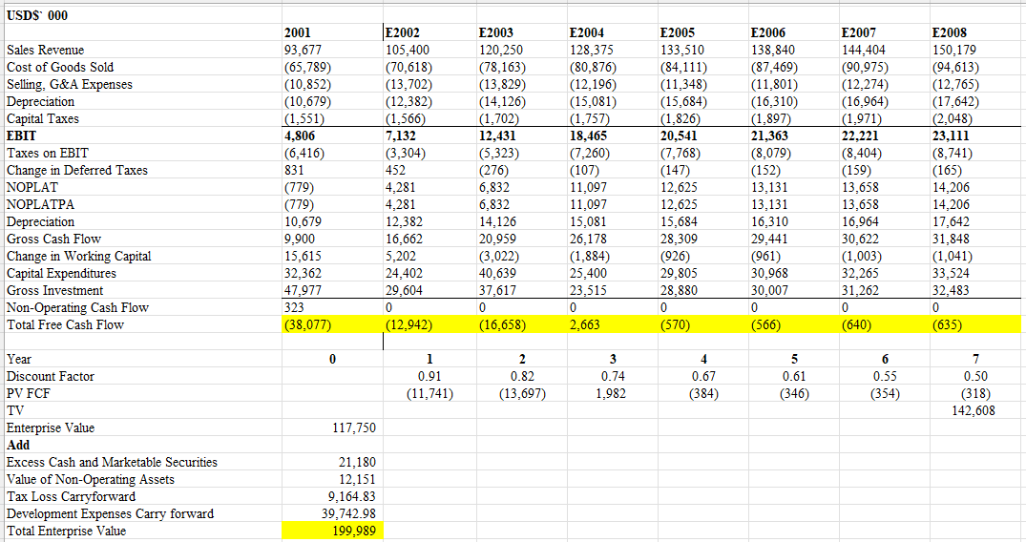

- Tax Shield Calculation
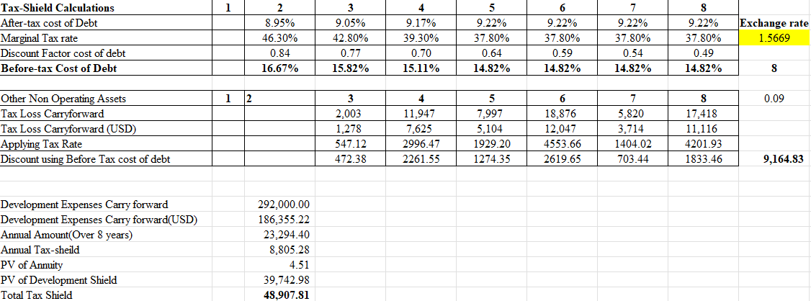

- Real Option Valuation
