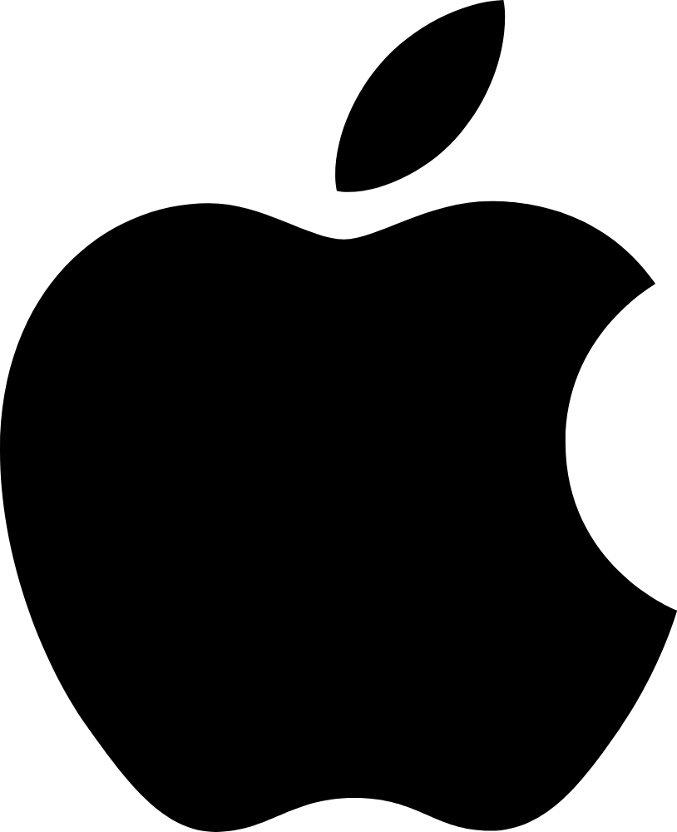
Apple Inc. Analysis
Devan Shankar, Yazhen Wu, Alexei Habermehl, Alexander Danning Li
American University
FIN368

Table of Contents
Section 1: Company Background
- About Apple Inc.
- Finance Statements
- Sector Information
- Company Narrative

Section 2: Corporate Governance Analysis
- Corporate Governance Structure
- Bondholder Concerns
- Financial Markets
- Society and Other Stakeholders

Section 3: Stockholder Analysis
- Stockholder Composition
- Risk Profiling
- Risk Measures

Section 4: Risk and Return: Analysis of the Firm
- Estimating Risk-Free Rate and Equity Risk Premium
- Estimating Relative Risk
- Estimating Default Risk and Cost of Debt
- Estimating Cost of Capital
Section 5: Estimating Earnings and Cash Flows
- Typical Investment
- Investment Overall Introduction
- Production Investment
- Technology Investment
- Firm Size and Ownership Structure
- Investment Decision Rule

Section 6: Evaluating Existing Investments and Competitive Advantages (Alexei)
- Analyze Existing Investments
- Assessing Competitive Strengths

Section 7: Analyzing a Firm’s Current Financing Choices (Augustine)
- Current Financing Mix
- Financing Type
- Financing Trade-off

Section 8: The Optimal Financing Mix (Alex)
- Intrinsic Approaches
- Relative Analysis

Section 9: Mechanics of Moving to the Optimal (Devan and Alex)
- The Immediacy Question
- Alter Financing Mix or Take Projects
- Financing Type

Section 10: The Trade-Off on Dividend Policy (Devan)
- Historical Dividend Policy
- Firm Characteristics

Section 11: A Framework for Analyzing Dividends
- Cash Return to Stockholders
- Affordable Dividends
- Management Trust
- Changing Dividend Policy
- Comparing to Sector and Market

Chapter 12: Valuation
- Cash Flow Estimation, Growth Choices, and Discount Rate
- Terminal Value
- From DCF Value to Equity Value per Share
- Relative Valuation

Section 1: Company Background

About Apple Inc.
Apple Inc (Formerly Apple Computer, Inc.) is an American multinational technology company located in Cupertino, California, in Silicon Valley. It designs, develops, innovates, and sells electronics, computer software, and online services to customers. Devices include iPhone, iPad, Apple Watch, Mac, and Apple TV. Apple was founded by Steve Jobs, Steve Wozniak, and Ronald Wayne in April 1976 to develop and sell Wozniak's Apple I personal computer.
Apple continues to work on innovation. Apple is famous for innovative physical products such as the iPhone smartphone, iPad tablet computer, Mac personal computer, iPod portable media player, and the Apple Watch smartwatch. Its online services include the iTunes Store, the iOS App Store, the Mac App Store, Apple Music, and iCloud. Additionally, Apple offers software like the macOS, iOS, and iPadOS operating systems, the iTunes media player, the Safari web browser, and the iLife and iWork creativity and productivity suites. Finally, Apple supports its own culture and attitude to provide consumer services.
Moreover, Apple Inc. provides consumers with special services, such as Genius Bar, which helps people find small tips and teaches them how to use the iPhone or iPad smoothly. Trade-in service is also good for eco-friendly and saves money for customers.
Right now, Apple operates retail stores known as Apple Stores worldwide and an online store that sells Apple products and third-party accessories. Moreover, Apple is one of the Big Tech technology companies, alongside Amazon, Google, Microsoft, and Meta, and is well-known for its brand loyalty. It's also recognized for its size and revenue, with a valuation that has often made it the world's most valuable company. Apple uses its creative and innovative attitude to inform people about a worldwide technology company and the tech industry.

Finance Statement
Below are Apple Inc.’s balance sheets from 2020-2023, which are the unaudited balance sheets. The dollar amounts are recorded by millions, except the number of shares, which are reflected in thousands and par value. (Apple.com)
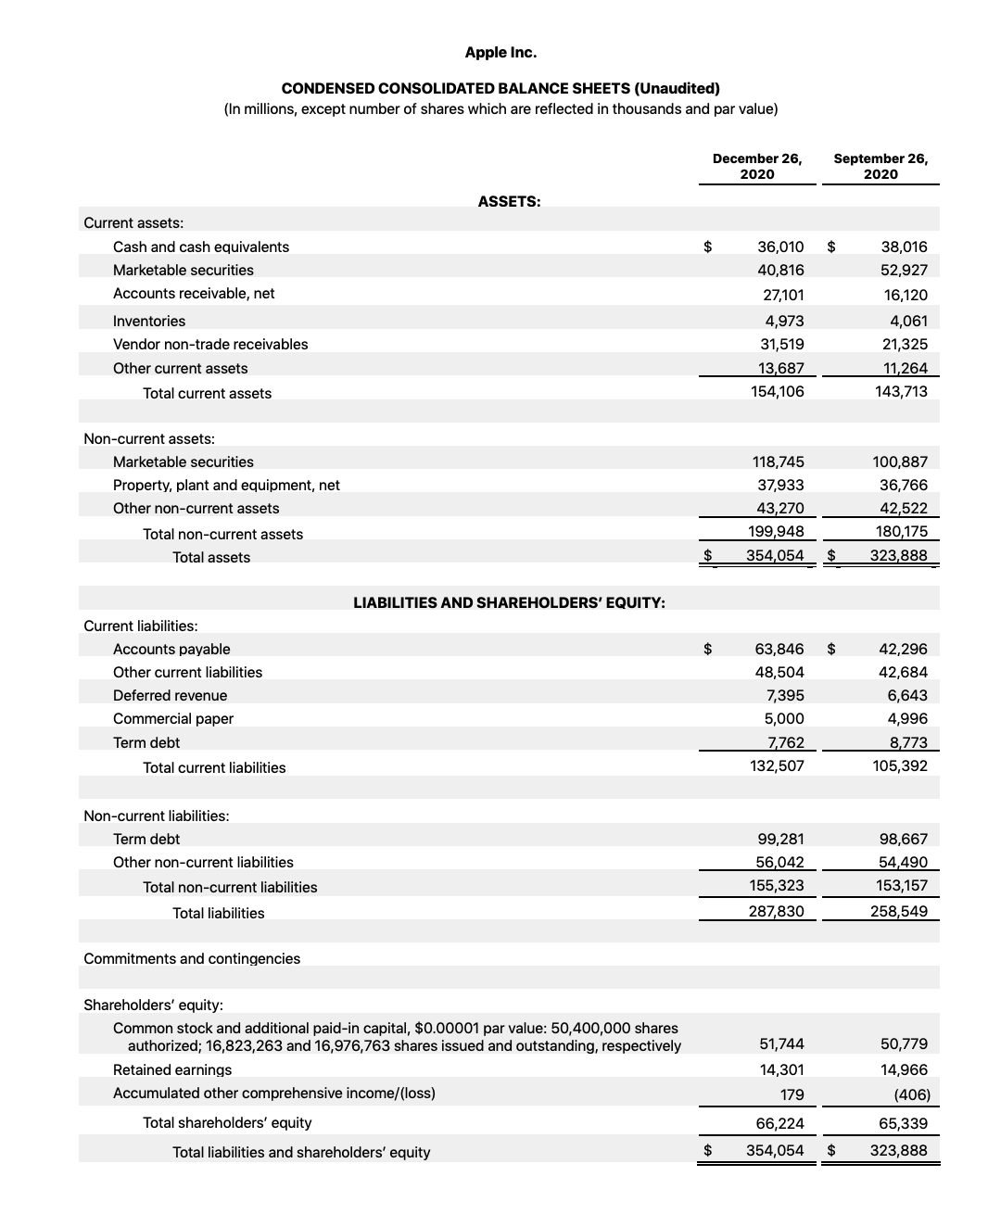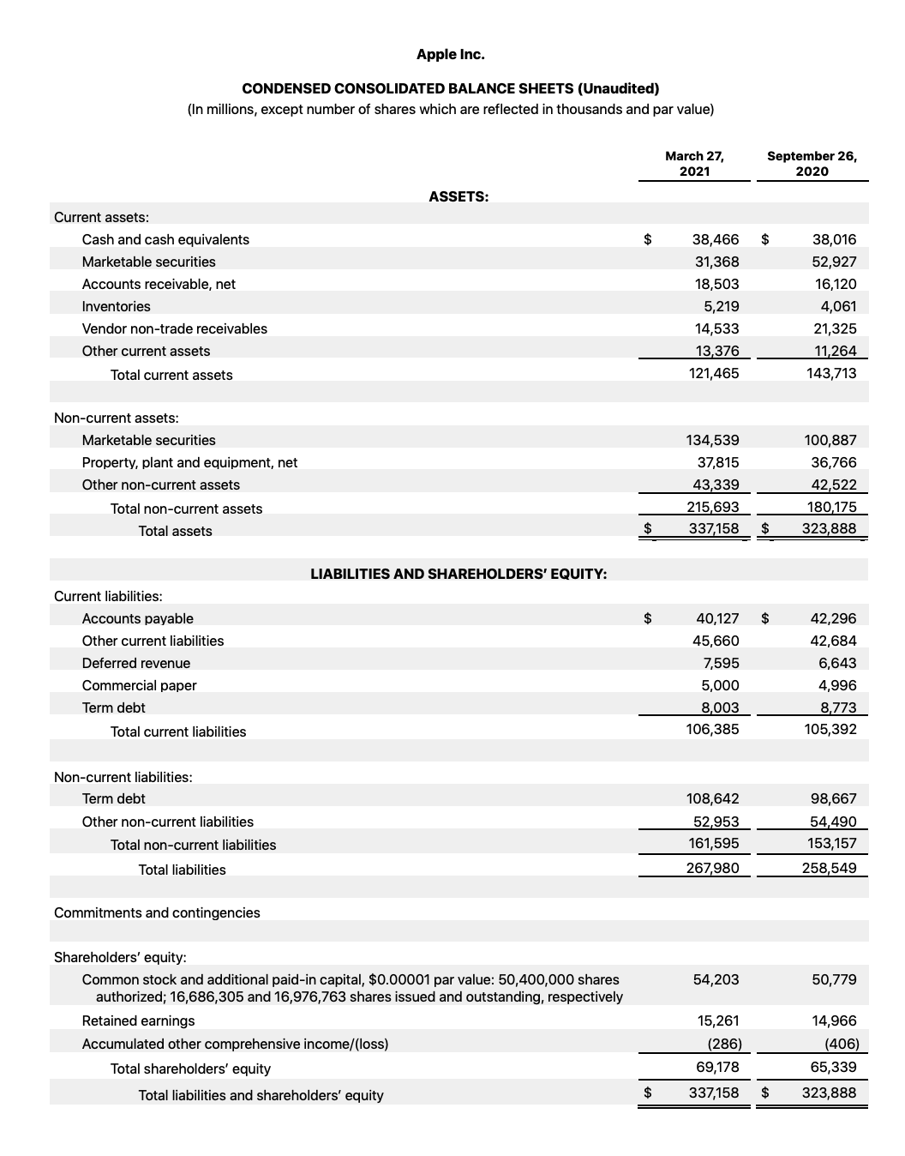
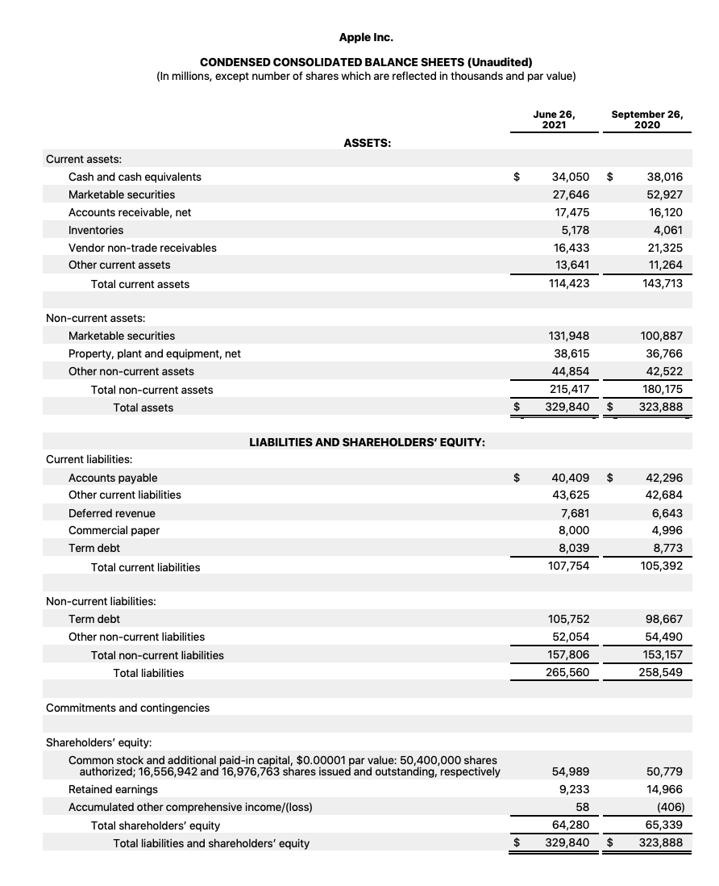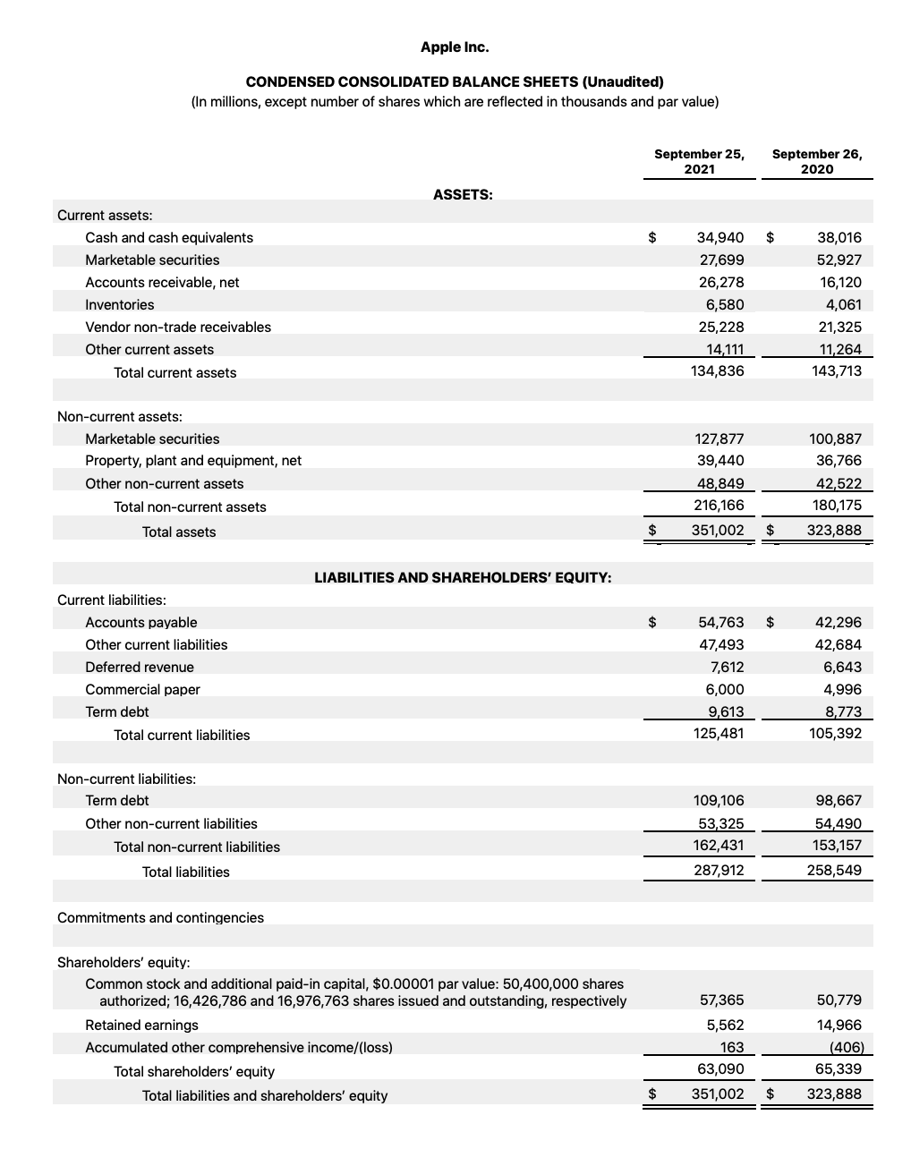

Sector Information
Apple Inc. is a technology company in the consumer electronics and information technology industry. It is often associated with various sub-sectors due to its diverse product lineup: Consumer Electronics, Computer Hardware, Software and Services, Telecommunication Equipment, Wearable Technology, Digital Content, and Media. These six parts play different roles in helping the company run. They help Apple Inc. run and support the consumers in different views, then bring Apple Inc. multiple revenues.
Consumer Electronics is the main area of Apple Inc., which includes a range of products such as iPhone, iPad, Mac, Apple Watch, and Apple TV. Computer Hardware is the sector due to the excellent Macintosh computers and laptops. Software and Services means the strong services provided by Apple Inc., including macOS, iOS, and a variety of productivity and creative tools. Its services sector has grown significantly with offerings such as the App Store, Apple Music, iCloud, and Apple Pay (Apple Wallet). Telecommunication Equipment through development and sales of the phones related. Wearable Technology seems like the productions can be worn, like Airpods, Apple Watch, and Apple Vision Pro, etc. Digital Content and Media always run this sector by providing services like iTunes, Apple Music, Apple TV, and the App Store.

Company Narrative
Apple Inc.'s company narrative is one of innovation, design excellence, and market transformation since its inception in 1976 by Steve Jobs, Steve Wozniak, and Ronald Wayne as partners. Apple has positioned itself as a pioneer in personal computing by introducing the Apple I and, later, the Apple II. The company's narrative took a significant turn in the 1980s with the Macintosh launch, the first commercially successful personal computer to feature a mouse and a graphical user interface.
Apple's narrative extends beyond its products to its distinct approach to design and functionality, often characterized by minimalist aesthetics, user-friendly interfaces, and high-quality materials. Apple's brand story is also about creating an entire ecosystem of hardware, software, and services that work seamlessly together, providing a unique and cohesive user experience. This ecosystem includes physical products, software platforms like iOS and macOS, and services such as the App Store, Apple Music, and iCloud. Apple Inc. still produces and creates creativity, productivity, and entertainment to support big development and bring a lot of convenience for people.
Moreover, sustainability and privacy have become increasingly prominent in Apple's narrative as the company seeks to address environmental concerns through more sustainable production practices and emphasizes user privacy as a core value in its product and service design. In their advisements and slogan today, privacy can always be first.
In summary, Apple Inc.’s development process is not easy. It uses a compelling story to tell the people in the world what their attitude is and what they want to do. More than designing good products, creating a comprehensive system to lock the customers’ loyalty.

Section 2: Corporate Governance Analysis

Corporate Governance Structure:
Currently, Apple just has one class of shares with equal voting rights. This means that “one share equals one vote” (SEC, 2023). In addition to this, we found zero government institutions, both national and global, directly holding a noticeable amount of stock in Apple. (Refinitiv). In Apple's SEC document, there is no mention of anyone or anything holding a veto power over votes.
The ownership structure of Apple is rather homogenous; over 99% of outstanding stock is owned by institutions. (Refinitiv) When breaking down the type of institutions investing in Apple, around ~99% of ownership is by Investment Managers. Individual investors makeup only ~.2% of ownership in Apple, showcasing just how much of Apple is owned by corporations.
Apple's top shareholders reflect the previous information from above: The top 20 investors in Apple include 18 investment managers, with just two other investors being labeled as a strategic entity, and a brokerage firm, respectively. Researching the impact certain companies have on individually contending Apple's actions seems limited; only 8 companies have more than a 1% share in Apple. Vanguard Group, Inc. has the highest amount of outstanding stocks, with an 8.49% share. This is followed by Berkshire Hathaway, BlackRock Institutional Trust Company, State Street Global Advisors, and Geode Capital Management, at 5.86%, 4.40%, 3.80%, and 1.95% respectively.
Tim Cook has been the CEO of Apple since 2011, after Steve Jobs, a notable CEO and one of the founders of Apple, appointed him while he was on his deathbed. Tim Cook wasn’t randomly selected: Steve Jobs specifically mentored Cook because Jobs thought Cook was “quite efficient and could get things done with ease” (Mohamed, 2023). In addition to this, Cook had run the company before: Cook would run Apples when Steve Jobs would take leaves of absence due to his sickness. Researching the management team at Apple introduces a healthy mixture of individuals with a history with Apple along with members who are rather new to working with Apple. For instance, the Senior Vice President of Retail, “Deidre O’Brien”, has been an “Apple veteran for more than 30 years” (Apple, 2024) while “Katherine Adams”, Senior Vice President and General Counsel, has only been a part of Apple since 2017.
Apple has a very transparent approach when it comes to sharing information about the board of directors; aside from Tim Cook, every single board member is labeled as independent from the company. All board members are between the ages of early 60’s to late 70’s and include notable figures such as Al Gore, Alex Gorsky, and James Bell. All board members, except for Al Gore, are currently board members of other notable companies, including Boeing, BlackRock, Target, and more. While researching news revolving around controversy regarding the board of directors, simply nothing came up. There has been recent news regarding the replacement of two board members as Apple has a rule that board members cannot run for reelection once they turn 75, meaning that they’ll have to replace two members this year. Aside from that, there is no controversy revolving around them.
Cook, in 2023, received a base salary of $3 million, along with an annual cash incentive of 6 million, along with an additional “equity award value” of approximately 47 million dollars which is half split based on performance-based vesting and time-based vesting. Other executive board members share the same structure in income, although they make a little less. All other executive board members make approximately ~27 million dollars. (SEC, 2023). The majority of this came from stock awards, with the total income, from stocks, being around ~22 million dollars. For these executives, they only get $1 million as a base salary. Their “non-equity incentive plan” can multiply their income by 400% depending on how well the company is doing relative to “ predetermined financial goals for the year and the performance” that take net sales and operating income into consideration (SEC, 2023).

Bondholder Concerns
Apple does borrow a lot of money to finance its operation. Looking at their recent EDGAR report, their short-term liabilities add up to ~145 billion while their long-term liabilities also add up to approximately ~145 billion. (SEC, 2023). Although we couldn’t access the exact source of the majority of their short-term liabilities, “the Company had outstanding fixed-rate notes with varying maturities for an aggregate principal amount of $106.6 billion.”(SEC, 2023). Another source of Apple's long-term liabilities comes from their issuance of bonds. Approximately 13.5 billion of their debt comes from bonds (Refinitiv), implying that the vast majority of their long-termm debt comes from these two sources. Apple does disclose that approximately ~9 billion of their short-term debt comes from promissory notes but doesn’t include any additional information.
Apple specifically states, in its 10-K form, that its debt comes from “unrestricted marketable securities”, implying that they do not face any tangible covenants on its debt. Although Apple may have an incentive to save face, they are a reputable company and almost fully rely on its reputation as a large corporation when it comes to repaying debts.
Apple has been rated a 9.0/10 when it comes to the safety of their bonds (Infront, 2024). In addition to this, Apple's score is “significantly higher than its peer group's.” with the implied group being both national and international companies within the same industrial field. On both S&P and Fitch, Apple is rated AA+, further implying Apple's risk of defaulting is close to zero. (Wikirating, 2024).

Financial Markets
There are currently 15.4 billion stocks outstanding at Apple. Again, Apple is almost exclusively owned by outsider organizations and institutions, so the vast majority of its stock is not owned by insiders. Apple's float shares are around 15.432 billion while their total shares outstanding are 15.441 billion, implying that their total shares outstanding are approximately %99.94 (Refinitiv). According to Refinitiv, the big-ask spread is 182.95 / 182.96, implying that the stock is very liquid. The value of .01 is the transaction cost of buying and selling the stock, and the smaller the value is, the more liquid the stock is.
According to a compilation of 43 professional analysts, it’s assumed that the EPS in 2024 will be 6.57, with the vast majority of analysts split between either buying Apple stock or holding it (Marketwatch, 2024). Currently, 19 analysts say to buy the stock, 13 say to hold the stock, and 2 say to sell the stock, implying that the average analyst generally expects the stock to increase in value (Marketwatch, 2024).

Society and Other Stakeholders
Apple seems rather questionable when it comes to employee satisfaction. While researching the retention rate and employee happiness levels, the company used to seem rather renowned for its employment: anecdotal reports along with high retention rates indicated that Apple was doing rather well when it came to retaining employees. However, recent reports indicate a rather grim turn: Apple's median tenure for employees is estimated to be approximately 1.7 years (Fathi, 2023), a number that's lower than both Amazon and Meta. One employee indicated that the reasoning behind this changing workplace environment can be explained by an “ increasingly bureaucratic work environment, internal politics, and reallocation of resources” (Fathi, 2023). Other anecdotal reports generally highlight the same problems at hand: workers feel like they aren’t being valued for their work and are leaving in droves to other companies for a better workplace environment.
Apple is rather ubiquitous in the eyes of American’s. Most people in this country have Apple products: almost everyone in any class has an iPhone, Macbooks are found everywhere, and Airpods are the new in-trend way to listen to music—people seem unable to live without Apple products. However, with the progression of AI and technologies such as the Apple Vision Pro, it’s becoming rather clear that the perception of Apples “new products” seem increasingly grim. Looking at the comments on Apple Vision Pros’ introduction into the common society on YouTube, the majority of comments spark fear and worries about what the future holds: people are talking about a scary future where everyone has a device connected to their head at all times. In summary, it seems like the relationship society has with Apple is rather counterintuitive: the products are desired, but people are scared about the impacts they will have on themselves.

Section 3: Stockholder Analysis

Stockholder Composition
As of today, February 20th, Apple has 15,441,881,000 outstanding shares with a market capitalization of $2,815,209,325,110. In addition, today Apple is trading around $180. The majority of Apple’s investors are institutional investment managers, who own 54.65% of outstanding shares. The average investor for Apple is typically investment advisors and hedge funds. They tend to be very bullish on Apple.
The marginal investor for Apple is The Vanguard Group. They are the biggest shareholder of Apple, owning 8.49% of all outstanding shares. If they sold their $252,462,077,638.68 position, Apple’s stock price would plummet. Furthermore, they’re not just long-term investors in Apple, and they recently purchased almost 18 million more shares.

Risk Profiling
Risk | Systematic/Idiosyncratic
Global and regional economic conditions | This is a systematic risk but it can affect Apple more than other companies because of supply chain dependence on Asian countries including China.
Black swan events such as war, political events, terrorism, business disruptions | Systematic risk
Competition in global markets | Systematic risk
Product cycles with frequent upgrade transitions | Idiosyncratic risk because Apple’s product cycles are more frequent than other companies in the industry
Reliance on foreign outsourcing partners | Idiosyncratic risk, although other companies may rely on foreign outsourcing partners

Risk Measures
Apple’s standard deviation is about 45.82%, compared to 30.05% for Google (GOOG), 76.38% for Microsoft (MSFT), and 56.73% for Motorola (MSI).
Furthermore, Apple’s bonds haven’t been rated since May 2022, and they received a domestic rating of A+ from Egan-Jones rating company. In February 2020, they received a domestic rating of AA-. Apple’s bond rating went down from February 2020 to May 2022, but it is not that much of a difference. All it means is that in 2020 they had a slightly higher level of creditworthiness with low sensitivity to the changing credit conditions.

Section 4: Risk and Return: Analysis of the Firm

Estimating Risk-Free Rate and Equity Risk Premium
Vanguard’s Global Credit Bond Fund’s interest rate is 3.69%, which will be our Risk-Free Rate. Our estimate of the Equity Risk Premium is 5.75%, which was calculated by taking the revenue segments for each country and multiplying those weights by the regions’ equity risk premium.

Estimating Relative Risk
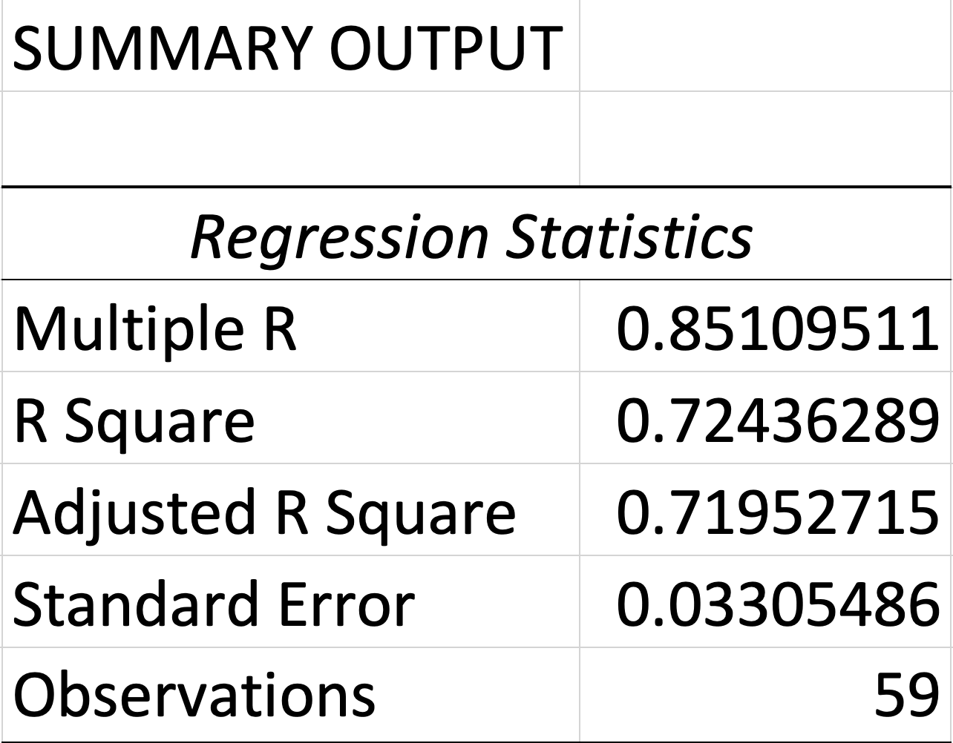
Synthetic rating = EBIT/Interest expense = 29.06
Beta to NASDAQ: X variable: 0.621261073
Bottom up beta = 0.62 x (1 + (1-0.15) x 1.458) = 1.39

Estimating Default Risk and Cost of Debt
MV of debt = Apple reported their total debt to be $108,040,000,000
Our estimate of Apple’s “bottom-up” beta is 1.39 adjusted for the tax rate and debt/equity ratio. Also, their competitors in their sector (Google, Microsoft, and Motorola) have an average beta of 0.963. Apple’s bond rating is AA. Subtracting the 30 year treasury rate from a 30 year Apple bond, 5.32-4.72 = 0.6. The marginal tax rate for Apple is 14.7%. The after tax cost of debt is annual interest expense / total debt * (1- tax rate) = (3,933,000,000/108,040,000,000)*(1-0.147) = 0.031 = 3.1%. Apple’s synthetic rating based on its interest coverage ratio of 30.2 is AAA.

Apple’s median tax rate is 14.7%

Cost of debt:
Annual interest expense / total debt * (1-tax rate)
(3,933,000,000/108,040,000,000)*(1-.147) = 0.031
=3.1%

Cost of Equity:
Cost of Equity = Risk free rate + Beta*ERP
= 3.69 + (0.96*5.75)
= 9.21%

Estimating Cost of Capital
MV of Equity = Share price * shares outstanding
MV of Equity = 183.90 * 15,441,881,000 = $2,839,761,915,900
MV of debt = 111.8 B
Debt to capital ratio = 111.8B/2,839.8B = 0.04 = 4%
MV of firm = $2,947,801,915,900
Wequity = 2,839,761,915,900 / 2,947,801,915,900 = 0.96
Wdebt = 0.04
WACC = (9.21*0.96)+((1-0.15)* (3.1*0.04)) = 8.947%

Section 5: Estimating Earnings and Cash Flows

Typical Investment
Investment Overall Introduction
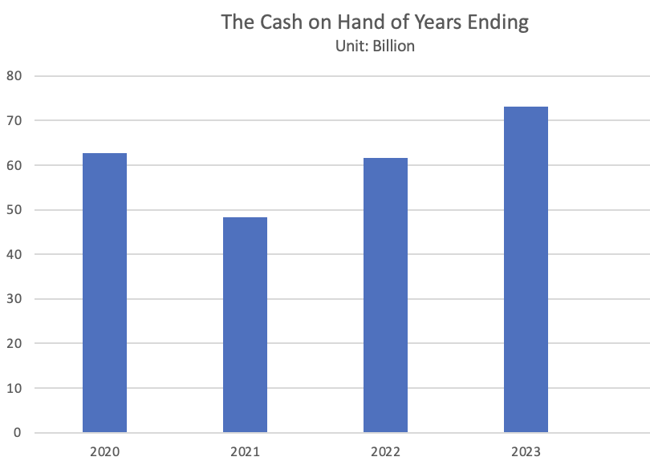
Apple Inc., a technology firm, is committed to advancing innovation in technology and devices to change global work efficiency and increase life quality. Apple Inc.'s usual investment is expected to be long-term, with the cash flows mostly determined by the market performance of its products and services. A typical gross profit and operating income for each year is increasing, and their cash on hand for each year is always higher than the previous one. Apple Inc. is a technology firm with good future development.

Production Investment
Apple's capital expenditures (CapEx) include investments in technology infrastructure, such as manufacturing equipment, data centers, and corporate facilities. These expenditures support Apple's product manufacturing capabilities and services infrastructure, including iCloud, Apple Music, and the App Store.
For example, Apple Inc. SG&A expenses for 2023 it was $24.932B, a 0.65% decline from 2022; for 2022, it was $25.094B, a 14.2% increase from 2021. For 2021, it was $21.973B, a 10.33% increase from 2020.
On the other hand, Apple Inc.'s cost of goods sold for 2023 was $214.137B, a 4.21% decline from 2022; for 2022, it was $223.546B, a 4.96% increase from 2021. For 2021, it was $212.981B, a 25.61% increase from 2020. (Macrotrends)
Technology Investment
In online research, Apple Inc. does not post a detailed report for the annual technology investment for the public, and due to the different years, the investment numbers are different. However, Apple Inc. increases its investment in technology, including research and development, acquisitions, and other related expenses, which vary by fiscal year and the scope of its projects. Apple's R&D expenditure has consistently increased over the years. Apple's R&D expenditures are a significant indicator of its investment in technology. These expenses cover the costs associated with developing new products and improving existing products, including software, hardware, and services. Over recent years, Apple has consistently increased its R&D spending, reflecting its commitment to innovation. From the report, Apple Inc.'s research and development expenses for the twelve months ending December 31, 2023, were $29.902B, an 8.13% increase year-over-year. Apple Inc.’s annual research and development expenses in 2023 were $29.915B, a 13.96% increase from 2022. The 2022 research and development expenses were $26.251B, a 19.79% increase from 2021, and 2021 research and development expenses were $21.914B, a 16.86% increase from 2020. (Macrotrends)
Firm Size and Ownership Structure
Apple Inc. is a titan in the technology industry. Until 2023, it has covered 100 countries and regions, and this exclusive footprint includes the major markets like the United States, United Kingdom, China, Japan, Australia, and countries throughout Europe, Asia, the Middle East, Africa, and Latin America. Apple has approximately 154,000 employees and operates retail stores in various countries worldwide. The current price for Apple Inc. is 181.56 on the NYSE, and the total market value is 2.804 trillion. (Yahoo Finance)
The cooperation has a diverse ownership structure, with stockholders including private investors, institutional investors, and mutual fund holders. The institution controls most of the stock shares, around 56.65%, and holds about 60.22% float. The total number of institution shareholders is 6143. Vanguard Group Inc. (institutional, holding 1,317,966,471 shares) and Vanguard Total Stock Market Index Fund (Mutual, holding 462,496,298 shares) are the two largest shareholders of Apple Inc. (Yahoo Finance)

Investment Decision Rule
For Apple, accessing new capital is not difficult due to its strong financial position and market reputation. In terms of their bonds, Apple has repeatedly scored very high in their bond strength and trust; Apple has been rated a 9.0/10, and on both S&P and Fitch, Apple is rated AA+, further implying Apple’s risk of defaulting is close to zero. Their high ratings in their bonds are also comparatively better than their competitors, implying that Apple will not have issues with accessing new capital from potential investors. In addition to this, Apple does not have any noticeable capital constraints when it comes to its stock; internally, Apple does not have any tangible covenants. They also don’t seem to have too many external restraints, either. They are currently sitting on “$166.3 billion”(Refinitiv) in cash, meaning that they have ample expendable income to finance any potential operations. The only instability that Apple faces comes from geopolitical factors: they produce a lot of their products in countries like China which may disrupt their supply Chain to produce their goods. However, with their stellar credit rating paired with their hefty excess cash supply and positive outlook from the vast majority of investors, Apple is in a stellar position to access new capital and has no signs of having trouble accessing new capital in the foreseeable future.

Given Apple’s profile which includes a hefty cash reserve, ease in accessing new capital, the market having a positive outlook on Apple's future, access to trillions of dollars in funds, lack of corruption in the corporate structure, a company culture that emphasizes transparency to investors, dividend payments on stocks and the company currently operating at a profit, Apple should emphasize earnings over cash flows, invest in long-term profitable activities, and emphasize scaled over unscaled returns. Apple should emphasize earnings over profits because Apple is a mature company that emphasizes maximizing shareholder profit and is liquid. Although cash flow is incredibly important and a metric that Apple should look at, an emphasis on cash flow usually occurs when a company isn’t too secure in accessing capital to expand its business. Apple should also invest in long-term activities for these very reasons as well: Apple has the finances to invest in itself and research products that will bring hefty profprofitsthe future. They have both an excess amount of cash along with capital that is almost unrivaled. Although short-term projects are important for yearly cash, Apple has predominantly made most of its profits through products that were ahead of its time in terms of technology. This is being showcased now through their hefty investments in the Apple Vision Pro; the product seems incredibly futuristic and has the potential to change how our society fundamentally acts, similar to when they released the iPhone. Finally, due to the prior reasons above, Apple should emphasize scaled returns over unscaled returns. They are a massive corporation that has access to a lot of capital, and a scaled return, given their incomprehensibly massive endowment, and if they can produce a profit relative to this endowment, the returns would amount to the billions per year. Unscaled returns are relatively popular to startups and companies that are rather small, but with Apple’s titan position in the market, an emphasis on scaled returns may help reach goals of revenue that may be harder to reach if they focus on unscaled returns.

Section 6: Evaluating Existing Investments and Competitive Advantages

Calculating the accounting return on capital (equity) can be calculated with this formula:

Return on Equity = Net Income/Book Value of Equity

Utilizing data from Refinitiv, the net income of Apple in 2023 was 96995 million. Calculating the Book Value of Equity was a little more difficult: Refinitiv doesn’t give the Book Value of Equity up front. As a workaround, I calculated the book value of equity by multiplying the 2023 book value per share ($4.00) and multiplying it with the shares outstanding in 2023 (15550 million shares). This calculation doesn’t need any additional math since all stock in Apple is common stock: they do not issue preferred stock. The return on equity is calculated in the following steps:

Return on Equity (2023) = (96,955 million)/($4.00 * 15,550 million)
= (96,955,000,000)/62,200,000,000)
Return on Equity (2023) = ~1.56 or ~156%

Calculating the cost of equity for Apple utilizes the following formula:

Cost of Equity = Risk-free rate + Beta * Risk Premium

Utilizing Bloomberg and Refinitiv, the Risk-free rate in 2023 had a 4.16% average yield. The Beta was listed as 1.24, and the equity risk premium was approximately 6.74%. Plugging these values into the formula comes up with:

Cost of Equity (2023) = (.0416) + (1.24 * .0674)
= (.0416) + (.083576)
Cost of Equity (2023) = 12.52%

The return on equity generally measures how effectively a company is using its equity to generate profits. Utilizing the return on equity from 2023, it’s implied that Apple has a return on equity of about 156%, meaning that for every dollar that comes from equity invested into the company, Apple is making about $1.56 with the investment. This is exceptionally high and uncommon for most companies and is a great look at a company's financial strength. The cost of equity represents the required rate of investment that investors expect to get in return for investing in a company due to the risk that they will face with the investment. In this case, Apple's Cost of Equity in 2023 was approximately 12.52%, meaning that Apple's shareholders were expecting at least a 12.52% return to compensate for the risk that the shareholders would be facing. According to the textbook, if the ROE is greater than the COE, then you should accept the project. Again, since this data is historical, this can be analyzed as Apple’s investors had their expectations exceeded since their ROE was much greater than the COE.

Applying these models to Apple's other “businesses” doesn’t work out since Apple has a different approach when they acquire a business. Apple technically has “125 businesses” (Ahmed, 2023), however, the companies Apple purchases are predominantly related to technology and do not act as a standalone business. For example, Apple has purchased numerous semiconductor businesses, but the businesses are incorporated and tied into their main production pipeline for the Apple products we all know (Ahmed, 2023).

- Check to see if the most recent year represents an outlier, a typical year, or part of a trend, look at the return on capital (equity) in prior years for your company and at industry averages for these numbers.

In order to analyze if 2023’s ROE represents an outlier, a typical year, or part of a trend, their calculated ROE for 2020, 2021, and 2022 are as follows:

Return on equity (2020) = (57,411 million)/($3.85 * 16,977 million)
= (57,411,000,000)/(65,361,450,000)
Return on Equity (2020) = .8783, or ~87.83%

Return on Equity (2021) = (94,680 million)/($3.84 * 16,427 million)
=(94,680,000,000)/(63,079,680,000)
Return on Equity (2021) = 1.50, or ~150%

Return on Equity (2022) = (99,803 million)/($3.18 * 15,943 million)
= (99,803,000,000)/(50,698,740,000)
Return on Equity (2022) = 1.97, or ~197%

Reflecting on these past four years of Apple’s ROE, it’s hard to definitively state a major pattern as the values vary greatly, however, it’s relatively safe to say that on average, Apple’s ROE generally revolves around the 150% mark, as it is in 2023. In addition to this, it seems like there has been a gradual increase in the ROE, with a sudden drop occurring from 2022 to 2023.

Apple’s ROE has been steadily decreasing, quarter by quarter in 2023, which can be attributed to a few things. First, “total smartphone sales were the slowest in more than a decade” (Cattlin, 2023). It seems that there is a macro shift toward purchasing new phones: it seems like the market is less inclined to purchase new phones, most likely because many people are still suffering from financial issues from the COVID-19 pandemic’s impact on the financial world. In addition to this, Apple’s sales in China dropped dramatically in 2023 due to heightened competition from Chinese smartphone companies (Cattlin, 2023). This impacted Apple since almost 20% of its revenue comes from China. (Ahmed, 2023)

Although Apple’s ROE has decreased within the past year, the value is still absolutely stellar. A return on Equity that’s over 100% is strikingly unusual, and it can be attributed to Apple’s emphasis on innovation, image, and marketing. Apple has a massive grasp on the smartphone market across the world, especially in high-income nations such as the US, Japan, China, Denmark, and New Zealand (WPR, 2024). For example, approximately “98.5% of people” recognize the Apple logo worldwide (WPR, 2024). In summary, although Apple’s ROE has been slightly decreasing, the value is still abnormally high and can be attributed to their innovation, recognition, and marketing tactics that have established themselves as a global technological giant that almost every single human knows about.

- If your company generates accounting returns that exceed the cost of funding, examine how much of the difference is due to accounting choices and how much to operating efficiency.

To analyze whether Apple's excess accounting returns stem from either accounting choices or operating efficiency, we first have to analyze Apple's accounting decisions they utilize, compare them with Apple’s operating efficiency, and see which option impacts the ROE the most.

Apple's accounting choices, as stated in their 2023 10-K filing, tend to be rather conservative, focus on the long term, and result in the ROE being generally more accurate (USSEC, 2023). For example, Apple utilizes a conservative revenue recognition model where it only recognizes revenue when it fully transfers control of a product over to a customer (USSEC, 2023). They also recognize all potential tax expenses on reported revenue to not inflate the ROE. Combining this with their straight-line depreciation method, recognizing asset value with gross share market values, and more, Apple has a conservative, long-term oriented view with their accounting decisions. Given this information, it’s fair to state that the ROE is rather accurate and is not inflated.

The operating efficiency of a company can be calculated utilizing the following formula:

Operating Efficiency = Operating Expenses/Total Revenue

In Apple’s case for 2023, the value can be roughly calculated as:

Operating Efficiency = (268,984 million)/(383,285 million)
Operating Efficiency (2023) = ~70.18%

An operating efficiency ratio of ~70.18% is rather high and impressive when compared to the tech market, implying that Apple's accounting returns that exceed the cost of funding can generally be explained by their operating efficiency ratio. This value generally means that for every dollar that Apple gets in revenue, 70 cents go to operating expenses.

In summary, although it’s improbable to accurately quantify the impact of both Apple's accounting choices and operating efficiency on its exceeding accounting returns, it’s safe to say that Apple's high operating efficiency can be argued to be the leading factor in the high returns compared to investments. Apple’s accounting decisions can be argued to actually decrease the realized accounting returns compared to the cost of funding due to its conservative nature, meaning that the calculated values are not artificially inflated.

2. Assessing Competitive Strengths

- If your company generates positive excess returns, examine the source of these excess returns. Specifically, evaluate the barriers to entry that allow your company to earn these returns and at threats to those barriers from macro-factors (regulatory changes and shifts in economic variables), competition, and within the company (expiring patents, for instance).

As stated in the prior paragraphs, Apple's stellar ROE and high positive excess returns can be attributed to brand loyalty, emphasis on technological investment, and brand recognition, all resulting in their revenue for products such as iPhones, Macbooks, and Airpods being worth more than the operating expenses. However, when analyzing the more macro reasonings for Apple's success, Apple does do so well since the tech market’s barriers of entry include high research and development costs, established competitors, and few massive competitors making up the majority of the market share.

Research and Development is crucial in maintaining a company’s position in the tech market since the tech market is unique in that it’s at the forefront of constant development and research. Companies like Apple and Microsoft dominate in the tech industry because they’re able to invest billions of dollars per year into the research and development of their current products, and the cultivation of new, “futuristic” products. This results in smaller competitors falling behind the major competitors since they simply do not have the funds to compete against these large competitors. The threats to this barrier to entry primarily focus on regulation, more specifically, if the government believes that the tech market is turning into a monopoly, Apple may be disbanded into separate parts. However, this most likely won’t happen anytime soon: the market still has major competitors such as Samsung, Microsoft, and Amazon that all compete with Apple in terms of technological advancement, meaning that unless one specific company can establish itself as the untouchable tyrant of the tech market, nothing will happen regulation wise.

Existing Established networks and access to distribution channels both occur when a company, usually very large, exists in a market space for years and can build up its reputation and solidify its supply chain. Not only is Apple known by 98.5% of people in the world, but it’s also established its supply chain, reducing costs and making its production efficient(Diaz, 2018). An incoming competitor in this market would find that establishing their own distribution channels and brand identity is incredibly challenging, timely, and costly. For instance, if a new tech company wanted to compete with Apple in the phone market, the new company would most likely have to pay more for every part of the production line, resulting in smaller profits and, in turn, less money to invest in research. One threat to this barrier of entry would be if either Apple's reputation took such a hit, or if China decided to fully prioritize Chinese tech producers. In these examples, Apple’s current distribution channels would crumble and need to be rebuilt from scratch. This wouldn’t necessarily lower the barrier of entry for new competitors, rather it would put Apple and competitors of Apple on the same level. This is most likely Apple’s biggest weakness: Apple's distribution channels heavily rely on China for production and resources, and China continues to prioritize Chinese companies. Apple will have to react to the continuous stresses they face within the supply chain.

Reflecting on other issues Apple could potentially face doesn’t come up with much. Apple wouldn’t be affected if their patents expired after a certain amount of years since they could just research and develop a better product. The largest threats to Apple, such as monopoly crackdowns and macro impacts on the market, are either improbable or would also apply to Apple’s competitors. In summary, Apple’s excess returns can be explained by their key advantages such as market share, brand recognition, and technological investment; all bolstered by the fact that the current tech market has high barriers of entry that eliminate smaller competition and make it difficult for newcomers to enter into the market.

Section 7: Analyzing a Firm’s Current Financing Choices

Current Financing Mix
Apple Inc. holds a higher proportion of debt in terms of book market value. As calculated, Apple Inc. has a total liabilities of $290.437 Billion for 2023 and a 3.86% decline from 2022. And a total debt of $108.04 Billion for 2023. The total assets from Apple Inc. in millions is $143,556 in 2023. Apple Inc. combines equity and debt as the basic elements of its operations. The debt-to-equity ratio of the last quarter ending of 2023 is around 1.46%. The ratio is close to the market ratio for 2023, December. The market value here is also positive, similar to the booked value, and Apple Inc. is still good for investment in the market. Furthermore, Apple is a mature and established company that can handle a lot of debt.

Financing Type
Apple Inc. is publicly traded, the primary form of equity financing comes from the issuance of common stock. This means the public can buy these stocks in a public way, like trading posts and on the NASDAQ under the ticker symbol AAPL. Apple's equity structure may also include additional equity-linked securities, such as Employee Stock Option, Restricted Stock Units, and Warrants. On the other hand, the stock can be separated into private and public stock. The three types mentioned above are private stocks, and institutions and traders can trade the public ones. The top 1 institution that holds the AAPL is Vanguard Group Inc., which holds 1.32 Billion shares and occupies 8.54%. Moreover, Apple Inc. also separates the stock shares and puts them in different directions. The best way that Apple Inc. uses stock buyback to earn revenue. Over the past decade, Apple has reduced its outstanding shares from 26 billion to 16 billion, effectively boosting its stock price. The expiration date of Apple Inc.’s debt is continued until 2062. Some of Apple's debt may have fixed interest rates, which remain constant over the life of the bond, while other portions may have floating rates, which change with market conditions.
However, Apple Inc. is different from the other firms. Apple has not extensively used hybrid securities like convertible bonds or preferred stock, which are less common for companies with strong balance sheets and cash flows. The stock shares from Apple Inc. do not have any Convertible Bonds or Preferred Stock. For the purposes of analysis, the equity portion of the convertible bond will be the value of the conversion option, which depends on the price of the underlying stock and the terms of the conversion. The debt component will be similar to a direct bond with the same maturity and credit risk as a convertible bond minus the value of the conversion option. When analysts do the research, they usually separate the stock into two different models, so they can easily estimate the real value accurately. If it's not possible to separate the components easily, the security is typically treated as a single, distinct cost of capital in the company's financial structure.
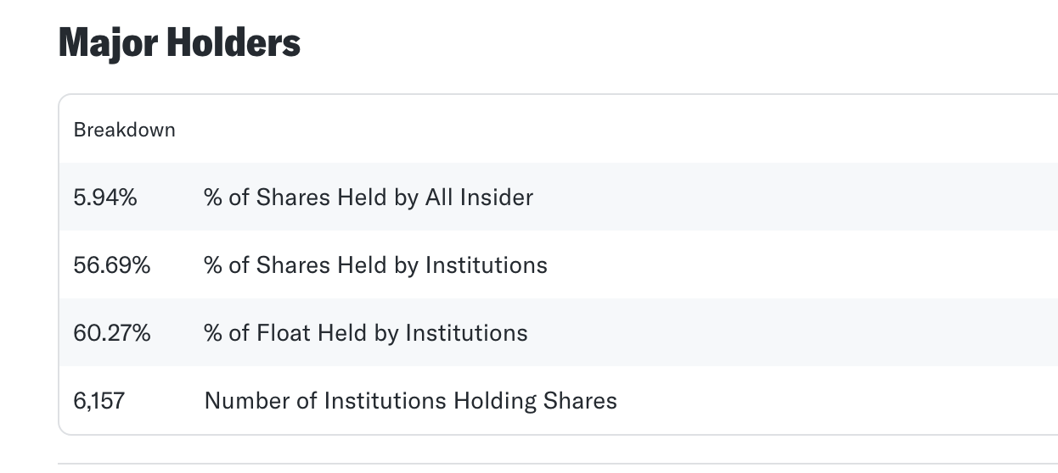
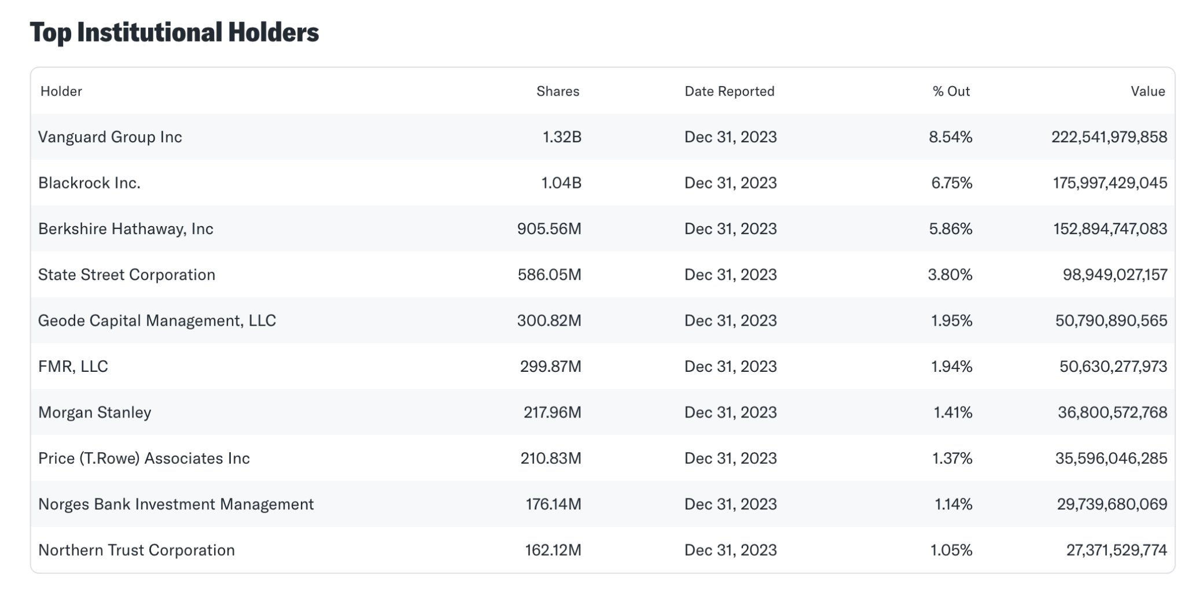
(Note: The two graphs show the private and public shareholders as well as the institutional holders.)
Due to the bonds from refinitiv, Apple Inc. has 85 bonds will expired in the future. Apple long term debt for the quarter ending December 31, 2023 was $95.088B, a 4.56% decline year-over-year. The most recent quarter debt for Apple Inc. was 2023 December 31st, and total outstanding was $95,088 million; and the most recently annual long term debt was 2023 and the total outstanding was $95,281 million. The most recently bond expired date is 2024 April 23, the period will continue until 2062 August 2nd. The model is a maturity radder, and it creates a maturity ladder to visualize when each debt instrument comes due. This helps in understanding the firm’s refinancing risks and cash flow needs. The most debts are at a fixed rate, providing stability in interest payments. The bonds type of Apple Inc. are simple and uniform, the rate problem can be ignored for a while. In short words, Apple Inc. should consider maintaining a balance between fixed and floating rate debts to hedge against interest rate volatility and possibly explore more natural hedging strategies for managing currency risks. The presence of special features like callable bonds and convertible notes adds complexity but also flexibility to Apple Inc.’s financial strategy.

Financing Trade-off
Apple Inc. on debt’s tax rate benefit, given as 14.72% annual effect tax rate from 16.2% a year ago. The varying global corporate income tax(PWC, 2024) rates (Australia 30% and 25% for small businesses; China 25%; Singapore 17%; United States 21%...) will affect potential savings in tax (PWC,2024). A small example is if Apple Inc. pays $1000 in the United States, Apple Inc. will save $210 on tax. Also, Apple Inc. operates in different countries and regions, and the tax rates from the global will affect revenue and sales. However, Apple Inc. can do something legal on the local level to avoid the high tax rate. However, Apple Inc., as a public company, will be separated by ownership and management team. The management team may be the person from ownership to lead. Debt can serve to discipline management by requiring regular interest payments, potentially reducing the free cash flow available for management to spend on less-than-optimal projects. From a different point of view, debt is a good thing to control one company and decrease the loss from one or more programs.
According to the history reports, Apple Inc. is still in a good trend regarding revenue, cash flow, debt, and liabilities. This means Apple Inc. can balance the cash flow in a good way, and Apple Inc. has a strong background with a diversified revenue stream from various products and services, including the iPhone, iPad, Mac, software, and services. Their revenue growth has been supported by consistent product innovation and a global brand appeal. However, even with a history of robust earnings, technology companies face rapid changes in consumer preferences and intense competition, which could affect future performance. Xiaomi in China recently developed the electronic car at the highest level as a technology company. The trends that Xiaomi has may destroy the Top 1 rank in a short time. The good news is, based on the solid background of Apple Inc., the revenue will not be affected in the short future time, and the cash flow will be stable in the future. However, the policy of technology, advice, and the supply chain change will also affect Apple Inc's revenue. The default risk is still one point that needs attention. Due to the world’s economic decrease, global economic recession, or a failed product launch, the unexpected downturn in sales could alter this risk profile.
Apple Inc.’s reputation for financial transparency and strong corporate governance provides lenders with assurance. Regular, detailed financial reporting, adherence to SEC regulations, and clear communication regarding business strategies contribute to predictability and security for lenders. Banks and lenders would like to invest in Apple Inc. for their program. Apple Inc.’s historical performance on K-10, including consistent revenue growth and profitability, enhances lender confidence. The high trust score means Apple Inc. does not need to use something to put in the lenders, but Apple Inc. has a strong knowledge industry. If necessary, they would like to put it into the lenders. Even in the unlikely event that Apple Inc. faces financial difficulties, the basic background will provide strong protection, and Apple Inc. will have the ability to restructure. Apple Inc. usually invests in programs that can help the country and areas develop their technology ability (Apple, 2021). So, when Apple faces an uncertain financial situation, it will still choose it without any reason. This is because this program will affect the honor and customer loyalty for customers. Apple Inc. helps these programs; the final result will be a win-win situation. However, Apple Inc. is a huge company in the world. They will set up backup money to use when they need it. The situation now for Apple Inc. is stable to continue, so the best way to keep Apple Inc. at the Top in the technology industry, the best choice is to keep the investment stable. But leveraging is a two-edged sword. It will cause Apple Inc. to get into trouble. Combining the global economy nowadays, Apple Inc. should consider investment and expenses more.

Section 8: The Optimal Financing Mix

NOTE* For this section, the questions will have their work showcased on the “Optimal CS Worksheet” page on the Excel file.

As calculated on the Optimal CS Worksheet, we calculated the current debt ratio to be approximately 64%. We also calculated the cost of capital to be approximately 9.21% (again, calculations on the Optimal CS Worksheet).

The optimal cost of debt is approximately 3.73%, the cost of equity is approximately 6.31%, and with these two new variables, the optimal mix of debt and equity for the firm is 20% debt to 80% equity.

While playing around with certain micro and macro inputs from the analysis, I noticed a few things. First, I noticed a decrease in equity, for both the previous and optimal WACC, both decreased. However, it was the opposite when debt is decreased, implying that the lower the equity is relative to debt, the better the WACC would be. One other thing that I found interesting is how the tax rate can have a fairly significant impact on the overall calculations. Similar to the equity, when the tax rate is decreased, I noticed that the WACC decreased for the previous and optimal debt to equity ratio.

Relative to the industry, Apple’s debt to equity ratio of 1.458 is high. The average debt ratio of the tech industry is 26%. The same is true relative to the market.

Section 9: Mechanics of Moving to the Optimal

The Immediacy Question
Apple’s debt-to-equity ratio of 1.46 means that its total liabilities are greater than its total equity, implying that Apple is over-levered. For smaller companies, this could be a problem, but since Apple is an established and mature company, this isn’t an issue. They’re in the top 5 biggest companies in the United States, thus they’re able to handle all the debt they have with relative ease. Additionally, they are not at risk for a hostile takeover. Furthermore, Apple’s average leverage ratio from 2019 to 2023 was 5.4x. This means that Apple has proven over and over again that they can pay off their debt.

Alter Financing Mix or Take Projects
Based on the optimal financing mix, Apple should take on a lot more equity. We recommend that Apple reduces its reliance on debt by paying off its debts and pausing its reliance on debt, rather, than issuing more stock to increase its investments from equity. Through this, Apple can lower their WACC and leverage themselves to grow at a faster, more efficient rate. In addition to this, we recommend that they take on projects since they have a relatively high amount of disposable cash. This could result in Apple undergoing numerous projects, boosting their revenue growth, along with potential benefits such as growth in research.

Financing Type
The type of Apple Inc. income statement can be separated into five parts: Total Assets, Cash on hand, Long Term Debt, Total Liability, and Shareholder Equity. Due to the recent reports from Apple Inc., the cash flow increased by 42.34% year-over-year. This shows that big companies would like to put more cash in hand in case of financial problems. The long-term debt and liability will be decreased by 2023. More cash flow in hand means more flexibility in dealing with financial events—the history data of Apple Inc. was presenting a good way, and this is very important for Apple Inc.'s development. The cash flow that Apple Inc. has increased from last year is the reason that the rate is too high, so Apple Inc. decreases the liabilities and then decreases the cost of one company. The result is showing like it because the whole data works together.
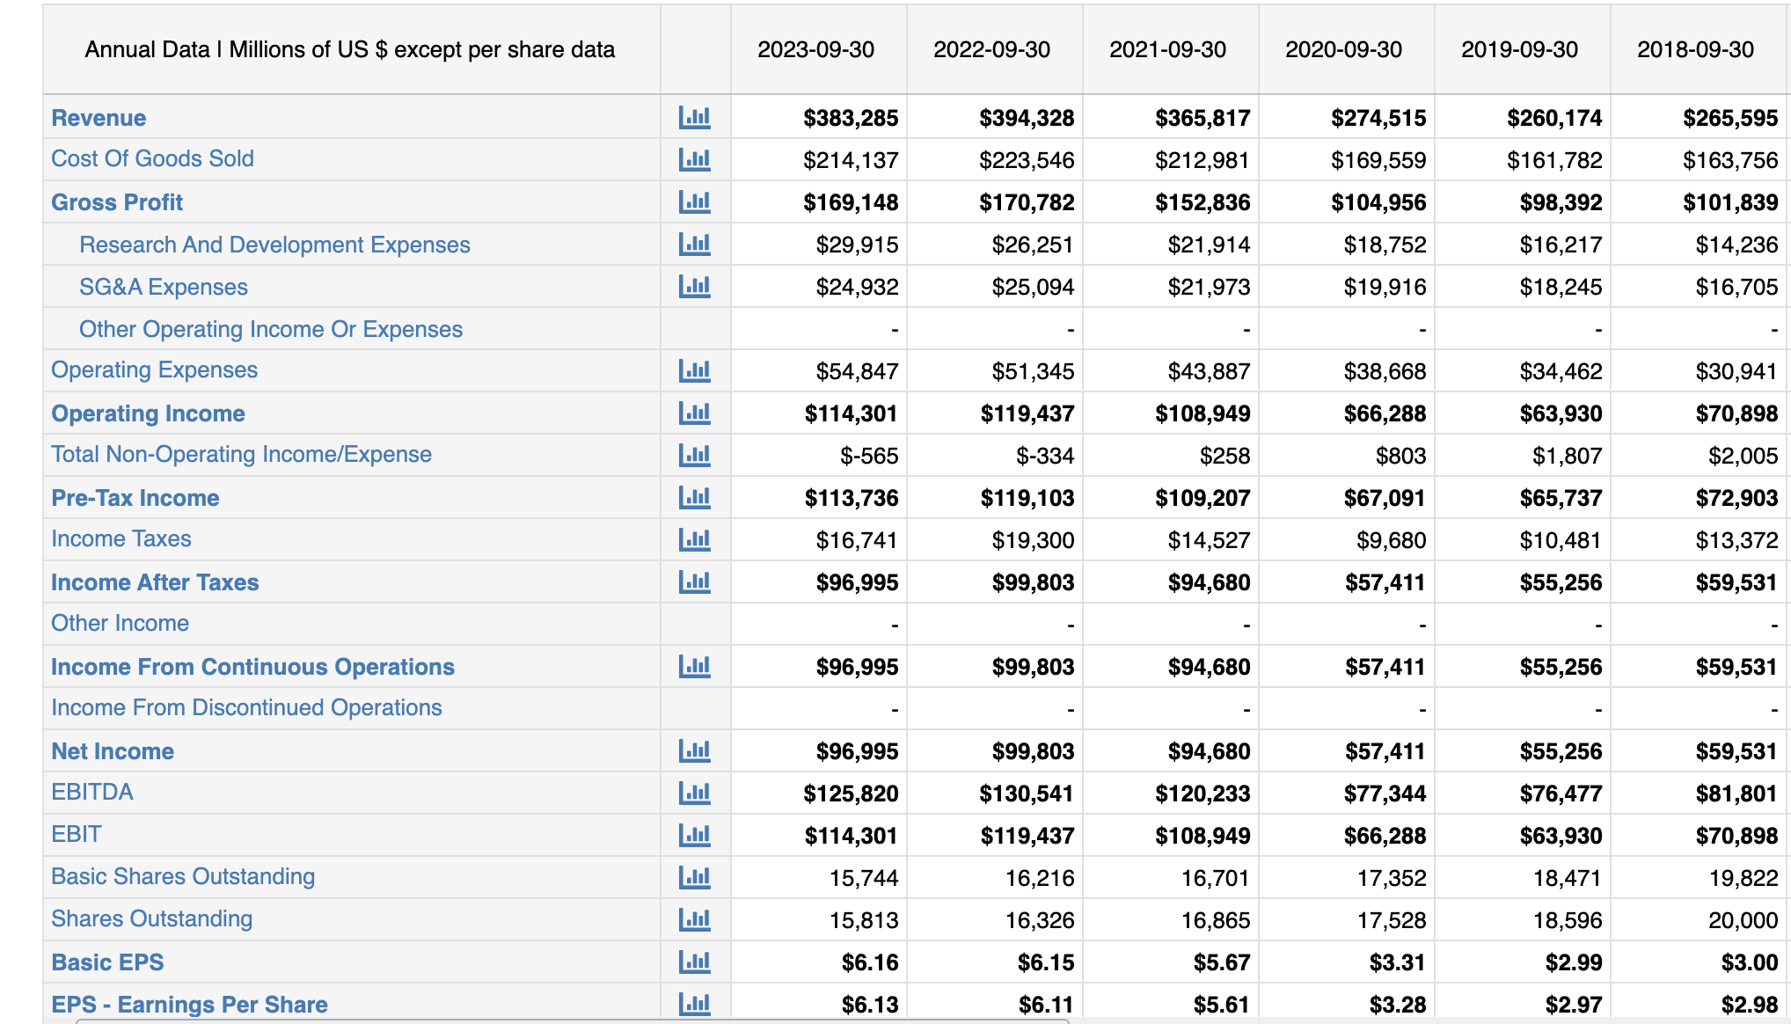
From the data of Central Bank, the interest rate of United States is 5.5%, the inflation rate is 4.98%, GDP growth rate of US in 2022 is 1.9%. Due to the economy data from lately years, the world economy goes slowly. Combined with the income statement of Appl Inc. Avenue started from 2018, the revenue of Apple Inc. is decreased. It was a trend that follow the world economy, which means the world economy related to the company’s income. First, the interest rate of United States is 5.5%, which is higher than other countries, and Apple Inc. needs to pay more on company’s expense. Also, it will affect the stock valuation of Apple Inc, because other fixed income and bonds will have higher attractions for public. Moreover, the inflation rate is 4.98% last year, which means the operating cost is higher than before, and the stock valuation will be lower. The GDP growth rate in US is lower than previous year (compared to 2021 is 5.9%), it will aslo be one of the elements to decrease the operating income. It can also erode the real value of earnings, affecting stock prices. The world economic situation is terrible in recently year, this is the main reason to cost income be lower. Even though the exchange rate is higher, and it will effect the saling price increase, but under the negative world economic, it will also a small point to discuss.

C. If your company does not have a long history or there is too much noise in the data, try to assess, based on the sector, how sensitive your firm’s value and earnings are to macroeconomic variables.

Apple was established approximately 48 years ago and has managed to showcase its resilience and survivability in comparison with competitors from within the same industry. Indeed, the tech market is deadly; approximately 90% of all tech startups eventually go out of business (Howarth, 2023), implying that the technology market’s low success rate can be attributed to certain macroeconomic factors that act as a filter. In 2023, An in-depth study attempting to analyze the top three macroeconomic factors that shook the tech market the most identified economic recession, rivalry with China, and the energy crisis as the three biggest factors that negatively impacted tech companies the most(Wang, 2023).

Apple has been through numerous major economic recessions and continues to flourish, despite the impact on the overall market. For example, Covid-19 drastically strangled the market by disrupting supply chains and decreasing demand for certain products. Apple was no exception: their supply chain heavily relies on China to manufacture and produce goods, so when COVID-19 hit and China closed down, Apple felt the repercussions. However, what made Apple unique in its ability to survive the recession is that since people were stuck inside, there was an increase in demand for products like apps, music, and Apple TV. In fact, from 2020 to 2021, Apple’s service revenue increased by 33% (Apple, 2024). So although Apple did face declines in Apple product production, their streams of revenue were diversified enough to the point where they did just fine.

Energy recessions also can drastically impact tech companies: a decrease in reliable energy can result in heightened costs and instability regarding production and transportation, both heightening costs and decreasing reliability. Apple simply doesn’t have this problem since they used” 100 percent renewable energy to power its offices, stores, and data centers since 2018.” (Apple, 2024). This means that even even though the Russia-Ukraine war, they weren’t affected since they didn’t rely on the embargoed gas from Russia to run.

The third, but most important macroeconomic factor that arguably has impacted Apple the most is the US and China rivalry. Apple relies heavily on China in terms of their production line which has recently become destabilized from the conflict. A destabilized supply chain can decrease the production rate of products, resulting in delays and loss of profits. This has already occurred with Apple: In 2021, Apple was not able to keep up with demands and lost a hefty amount of potential profits (Apple, 2024). Apple’s revenue can, and has been affected by this trade war, however, since the rivalry and tensions are only just continuing to spiral, we haven’t seen the major impacts that Apple may face.

D. Compare the actual financing used by the firm to the optimal financing and examine reasons for the differences. If you can find a way to bridge these differences, given market constraints, do so.

The actual financing used by the firm utilizes a debt-to-equity ratio of .64, while the new optimal financing uses a debt-to-equity ratio of .2. This is a rather stark difference, and can be attributed to Apple’s reliance and advisability of utilizing debt over equity. First, Apple may choose to utilize debt over stock, despite an increase in the WACC because there are tax advantages to doing so. In simple terms, repayment of debts can be a tax deduction, meaning that Apple may realize significant tax benefits from this way of financing. Another reason for this behavior is that the primary investors in Apple (BlackRock, Vanguard, board members, etc.) have greater control over the company when Apple primarily uses debt to finance its operations. This is because if there is less stock spread out, the ones who have stock will have a greater share. Finally, financing with stock may signal to investors that Apple is financially stable and long-term oriented, rather than doing everything they can to create the optimal ratio for short-term growth.

Section 10: The Trade-Off on Dividend Policy

Historical Dividend Policy
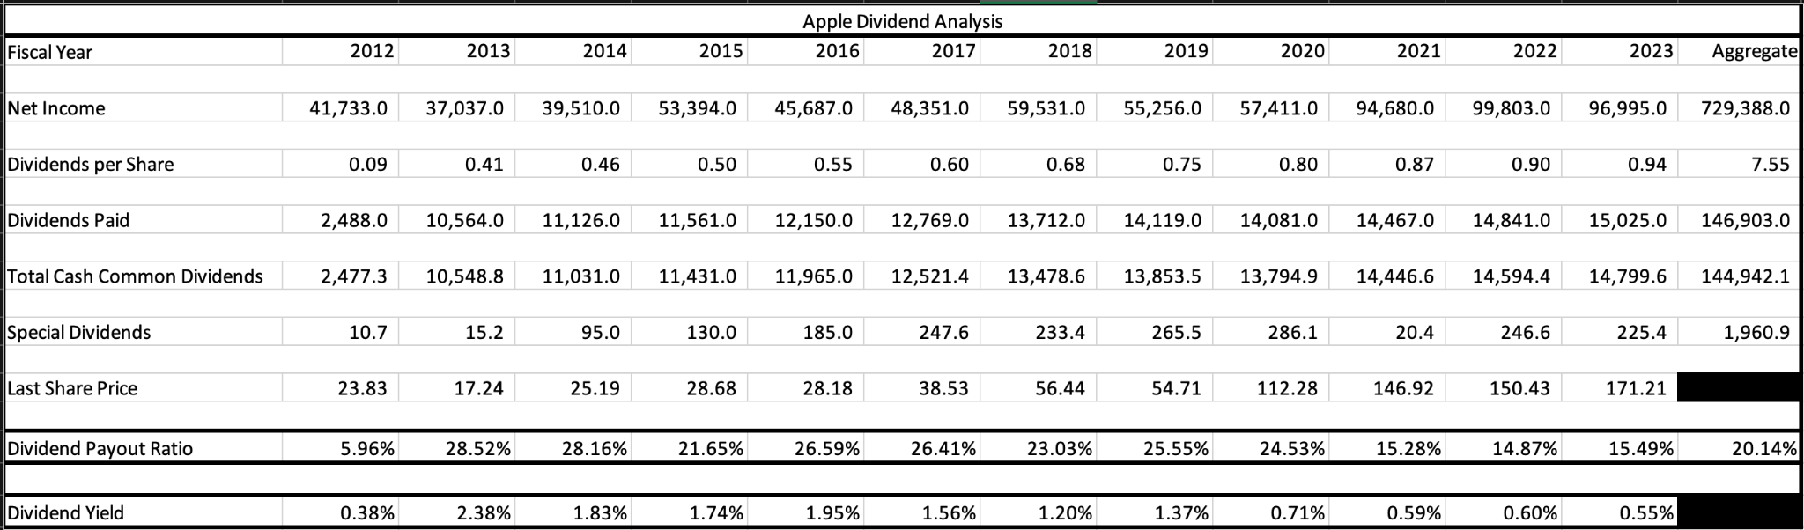

Firm Characteristics
- Dividend clientele
Based on the breakdown of who holds Apple stocks, we believe that these institutional investors are receptive to these dividends. This is because most institutional investors have taken a long on Apple and have bought the stock before the ex-dividend date. Furthermore, if the stockholders reinvest the dividends back into Apple, then they can maximize their returns. For example, Vanguard owns 1,317,966,471 shares of Apple. This means that if they receive the yearly dividend of $0.96, then they will receive approximately $1,265,247,812.16 and they have the ability to buy around 7,486,673 more shares. This is huge because they already own 8.5% of all shares outstanding.
- Dividend signaling
Apple paying dividends shows strong financial health, but the dividend yield shows that their growth has slowed down significantly. From 2012 to 2019, Apple consistently increased its dividend yield, but it fell after 2019. This shows that Apple’s growth is slowing down.
- Future financing
We believe that the dividend yield will continue to increase, especially because Apple’s revenue might decline this year due to a slowdown in iPhone sales. This would be the first drop in Apple’s revenue in 10 years. Therefore, we believe that less of Apple’s current earnings and cash flows will be paid out as dividends.
- Debt covenants
Apple pays dividends four times a year. The dividend yield is 0.58% and the payout ratio is 14.95%. There are no statutory or regulatory requirements for dividend policy.
- Overall assessment
We expect Apple to become an even smaller dividend payer because, as I mentioned above, Apple is expected to see the first drop in revenue in 10 years this year. This weakens Apple’s cash flows and investor expectations. With the expected decrease in cash flows and expectations, Apple’s stock price will tank and so will their dividend yield. By paying dividends, investors will be rewarded in addition to the stock returns. However, paying dividends is expensive for the company and could take away from spending elsewhere. I would expect Apple to be a big dividend payer given its enormous free cash flow. Once Apple’s revenue returns to growth then we’d expect them to increase their dividends to shareholders.

Section 11: A Framework for Analyzing Dividends

Cash Return to Stockholders
According to Investopedia's research report, Apple Inc.’s dividend payments aren’t low relative to other companies within the tech sector. In contrast, Apple Inc. will consider reinvesting the cash instead of paying higher dividends. According to the report, Apple Inc.’s annual dividend is $0.88 in 2021 ($0.22 paid per quarter), and based on Apple's stock price as of March 1, 2022, of around $163 per share, the dividend yield is approximately 0.50%. The graph shows Apple Inc. has increased its dividend in several years. Apple Inc. was paying out $0.24 per share from May 2023 to February 2024, paying out $0.23 from May 2022 to February 2023. Apple Inc. pays dividends under the average of the tech industry, but compared to other companies in the same industry, Apple Inc. pays higher than others. “For example, does not pay any dividend. Nor do Meta (Facebook), Tesla, or Netflix. Some comparable larger, mature tech companies also pay low dividends, such as Nvidia (0.16% dividend yield) and Microsoft (0.83% dividend yield)” (Investopedia, 2022). For the recent period, Apple Inc. has kept its stock price in flat price. So, Apple Inc. can reinvest in the stock market and pay fewer dividends.
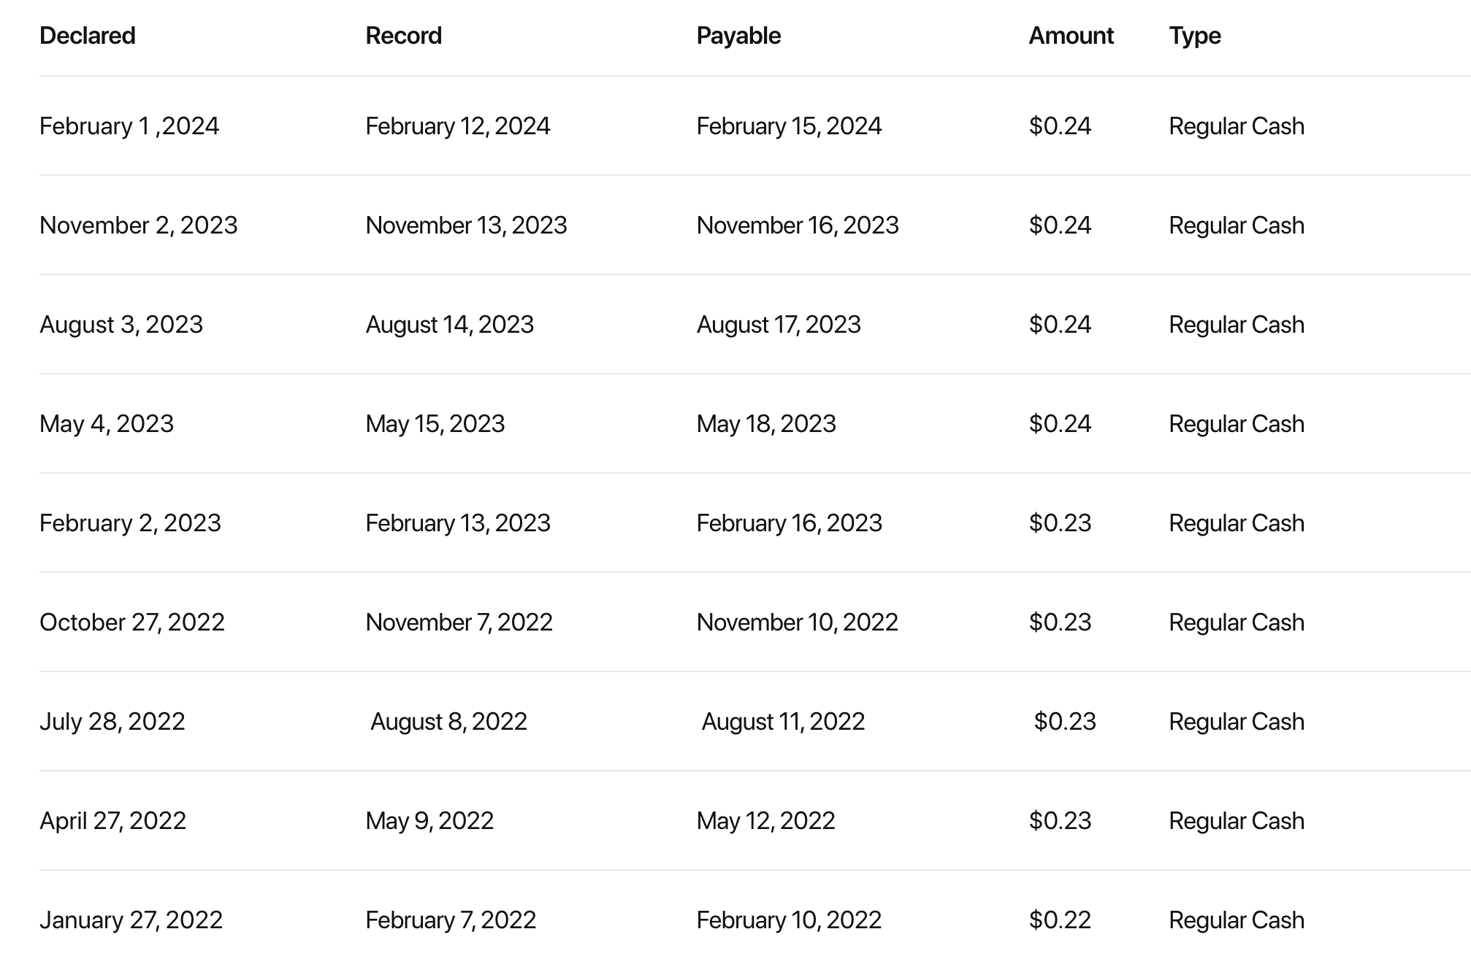

Affordable dividends

Apple had $99.584 B in free cash flow at the end of FY 2023. Apple’s income after taxes at the end of 2023 was $33.916B. Apple’s reinvestment was -$4.1 billion at the end of 2023. Apple’s debt issuance was $5.228 B and repayment of debt was $11.151 B. Apple would have $36.77B left over as cash flows after taxes and reinvestment needs. $99.584B * 0.39 = $38.84B- (0.1589 * 38.84) + $4.1B = 38.84- 6.17 + 4.1 = 36.77 B. Apple’s free cash flow was $73.365 B in 2020, $92.953 B in 2021, $111.443 B in 2022, and $99.584 B in 2023.

Management trust
Apple’s cost of equity was 10.1% and Cost of Capital 9.9% as of 2/1/24. Apple’s return on equity was 136.2% and the return on invested capital was 92.8%. It significantly exceeded the cost of equity but did not get the required returns to recover the cost of capital. Google’s returns have remained stable over time as well along with other firms in the peer group. Apple’s risk-adjusted performance is 0.04 and its market risk-adjusted performance is 0.27.

Year | ROE | ROIC
2018 | 50.4% | 39.4%
2019 | 64.3% | 62.0%
2020 | 96.5% | 62.5%
2021 | 139.8% | 76.9%
2022 | 167.8% | 82.1%

Return on equity has significantly increased year by year since 2018 along with return on invested capital. Apple’s return on equity and invested capital have increased substantially compared to Motorola whose returns have remained stable.

Changing dividend policy
According to the latest data (Yahoo Finance), Apple Inc.’s operating cash flow was $116,443 million, and the net cash flow from finance and investment activities, including the payout, was $103,510 million. The remaining cash flow was $41,974 million. This means Apple Inc.'s cash flow is surplus. The most recently divided date for Apple Inc. was 2024 February 9th, and the per-share price was $0.24. Apple's dividend yield is 0.25%, which is lower than the average in the technology industry. The payout ratio is 14.89%, which is under average level. The firm is currently overleveraged compared to the same technology company. In Cash Return to Stockholders mentioned, some of the technology companies do not pay the dividends. Apple’s dividend yield and payout ratio are exceptionally low for a company with a very high free cash flow. It should reward investors for impressive accounting and stock returns. It is also looking for some new debt to balance the company's cash flow. The dividend policy is therefore furthering the objective of moving towards the optimal amount of debt. It will be a correct choice that Apple Inc. lower the levered, and keep more cash flow in hand to expand and reinvest.

Comparing to sector and market

Apple is returning significantly more cash than the typical firm in the sector as it is by far the strongest company in the sector with significant cash holdings. Given Apple’s significant accounting and stock returns over the past few years, the dividend yield of 0.58% and the payout ratio of 14.95% are not enough to satisfy the needs of investors. Given Apple’s significant cash holdings, it could certainly issue more shareholder equity. Apple is returning significantly more cash the the rest of the firms in the market.

Section 12: Valuation

Cash Flow Estimation, Growth Choices, and Discount Rate
Income Statement Revenue Growth and FCF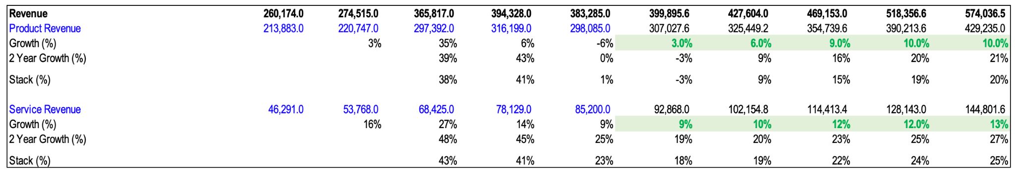
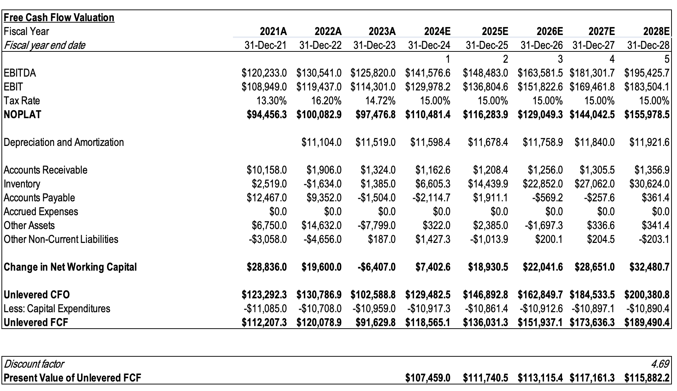

Terminal Value
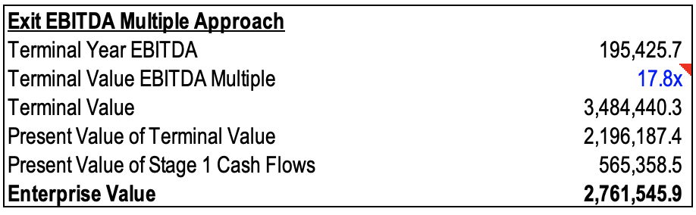

From DCF Value to Equity Value per Share
Equity value per share = $175.85
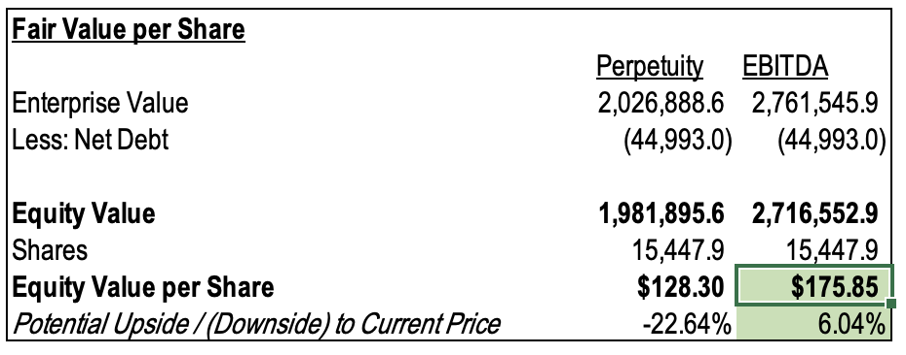

Relative Valuation
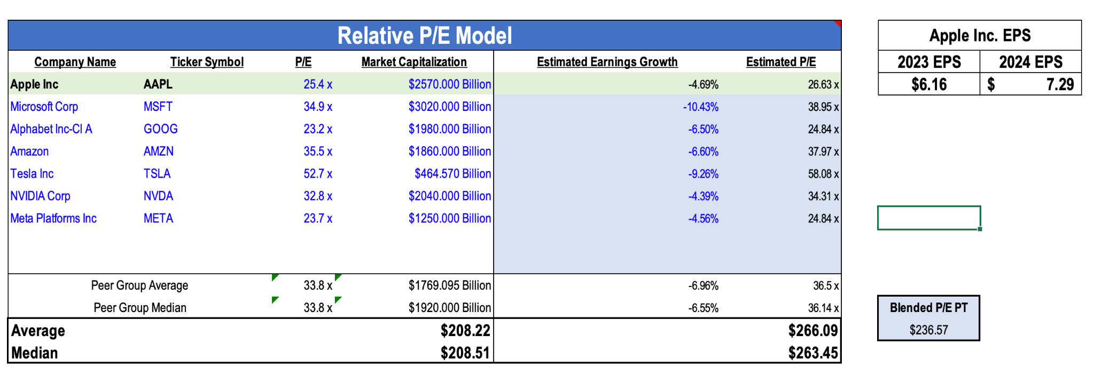

Works Cited
AAPL | Apple Inc. Analyst Estimates | MarketWatch. (n.d.). MarketWatch. https://www.marketwatch.com/investing/stock/aapl/analystestimates
Analytics, I. (n.d.). Apple Inc.: Risk analysis (AAPL | USA | Computer Hardware) - Infront Analytics. https://www.infrontanalytics.com/fe-en/US0378331005/Apple-Inc-/gprv-risk
Apple. (n.d.). Apple Leadership - Deirdre O’Brien. https://www.apple.com/leadership/deirdre-obrien/
Apple Cash on Hand 2010-2023 | AAPL. (n.d.). MacroTrends. https://www.macrotrends.net/stocks/charts/AAPL/apple/cash-on-hand
Apple Cost of Goods Sold 2010-2023 | AAPL. (n.d.). MacroTrends. https://www.macrotrends.net/stocks/charts/AAPL/apple/cost-goods-soldn
Apple Research and Development Expenses 2010-2023. (2024). Macrotrends. https://www.macrotrends.net/stocks/charts/AAPL/apple/research-development-expenses
Apple SG&A Expenses 2010-2023 | AAPL. (n.d.). MacroTrends. https://www.macrotrends.net/stocks/charts/AAPL/apple/selling-general-administrative-expenses
Apple. (2021, April 26). Apple commits $430 billion in US investments over five years. Apple Newsroom. https://www.apple.com/newsroom/2021/04/apple-commits-430-billion-in-us-investments-over-five-years/
AAPL: Apple Dividend Analysis. Investopedia. https://www.investopedia.com/articles/markets-economy/091816/aapl-apple-dividend-analysis.asp#:~:text=Dividend%20Yield,-While%20dividend%20payout&text=Apple's%20annual%20dividend%20in%202021,dividend%20yield%20is%20approximately%200.50%25.
Apple Long Term Debt 2010-2023 | AAPL. (n.d.). Macrotrends. https://www.macrotrends.net/stocks/charts/AAPL/apple/long-term-debt
Fathi, S. (2023, July 28). Apple has the worst staff retention rate of any major company in the United States, survey finds -. Supercharged. https://superchargednews.com/2023/07/28/apple-worst-staff-retention-rate/
Inline XBRL Viewer. (n.d.). https://www.sec.gov/ixviewer/ix.html?doc=/Archives/edgar/data/320193/000032019324000006/aapl-20231230.htm#i615fd6445dca47ee923200c2cb03d4a3_13
Mohamed, Y. (2023, June 5). Steve Jobs personally chose Tim Cook to be Apple’s CEO. Medium. https://medium.com/the-techlife/steve-jobs-personally-chose-tim-cook-to-be-apples-ceo-de4a77c848c5#:~:text=Tim%20Cook%20used%20to%20work,he%20started%20relying%20on%20him
Wikirating. (2022, August 3). Apple Inc. - WikiRating. https://www.wikirating.com/apple-inc/
Yahoo is part of the Yahoo family of brands. (n.d.). https://finance.yahoo.com/quote/AAPL
Ahmed, Z. (2023, December 31). 2023 was Apple’s toughest year in recent memory; here’s why. The Indian Express. https://indianexpress.com/article/technology/tech-news-technology/apple-tough-year-2023-watch-ban-tim-cook-ipad-9083377/#:~:text=The%20primary%20causes%20for%20the,Macs%20and%20iPhones%20this%20year
Cattlin, R. (2023, April 27). Apple’s biggest acquisitions: what does Apple own? Forex. https://www.forex.com/en-us/news-and-analysis/apple-acquisition-history/#:~:text=What%20companies%20does%20Apple%20own,approximate%20value%20of%20%248%20billion
Diaz, J. (2018, September 18). Why you won’t recognize the logos of the world’s top companies. Fast Company. https://www.fastcompany.com/90232854/why-you-wont-recognize-the-logos-of-the-worlds-top-companies
tipranks. (2024, April 17). Apple (AAPL) stock dividend date & history. TipRanks. https://www.tipranks.com/stocks/aapl/dividends
IPhone market Share by country in 2024. (n.d.). https://worldpopulationreview.com/country-rankings/iphone-market-share-by-country
Leswing, K. (2023, December 29). Apple’s stock underperformed top tech peers in 2023 due to the longest revenue slide in 22 years. CNBC. https://www.cnbc.com/2023/12/29/apple-underperformed-mega-cap-peers-in-2023-due-to-revenue-slide.html
UNITED STATES SECURITIES AND EXCHANGE COMMISSION. (2023). Form 10-K. In Apple Inc. https://s2.q4cdn.com/470004039/files/doc_earnings/2023/q4/filing/_10-K-Q4-2023-As-Filed.pdf
PWC. (n.d.). Corporate income tax (CIT) rates. Worldwide Tax Summaries Online. https://taxsummaries.pwc.com/quick-charts/corporate-income-tax-cit-rates

