Car Crashes and the Impact of Automatic Traffic Cameras in D.C.

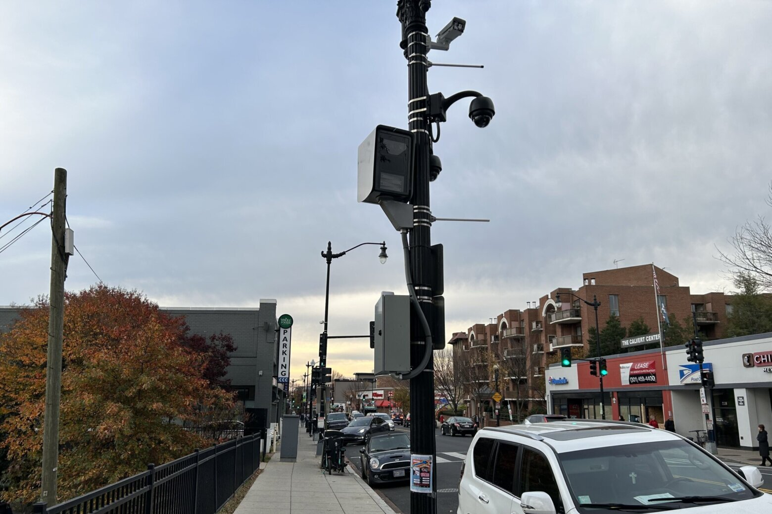

Report By:
Alexei Habermehl
10/23/2026

Table of Contents

- Executive Summary
- Introduction
- Data
  - Crash Data
  - Street Block Data
  - Automated Safety Camera Data
- Descriptive Analysis
  - Day-of-Week Analysis
  - Time-of-Day Analysis
  - Ward-Level Analysis
  - Crash Severity
  - Driver Characteristics
  - Camera Inventory
  - Time Series of Crashes
- ASC Impact Analysis
  - Methodology
  - Identifying New Cameras
  - Corridors and Comparison Groups
  - Results: All Crashes
  - Results: Injury and Speeding Crashes
  - Pre-Trend Check
  - Robustness Check
- Driver Behavior Analysis
  - Violations After Cameras Start
  - First Months vs One Year Later
- Limitations
- References
- Appendix

- Executive Summary
This report compiles crash statistics and automated safety camera (ASC) analyses for District of Columbia roadways from 2020 to 2026 to examine the correlation between ASC placement and car crash severity and frequency. Our goal is to provide a resource for identifying recent car crash trends and to evaluate the ASC program's effectiveness in curbing crash frequency and severity. We rely on basic summary statistics, time series, and a difference-in-differences (DiD) design to conduct the analysis.
Key Findings:
- Car crashes are primarily driven by seasonal trends, significantly decreasing in quantity and injury severity during winter months
- Automated Safety Cameras do not have a statistically significant impact on car crash frequency and severity
- On average, speed cameras will see a ~48% decrease in tickets given out after a one-year period, yet crash frequency and severity remain relatively stable within the same area

- Introduction
In 2015, District of Columbia Mayor Muriel Bowser led D.C. to join the “Vision Zero” campaign to address the shared, chronic problem of traffic-related deaths and injuries worldwide, enshrining traffic safety as a top priority for D.C. transportation with the goal of reaching zero traffic-related fatalities by 2020 (D.C. Policy Center, 2018). A myriad of policies governing the design, construction, operation, and maintenance of roadways—including the implementation of nearly 550 automated traffic cameras across the district—aimed to make DC streets safe for everyone.
Despite the implementation of these evidence-based policies, D.C. traffic deaths doubled within the decade, rising from 26 deaths in 2015 to 52 deaths in 2024. Furthermore, residents have raised concerns that the main incentive for these devices has shifted from pedestrian safety to financial gain, with D.C. reporting $267.3 million in revenue in 2025 alone (Fox Business, 2026). With additional concerns pertaining to ASC’s contributions to the historical legacies of overpolicing Black neighborhoods, along with their assistance in extracting regressive fines that impose disproportionate financial burdens on low-income residents, it’s imperative to analyze whether these cameras are really helping lower traffic injuries and fatalities as planned.
By analyzing D.C.’s crash and camera enforcement data, we seek to identify:
- Frequency, location, and severity of crashes happening in DC over time
- Frequency, location, and type of ASC’s placed in DC over time
- Correlations between ASC placement and both car crash severity and quantity
- Behavioral changes of DC drivers at new camera placements

- Data
This project uses public datasets sourced from Open Data DC. Summaries are below.
3.1 Crash Data
The car crash dataset has one row per reported crash, including the date and time, location, injury and fatality counts, and whether speed was involved. After cleaning, our study uses 117,626 crashes from October 2020 to September 2026.
Data cleaning and preparation:
- Formatting: Crash timestamps were converted to dates in Eastern Time and floored to the month for aggregation
- Missing Values: Crashes without location data were dropped
- Outcomes: An injury crash includes a crash with at least one major injury, minor injury, or fatality. A speeding crash is the same, but with speeding flagged.
- Validation: Fatality counts differ slightly from official totals (51 vs 52 in 2024, 23 vs 25 in 2025) since we dropped crashes without locations. The following descriptive analyses use the unfiltered data, and the machine learning models drop the incompatible counts.
3.2 Street Block Data
DDOT’s Roadway Subblock data include street block route ID and shape. Only “regular streets” were selected for our analysis. XY coordinates were projected to the Maryland State Plane for spatial data analysis.

3.3 Automated Safety Camera Data
DDOT’s Automated Safety Camera inventory lists camera ID, enforcement type, mobility (fixed or portable), location, and number of tickets given out from September 2022 onward. Missing camera installation dates are supplemented through DC’s moving violation datasets to capture when the cameras first began issuing tickets.
- Descriptive Analysis
The following analysis comes from DC’s 2022-2026 Car Crash Data.
4.1 Day-Of-Week Analysis
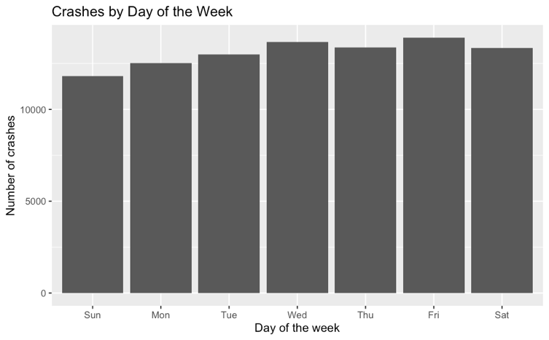
Crashes vary only modestly by day of the week. Sunday is the lowest (~11,800 crashes) and Friday the highest (~13,900 crashes)—around an ~18% difference.
Figure 1: Crashes by day of the week, 2022-2026
4.2 Time-Of-Day Analysis
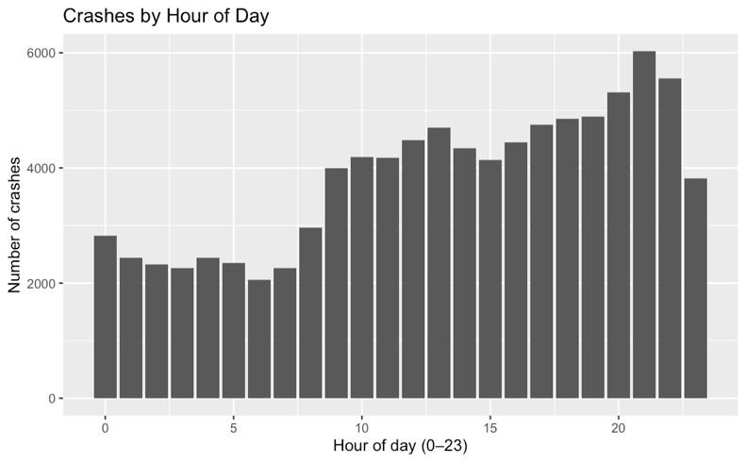
Crashes are lowest between 1 and 7 a.m. (hovering around ~2000 crashes) and slowly increase til the morning traffic rush. Apart from a small dip at around 3 pm, crashes slowly increase in frequency, peaking at ~9 pm, then quickly drop toward midnight.
Figure 2: Crashes by hour of day (2022-2026)
4.3 Ward-Level Analysis
Ward 2 has the most crashes, ranging from 250 to 350 per month, followed closely by Wards 5, 6, 7, and 8, respectively. Wards 1 and 4 range from 100 to 200 crashes per month, while Ward 3 has the fewest crashes, at around 60-100 per month.
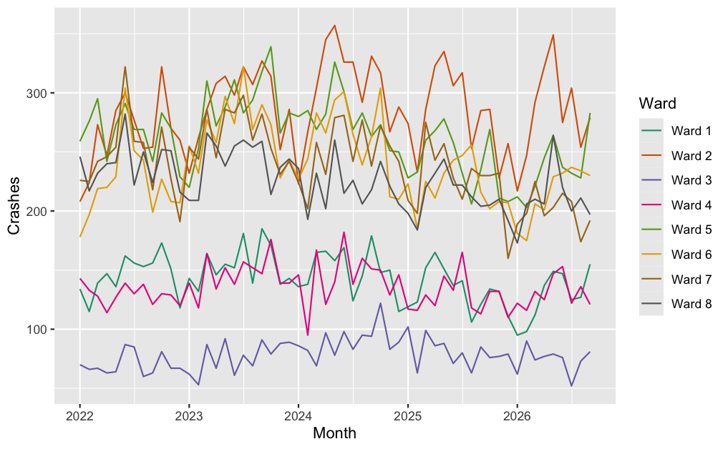
Figure 3: Monthly crashes by ward, 2022-2026

4.4 Crash Severity
Table 1: Traffic fatalities by person type, 2022-2026
 | 2022 | 2023 | 2024 | 2025 | 2026*
Total Fatalities | 37 | 48 | 51 | 23 | 27
Bicyclists | 2 | 3 | 2 | 0 | 2
Pedestrians | 18 | 17 | 17 | 14 | 12
Drivers | 14 | 20 | 21 | 7 | 10
Passengers | 2 | 6 | 9 | 2 | 2
Other | 1 | 2 | 2 | 0 | 1
*2026 includes crashes from January to October only.
Fatalities initially increased from 2022 to 2024, then dropped sharply in 2025. Note that the 2026 data only runs through October, so its totals will be lower than a full year.
Table 2: Traffic injuries by severity, 2022-2026
 | 2022 | 2023 | 2024 | 2025 | 2026*
Total Injuries | 6,485 | 6,901 | 6,616 | 5,879 | 4,595
Major Injuries | 372 | 364 | 345 | 306 | 241
Minor Injuries | 6,113 | 6,537 | 6,271 | 5,573 | 4,354
*2026 includes crashes from January to October only.
Injuries share a similar story: they peak at ~6,901 in 2023, falling to 5,879 in 2025 (~15% decrease). Major injuries have decreased every year.
4.5 Driver Characteristics
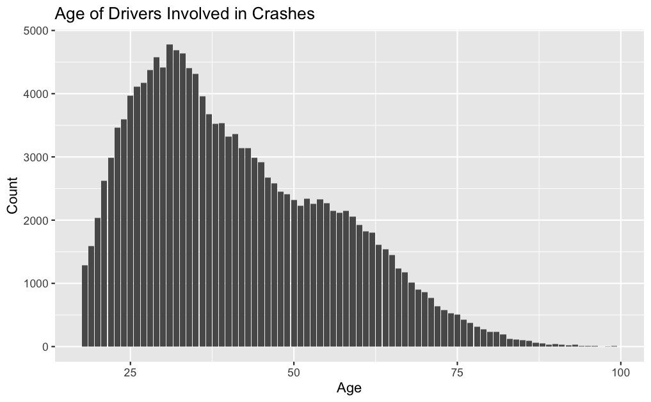
The age of drivers involved in crashes is right-skewed, peaking around age 31 and tapering steadily after 35.
Figure 4: Age of drivers involved in crashes, 2022-2026
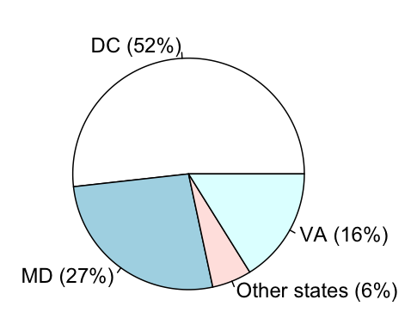
About half of vehicles involved in accidents carry D.C. plates (~52%), with Maryland (27%) and Virginia (16%) making up most of the rest. Other states only account for around ~6%.
Figure 5: Split of license plates involved in car accidents, 2022-2026

4.6 Camera Inventory
DDOT lists 550 cameras of six types. Speed (216) and clear-lane (210) cameras make up 77% of the total (Table 3). Visually, we can see that cameras cluster around the arterials where crashes concentrate (Figure 6).
Table 3: Automated safety cameras by enforcement type
Enforcement Type | Cameras | Share of Total
Speed | 216 | 39.3%
Clear Lane | 210 | 38.2%
Red Light | 55 | 10.0%
Stop Sign | 34 | 6.2%
School Bus | 25 | 4.5%
Truck Restriction | 10 | 1.8%
Total | 550 | 100%

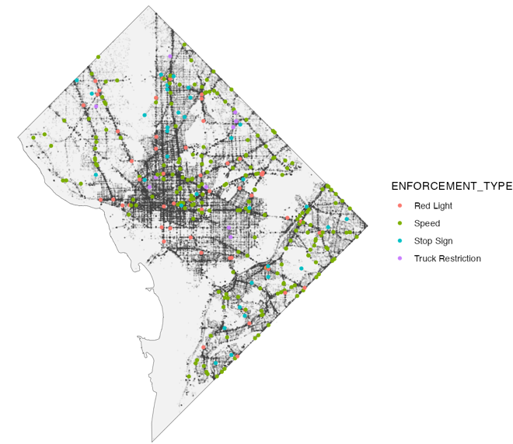

Figure 6: Camera locations by enforcement type (colored points) plotted over crash locations (black points), 2022-2026

4.7 Time Series of Crashes
Citywide crashes follow a seasonal pattern: they peak during the summer and drop during the winter. The worst stretch was mid-2023, at around 1,700 to 1,900 crashes a month, while the lowest month was January 2026 at ~1,250.
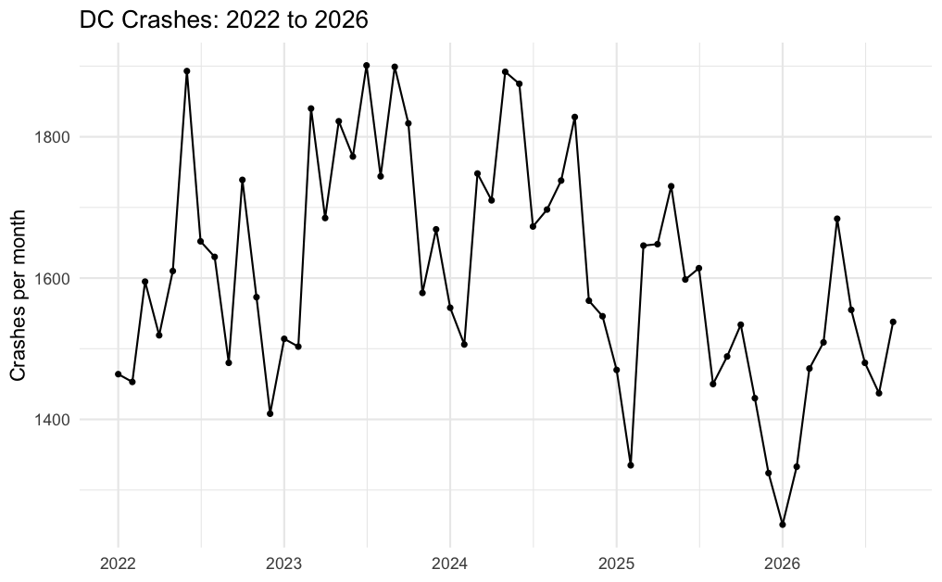

Figure 7: D.C. crashes per month, 2022-2026
This temporal pattern is important to consider for our camera analysis. Most new cameras were installed between October 2023 and March 2024, right before citywide crashes began to (relatively) fall. Section five will compare streets with cameras against streets without cameras over the same months.

- Automatic Safety Camera Impact Analysis
This section tests whether crashes fell on streets where D.C. installed a new camera. Prior to camera installation, camera corridors averaged ~1.68 crashes a month. In the months after each camera started, crashes in the same corridors were about 0.01 higher than the comparison corridors predicted (+0.6%). However, the 95% CI is from -21% to +22%, meaning this isn’t statistically significant.

In summary, they didn’t change by a detectable amount: across all 119 new cameras, crashes per corridor changed by +0.6% after the camera started, with a 95% confidence interval (CI) of -21% to +22%. In other words, the data can’t tell the cameras’ effect apart from no effect at all.
5.1 Methodology
Since cameras started in different months, we couldn’t rely on a single before/after split. In addition to this, crashes rose and fell citywide over the same years (Section 4.7). As a result, we used the Callaway and Sant’Anna (2021) estimator for staggered start dates, utilizing a difference-in-differences (DiD) design. In other words, we measure how much crashes changed on a camera’s street after the camera was installed, then subtract how much they changed over the same exact months on comparison streets without a camera. The final result is the camera’s effect.
Our formula was:
ATT (g,t) = E[Y_{t} - Y_{g – 1} | G = g] – E [Y_{t} – Y_{g-1} | C_{t} = 1]
Where:
- Y_{t} is # of crashes in a corridor in month t
- Y_{g – 1} is the crash count in the last month before the group’s camera installation
- The first term is the average change in crashes for corridors with cameras that started in month g (G = g)
- The second term is the same change for comparison corridors (C_{t} = 1) (ie. corridors whose cameras hadn’t started by month t, and the far-away stretches described in 5.3)
Standard errors were estimated by bootstrapping, clustered by corridor and 95% CIs were calculated as ATT ± 1.96 × SE. All models were estimated in R using the did package (Callaway & Sant’Anna, 2021).
This design relies on four assumptions:
- Without cameras, camera corridors and comparison corridors would’ve had the same car crash trends. (Checked in section 5.6)
- Crashes were not shifting significantly before the camera installation. (Checked in section 5.6)
- An installed camera does not alter the amount of crashes occurring in comparison corridors
- The start dates of these cameras are correct.
5.2 Identifying New Cameras
DDOT’s ASC installation date data was riddled with errors for cameras installed prior to 2022. For example, we found cameras issuing tickets before they were listed as being installed. As a result, we only considered cameras as new if (1) their first ticket came after September 2022, and (2) there was no camera ticket location of the same type within 150 m in the 2010-2020 moving violation files. Cameras that failed these tests were removed for the analysis.
Table 4: Fixed cameras in the inventory vs. new cameras studied, by start year
Camera Type | Fixed in Inventory | New (Studied) | 2023 | 2024 | 2025 | 2026
Speed | 185 | 86 | 22 | 42 | 12 | 10
Stop Sign | 34 | 25 | 11 | 10 | 0 | 4
Red Light | 55 | 8 | 0 | 8 | 0 | 0
Total | 274 | 119 | 33 | 60 | 12 | 14
Start year = year of each camera’s first ticket.
This left us with 119 new cameras. Of these, 75 (63%) switched on between October 2023 and March 2024. Since most red light cameras are older, only 8 qualified.
5.3 Corridors and Comparison Groups
Each camera’s corridor is the stretch of the same street within a quarter mile (402 m) on either side. A crash belongs to a corridor if it’s on that street and within 402 m of the camera (Figure 8). When two corridors overlap, the crash is assigned to the closer camera, so no crash is counted twice. This assigned 14,388 crashes to corridors.
The resulting panel has 141 corridors × 72 months (10,152 corridor-months). Before the cameras started, camera corridors averaged 1.85 crashes per month (speed), 1.97 (red light), and 0.98 (stop sign). They averaged about 0.5 injury crashes and only ~0.05 speeding-related crashes a month, or roughly one every 20 months.
5.4 Results (All Crashes)
All cameras together, nor individual camera types, showed a statistically significant change in crashes. Every CI is spread over zero, and intervals are quite wide.
Table 5: Estimated change in crashes per corridor per month after a camera starts
Cameras | Cameras (n) | Crashes/Month Before | Change | 95% CI
All cameras | 119 | 1.68 | +0.6% | -21% to +22%
Speed | 86 | 1.85 | -2.5% | -28% to +23%
Stop sign | 25 | 0.98 | +12% | -30% to +55%
Red light | 8 | 1.97 | -1.4% | -33% to +30%

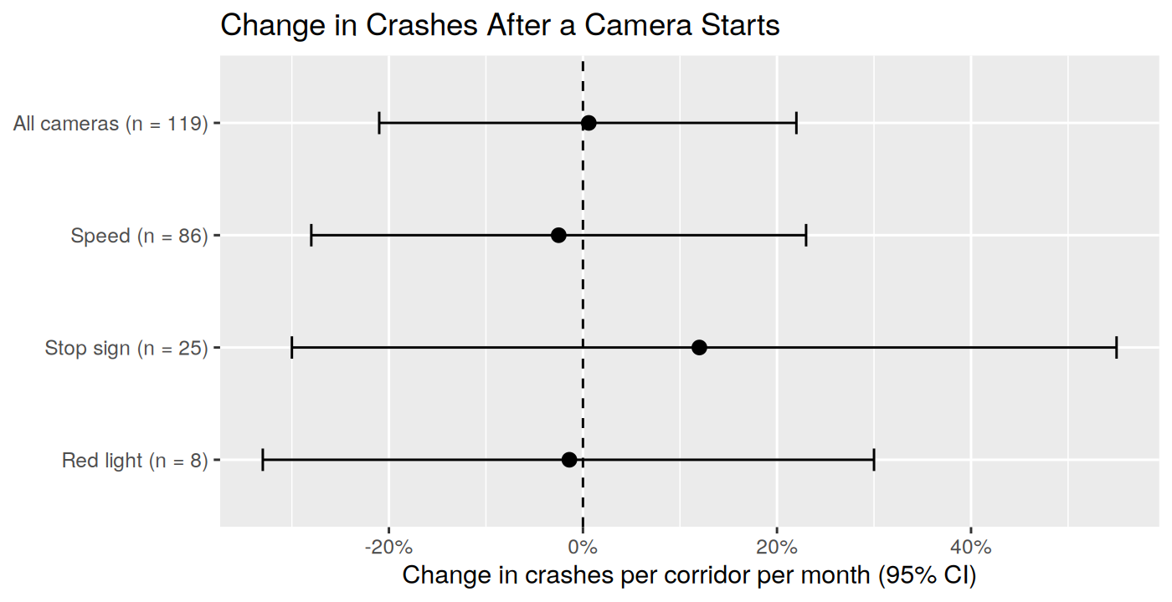
Figure 9: Estimated change in crashes per corridor per month after a camera starts, with 95% CIs
With only about 1-2 crashes per corridor per month, a camera that theoretically cuts crashes by 10-15% would prevent only about one crash every four to six months per corridor. This is nearly impossible to separate from normal month-to-month noise, and we can only really rule out large effects (± 20%).
5.5 Results (Injury and Speeding Crashes)
Injury crashes alone show the same result: no statistically significant change either way. Speeding-related crashes would be the most direct test for speed cameras, but they’re so rare (~0.05 per corridor per month) that the estimate tells us essentially nothing.
Table 6: Estimated change in injury and speeding-related crashes
Outcome | Cameras (n) | Per Month Before | Change | 95% CI
Injury crashes (all cameras) | 119 | ~0.5 | +6.6% | -19% to +32%
Speeding crashes (speed cameras) | 86 | ~0.05 | -8% | ~-155% to +139%

5.6 Pre-Trend Check
The event study estimates the effect separately for each month before and after a camera starts, shown for two years on either side (Figure 10).
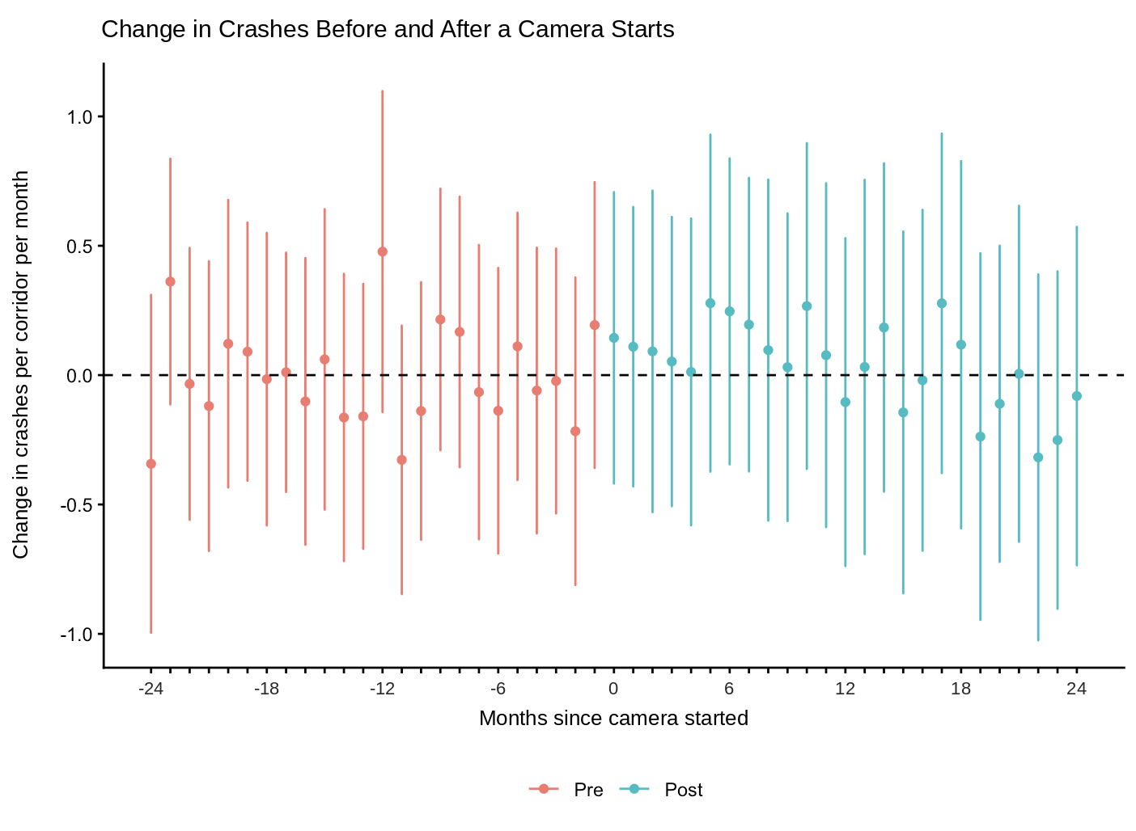
Figure 10: Estimated change in crashes per corridor per month, by months since camera start (95% CIs)
Before the cameras start, the estimates bounce between roughly -0.35 and +0.5 crashes per month with no upward or downward trend, and every interval crosses zero. This supports both the parallel trends and no anticipation assumptions. After the cameras start, the estimates stay just as close to zero, with no sign of a drop building over time.
5.7 Robustness Check
The 22 far-away stretches have far fewer crashes than camera corridors, so we re-ran the main result without them, using only cameras that hadn’t started yet as the comparison. The estimate moves from +0.6% to +13% (95% CI: -13% to +39%), but both versions cross zero, so the takeaway stays the same in that there’s no detectable change in crashes.
- Driver Behavior Analysis
Despite no statistically significant shift in crashes, violations at new cameras dropped substantially, nearly halving at speed cameras within a year. Unlike crashes, violations number in the hundreds or thousands per camera each month, so finding statistically significant shifts is much easier.
6.1 Violations After Cameras Start
For each new camera, monthly violations were lined up by months since the start month, from month 1 to 24. The start month itself is left out since cameras typically start on a random day within the month.
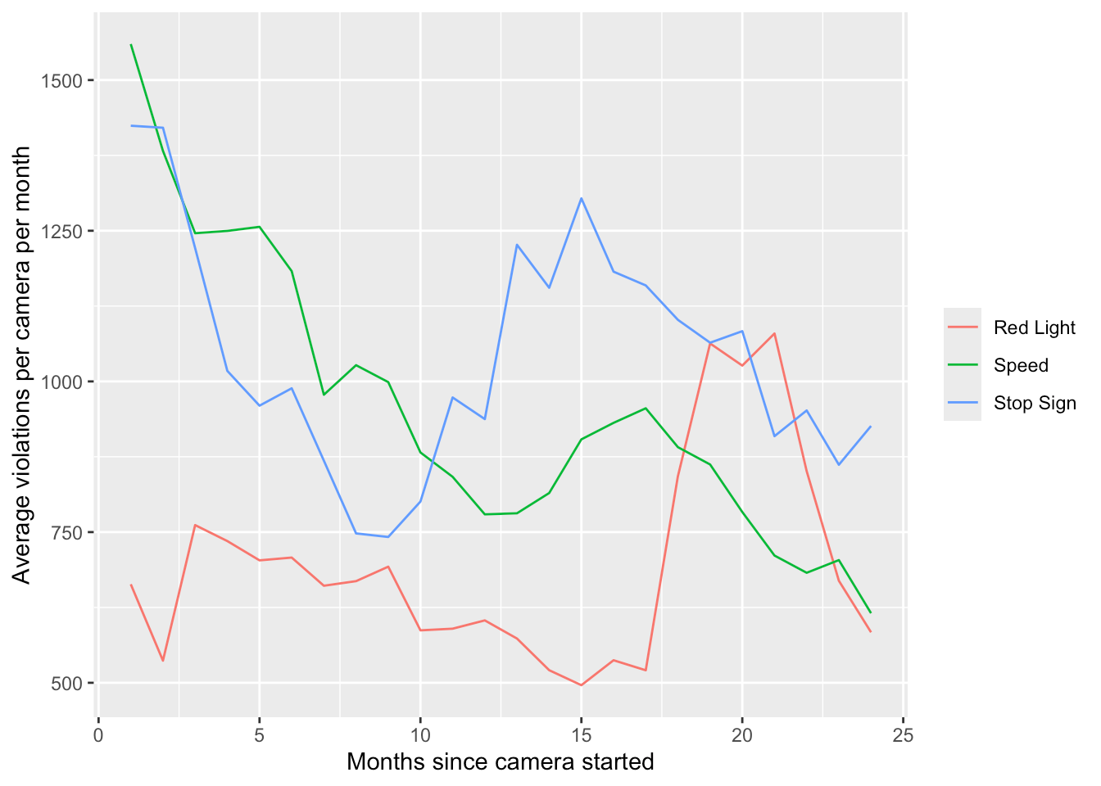
Figure 11: Average violations per camera per month, by months since camera start
Speed camera violations fall the most steadily, from ~1,550 per camera in month 1 to ~780 by month 12 and ~620 by month 24. Stop sign violations drop quickly over the first nine months, rebound to ~1,300 by month 15, then ease again. Red light violations stay between roughly 500 and 750 for the first year and a half before spiking around months 19-21.
6.2 First Months vs. One Year Later
To measure the change, we compared average violations per camera per month between months 1-3 and months 13-15 after start. Only cameras with data in both windows were included, so the same cameras are compared.
Table 7: Average monthly violations per camera, months 1-3 vs. months 13-15
Camera Type | Cameras | Months 1-3 | Months 13-15 | Change
Speed | 70 | 1,580 | 825 | -48%
Stop Sign | 21 | 1,405 | 1,229 | -12.5%
Red Light | 8 | 654 | 530 | -19%

Speed cameras show the clearest change, falling ~48% on average. Stop sign (-12.5%) and red light cameras (-19%) declined noticeably less.
Months 13-15 fall in the same calendar months as months 1-3, ensuring seasonal swings in traffic do not explain the drop. However, there’s no comparison group here, so we can’t rule out other citywide changes over that year.
- Limitations
Limitations include:
- Data integrity: DDOT’s ASC data is incomplete and includes errors in installation dates
- Time frame: Most cameras (available for analysis) only started in late 2023 to early 2024, meaning we only have around ~2.5 years of follow-up.
- Statistical power: Due to the aforementioned limitations, we’re stuck with only a fraction of ASCs to conduct analyses on.

- References
Callaway, B., & Sant’Anna, P. H. C. (2021). Difference-in-differences with multiple time periods. Journal of Econometrics, 225(2), 200-230.
D.C. Policy Center. (2018, June 28). Predominately black neighborhoods in D.C. bear the brunt of automated traffic enforcement (W. Farrell). https://www.dcpolicycenter.org/publications/predominately-black-neighborhoods-in-d-c-bear-the-brunt-of-automated-traffic-enforcement/
District Department of Transportation. (n.d.). ASC council report [Semiannual report]. https://asc.ddot.dc.gov/pages/asc-council-report
Fox Business. (2026, January 8). Department of Transportation proposes scrapping automated traffic cameras in DC (L. Mion). https://www.foxbusiness.com/politics/department-transportation-proposes-scrapping-automated-traffic-cameras-dc
NYC Department of Transportation. (2024). Automated speed enforcement program report. New York City Department of Transportation.
Office of the Mayor. (n.d.). Mayor Bowser releases year one Vision Zero progress report. https://mayor.dc.gov/release/mayor-bowser-releases-year-one-vision-zero-progress-report
Open Data DC. (2026). Crashes in DC; Automated Safety Cameras (ASC); Automated Safety Cameras Violation Count by Month; Moving Violations (2010-2020); Roadway SubBlock [Data sets]. https://opendata.dc.gov
The Washington Informer. (2026, January 5). Traffic deaths fall in D.C. in 2025, but pedestrian risk remains high (S. M. Brown). https://www.washingtoninformer.com/dc-pedestrian-traffic-deaths-2025/
Vision Zero DC. (n.d.). 2022 update. https://visionzero.dc.gov/pages/2022-update
- Appendix
Full code is in dc_camera_corridors.qmd. Key steps are below.
Code A1: Keeping only genuinely new cameras
cameras <- cameras |>
left_join(first_ticket, by = "camera") |>
rowwise() |>
mutate(spot_existed = camera_spot_existed(type, x, y)) |>
ungroup()

new_cameras <- cameras |>
filter(first_ticket > first_ddot_month, !spot_existed) |>
rename(start = first_ticket)
Code A2: Assigning each crash to the nearest corridor on the same street
crash_corridor <- crashes |>
inner_join(select(corridors, corridor, ROUTEID, cx = x, cy = y),
by = "ROUTEID", relationship = "many-to-many") |>
mutate(d = distance(x, y, cx, cy)) |>
filter(d <= corridor_m) |>
group_by(CRIMEID) |>
slice_min(d, n = 1, with_ties = FALSE) |>
ungroup()
Code A3: Difference-in-differences estimate and event study
results <- att_gt(yname = "crashes", tname = "period", idname = "id",
gname = "first_period", data = panel,
control_group = "notyettreated")
overall <- aggte(results, type = "simple", na.rm = TRUE)
event <- aggte(results, type = "dynamic", na.rm = TRUE,
min_e = -24, max_e = 24)
ggdid(event)

