To: Megan Thee Stallion
From: Alexei Habermehl
Date: 9/10/25
Subject: Spotify AI Must Be Perfected

Opening statement
This memo addresses the newly launched suggested songs AI algorithm and it’s potential to hone in on consumer preferences. The current algorithm doesn’t take into account the track traits (danceability, tempo, key, year of release) when suggesting songs. By analyzing over 600k Spotify tracks categorized into these categories, we can observe which variables correlate with a higher popularity score, and how this relationship can vary by genre.
Key Findings:
- Tracks higher in danceability, especially in genres such as Hip-Hop and Pop, are more likely to be popular.
- The impact of danceability, tempo, and key on a song’s popularity is genre-dependent
- Newer music tends to be more favorable across all categories

Data Overview:
This sample includes ~600k Spotify songs, filtered to focus on songs produced after 2012, and with popularity >=0. Univariate tables can be found below with specific variable information related to how/if they were cleaned along with any significant findings.
Table 2: Quantitative Summary
 | Freq | Min | Max | Med. | Mean |  | Skewness
Popularity | 568897 | 1.00 | 100.00 | 23.00 | 25.08 |  | 0.56
Danceability  Tempo  Year | 568897  568897  568897 | 0.00  0.00  2012 | 0.99  249.79  2023 | .56  122.00  2018 | .54  121.73  2017 |  | -0.34  0.20  -0.06

Table 1: Categorical Summary
 | Freq. | Percent
Song Key
0  1  2  3  4  5  6  7  8  9  10  11 | 63426  59041  58414  18381  43253  47139  39689  64688  36248  55632  37210  45776 | 11.2%  10.4%  10.3%  3.23%  7.6%  8.29%  6.98%  11.40%  6.37%  9.78%  6.54%  8.05%
Total | 568897 | 100%
Music Genre
Classical/Opera | 32027 | 5.63%
Country/Folk | 35963 | 6.32%
Electronic/Dance  Hip-Hop  Jazz/Blues  Latin/World  Pop  Rock/Metal  Soul  Other | 160409  9155  26558  93734  30908  35456  120556  24131 | 28.20%  1.61%  4.67%  16.48%  5.43%  6.23%  21.19%  4.24%
Total | 568897 | 100%

Genre: The genres of the songs were categorized based on their subcategories. Electronic/Dance & Soul were the most prevalent categories of songs.
Key: The distribution of the songs’ keys didn’t follow a specific pattern. Song key #3 was noticeably least popular.
Popularity: The popularity of songs were left-skewed. Few songs reached high popularity.
Danceabillity: The danceability of songs were right-skewed: most were generally able to be danced to.
Tempo: The tempo wasn’t inherently too significant: songs generally fell on a bell curve with a slight positive skew.
Year: Generally, songs fell on a bell curve, however, there was a slight negative skew.

Bivariate and Trivariate Findings:
With so many datapoints, quite literally all p values were statistically significant. Danceability and popularity are positively correlated, but it’s strength was highly genre dependent. There has been a somewhat noticeable positive correlation with track popularity and danceability when compared to year: recent music is more danceable and it’s resulting in the songs being more popular.
The keys and tempo were also significant in comparison of track popularity. More specifically, key #10 in the pop, Hip-hop, and Electronic/Dance catergories was generally overrepresented when compared to it’s counterparts. However, when it came to jazz and classical music, keys didn’t really matter.
Summary:
The quantitative results discussed above showcases the importance of typically unaddressed variables of songs on the popularity of a song. The current algorithm puts too much weight on variables like popularity when suggesting songs rather than focusing on the fundamentals of song basics.

Recommendation:
Prioritize using danceability, key, and tempo when suggesting music, especially when it comes to R&B, Pop, and Rock/Metal in order to maximize listener experience.
Bivariate Tables:
Danceability X Popularity
Danceability | Min | 1st Qu. | Median | Mean | 3rd Qu. | Max | SD
(0.00, 0.20] | 1 | 11 | 19 | 20.32 | 28 | 87 | 12.35
(0.20, 0.40] | 1 | 11 | 20 | 21.48 | 30 | 88 | 13.43
(0.40, 0.60] | 1 | 13 | 23 | 24.63 | 35 | 95 | 15.09
(0.60, 0.80] | 1 | 13 | 26 | 27.17 | 39 | 100 | 16.55
(0.80, 1.00] | 1 | 14 | 27 | 28.47 | 41 | 93 | 17.66

Genre X Popularity
Genre | n | Min | 1st Qu. | Median | Mean | 3rd Qu. | Max | SD
Classical/Opera | 32,027 | 1 | 9 | 18 | 20.03 | 29 | 91 | 12.81
Country/Folk | 35,963 | 1 | 23 | 32 | 32.61 | 41 | 89 | 13.48
Electronic/Dance | 160,409 | 1 | 13 | 23 | 24.79 | 35 | 93 | 14.97
Hip-Hop | 9,155 | 1 | 46 | 52 | 52.61 | 59 | 96 | 10.66
Jazz/Blues | 26,558 | 1 | 16 | 24 | 25.07 | 33 | 78 | 12.18
Latin/World | 93,734 | 1 | 11 | 23 | 24.58 | 36 | 92 | 16.12
Other | 30,908 | 1 | 8 | 17 | 20.89 | 29 | 91 | 15.95
Pop | 35,456 | 1 | 8 | 19 | 25.16 | 41 | 100 | 20.34
Rock/Metal | 120,556 | 1 | 12 | 21 | 23.14 | 33 | 91 | 14.02
Soul | 24,131 | 1 | 18 | 27 | 28.82 | 38 | 84 | 13.68
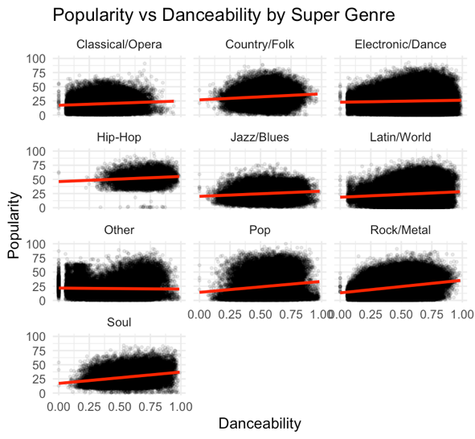
*Additional tables can be found on Excel/R

